Q4b.)





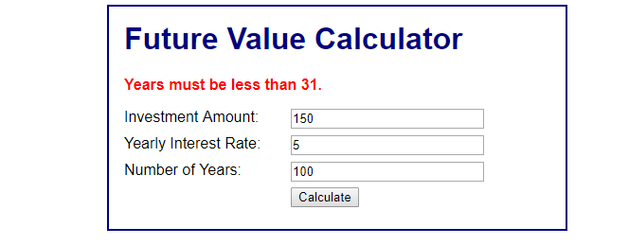

Q5) No issues setting up and doing hw