Cs437 Hw3

1. Simple hello.html put into topcat webserver directory. No given URL name for the hello.html

Its URL is as give http://topcat.cs.umb.edu/cs637/danwaba/hello.html

1. Drawn on A piece of paper on the back. Please refer to the Back for the Flow graph
2. Drawn communication diagram on the back. Please refer to the Back for the diagram
3. A.) FK in my_guitar_shop2.sql tables:

Table customers: shipAddressID, billingAddressID

Table addresses: customerID

Table orders: customerID, shipAddressID, billingAddress

Table orderItems: orderID, productID, categoryID

Table categories: no FK

Table administrator: no FK

B.)

1.) orders and orderItems has a 1-N

2.) orders and customers has a 1-N relationship, both tables share multiple columns

3.) orders and products have N-N relatioship

4.) Products and categories has a 1-N relationship

5.) customers and addresses a 1-N relationship

1. A.) SELECT DISTINCT customerID

FROM customers

WHERE emailAddress LIKE '%gmail.com'

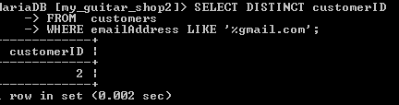

SELECT productID, quantity

FROM orderItems

WHERE orderID = '2'

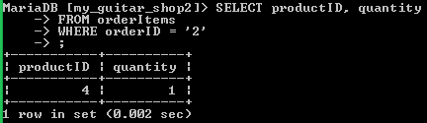

SELECT p.orderID, p.orderDate

FROM orders p, customers c

WHERE p.customerID = c.customerID AND emailAddress ='christineb@solarone.com'

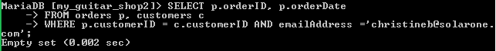

SELECT p.productID

FROM orders c, customers d, orderItems p

WHERE c.orderID = p.orderID AND c.customerID = d.customerID AND emailAddress = 'christineb@solarone.com'

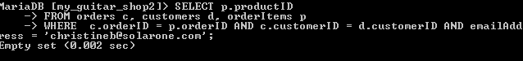

SELECT p.productID

FROM products p, orderItems o, orders b

WHERE p.productID = o.productID AND o.orderID = b.orderID AND b.orderDate > p.dateAdded

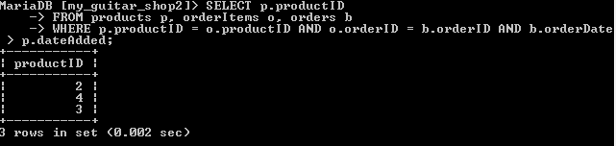

1. a.) unzipped file and set everything up. No problems fixed CSS to display the page

b.) imported the tables needed into pizzadb : command: source htdocs/cs637/danwaba/pizza1/database/createddb.sql

danwaba@topcat:/var/www/html/cs637/danwaba/pizza1/database$ mysql -D danwabadb -u danwaba -p < showdb.sql

Enter password:

menu_toppings

menu_toppings

id topping_name is_meat

1 Pepperoni 1

2 Onions 0

3 extra cheese 0

4 beef 1

5 Chicken 1

6 peppers 0

7 Onions3x 0

menu_sizes

menu_sizes

id size diameter

1 Small 12

2 Large 16

shop_users

shop_users

id username room

1 joe 6

2 sue 3

pizza_orders

pizza_orders

order_topping

order_topping

status_values

status_values

status_value

Baked

Finished

Preparing

pizza_sys_tab

pizza_sys_tab

current_day

c.) changed files putting in the usename xxxx -> danwaba and yes it listed toppings! Successful

d.) set up pizza1_setup into Net beans successfully running netbeans works!