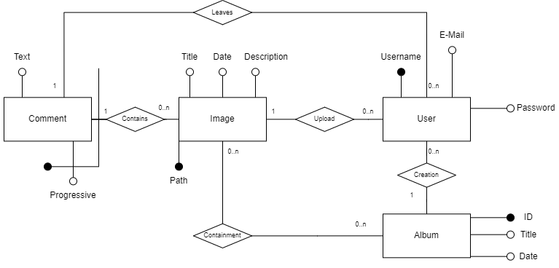

**Tables:**

USER(Username, E-Mail, Password)

IMAGE(Path, Title, Date, Description, UploaderUsername)

ALBUM(ID, Title, Date, CreatorUsername)

COMMENT(Progressive, ImagePath, User, Text)

CONTAINMENT(ImagePath, AlbumID)

**References:**

IMAGE.UploaderUsername -> USER.Username

ALBUM.CreatorUsername -> USER.Username

COMMENT.ImagePath -> IMAGE.Path

COMMENT.User -> USER.Username

CONTAINMENT.ImagePath -> IMAGE.Path

CONTAINMENT.AlbumID -> ALBUM.ID

**Legend**:

Primary key

Foreign key