# NAMA :AHMAD DANI

**NPM 141220034**

# KELAS : 2020 B

## EDIT GRADLE DI PROJECT :ROOT

// Top-level build file where you can add configuration options common to all sub-projects/modules.

buildscript **{**

repositories **{**

google()

**}**

dependencies **{**

def nav_version = "2.5.3"

classpath "androidx.navigation:navigation-safe-args-gradle- plugin:$nav_version"

**}**

**}**

plugins **{**

id 'com.android.application' version '8.0.2' apply false id 'com.android.library' version '8.0.2' apply false

id 'org.jetbrains.kotlin.android' version '1.8.20' apply false

**}**

ext **{**

coroutines = '1.6.0'

lifecycleVersion = '2.4.0'

roomVersion = '2.5.1'

**}**

EDIT GRADE DI MODUL :APP

plugins **{**

id 'com.android.application'

id 'org.jetbrains.kotlin.android' id 'kotlin-kapt'

id 'kotlin-parcelize'

id 'androidx.navigation.safeargs.kotlin'

**}**

android **{**

namespace 'com.example.mebelkayu' compileSdk 33

defaultConfig **{**

applicationId "com.example.mebelkayu" minSdk 21

targetSdk 33

versionCode 1

versionName "1.0"

testInstrumentationRunner "androidx.test.runner.AndroidJUnitRunner"

**}**

buildTypes **{**

release **{**

minifyEnabled false

proguardFiles getDefaultProguardFile('proguard-android- optimize.txt'), 'proguard-rules.pro'

### }

**}**

compileOptions **{**

sourceCompatibility JavaVersion.*VERSION_17* targetCompatibility JavaVersion.*VERSION_17*

### }

kotlinOptions **{**

jvmTarget = '17'

### }

buildFeatures **{**

viewBinding true

### }

**}**

dependencies **{**

implementation 'androidx.core:core-ktx:1.8.0' implementation 'androidx.appcompat:appcompat:1.6.1' implementation 'com.google.android.material:material:1.5.0'

implementation 'androidx.constraintlayout:constraintlayout:2.1.4' implementation 'androidx.navigation:navigation-fragment-ktx:2.5.2' implementation 'androidx.navigation:navigation-ui-ktx:2.5.2' testImplementation 'junit:junit:4.13.2'

androidTestImplementation 'androidx.test.ext:junit:1.1.5' androidTestImplementation 'androidx.test.espresso:espresso-core:3.5.1'

// Room components

implementation "androidx.room:room-ktx:$rootProject.roomVersion" kapt "androidx.room:room-compiler:$rootProject.roomVersion"

// Lifecycle components

implementation "androidx.lifecycle:lifecycle-viewmodel- ktx:$rootProject.lifecycleVersion"

implementation "androidx.lifecycle:lifecycle-livedata- ktx:$rootProject.lifecycleVersion"

implementation "androidx.lifecycle:lifecycle-common- java8:$rootProject.lifecycleVersion"

// Kotlin components

api "org.jetbrains.kotlinx:kotlinx-coroutines- core:$rootProject.coroutines"

api "org.jetbrains.kotlinx:kotlinx-coroutines- android:$rootProject.coroutines"

// Map

implementation 'com.google.android.gms:play-services-maps:18.1.0' implementation 'com.google.android.gms:play-services-location:21.0.1'

**}**

## DESAIN UI

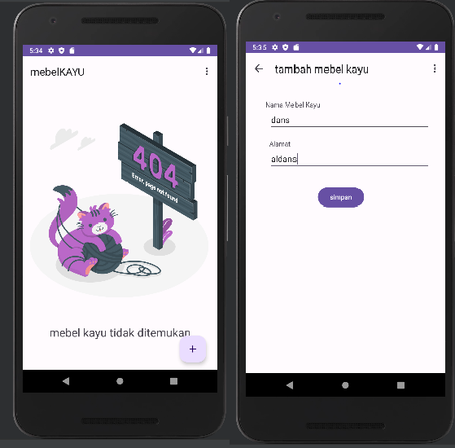

MEMBUAT TABLE DAO DESINE REPOSITORY DAN APLIKASI

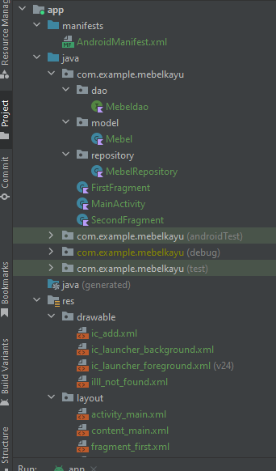

## UPLOAD DI GITHUB

