Exercise 2.B Creating a Learning Project
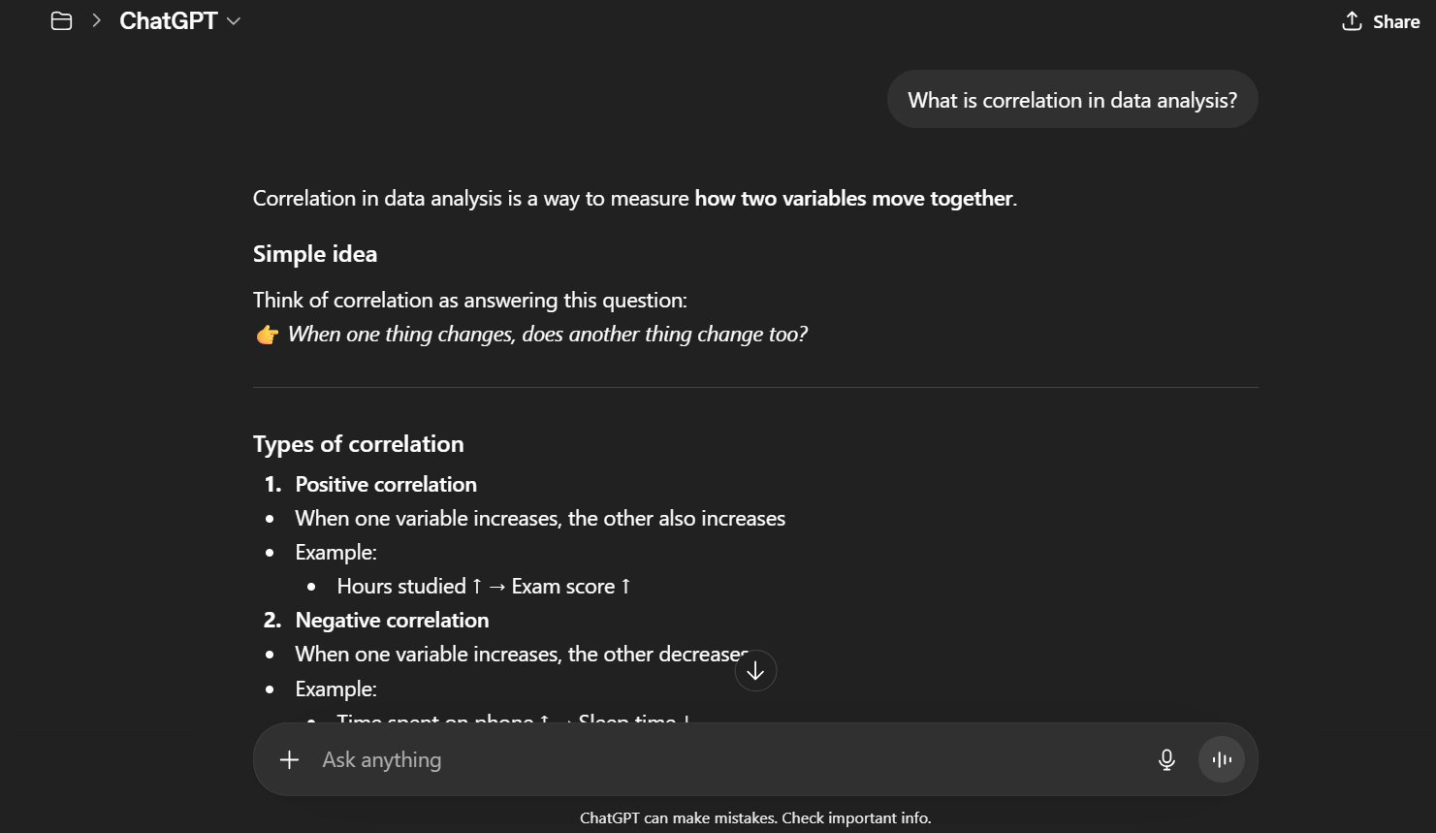
The persistent instructions helped guide the response to focus on clear, beginner-friendly explanations for data analytics concepts. They made the examples simple, small, and easy to understand, which is helpful for learners just starting out. The instructions also encouraged the use of step-by-step tables and practical examples, making the content more interactive and applicable.

