Exercise 2.A Improving Weak Prompts
Weak prompt:
- Explain regression
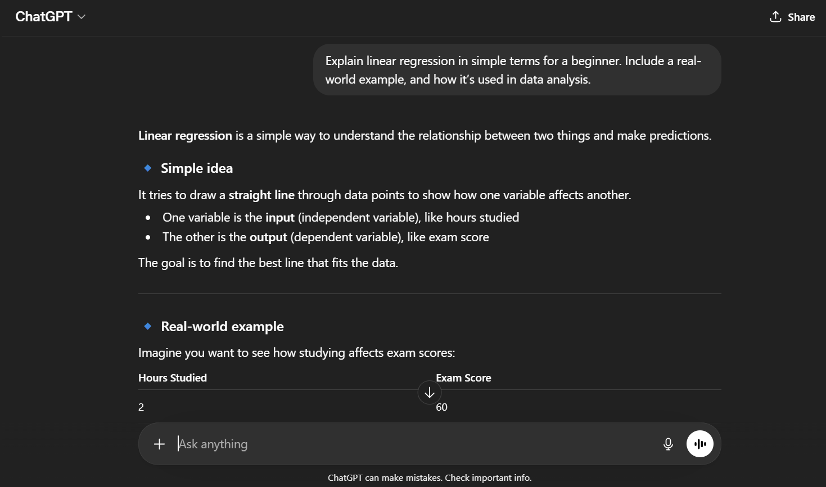
Improved: Explain linear regression in simple terms for a beginner. Include a real-world example, and how it’s used in data analysis.

Why it’s stronger:
This version is more specific about the type of regression (linear), the audience (beginner).

- Help me understand SQL
Improved: I’m a beginner learning SQL. Can you explain basic concepts like SELECT, WHERE, and JOIN with simple examples?
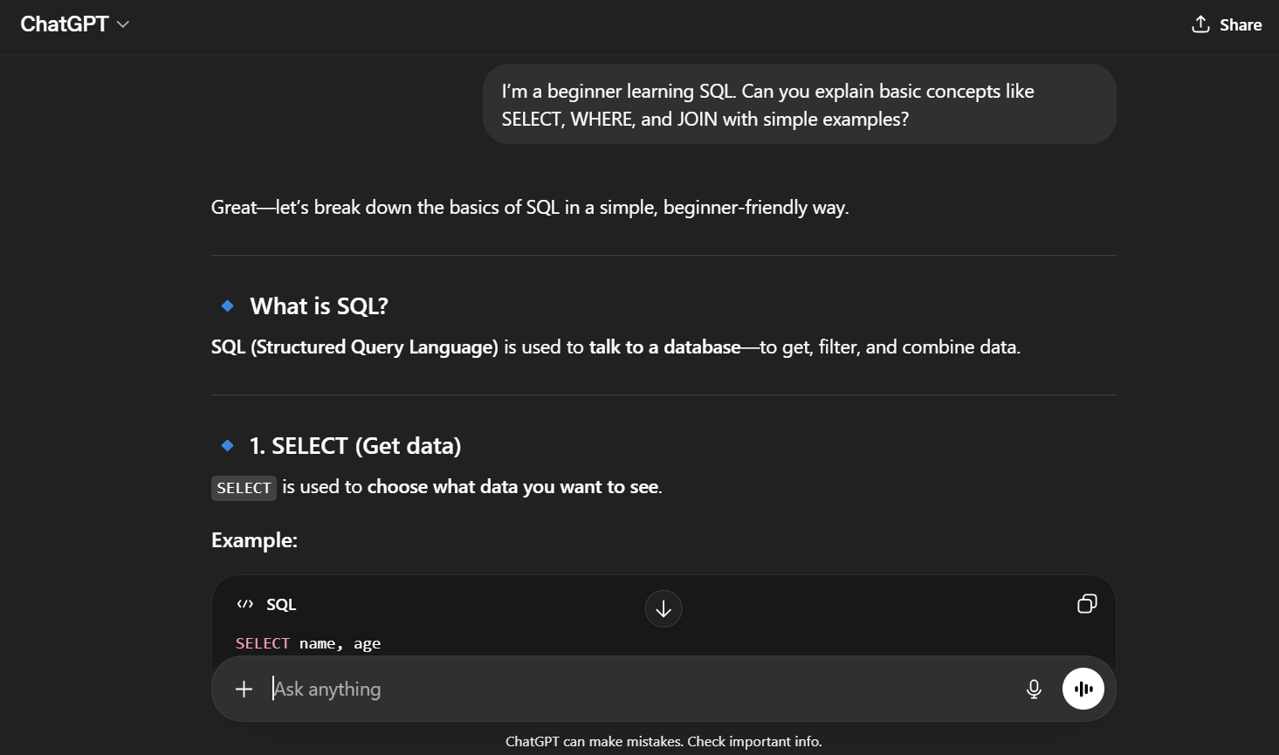
Why it’s stronger:
It defines the user’s level (beginner), the exact topics (SELECT, WHERE, JOIN), and simple examples.

- Create a dataset
Improved: Create a sample dataset for a retail store with 10 rows. Include columns for date, product name, category, quantity sold, and total sales. Format it as a table.
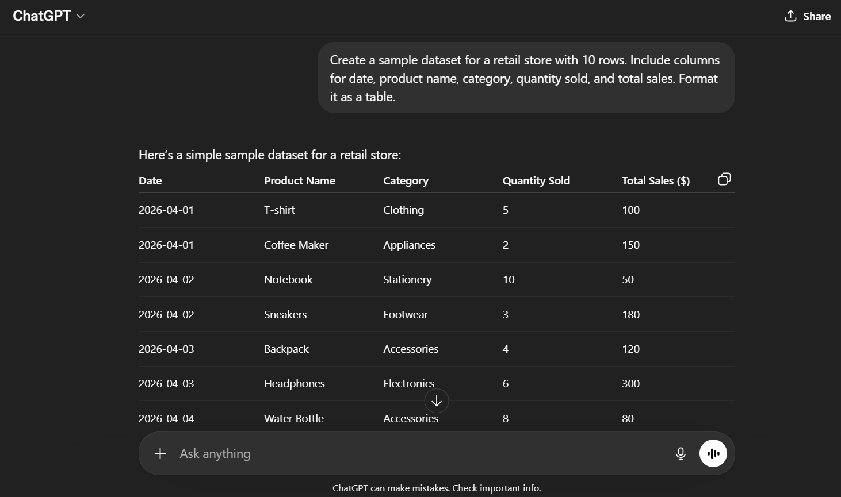
Why it’s stronger:
This prompt specifies the context (retail store), structure (columns), size (10 rows), and format (table).

