An-Najah National University

Faculty of Engineering

Department of Computer Engineering

Distributed and Operating Systems

**Bazar.com: A Multi-tier Online Book Store**

Team members:

Hamzi damide (11612453)

Dania Aqel(11642509 )

# **Chapter 1: Overview**

We use lumen framework on Ubntu Virtual Machine , to run our application you must dawnload Oracle VM VirtualBox , then made 3 VM’s inside it :

1-Frontend.

2-Catalouge Server.

3-Order Server.

As shown below:

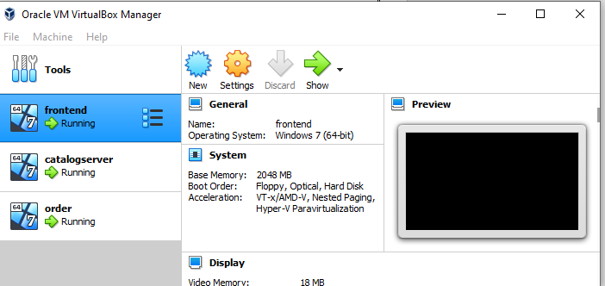

Then we install Ubntu inside each VM, then install Vscode and lumen php, after that we start writing code, we make network to communication between VM’s

1.Frontend:192.168.1.4.

2.Catalouge server:192.168.1.5.

3-Order Server:192.168.1.6.

# **Chapter 2: Output:**

**1.Search:** which is Topic based search, it is just return the title book and it's number of item. It is catalogue server responsibility, so the front-end server send query to the catalogue server and then display the response:

**1-Successful Search:**

**a-Successful search for graduatedschool topic search:**

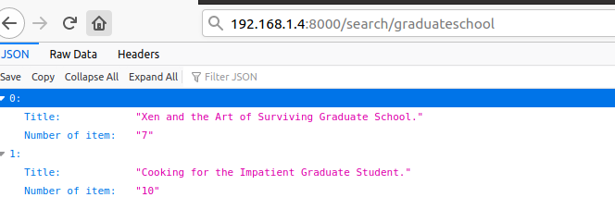

**b-Successful search for distributedsystem topic search:**

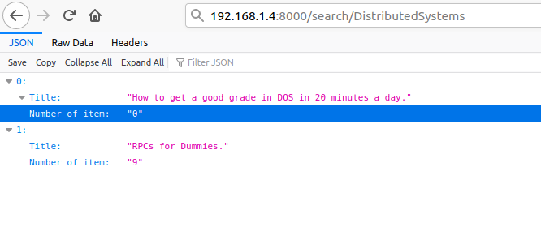

**2-Unsuccessful Search:**

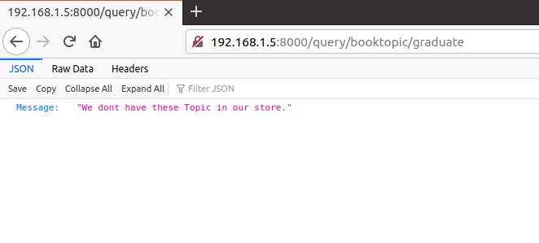

**2.Lookup:** which is ID based lookup, it is just return the number of books and it's cost,and the rest of information. It is catalogue server responsibility, so the front-end server send query to the catalogue server and then display the response :

**1-Sucessful LookUp: book is exist**

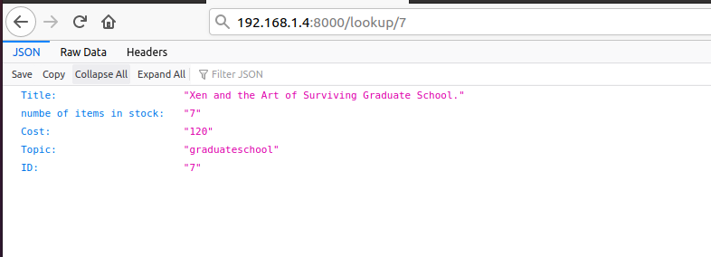

**2-UnSucessful LookUp: book does not exist**

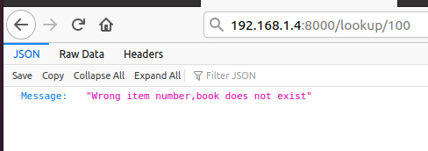

**3.Buy:** which is ID based buy. This operation is go through all servers. Front-end send buy query to order server and then order server send two consecutive queries to catalogue server, the first to check if the book exist and have adequate copies for purchase if the response is

negative then the second query will not be applied, otherwise the number of copies will decremented in the same query and second query will send to stressing the success of process.

**1-Successful buy:**

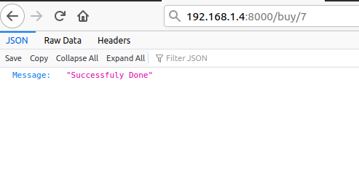

**2-Unsuccessful buy: wrong Id**

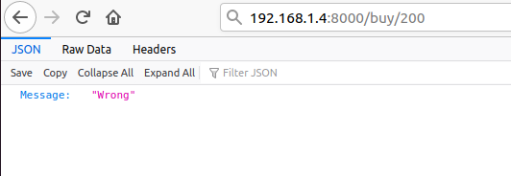

**3-Unsuccessful buy: We don’t have copies in store**

