Glasgow on the Go:

Visualising Urban Mobility in Glasgow

Danial Sheikh

17/11/2023

Table of Contents

Project Aims and Objectives 3

Related Work 4

Project Specification 6

Functional Requirements: 6

Project Plan 7

Project Progress 8

Methodologies 10

References 12

[1] D. Sandelands, "Latest figures show rise Glasgow's population due net-migration," Glasgow Times, 29-Jun-2021. [Online]. Available: https://www.glasgowtimes.co.uk/news/19404825.latest-figures-show-rise-glasgows-population-due-net-migration/ . [Accessed: 21-Nov-2023]. 12

[2] P. Bartlett, "Central Glasgow public transport the worst it's ever been say residents," STV News, 12-Feb-2022. [Online]. Available: https://news.stv.tv/west-central/glasgow-public-transport-the-worst-its-ever-been-say-residents [Accessed: 21-Nov-2023]. 12

Project Aims and Objectives

Glasgow is a bustling and vibrant city, the way people navigate their way around it has a huge impact on important matters such as traffic jams to air pollution levels. According to the Glasgow times “Glasgow’s population has been steadily increasing since 2006, when it was 568,480. In 2019, it was recorded as 633,120” [1]. This figure is expected to continue rising putting increased pressure and demands on the existing transport infrastructure with implications for transport planning on future expansion needs . An article from STV highlighted this issue with people on record saying ““It’s the worst it’s ever been” [2]. That’s what people who rely on public transport in Glasgow are saying about the services.” Due to the rising transport costs and lack of services available this will lead to an increase in car usage. Meaning more pollution and less people walking (which benefits their health).

One of the key aims of my project is to monitor and visualise urban mobility within Glasgow. I hope to do this by utilising datasets from the Glasgow Open Data hub and present this data through an interactive map. The interactive map will portray the movement and flow of Glasgow’s population. I am planning on accessing the data available through multiple r Application Programming Interface (API) from the Glasgow open data hub that shows the pedestrian footfall in Glasgow. This will help people to understand Glasgow’s traffic patterns, pedestrian flows, and cyclists’ routes in a clear and concrete manner. This would then allow them to identify [1]potential areas of congestion and gain a perspective on the current infrastructure.

The other key aim is to encourage active travel aiming to improve public health and easier to understand traffic congestion. I am going to illustrate the benefits of this by showing the volume of pedestrian and cyclist versus vehicular traffic through the datasets provided by Glasgow open data hub. This comparison will not only showcase the potential health benefits for individuals who walk and cycle but demonstrate the collective impact on urban traffic flow. To prove this, I will present studies where shifts toward active travel have led to a positive impact in both community health and traffic conditions.

Understanding urban mobility is essential for the sustainability of a modern city such as Glasgow. By providing an interactive tool that can visualise this data it can impact urban planning and environmental management in Glasgow. It will identify how the city’s population moves around the city. This will offer an insight on how to improve traffic management, reduce environmental impact thus improving urban planning decisions.

For the outcomes of my final application, I am hoping to have a user-friendly map that accurately represents traffic, pedestrian, and cyclist data. Improve public awareness of the factors influencing urban mobility. A platform that can be used by city officials to plan infrastructure improvements. An application that could be mirrored for other cities.

Related Work

**Academic Research on Urban Mobility**

The paper “Transport Issues and Sustainable Mobility in Smart Cities” talks about the complexity of urban mobility and city sustainability [3]. It highlights the significance of using geographical data to clearly illustrate urban planning and policymaking, a concept key to my project on visualising Glasgow's urban mobility. Furthermore, the paper also advocates about the importance of about the need for tools that offer real-time, accessible information. This reinforces the aim of my project to create an interactive map that can help users observe mobility patterns and infrastructure planning in Glasgow.

**Academic Research on GeoJSON**

For urban mobility GeoJSON is a powerful tool for visualising complex datasets. This is proven by Esri’s an analysis of human mobility patterns using this data tool [4]. This article suggests the methodological approach of creating an interactive map of Glasgow, using GeoJSON is a strong approach to depict urban mobility.

**Comparison Analysis of similar applications**

The case study carried out on visualising São Paulo's urban mobility with various techniques offers valuable insights into data visualisation [4]. The paper illustrates on how complex mobility data can be simplified to ensure users understand it. For presenting and analysing the urban mobility data the study used the bundling method. This technique is used to simplify and clarify the presentation of large sets of data. I am hoping I can apply this to present Glasgow’s mobility data on an interactive map.

Figure : "Naïve straight-line drawing of OD trails form the Metropolitan area of São Paulo. [4]"

Figure 1 shows “OD Survey trajectories plotted over the map of the São Paulo metropolitan area, where each line represents an OD trail. The extreme clutter in this figure precludes the visualization of individual trajectories, traffic patterns, or connections between the regions of the map. [4]”.

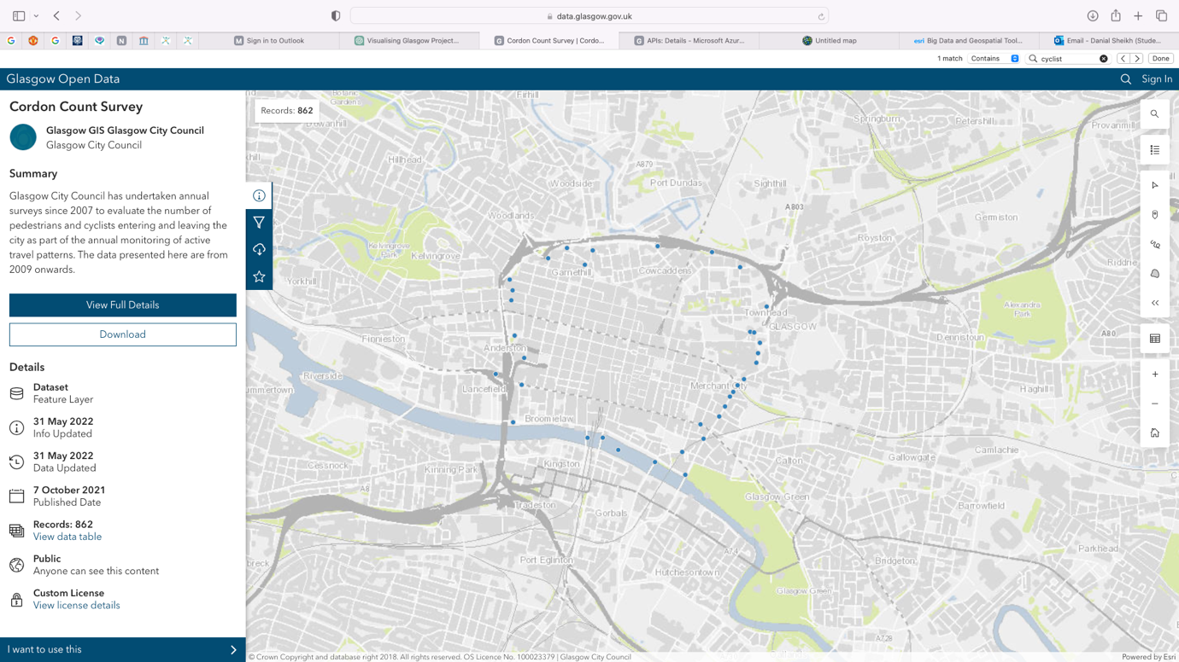

Figure : Glasgow Open Data Hub Cordon count map

The map in figure 2 from the Glasgow Open Data Hub displays the Cordon Count Survey data, which shows the number of pedestrians and cyclists. It is critical to show Glasgow’s active travel and urban mobility. It offers data from as early as 2009. I am hoping my application is similar but is more interactive and visually appealing to users.

Project Specification

Functional Requirements:

* The application will allow users to view an interactive map of Glasgow.
* Users will be able to see data on traffic, cyclists and pedestrians.
* The map will update in real-time data becomes available from Glasgow Open Data Hub APIs
* Users can interact with the map including zooming and analysis features.

Non-Functional Requirements:

* The map must load within ten seconds to ensure a responsive user experience.
* It must be compatible with modern web browsers and mobile devices.
* The application must ensure security of data and communications are protected against unauthorised access and data breaches.
* The application should be accessible according to WCAG standards (Web Content Accessibility Guidelines).

System use cases:

* A user selects a location to view how view traffic trends for that area.
* A user clicks on a pin on the map to get more details about footfall at a specific location.
* The developer in charge of the application (me) should ensure the dataset information from the API is updated and reflected in real time on the map.
* A user filters the data for a specific time period so they can study its impact on urban mobility.

User Stories:

* As a commuter, I want to check the traffic so I can avoid congested routes.
* As a city planner, I want to understand peak footfall areas to better plan urban infrastructure.
* As a health advocate, I want to find areas of high vehicle traffic and promote active travel initiatives.
* As someone relocating to Glasgow, I would like to find the least congested parts of the city, so I can live in a noise free environment.

Project Plan

To ensure my project stays on track I have set deadlines to ensure my meet my aims and objectives:

|  |  |
| --- | --- |
| Leaflet Map implementation |  |
| Dataset sorting from Glasgow open data hub |  |
| Implement interactive features |  |
| Include information to help users analyse results |  |
| Improve user interface and experience |  |
| Accessibility Compliance Adjustments |  |

**Features Implementation:**

|  |  |
| --- | --- |
| Leaflet Map implementation |  |
| Dataset sorting from Glasgow open data hub |  |
| Implement interactive features |  |
| Include information to help users analyse results |  |
| Improve user interface and experience |  |
| Accessibility Compliance Adjustments |  |

**Testing Stages:**

|  |  |
| --- | --- |
| Leaflet Map implementation | Complete by 11/12/2023 |
| Dataset sorting from Glasgow open data hub | Complete by 21/12/23 |
| Implement interactive features | Complete by 04/01/2024 |
| Include information to help users analyse results | Complete by 18/01/2024 |
| Improve user interface and experience | Complete by 07/02/2024 |
| Accessibility Compliance Adjustments | Complete by 21/02/2024 |

|  |  |
| --- | --- |
| Unit Testing | Start 04/01/2024 |
| Integration Testing | Start by 25/01/2024 |
| User Survey and applying for ethics approval | Start by 3/01/23 |
| User Acceptance Testing | Start by 26/02/2024 |
| User Acceptance Testing | Start by 01/03/2024 |
| Final Review of Application | Start by 12/03/2024 |

Project Progress

I am currently in the early stages of developing my application. I have decided that the high-level language I am going to use for my application is JavaScript. I have incorporated the leaflet library for the front-end map interaction and am currently trying to feed the data into the map.

Figure 3: GeoJSON conversion function

In Figure 3 it clearly illustrates how I have made a function that parses the JSON data from Glasgow open hub to GeoJSON. This is done by passing in JSON array as a parameter. Then reading it into the function to be converted into an array of GeoJSON features.

Figure 4:: Running leaflet on localhost

Figure 4 shows leaflet running on localhost and plotting the coordinate points from the GeoJSON data. However, still need to format the pop-up data when a user clicks on the pin. Ensuring it is relevant and easy to understand thus being able to perform analyse on it.

The issues I have faced so far with this project is trying to get the API (Application Programme Interface) for traffic movement to load data consistently as it was giving me server 404 not found error. I then raised this issue with the developers at Glasgow city council and the bug was resolved in just under a fortnight. Another issue I have faced is leaflet not being able to work in safari. I am currently still searching for a solution and have tried updating the software.

Methodologies

I have decided to build my application using JavaScript as it has strong graphics support, particularly for web development and producing interactive content. I will be using the datasets provided by Glasgow open data hub through its various Application Programming Interface (API). The data specifies traffic, cyclists, and pedestrian movement throughout Glasgow. When sending a request to the API it returns the data in a JSON format. However, I change the data in a GEOJSON format as it is a widely accepted standard for representing geographical features in web applications. This is allowing me to fully utilise geographical data and pinpoint exact locations in Glasgow when developing the interactive map. This allows for more accuracy when comparing results and trends.

For the interactive map I am planning on using an open-source JavaScript library called leaflet to build it. Leaflet has built in support for GeoJSON which will make the development process smoother. Leaflet is mobile friendly which means the map will be accessible to users using various devices. Another reason for choosing this framework is it handles real time updates which is beneficial for when new data is published to the API.

Planning on using pins on the map to plot the locations of the GeoJSON data. Develop popups that provide detailed data analysis for users, enabling them to understand factors of urban mobility. To ensure users have a positive experience I am going to ensure my application adheres to web accessibility standards. For the theoretical side of my application, am planning on including some information that users can use to analysis the data on the map.

When brainstorming ideas to represent the data for Glasgow’s urban mobility, User-Centred Design methodology was crucial. The project guidelines prioritised visualising the data in an appealing way and achieve this by designing an interactive map. The application allows users to engage with the real-time data and offers a dynamic experience. This is achieved through clickable features and data visualisations. I am following Web Content Accessibility Guidelines (WCAG) ensures that the map is accessible to as many users as possible. Following these guidelines, it allows for diversity and allows all users to use and benefit from the application.

In developing the application, I opted to use an Agile development approach. This is because it allows for flexibility and iterative development. I meet with my supervisor Fredrik Forsberg Nordvall every fortnight as this allows for regular feedback and continual improvement, when building the application. This will ensure my project aims and objectives are met, and appropriate adjustments are made.

Before my final application is complete, I will conduct rigorous testing. For my code I am going to write unit tests to ensure the application can is technically sound. An example of this is giving a helpful guidance message to the user when they have a bad or unusual request. I will also be conducting User Acceptance Testing to ensure the application meets users requirements and is ready for final submission.

For evaluating the application, I am planning on doing on analyse on its performance metrics. For example, what is the load time for the map to be fully interactive when the user loads it up. Another being the response time for executing user interactions when they click on a certain feature. Gather user feedback through surveys or interviews to gain deeper insights into potential improvements.

References

[1] D. Sandelands, "Latest figures show rise Glasgow's population due net-migration," Glasgow Times, 29-Jun-2021. [Online]. Available: <https://www.glasgowtimes.co.uk/news/19404825.latest-figures-show-rise-glasgows-population-due-net-migration/> . [Accessed: 21-Nov-2023].

[2] P. Bartlett, "Central Glasgow public transport the worst it's ever been say residents," STV News, 12-Feb-2022. [Online]. Available: <https://news.stv.tv/west-central/glasgow-public-transport-the-worst-its-ever-been-say-residents> [Accessed: 21-Nov-2023].

[3] E. Venezia and S. Vergura, "Transport issues and sustainable mobility in smart cities," in 2015 International Conference on Clean Electrical Power (ICCEP), Taormina, 2015, pp. 1-6. [Online]. Available: <https://ieeexplore.ieee.org/document/7177648>. [Accessed: Nov. 23, 2023].

[4]G. Milner, "What a Big Data Approach and Geospatial Tools Reveal about Human Mobility," Esri, 07-Sep-2021. [Online]. Available: <https://www.esri.com/about/newsroom/blog/big-data-geospatial-tools>. [Accessed: 23-Nov-2023].

[5] E. F. Zambom Santana, N. Lago, M. A. V. Meirelles, "Visualizing the structure of urban mobility with bundling: A case study of the city of São Paulo," 2020. [Online]. Available: <https://www.researchgate.net/publication/344874195_Visualizing_the_structure_of_urban_mobility_with_bundling_A_case_study_of_the_city_of_Sao_Paulo>. [Accessed: Nov. 21, 2023].