Overall Direction
Please use the new Nétanella mock-up as the master reference for the layout for both Nétanel and Nétanella
The structure, spacing and proportions should remain almost identical.
The only differences should be:
- imagery
- colour accents
- copy
- overall mood
Nétanel should feel deeper, richer and more commanding, while still feeling part of the same collection.
I have attached mock ups for reference
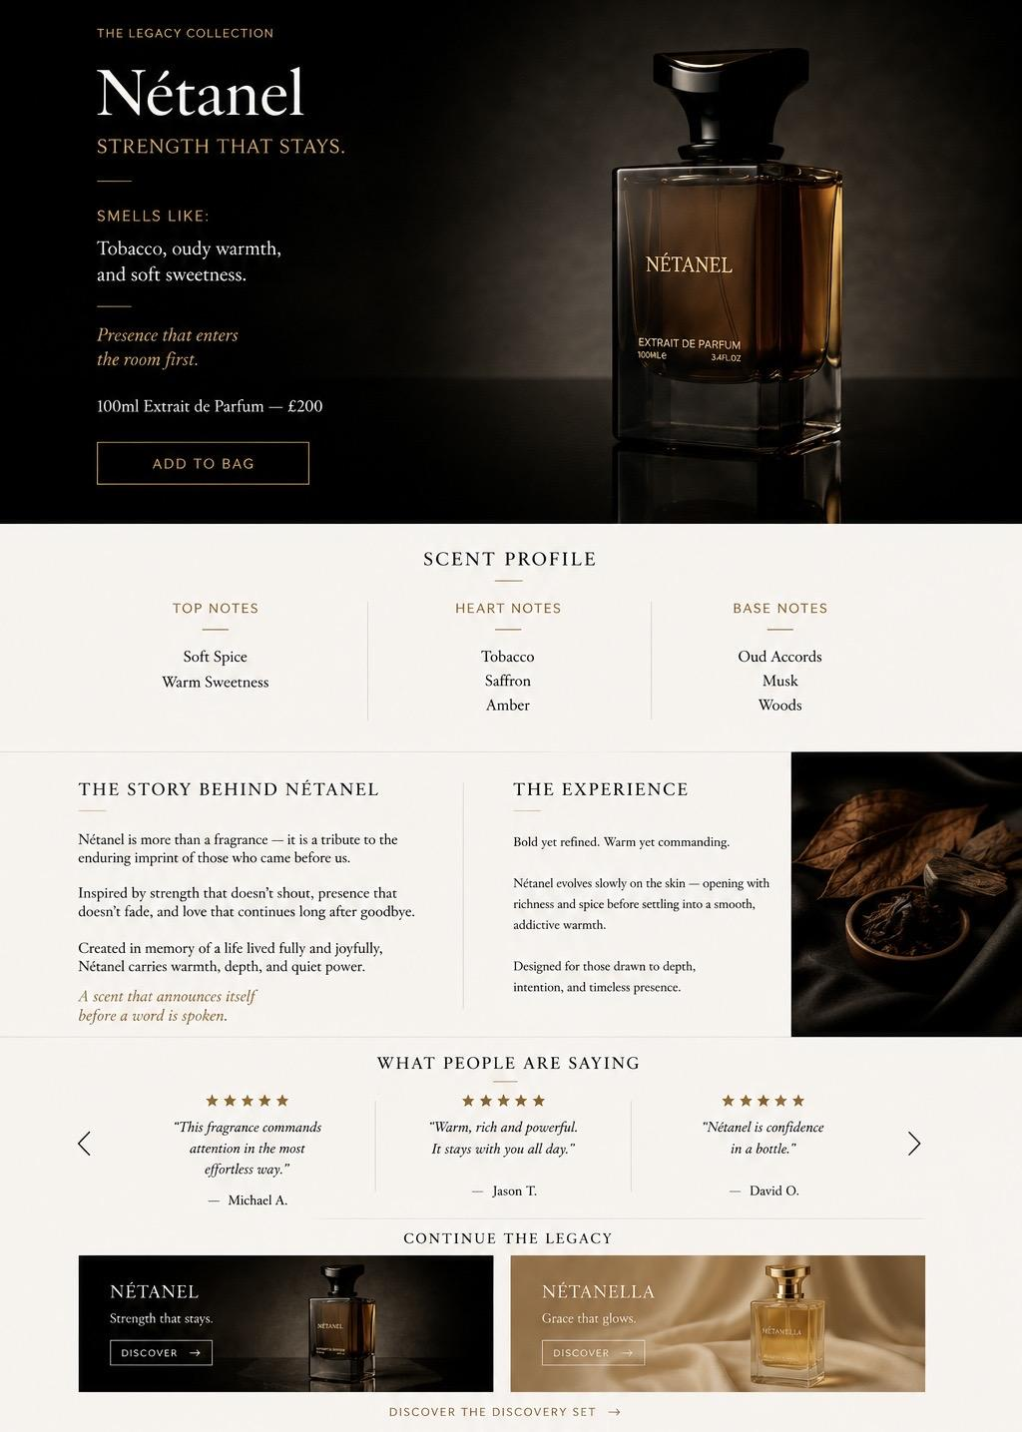

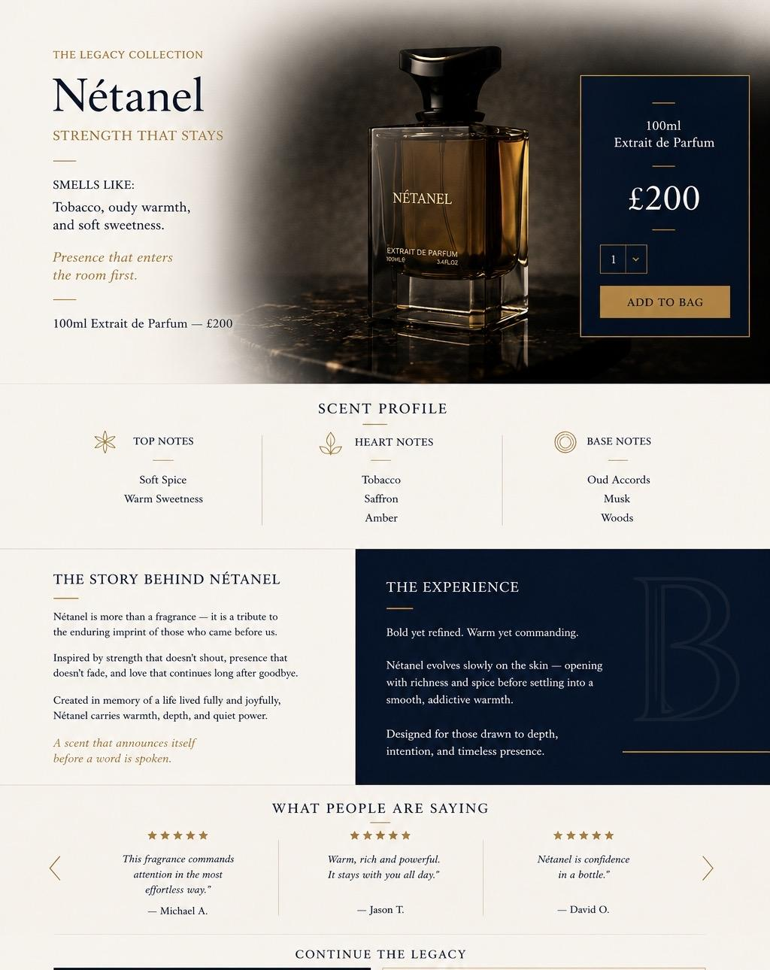

NÉTANEL PRODUCT PAGE
Nétanel
Strength that stays.
Smells like:
Tobacco, oudy warmth, and soft sweetness.
Presence that enters the room first.
100ml Extrait de Parfum — £200
CTA:
Add to Bag
⸻
SCENT PROFILE
Top Notes
Soft Spice
Warm Sweetness

Heart Notes
Tobacco
Saffron
Amber

Base Notes
Oud Accords
Musk
Woods
⸻
THE STORY BEHIND NÉTANEL
Nétanel is more than a fragrance — it is a tribute to the enduring imprint of those who came before us.
Inspired by strength that doesn’t shout, presence that doesn’t fade, and love that continues long after goodbye.
Created in memory of a life lived fully and joyfully, Nétanel carries warmth, depth, and quiet power.
A scent that announces itself before a word is spoken.
⸻
THE EXPERIENCE
Nétanel walks into the room before you do.
Warm tobacco, saffron and oud unfold with quiet confidence, creating a rich trail that’s noticed before a word is spoken.
Power, without excess.
⸻
REVIEWS
What People Are Saying
⸻
RELATED PRODUCTS
Continue the Legacy
⸻

⸻
NÉTANELLA PRODUCT PAGE
Nétanella
Grace that glows.
Smells like:
Frankincense at dusk, soft spice, and amber burning low.
Softness that lingers.
Warmth that stays with you.
100ml Extrait de Parfum — £200
CTA:
Add to Bag
⸻
SCENT PROFILE
Top Notes
Soft Spice
Pink Pepper

Heart Notes
Frankincense
Patchouli

Base Notes
Amber
Resin
Cedarwood
⸻
THE STORY BEHIND NÉTANELLA
Nétanella is a celebration of warmth in the midst of trial, and elegance that rises even during life’s most difficult seasons.
Inspired by softness that survives and grace that glows quietly, this fragrance was shaped by a journey of becoming.
It is both comfort and affirmation — a reminder that strength does not always need to announce itself.
Nétanella lingers gently: warm, intimate, and unforgettable

⸻
THE EXPERIENCE
Nétanella lingers long after you’ve gone.
Frankincense, amber and soft spice melt into the skin, leaving behind a soft warmth that’s felt rather than announced.
Elegance, remembered.

⸻
REVIEWS
What People Are Saying
⸻
RELATED PRODUCTS
Continue the Legacy

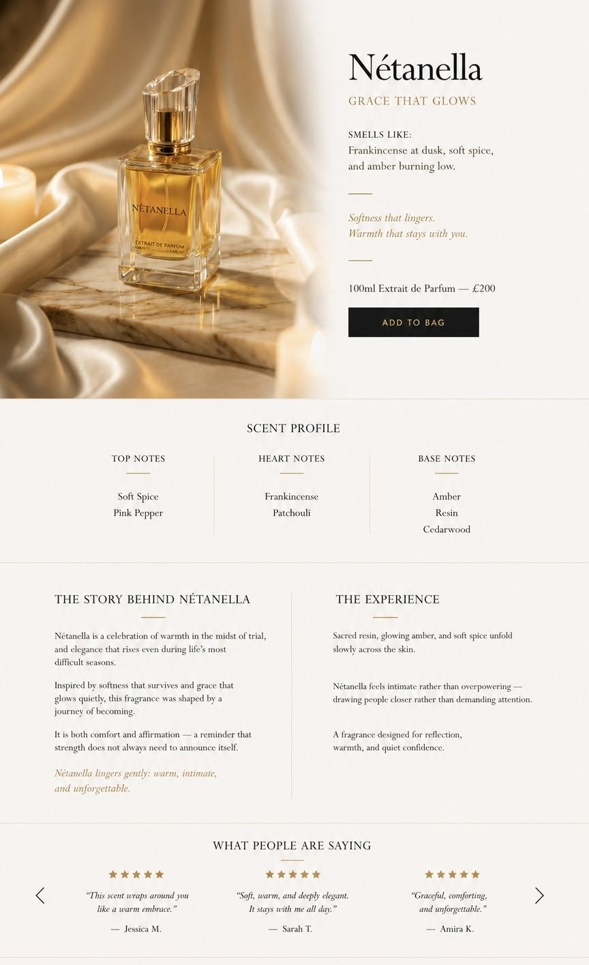

Discovery Collection — 10ml
An introduction to the world of Bealuxe.
Presented in reusable gold travel atomisers, crafted for discovery, effortless travel, and everyday presence.

Nétanel Discovery Edition
Tobacco, oudy warmth, and soft sweetness.
£30
Add to Bag

Nétanella Discovery Edition
Frankincense at dusk, soft spice, and amber burning low.
£30
Add to Bag

Discovery Collection
Experience both fragrances together and discover two distinct expressions of The Legacy Collection.
£58
Add to Bag
