Assignment Report

I have around 4 years of experience in Java Development. My expertises are Spring MVC, Spring Data, Spring Boot, Spring AOP, Hibernate, Restful Services and Amazon Web Services.

For developing this application I have used Spring Boot, Spring Data, Spring MVC and Hibernate and it is deployed on pivotal server.

* **To configure database, go to application.properties file to specify the database URL, driver and authentication.**

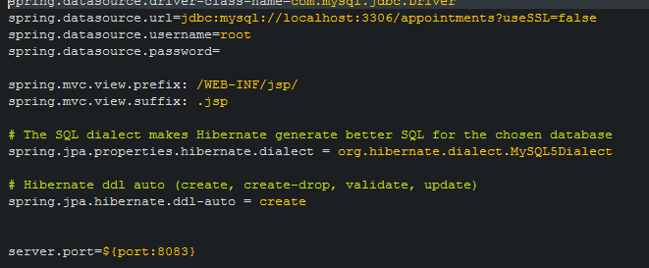

* **Hibernate is used in this application to create and update the database table**

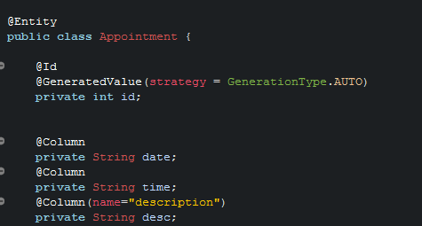

* **The following is the repository responsible for getting and inserting the data in the database**

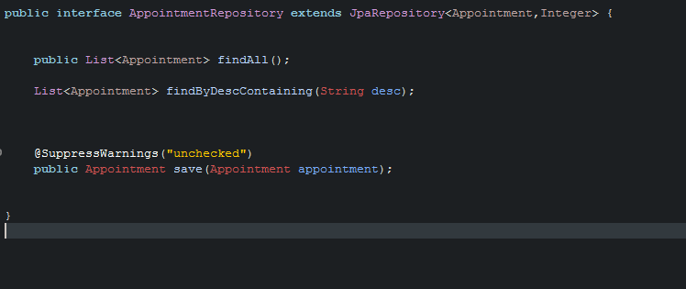

* **Spring JTA is responsible for handling all the transactions**

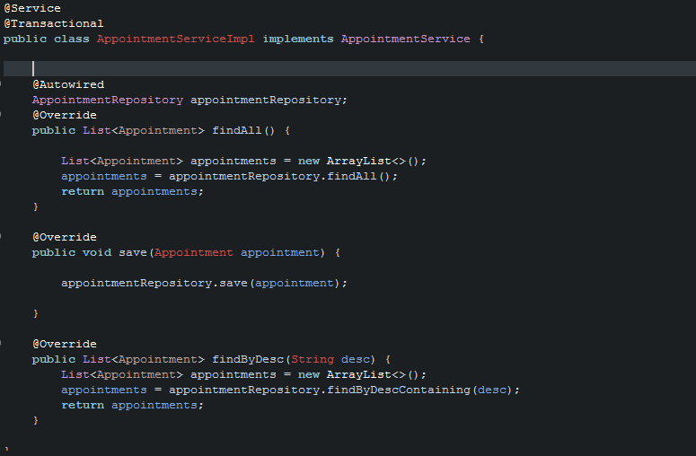

* **The following code snippet shows the AJAX call to the getAppointments Controller to get the data from the database and create table using DOM**

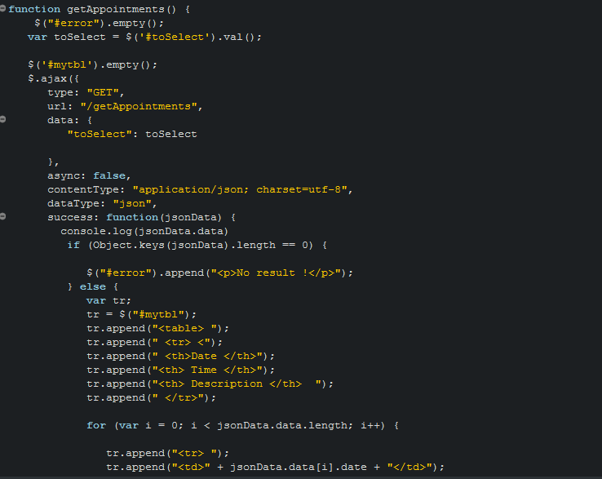

# Application Interface

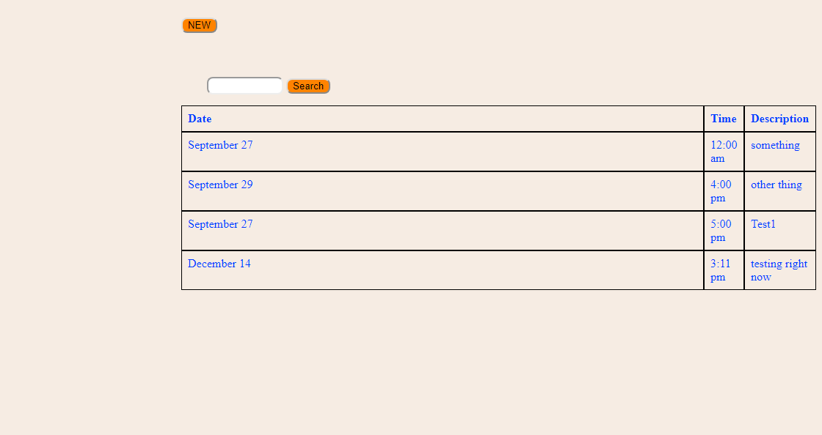

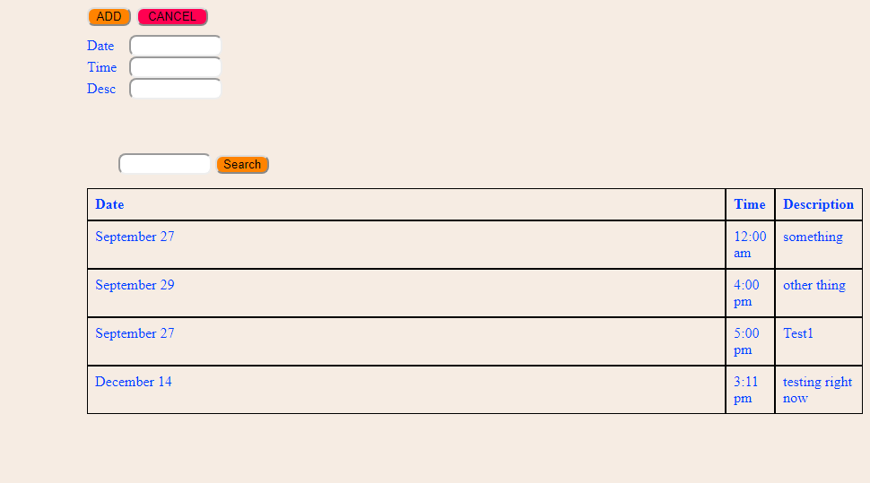

# How to run:

**Import this application in Java IDE as a maven project. Update maven and then execute as a spring boot application.**

**On browser type localhost: 8083 to run this application.**