Assignment Report

I have around 4 years of experience in Java Development using Spring (Spring MVC, Spring Data, Spring Boot, Spring AOP), Rest Web Services, Hibernate and AWS and for testing Mockito and JUnit. This assignment was really a fun thing to do.

The following are the walkthrough steps towards the application.

* **The application has been build using Spring boot**

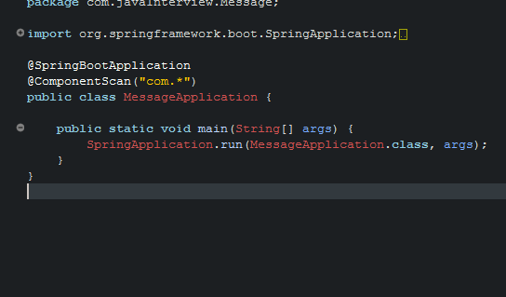

* **The technology I have used for writing a web service is Rest.**

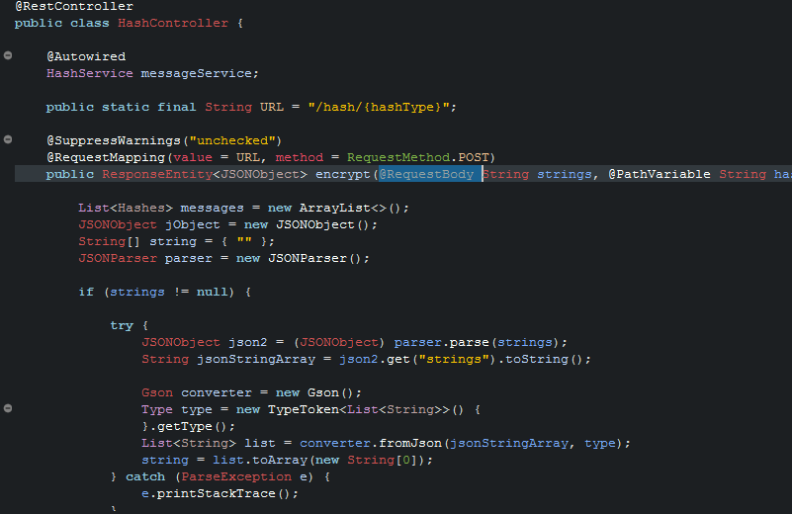

* **It is quite simple to run, it is a maven project. It should be imported in any Java IDE (Eclipse, Spring Tool Suite, IntelliJ).**
* **After importing the project maven should be updated to download the required dependencies.**
* **And then the application can be run just by executing the main application class.**



* **For sending the JSON response I have used postman, advance rest client can also be used to send the JSON body.**
* **The type of hashing can be provided in the path variable for example** localhost:8080/hash/all
* **And it will generate the response in JSON Media Type which can be seen in any rest client (Postman).**

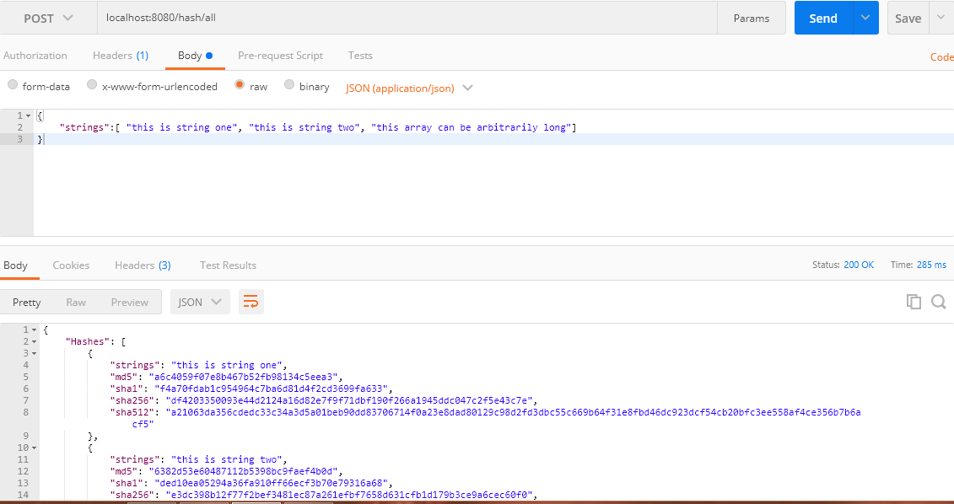

* **For Testing I have used Mockito Test cases for the controller to verify the status response and the response body returned in JSON format**

