Heart Disease Prediction: An End-to-End MLOps Pipeline
Name: Danial Barbhuiya
Course: AIMLCZG523 - MLOps
Assignment: Assignment 1
Repository: https://github.com/danialahmed97/heart-disease-mlops

Table of Contents
- Introduction
- Dataset and Exploratory Data Analysis
- Feature Engineering
- Model Development and Tuning
- Experiment Tracking (MLflow)
- Packaging and Reproducibility
- CI/CD
- Pipeline Failure Handling
- Containerisation
- Kubernetes Deployment
- Monitoring and Logging
- Architecture
- Challenges and Learnings
- Limitations and Future Work
- Conclusion

1. Introduction
Heart disease is a leading cause of death, and early screening relies on a handful of cheap clinical measurements. I built a binary classifier that predicts whether heart disease is present from 13 such measurements. The model is the smaller part of the work. The point of the assignment is the lifecycle around it: reproducible data processing, experiment tracking, automated tests and CI, containerisation, Kubernetes deployment and live monitoring.
I had three goals. First, a model I can defend with cross-validated numbers rather than one lucky split. Second, every step reproducible from a clean checkout with make targets or a single pip/python command chain. Third, a service that can be deployed, observed and scaled.
One design principle runs through everything. This is a screening use case, so a missed patient (false negative) costs more than a false alarm. Recall is therefore a first-class criterion in model selection and not an afterthought.

2. Dataset and Exploratory Data Analysis

2.1 Data and cleaning
I used the UCI Heart Disease Cleveland subset (processed.cleveland.data): 303 patients, 13 predictors and num, an angiographic severity score from 0 to 4. scripts/download_data.py fetches the file with four retries and exponential back-off, assigns the 14 column names and writes data/raw/heart.csv. src/data_processing.py then cleans it:
- ? becomes NaN. Only ca (4 rows) and thal (2 rows) are affected, under 2% of the data. I imputed both with the column mode. Both are categorical, so the mode is the natural fill, and imputing keeps all 303 rows.
- Discrete columns are cast to integers; oldpeak stays float.
- num > 0 becomes 1 (disease present). This turns the five-level severity into the screening question "disease or not".
- Duplicate rows are dropped; none were found.
The result is 303 rows with 164 healthy and 139 diseased patients. The cleaning functions are small and individually unit-tested.

2.2 Summary statistics
Feature | Mean | Std | Min | Max | IQR outliers
age | 54.4 | 9.0 | 29 | 77 | 0
trestbps | 131.7 | 17.6 | 94 | 200 | 9
chol | 246.7 | 51.8 | 126 | 564 | 5
thalach | 149.6 | 22.9 | 71 | 202 | 1
oldpeak | 1.0 | 1.2 | 0.0 | 6.2 | 5

The sample is 68% male (206 of 303) and only 15% have raised fasting blood sugar (45 of 303). The outlier counts are small (1.5 x IQR rule). The single chol value of 564 is extreme but physiologically possible, so I kept it. Standard scaling plus a regularised model keeps its influence limited.

2.3 Class balance
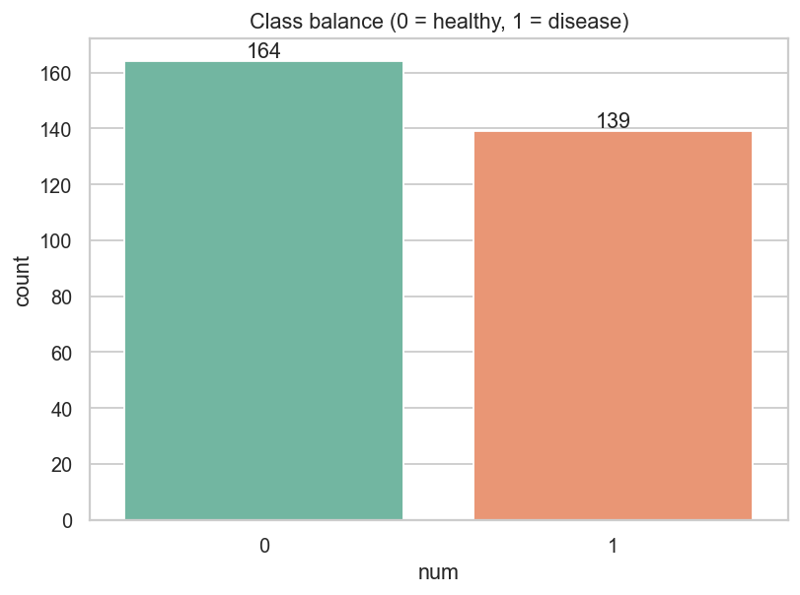
Class balance
The classes are close to balanced (54% / 46%). Accuracy is therefore meaningful, but I still optimise ROC-AUC and watch recall because they match the screening objective. With this balance, resampling or class weights are not required; I only keep class_weight as a tunable option for logistic regression.

2.4 Distributions
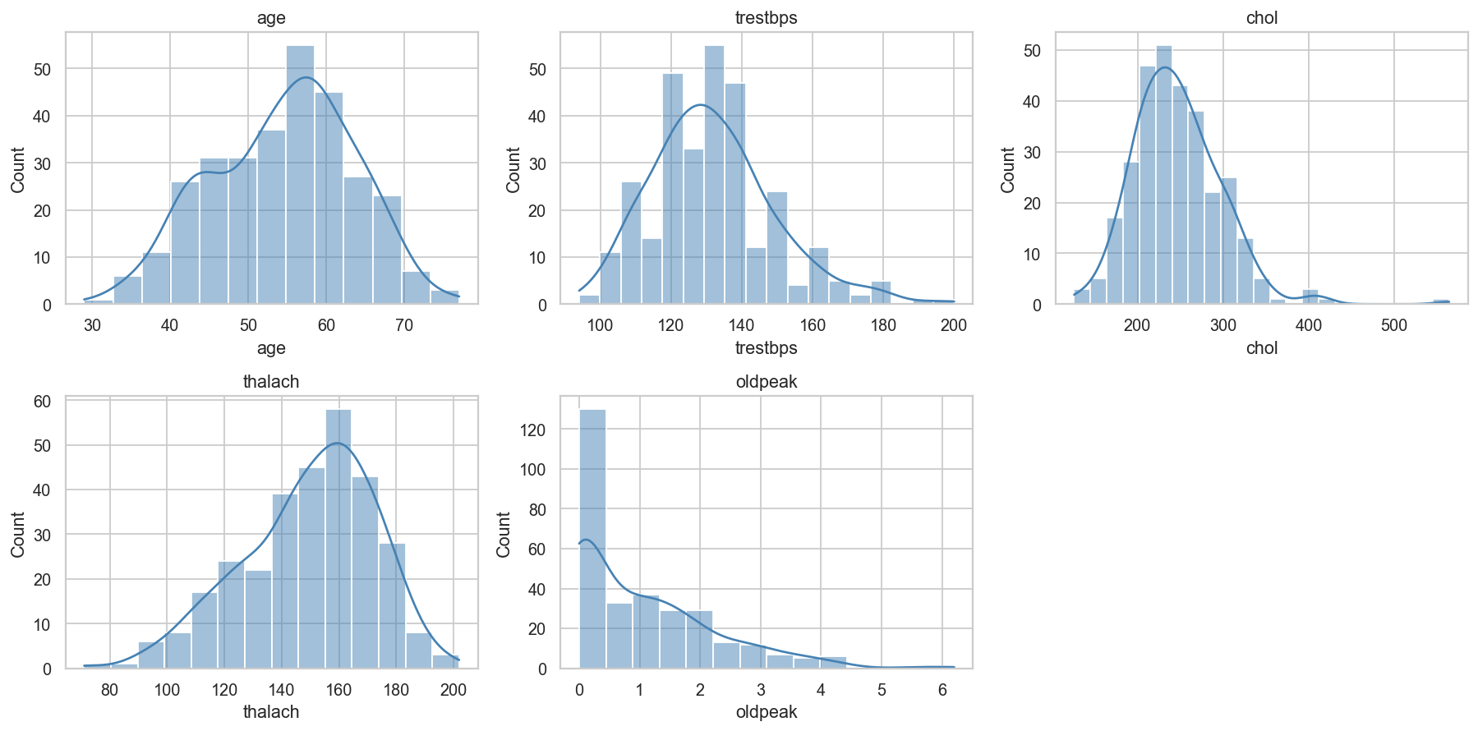
Histograms of numeric features
chol (skew about 1.1) and oldpeak (about 1.3) are right-skewed, while thalach (about -0.5) leans left. age and trestbps are roughly bell-shaped. The skew justifies scaling for the linear model. I did not log-transform, because the tree models do not need it and logistic regression with standardised inputs was already competitive.

2.5 Categorical features against the target
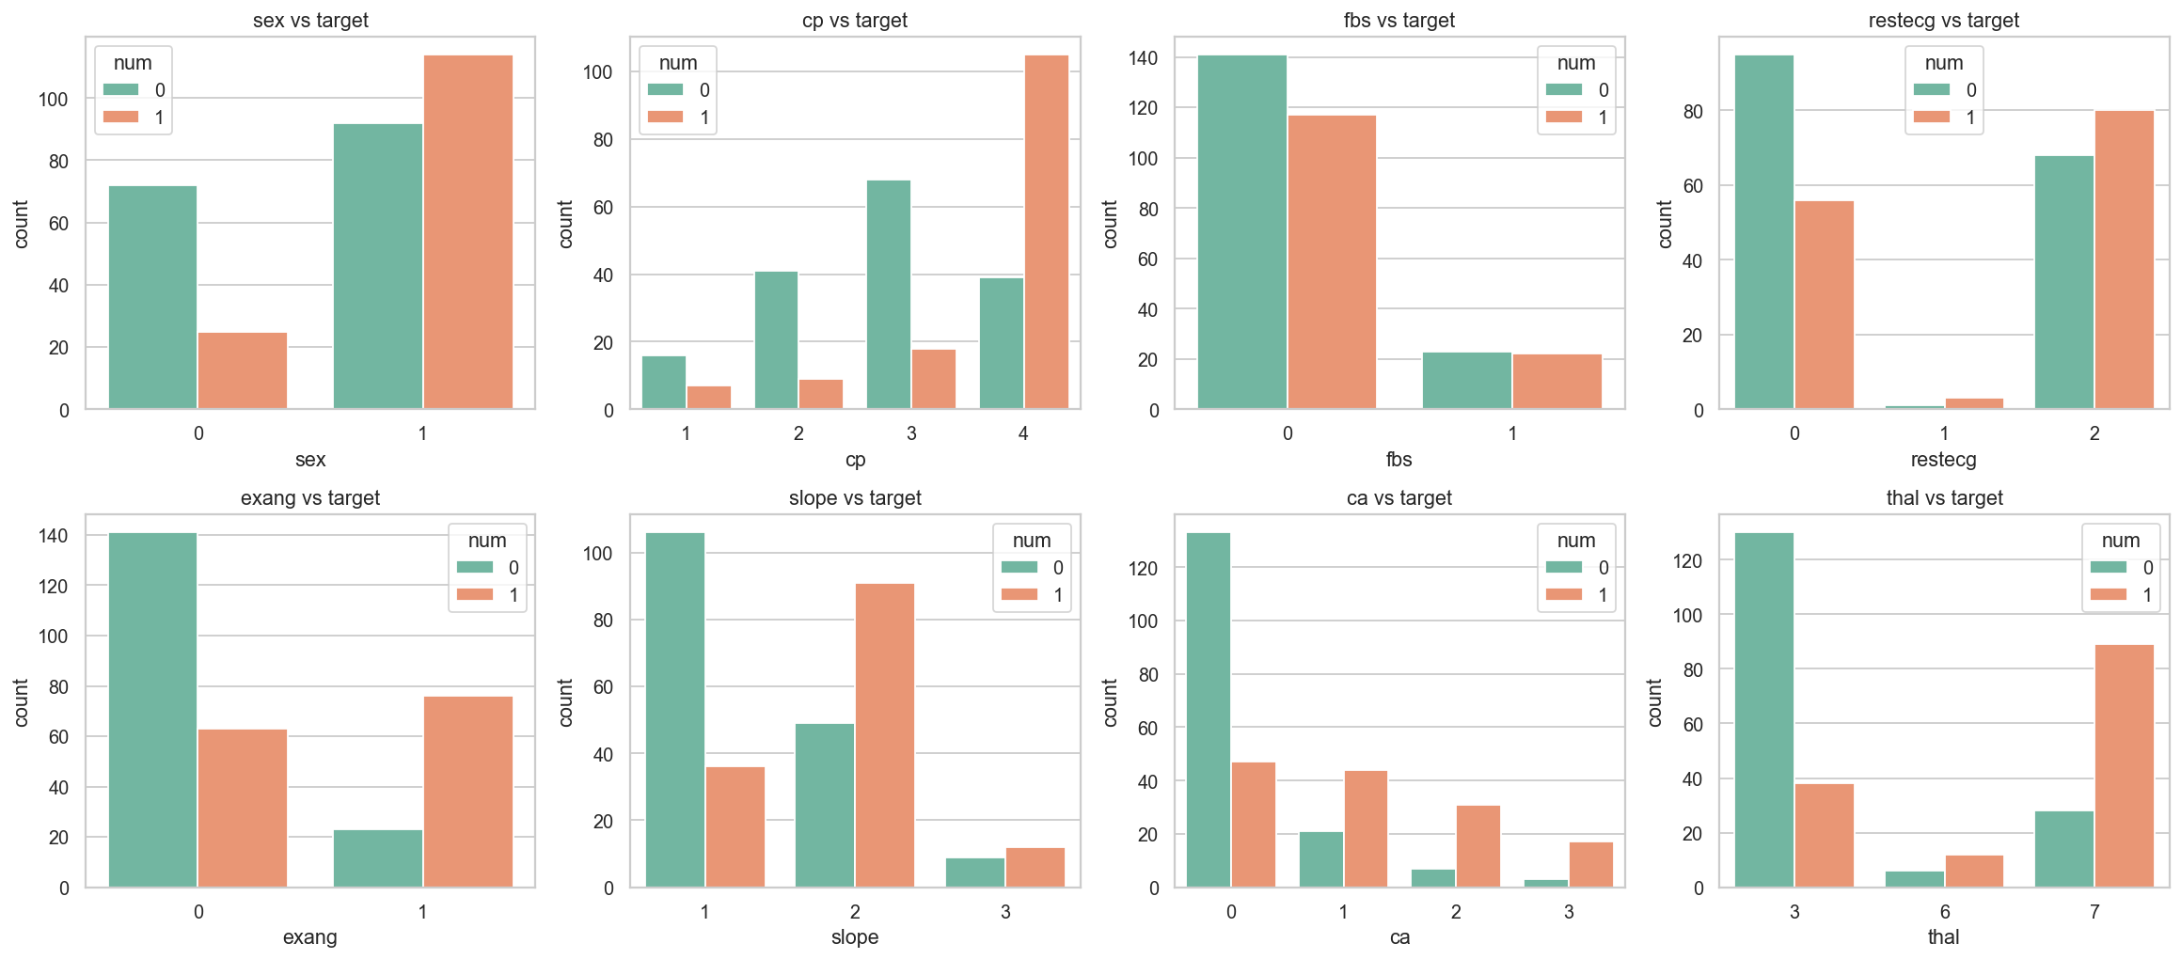
Categorical features vs target
These plots carry most of the signal.
- Chest pain type: about 73% of patients with asymptomatic chest pain (cp = 4) have disease, against 18-30% for the other three types. This is counter-intuitive but well known in this dataset.
- Exercise angina: 77% disease with exang = 1, against 31% without.
- Major vessels (`ca`): prevalence climbs from 26% at 0 vessels to 68%, 82% and 85% at 1, 2 and 3.
- `thal`: 23% for normal (3), 67% for fixed defect (6) and 76% for reversible defect (7).
- `slope`: 25% for the up-sloping value 1, against about 60% for values 2 and 3.
- `fbs`: 45% against 49%, which is practically no signal. I kept it because it costs nothing and the model can ignore it.
- Sex: 55% disease in men against 26% in women. Age shows a similar trend: 33% under 40, 30% for 40-49, 51% for 50-59 and 56% for 60 and above.
The age pattern is what motivated the age_group feature described in section 3.

2.6 Correlations
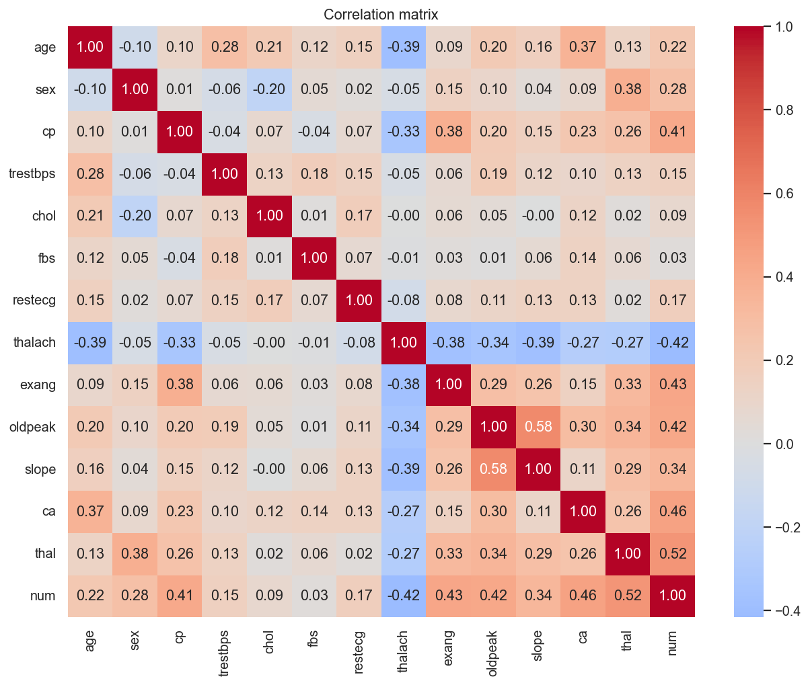
Correlation heatmap
The strongest correlates of the target are thal (0.52), ca (0.46), exang (0.43), oldpeak (0.42), cp (0.41) and thalach (-0.42). No two predictors are highly collinear, so I keep all 13. Note that cp, thal, ca and slope are nominal or ordinal codes, so their Pearson values are only a rough guide, which is why they are one-hot encoded in the model.

2.7 Numeric features by target
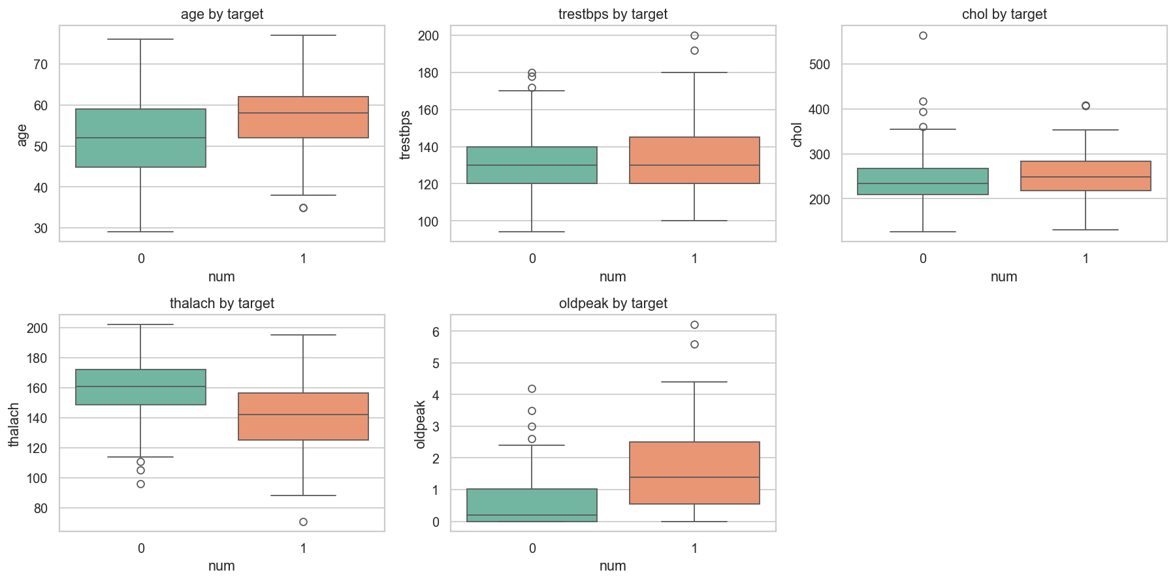
Boxplots by target
Diseased patients reach a much lower maximum heart rate (mean 139 against 158) and show higher ST depression (1.6 against 0.6). chol and trestbps overlap heavily between the groups and are weak signals, as the correlation matrix already suggested. The thalach gap is the second hint behind the heart_rate_reserve feature.
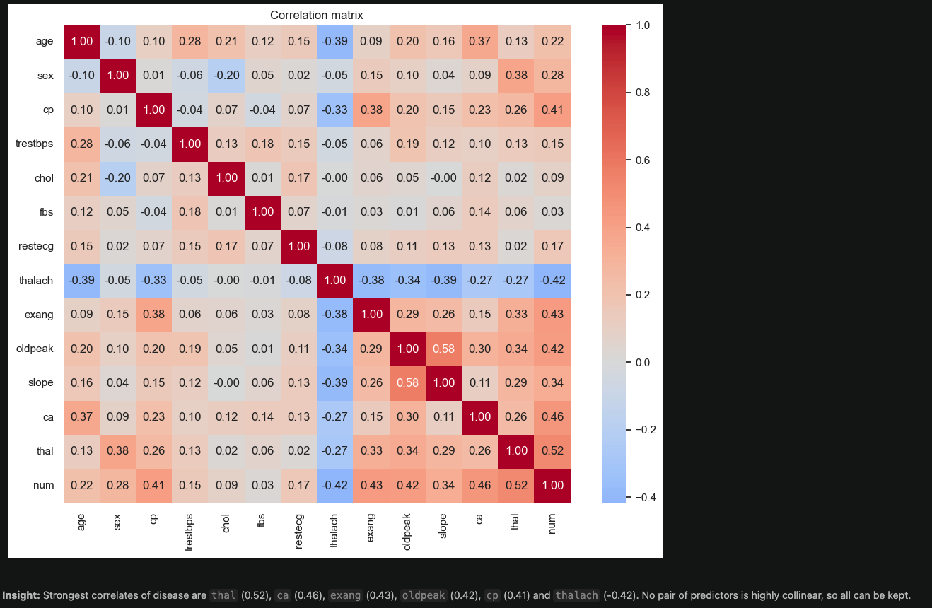
Screenshot: eda_notebook.png

3. Feature Engineering
src/features.py builds one scikit-learn Pipeline: ClinicalFeatureEngineer -> ColumnTransformer -> estimator.
Group | Columns | Treatment
Numeric | age, trestbps, chol, thalach, oldpeak + 3 engineered | StandardScaler
Categorical | cp, restecg, slope, thal, ca | OneHotEncoder(handle_unknown="ignore")
Binary | sex, fbs, exang | passthrough

3.1 Custom transformer (original contribution)
ClinicalFeatureEngineer is a BaseEstimator/TransformerMixin that appends three domain features.
- `age_group` buckets age into under 40, 40-49, 50-59 and 60+. The EDA shows disease prevalence stepping up from about 30% to above 50% between the 40s and 50s. A linear term in raw age cannot express that step.
- `chol_age_ratio` is cholesterol divided by age. The same cholesterol level is more alarming in a younger patient, and the ratio puts both on one scale.
- `heart_rate_reserve` is (220 - age) - thalach: the gap between the age-predicted maximum heart rate and the rate actually reached. A large reserve means the patient could not reach the expected exertion, a recognised marker of ischaemia. It combines two columns that the EDA already flags as informative.

3.2 Why a pipeline
Because the transformer lives inside the pipeline, training, the CLI, the API and the container run identical code, so there is no training-serving skew. The transformer is stateless, never mutates its input and is unit-tested for values, bucket edges and unknown categories. OneHotEncoder(handle_unknown="ignore") means a category unseen at training time yields an all-zero block instead of a crash. All inputs are cast to float64 at load time so the schema is the same in training and in the API.

4. Model Development and Tuning

4.1 Protocol
I split the data once, stratified 80/20 with random_state=42 (242 train, 61 test). Every model is tuned with GridSearchCV on the training portion only, using 5-fold StratifiedKFold (shuffled, seed 42) and ROC-AUC as the score. The best estimator is refit on the full training split and evaluated once on the test set.

4.2 Hyperparameter grids
Model | Grid | Combinations | Fits (x5 folds)
LogisticRegression | C in {0.01, 0.1, 1, 10}; class_weight in {None, balanced}; penalty l2 | 8 | 40
RandomForest | n_estimators in {100, 300}; max_depth in {3, 5, None}; min_samples_leaf in {1, 3} | 12 | 60
XGBoost | n_estimators in {100, 200}; max_depth in {2, 3, 4}; learning_rate in {0.03, 0.1} | 12 | 60

The grids are small on purpose. With 242 training rows a large search mostly overfits the CV folds. If XGBoost cannot be imported, GradientBoostingClassifier is used automatically.

4.3 Cross-validation results: top configurations
Model | Rank | Parameters | CV ROC-AUC (mean ± std)
LogisticRegression | 1 | C=1, class_weight=None | 0.9018 ± 0.0156
LogisticRegression | 2 | C=1, class_weight=balanced | 0.9004 ± 0.0155
LogisticRegression | 3 | C=10, class_weight=None | 0.8978 ± 0.0165
RandomForest | 1 | depth=3, leaf=3, trees=300 | 0.8976 ± 0.0215
RandomForest | 2 | depth=3, leaf=3, trees=100 | 0.8959 ± 0.0229
RandomForest | 3 | depth=3, leaf=1, trees=300 | 0.8959 ± 0.0209
XGBoost | 1 | lr=0.03, depth=2, trees=100 | 0.8889 ± 0.0225
XGBoost | 2 | lr=0.03, depth=2, trees=200 | 0.8851 ± 0.0192
XGBoost | 3 | lr=0.03, depth=3, trees=200 | 0.8757 ± 0.0186

The worst grid cell per family was 0.870 (LogisticRegression, strongest regularisation), 0.884 (RandomForest) and 0.856 (XGBoost). Two patterns stand out. The best tree models are the shallowest and the best boosted model uses the smallest learning rate and depth: the data is small, so low capacity wins. And balanced class weights made no real difference, which agrees with the near-balanced classes.

4.4 Test-set results
Model | CV ROC-AUC | Test Acc | Precision | Recall | F1 | Test ROC-AUC
LogisticRegression | 0.902 ± 0.016 | 0.885 | 0.839 | 0.929 | 0.881 | 0.966
RandomForest | 0.898 ± 0.022 | 0.902 | 0.893 | 0.893 | 0.893 | 0.956
XGBoost | 0.889 ± 0.023 | 0.885 | 0.862 | 0.893 | 0.877 | 0.948

4.5 Selection rule and result
The winner is the model with the highest cross-validated ROC-AUC. Models within 0.005 AUC of the best count as tied, and the one with higher test recall is chosen. I select on CV rather than on test AUC so the hold-out set stays an unbiased estimate. LogisticRegression wins: best CV AUC and best recall (26 of 28 diseased patients found, 2 missed, 5 false alarms among 33 healthy patients).
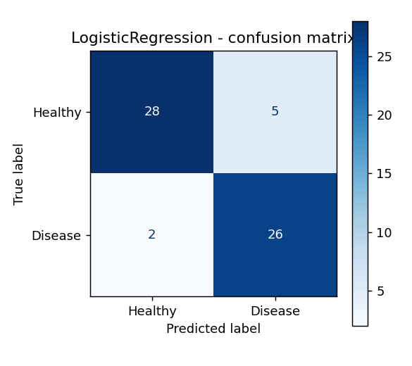
Confusion matrix of the selected model
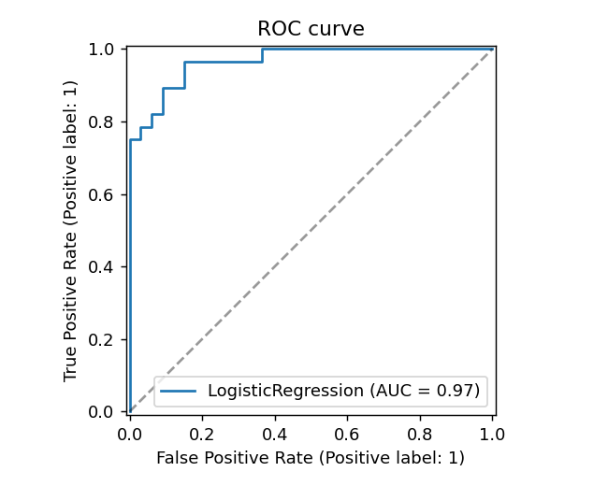
ROC curve of the selected model
I want to be honest about the margin. The gap between logistic regression and the tree models (0.004 to 0.013 AUC) is smaller than one CV standard deviation (about 0.02). The fair reading is that three models are comparable on this small dataset, and the simplest and most interpretable one wins. The test set has only 61 rows, so one patient moves a metric by about 1.6 points. That is why decisions rest on CV, not on the test table.
The largest absolute coefficients of the final model are ca = 0 (protective), sex, cp = 4 and thal = 7 (reversible defect). These match what the EDA showed.
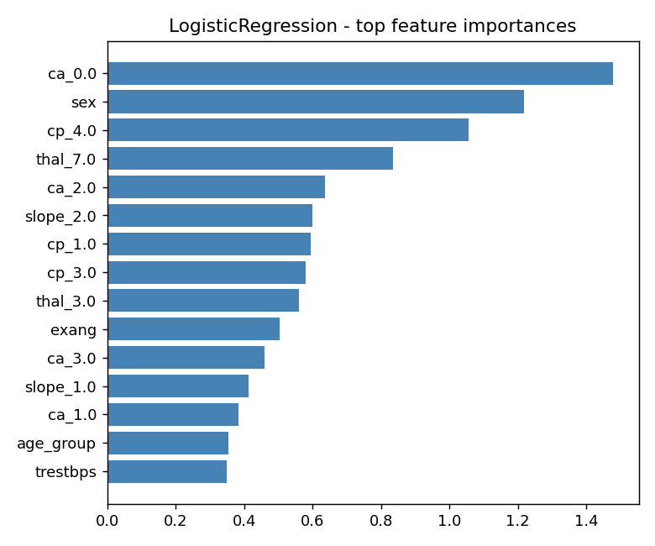
Feature importance of the selected model

5. Experiment Tracking (MLflow)
src/train.py logs to the experiment heart-disease-classification, stored locally in ./mlruns. Each of the three runs records the following.
- Parameters: the best hyperparameters found by the grid search.
- Metrics: CV mean and std of ROC-AUC, and test accuracy, precision, recall, F1 and ROC-AUC.
- Artifacts: confusion-matrix, ROC and precision-recall PNGs, a feature-importance plot (absolute coefficients or impurity importances), and a classification report text file.
- Model: the full pipeline through mlflow.sklearn.log_model, with an inferred signature and an input example.
The best run is tagged best_model=true and registered as heart-disease-classifier with the alias champion.

5.2 Model registry and versioning
Each training run registers its best model under the name heart-disease-classifier, which creates a new version. I trained twice, so the registry shows 2 versions of heart-disease-classifier, one per training run. After each run the champion alias is moved to the newly registered version, so it now points to the latest version (v2) and v1 stays available as the earlier version. This demonstrates both versioning (every run is kept and traceable to its MLflow run) and alias promotion (consumers ask for "champion" instead of a hard-coded version number, and promotion or rollback is just moving the alias). The version number is also written to models/metadata.json and returned as model_version by the API.

5.1 Run comparison
Run | Model | CV AUC | CV std | Test Acc | Precision | Recall | F1 | Test AUC | Tag
0a463502 | LogisticRegression | 0.9018 | 0.0155 | 0.8852 | 0.8387 | 0.9285 | 0.8813 | 0.9664 | best_model
d72afd19 | RandomForest | 0.8975 | 0.0215 | 0.9016 | 0.8928 | 0.8928 | 0.8928 | 0.9556 | -
7e772201 | XGBoost | 0.8888 | 0.0225 | 0.8852 | 0.8620 | 0.8928 | 0.8771 | 0.9480 | -

Run IDs are shortened and change when the experiment is re-run; the numbers do not, because every seed is fixed. Having all three runs in one table with plots attached made the comparison a one-click task in the MLflow UI and kept the choice auditable.
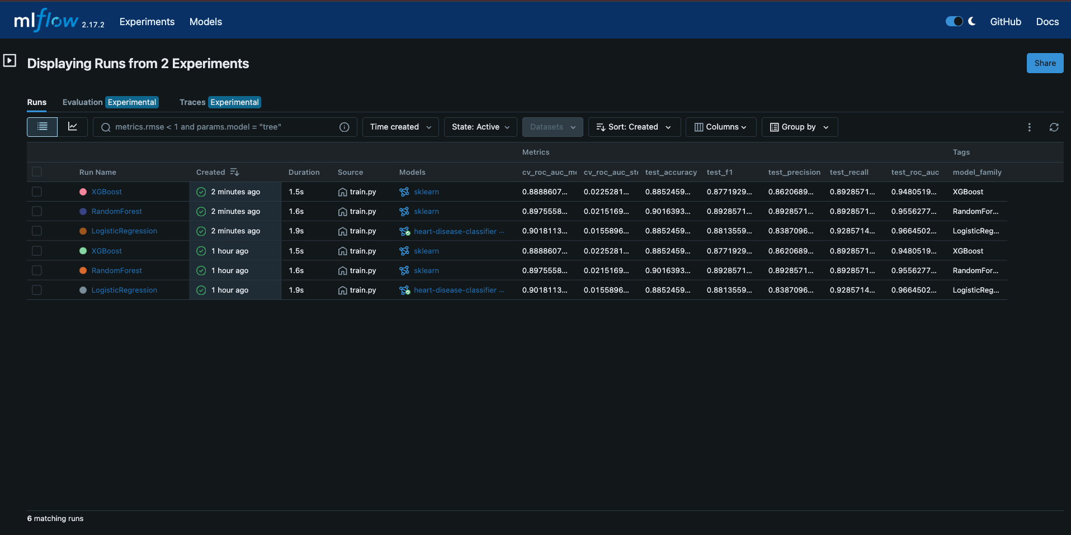
Screenshot: mlflow_runs.png
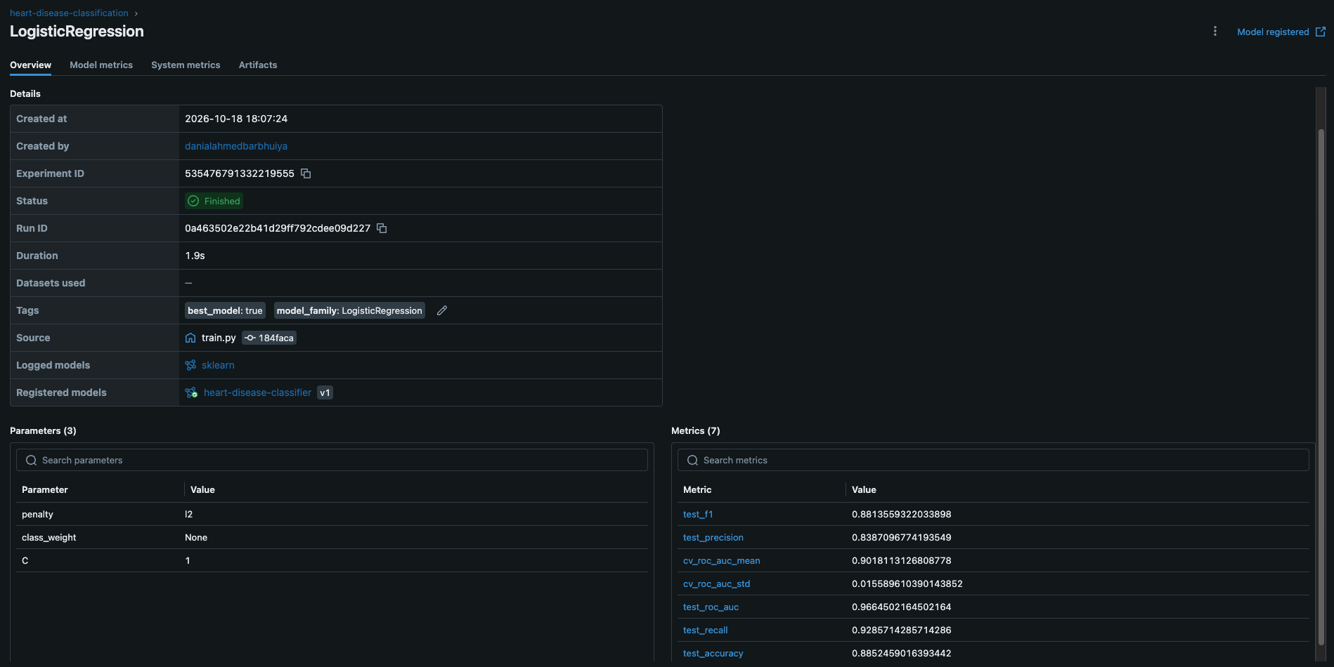
Screenshot: mlflow_best_run.png
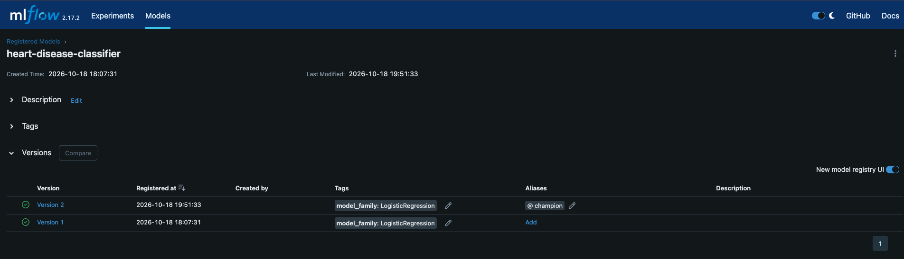
Screenshot: mlflow_model_registry.png

6. Packaging and Reproducibility
- Model artifact: models/model.joblib holds the entire pipeline (features, preprocessing, estimator). models/metadata.json stores the model name, version, metrics, hyperparameters, feature list, training date and scikit-learn version.
- Seeds: Python, NumPy and PYTHONHASHSEED are set, and every estimator, splitter and CV object gets random_state=42.
- Pinned dependencies: requirements.txt pins exact versions. My first environment came with pandas 3.x and NumPy 2.4. I replaced them with a conservative, mutually tested set (NumPy 1.26.4, pandas 2.2.3, scikit-learn 1.5.2, XGBoost 2.1.3, MLflow 2.17.2) and confirmed pip check is clean. requirements-dev.txt adds pytest, pytest-cov, flake8, black, httpx and the report-builder libraries.
- Clean-venv check: I verified pip install -r requirements.txt && python scripts/download_data.py && python src/train.py in a brand-new virtual environment. train.py rebuilds the processed CSV itself if it is missing, so the documented command chain works even without the data-cleaning step.
- Tooling: a Makefile exposes setup data train test lint docker-build docker-run k8s-deploy monitoring-up load-test, and src/predict.py is a CLI for JSON or CSV input.

7. CI/CD
The workflow .github/workflows/ci.yml runs on every push and pull request to main, with a concurrency group so a newer push cancels an older run of the same ref. Jobs are chained with needs, so the pipeline fails fast and later (more expensive) jobs never run on broken code.

7.1 Job by job
- Lint (flake8). Installs only flake8, then checks src api scripts tests with the rules in .flake8 (max line length 100). It takes seconds and catches style and syntax errors before anything else.
- Unit tests + coverage. Installs the dev requirements (pip-cached), then runs pytest with --cov-fail-under=80. It writes coverage XML and HTML and uploads them with actions/upload-artifact@v4 even if the job fails, so the reports are always available.
- Train model. Downloads the data from UCI, runs python src/train.py and uploads models/, mlruns/, reports/figures/ and the model-comparison document. This proves the training path works on a clean runner and gives every commit a reproducible model artifact.
- Docker build + smoke test. Downloads the freshly trained model, copies it into models/, builds the image, runs the container, polls /health for up to 60 seconds, posts sample_request.json to /predict and validates the response, and finally checks that an invalid body returns 422. It always prints the container logs at the end.

7.2 Tests
There are 36 tests in tests/.
- test_data_processing.py covers '?' handling, mode imputation, binarisation, type casting, duplicate removal and the file round trip.
- test_features.py covers engineered values, age buckets, no input mutation, pipeline output names and unknown categories.
- test_model.py covers selection logic (recall tiebreak and clear AUC winner), metrics, the prediction CLI, and an end-to-end train.main run with and without MLflow on synthetic data.
- test_api.py uses FastAPI's TestClient for /health, valid /predict, six parametrised out-of-range cases, a missing field, a wrong type, batch, an empty batch, and the /metrics endpoint.
Coverage is about 97%. The tests build their own small model from synthetic data with the real schema, so they need neither network access nor the committed model.
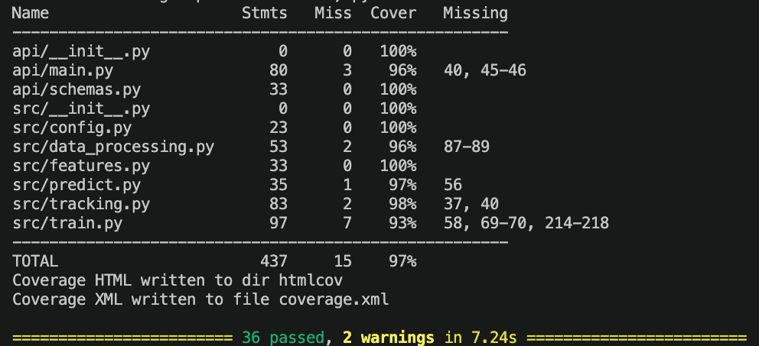
Screenshot: pytest_coverage.png
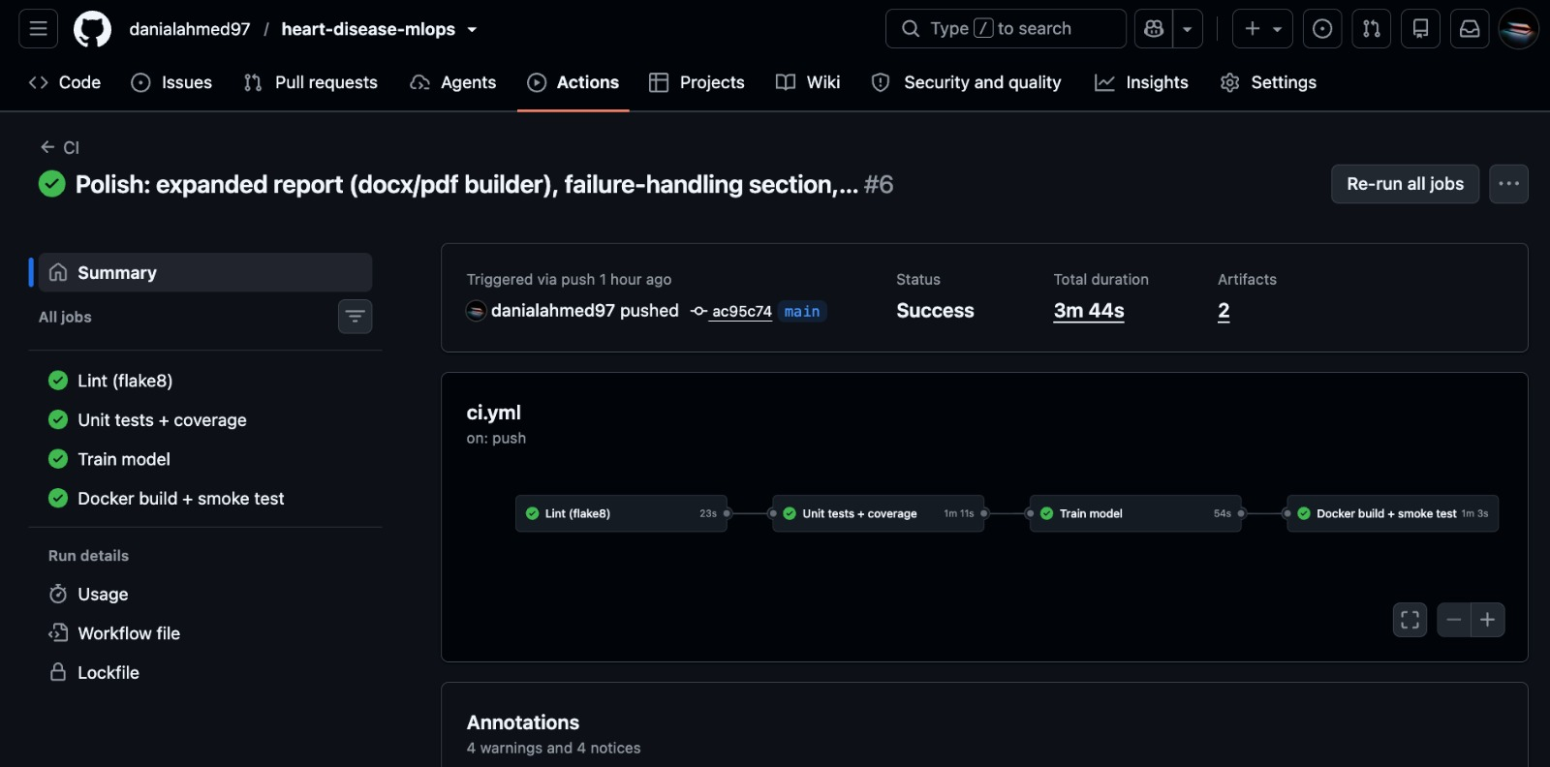
Screenshot: github_actions_green.png
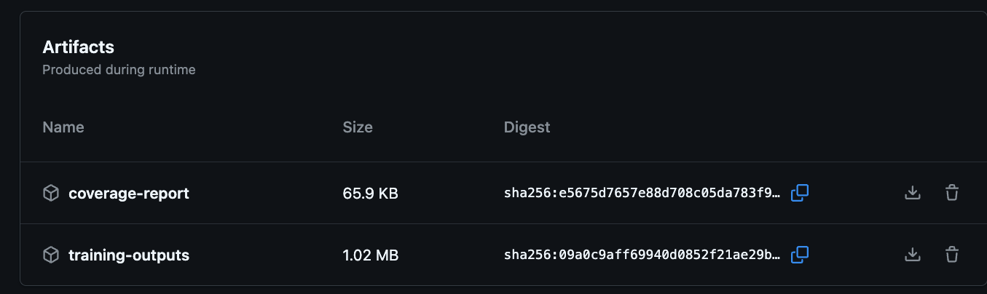
Screenshot: github_actions_artifacts.png

8. Pipeline Failure Handling
A pipeline is only trustworthy if it fails when it should. To demonstrate this I created a throwaway branch, demo/ci-failure, with one deliberately wrong test: it posts a valid patient to /predict and asserts that the predicted class equals 2, which is impossible for a binary classifier. I opened a draft pull request against main to trigger the workflow (pushes to other branches do not trigger it), and left main untouched.
The result:
- Lint passed.
- Unit tests + coverage failed with assert 0 == 2 (1 failed, 36 passed).
- Train model and Docker build + smoke test were skipped because of the needs chain, so no model was trained and no image built from the broken commit.
The failed run is at https://github.com/danialahmed97/heart-disease-mlops/actions/runs/39131770605. Afterwards I closed the PR without merging and deleted the branch locally and on the remote.
This shows three properties I wanted: failures are visible in the first job that can detect them, the chain stops there, and the log points at the exact assertion.
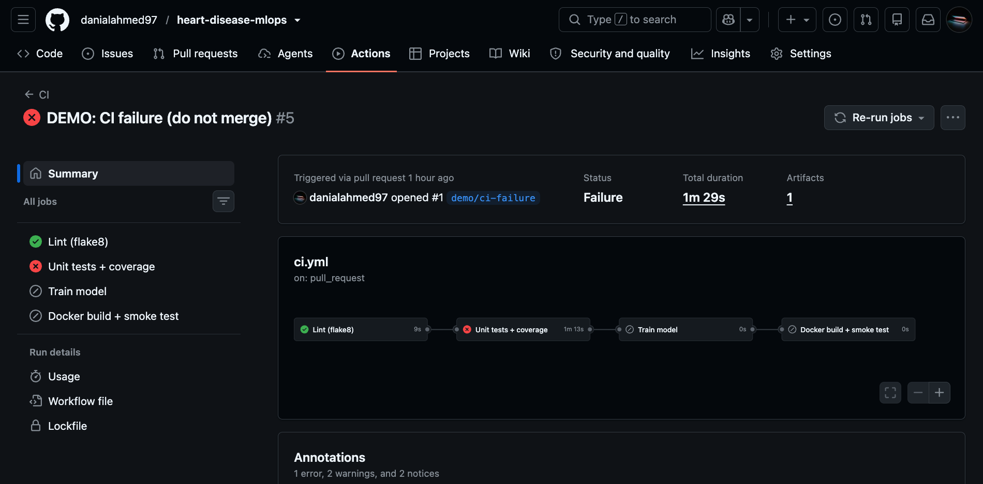
Screenshot: github_actions_failed.png

9. Containerisation

9.1 Service
api/main.py (FastAPI) loads the model once at start-up through a lifespan handler and exposes:
- POST /predict returning {prediction, label, confidence, probability_disease, model_version};
- POST /predict/batch for up to 500 patients (my extra endpoint);
- GET /health, GET /model-info and GET /metrics.
A Pydantic model validates every input against clinical ranges (for example age 18-120, cp 1-4, ca 0-3, and thal limited to 3, 6 or 7). Violations return HTTP 422 before the model is ever called. confidence is the probability of the predicted class, max(p, 1 - p).

9.2 Image
The Dockerfile is multi-stage. A builder stage creates a virtual environment from a minimal requirements-api.txt (no Jupyter or MLflow), and the runtime stage is a clean python:3.11-slim with only that environment, src/, api/ and models/. It installs libgomp1 for XGBoost, runs as a numeric non-root user (UID 10001), defines a HEALTHCHECK against /health, and starts uvicorn on port 8000. .dockerignore keeps data, notebooks, tests and manifests out of the build context. The image is built for linux/arm64 locally and for amd64 in CI.
The model pickle refers to src.features.ClinicalFeatureEngineer, so the src package must be inside the image at the same import path.
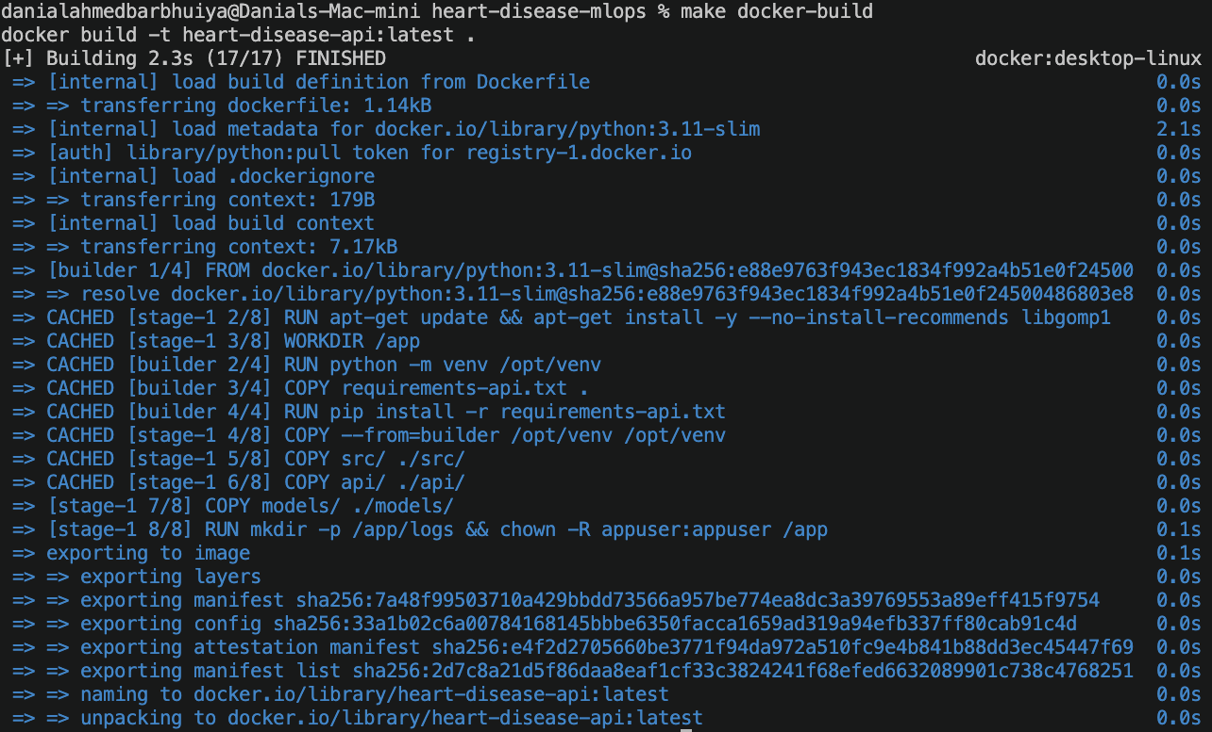
Screenshot: docker_build.png
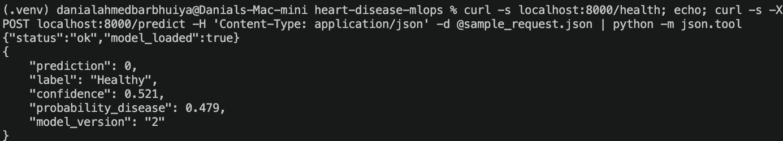
Screenshot: docker_curl.png
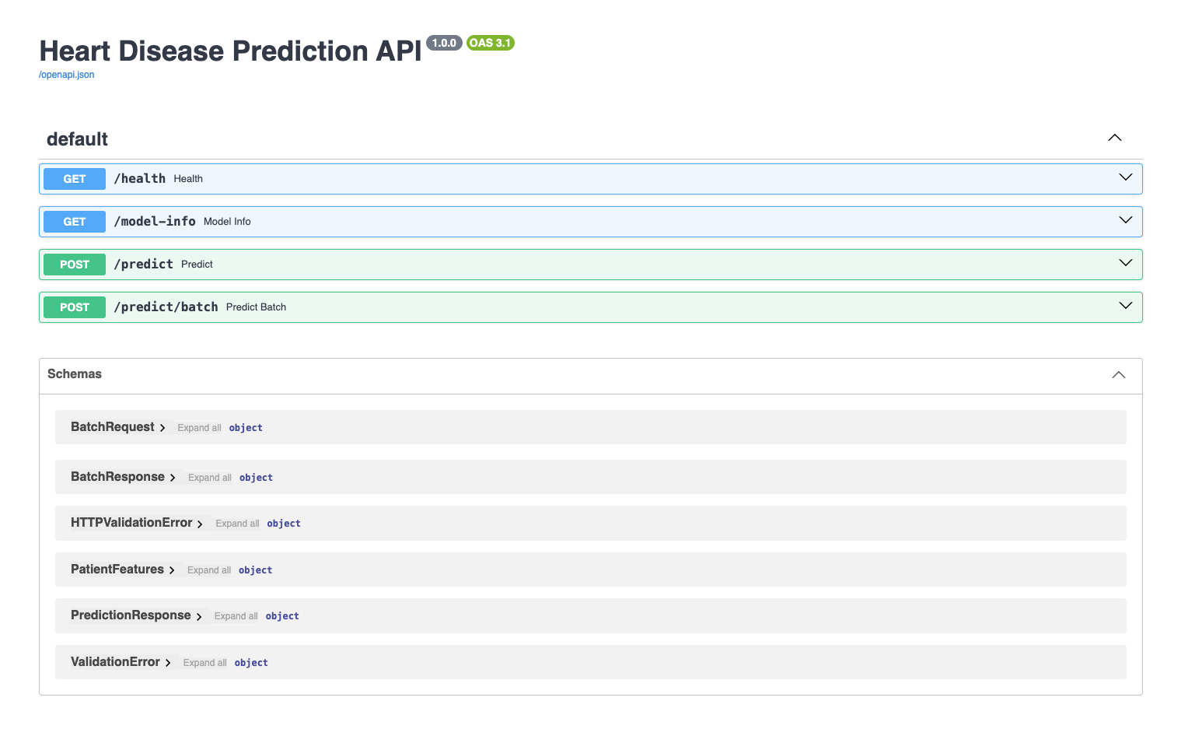
Screenshot: api_docs.png
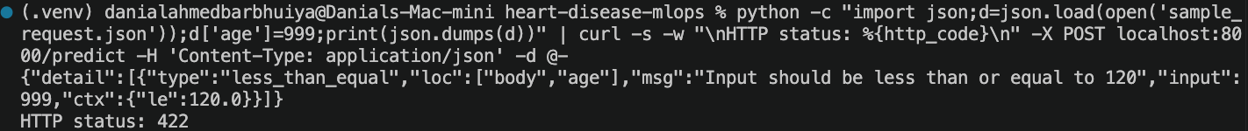
Screenshot: api_422.png

10. Kubernetes Deployment
I deployed to the Kubernetes cluster that Docker Desktop provisions with kind (context docker-desktop).

10.1 Manifest walkthrough
- `namespace.yaml` creates the heart-disease namespace to isolate the app.
- `deployment.yaml`
- 2 replicas with a rolling update (maxUnavailable: 0, maxSurge: 1), so a rollout never reduces capacity.
- imagePullPolicy: IfNotPresent and the local image heart-disease-api:latest.
- Readiness and liveness probes on /health. Readiness (5 s delay, 5 s period) keeps traffic away from a pod that has not loaded the model yet; liveness (15 s, 10 s) restarts a hung pod.
- Requests of 100m CPU / 256Mi and limits of 500m / 512Mi, so the scheduler can place pods and one pod cannot starve others.
- Prometheus annotations (prometheus.io/scrape, path, port).
- A security context with runAsNonRoot, runAsUser: 10001 and no privilege escalation.
- `service.yaml` is a LoadBalancer service on port 80, forwarding to the named container port http.
- `ingress.yaml` is optional and needs an ingress controller, which is not installed in this cluster.
- `hpa.yaml` scales between 2 and 5 pods at 60% average CPU (my extra). It needed metrics-server, which I installed with --kubelet-insecure-tls because kind uses self-signed kubelet certificates. The HPA now reports a real figure (3% idle).
An equivalent Helm chart lives in helm/heart-disease-api. Replicas, image, resources, probes, autoscaling and ingress are values, and the namespace comes from the release. helm lint is clean and I installed and removed a test release.

10.2 Deploy script
scripts/deploy_k8s.sh builds the image, applies the manifests, restarts the deployment, waits for the rollout and then calls /health and /predict through the service. The LoadBalancer receives an address on Docker's internal network (172.18.x.x) that macOS cannot route to, so the script tests that address with a short timeout and otherwise falls back to kubectl port-forward.
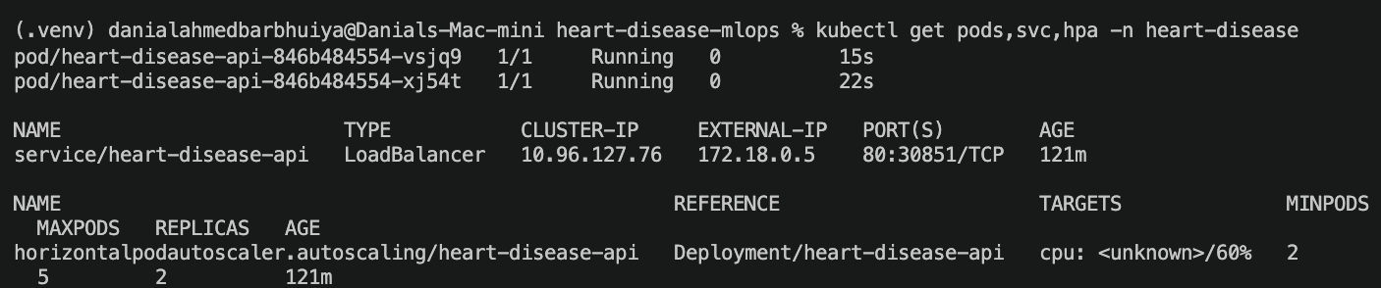
Screenshot: k8s_pods.png
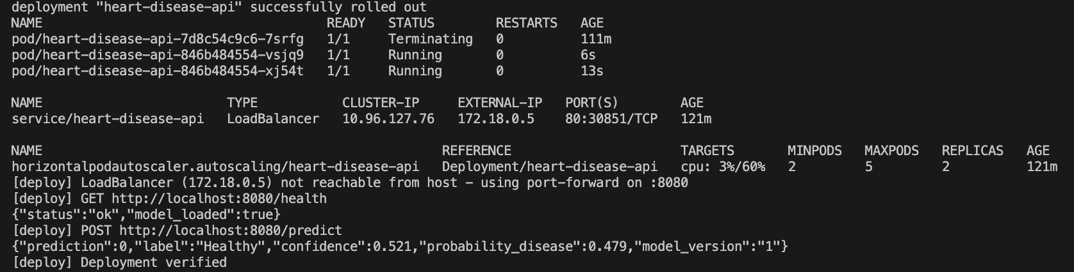
Screenshot: k8s_predict.png
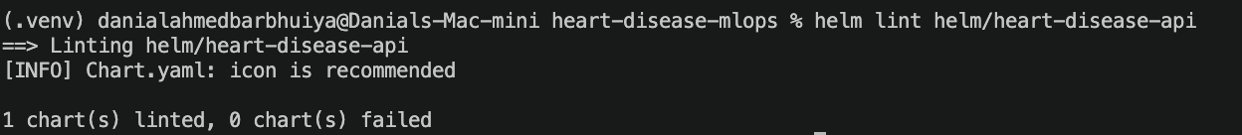
Screenshot: helm_install.png

11. Monitoring and Logging

11.1 Logs
A middleware writes one JSON line per request with timestamp, method, path, status, latency_ms and, for predictions, the predicted label. Lines go to stdout (picked up by docker logs and kubectl logs) and to logs/api.log. If the log directory is not writable, file logging is disabled with a warning instead of crashing the service.

11.2 Metrics
Metric | Type | Source | What it answers
http_requests_total{handler,method,status} | counter | instrumentator | request rate and error ratio
http_request_duration_highr_seconds | histogram | instrumentator | p95 latency
heart_predictions_total{label} | counter | custom | class mix of predictions
heart_prediction_confidence | histogram | custom | how sure the model is

The two custom metrics are the model-level signals. A sudden swing in the Healthy/Disease mix or a drop in confidence is an early hint of input drift, even without ground-truth labels.

11.3 Stack and dashboard
monitoring/docker-compose.yml starts the API, Prometheus (5 s scrape interval) and Grafana with a provisioned data source and dashboard. The five panels are:
- Request rate: sum by (handler) (rate(http_requests_total[1m])).
- p95 latency: histogram_quantile(0.95, sum by (le) (rate(http_request_duration_highr_seconds_bucket[1m]))).
- Error rate: the share of 4xx and 5xx responses among all requests.
- Predictions by class: increase(heart_predictions_total[1m]) per label.
- Confidence distribution: the cumulative confidence histogram buckets.

11.4 Load test
scripts/load_test.py sends about 200 varied requests, 5% of them deliberately invalid so the error panel has something to show. One run produced 189 responses with status 200 and 11 with 422, with 133 Disease and 56 Healthy predictions. Prometheus showed the target UP, p95 latency around 20 ms and an error ratio around 3%.
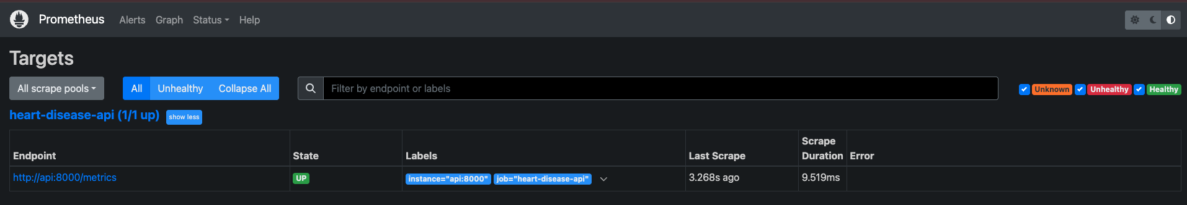
Screenshot: prometheus_targets.png
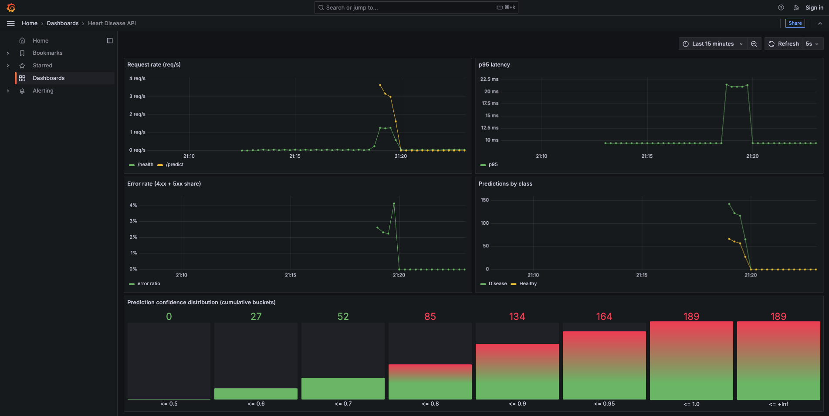
Screenshot: grafana_dashboard.png
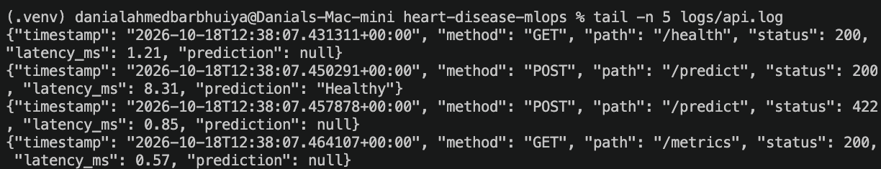
Screenshot: api_logs.png

12. Architecture
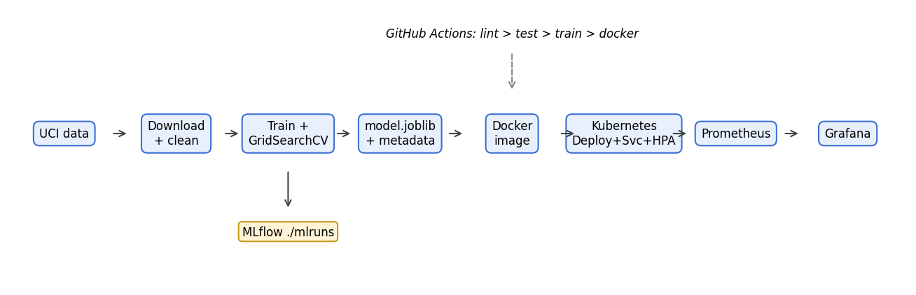
Architecture
Data flows left to right. The same image runs under Docker Compose and under Kubernetes, and both expose /metrics for Prometheus. CI validates the code path from lint to a running container but does not push the image to a registry or deploy it.

13. Challenges and Learnings
- Dependency compatibility. The default environment had pandas 3.x and NumPy 2.4. Pinning to a tested set avoided binary and API surprises with scikit-learn, XGBoost and MLflow.
- Pickled custom class. model.joblib references src.features.ClinicalFeatureEngineer, so the image has to ship the src package, and train.py must import it under that module path.
- Kubernetes non-root check. The first deployment failed with CreateContainerConfigError because the image user was the name appuser, which Kubernetes cannot verify as non-root. Switching to numeric UID 10001 fixed it.
- LoadBalancer on kind. The assigned IP is not routable from macOS, so the script falls back to port-forward. The HPA showed <unknown> until metrics-server was installed.
- Workflow triggers. My CI only triggers on main and pull requests to main, so the failure demo needed a draft PR. The concurrency setting also cancelled some intermediate runs when I pushed quickly.
- Small data. With 61 test patients, one prediction moves a metric by about 1.6 points. I therefore based conclusions on CV with its standard deviation, not on the test table.
- Image availability. Docker Desktop's kind node shares the local containerd store, so the locally built image was found without a registry. IfNotPresent prevents needless pulls.

14. Limitations and Future Work
Limitations
- One hospital, 303 patients, no external validation. The results say little about how the model would behave on other populations.
- The 61-row test set gives wide confidence intervals; the model ranking is not statistically established.
- The default 0.5 threshold is not tuned for a target recall, even though recall is the stated priority.
- There are no per-feature drift checks and no ground-truth feedback loop, so monitoring covers service health and prediction mix but not accuracy over time.
- MLflow runs on a local file store; there is no shared tracking server, and mlruns/ is not in git.
- CI builds and tests the image but does not publish it to a registry, and the deployment is manual.
- This is a teaching project and not a clinical device.
Future work
- Calibrate probabilities and choose a threshold for a target recall (for example 95%).
- Add input-drift detection (population stability index per feature) exported as Prometheus metrics, with alerts in Grafana.
- Validate on the Hungarian, Swiss and VA subsets of the UCI data.
- Push images to a registry from CI and deploy by promoting the MLflow champion alias.
- Move MLflow to a server with a database backend and artifact store.
- Add SHAP explanations to /predict responses.

15. Conclusion
The project delivers a validated screening model (CV AUC 0.90, test recall 0.93) and, around it, a reproducible, tested, containerised, orchestrated and monitored service. Every stage is automated through make targets or CI, and every claim in this report has evidence in the repository: the notebook and figures, the model-comparison document, the MLflow runs, the test and coverage output, the CI runs (including a deliberate failure), the Kubernetes manifests and the Grafana dashboard. The biggest lesson was that most of the effort and most of the bugs sat around the model (packaging, security context, networking, dependencies), not in the model itself.

