THE UNIVERSITY OF AZAD JAMMU & KASHMIR
DEPARTMENT OF SOFTWARE ENGINEERING

LAB TASK #01: UML USE CASE DIAGRAMS
Student Name | Danial Ayub Mughal
Roll Number | 2024-SE-20
Course Name | Software Construction & Development
Course Code | SE-3101
Session | 2024-2028 (5th Semester)
Lab | Lab Task #01
Instructor Name | Engr. Dr Asma Javed
Submission Date | October 26, 2026

Lab Explanation: UML Use Case Diagrams

1. Introduction to UML Use Case Diagrams
A Use Case Diagram is a behavioral UML diagram used to represent the dynamic aspects of a system. It defines system boundaries, external entities (Actors), and functional requirements (Use Cases) to clearly outline what the system does without getting into implementation details.

2. Question 1: Online Ticket Reservation System

2.1 Identified Actors
Actor Name | Actor Type | Role & Description
Customer / Passenger | Primary Actor | Initiates search, selects seats, completes ticket bookings, and downloads e-tickets.
System Administrator | Secondary Actor | Manages schedules, updates routes/fare prices, and monitors system reports.
Payment Gateway | External System Actor | Authorizes payments, processes bank transactions, and returns authorization status.

2.2 Use Cases & Diagram Workflow Explanation
- Search Tickets / Routes: Customer queries available trips based on origin, destination, and travel date.
- Select Seat: Customer views interactive seat layout and chooses available seats.
- Book Ticket: Core use case executed by Customer. Automatically triggers «include» dependencies for 'View Available Seats', 'Process Payment', and 'Generate Booking Confirmation'.
- Cancel Reservation: Customer requests booking cancellation and initiates refund processing.
- Download E-Ticket: Allows customer to retrieve and print finalized e-ticket after payment verification.
- Manage Routes & Schedules: Admin configures available trips, bus/train routes, and pricing.
- Generate Reports: Admin extracts booking and revenue statistics.

2.3 Use Case Diagram

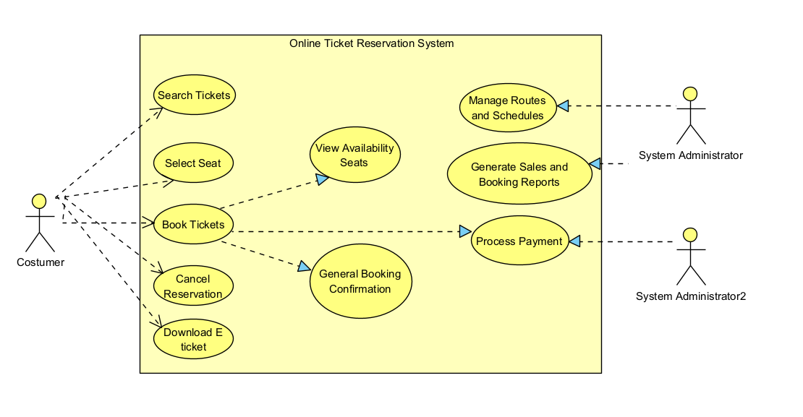

3. Question 2: Credit Card Processing System Case Study

3.1 Identified Actors
Actor Name | Actor Type | Role & Description
Customer | Primary Actor | Selects items, provides payment card, and signs printed transaction receipt.
Vendor | Secondary Actor | Generates bill/invoice, handles payment terminal interaction, and hands receipt to customer.
Credit Card Machine (POS) | System / Hardware Actor | Processes amount transaction, verifies balance limits, and prints receipt/statement.

3.2 Case Study Step-by-Step Mapping & UML Stereotypes
- Step 1 (Select Item): Customer selects items from shop. Connected via «extend» to Process Transaction.
- Step 2 (Make Bill): Vendor creates bill for items. Associated directly with Credit Card Machine.
- Step 3 (Swipe Card): Customer hands card to vendor. Triggers «include» relationship to 'Process Transaction'.
- Step 4 (Process Transaction): Credit Card Machine processes transaction amount and checks card balance limit.
- Step 5 (Print Statement / Receipt): Machine prints receipt statement. Includes «include» link to 'Print Receipt'.
- Step 6 (Sign Receipt): Customer signs physical receipt and returns to vendor. Stereotyped as «extend» to 'Print Statement'.

3.3 Use Case Diagram

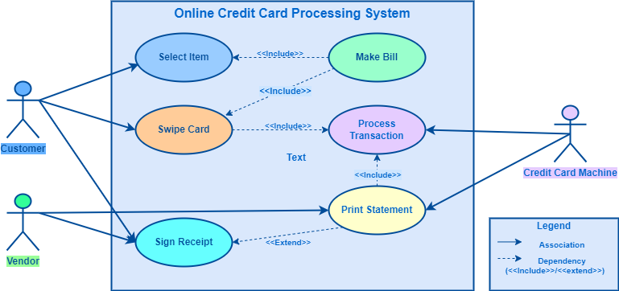

4. Summary of Key UML Stereotypes Used
Element | Meaning | Example from this lab
«include» | Mandatory sub-routine that always runs | Swiping a card always triggers transaction processing.
«extend» | Optional or conditional step | Signing a receipt happens after the statement is printed.
System Boundary | Box enclosing all use cases; separates the system from external actors | Online Ticket Reservation System, Credit Card Processing System

