**ASSIGNMENT#2 FE SE**

**CLO3 –(PBL)**



**Name:** Muhammad Furqan Mujeeb Dero

## Section: B

**Batch:** 2024

**Roll No:** SE-24091

**Course:** Applied Physics PH-122

**Semester:**2nd (Spring 2025) **Course Instructor:** Mr. Tahir Jamal **Date of Submission:** 12th May 2025

**COVERING PAGE**

**Subject:** PH-122 **Max.Marks:** 05 **Type:** Individual

**Title:** The purpose of this PBL is to study quantum mechanics and photoelectric effect by determining plank’s constant, work function and photon’s speed in the given problem

|  |  |  |  |  |  |  |  |
| --- | --- | --- | --- | --- | --- | --- | --- |
| **Linkage to Course Learning Outcome** | | | | | | | |
| **CLO**  **Number** | | **Description of CLO** | | **DOMAIN** | **Taxonomy**  **level** | **PLO** | |
| CLO-3 | | Apply the concepts of Modern Physics to solve the problems. | | Cognitive | 3 | PLO-2  (Problem Analysis) | |
| Sr.no. | **Problems Description** | | | | | | |
| 1. | To determine the work function and Planck’s Constant from the increasing relation between wavelength and Stopping Potential. | | | | | | |
| 2. | To determine the cut off wavelength for metal surface when illuminated by monochromatic light. | | | | | | |
| Sr.no. | **Constraints/Assumptions** | | |  |  |  |  |
| 1. | Work function of Sodium and Silver is given that is 2.64ev and 4.73ev | | | | | | |
| 2. | Same monochromatic light strikes on both metal surfaces | | | | | | |
| 3. | Measure the K.E of electron from both the surfaces | | | | | | |
| 4. | From Work function we can calculate the cut off wavelength for both metal | | | | | | |
| Sr.no. | **Identification of Areas where use of computational/modern Tools usage is required.** | | | | | | |
| 1. | Firstly require a monochromatic light source | | | | | | |
| 2. | For finding K.E and 𝛟𝑜 of electron, we use photoelectric apparatus and analytical software | | | | | | |
| 3. | Visualization of data collected as graph in Microsoft Excel Software | | | | | | |
| 4. | Report Writing in Microsoft word software | | | | | | |
| Sr.no. | **Expected Outcomes** | | | | | | |
| 1. | Determination of (K.E) of electron from different metals and also its work function | | | | | | |
| 2. | Understanding by using calculations and its formula | | | | | | |
| 3. | Report writing with proper formatting | | | | | | |
| Sr.no. | **Complex Engineering Activities**  **Preamble:** Complex activities means (engineering) activities or projects that some or all of the following characteristics listed below: | | | | | | |
|  | **Attributes of CEA** | | **Description** | | | | **Apply** |
| 1. | Range of resources | | Involve the use of diverse resources (for this purpose resources include money, equipment, materials, information and technologies). | | | | Yes |
| 2. | Level of Interaction | | Requires solution of significant problems arising from interaction  between wide ranging of conflicting technical, engineering and other issues | | | | No |
| 3. | Innovation | | Involve creative use of engineering principles and research based knowledge in novel ways | | | | No |
| 4. | Consequences to society and environ | | Have significant consequences in range of context, characterized by difficulty of prediction and mitigation | | | | No |
| 5. | Familiarity | | Can extend beyond previous experience by applying principle base approach | | | | Yes |

Teacher Signature……………………

Teacher Name…Mr. Tahir Jamal……

# ASSIGNMENT#2 (CLO- 3) DEPARTMENT OF SOFTWARE ENGINEERING

**QUESTION NO 1:** The data in table was obtained by Robert A. Millikan (United States, 1868-1953), who was awarded the 1921 Nobel prize in **physics for his verification of the photoelectric effect. Millikan’s** photoelectric data for lithium are:

# MAX. MARK S:05

|  |  |  |  |  |  |
| --- | --- | --- | --- | --- | --- |
| **Wavelength**  **(nm)** | **433.9** | **404.7** | **365.0** | **312.5** | **253.5** |
| **Stopping potential (V)** | **0.55** | **0.73** | **1.09** | **1.67** | **2.57** |

1. Make a plot of the table on graph paper with proper scaling
2. Find the Planks constant
3. Work function for lithium

**QUESTION NO 2**: Sodium and silver have work function of 2.64eV and 4.73eV, respectively.

1. If the surfaces of both metals are illuminated with same monochromatic light which metal will give off photons with greater speed? How much faster will those electrons be?
2. Calculate the cutoff wavelength of both metals?

# INSTRUCTIONS:

1. Submit the assignment in A4 sheet, with name and roll no. written on the very right side of the sheet
2. Last date for the submission is 12-MAY-2025

## ANSWER OF QUESTION NO 1:

**EXPLANATION OF GRAPH:**

Since Einstein's Photoelectric Equation is K.E= hf - fi , I first calculated frequency from the given data and plotted a graph between stopping potential V and Frequency which gives a liner graph and thus it is easier to calculate the slope . I used Microsoft Excel to Calculate the frequency by dividing the speed of light with the respective wavelengths and thus got their respective frequencies. I plotted the graph with frequency on x-axis and stopping potential on Y-axis. Then from the trendline the equation obtained was y= 4.13E-15x + (-2.3149) with

4.13E-15 being the value of slope m and (-2.3149) being the y intercept. This was obtained by the equation y=mx +c . Then for Planck's constant I multiplied the slope with e to get Planck's constant. For Work function it was equal to minus y intercept which was 2.3149 eV.

**VALUE OF PLANCK’S CONSTANT:**

Value of Planck’s constant was calculated to be 6.62E-34J near the standard value of 6.63E- 34J.

**WORK FUNCTION OF LITHIUM:**

The work function of Lithium was observed to be 2.31 eV or 3.7E-19J.

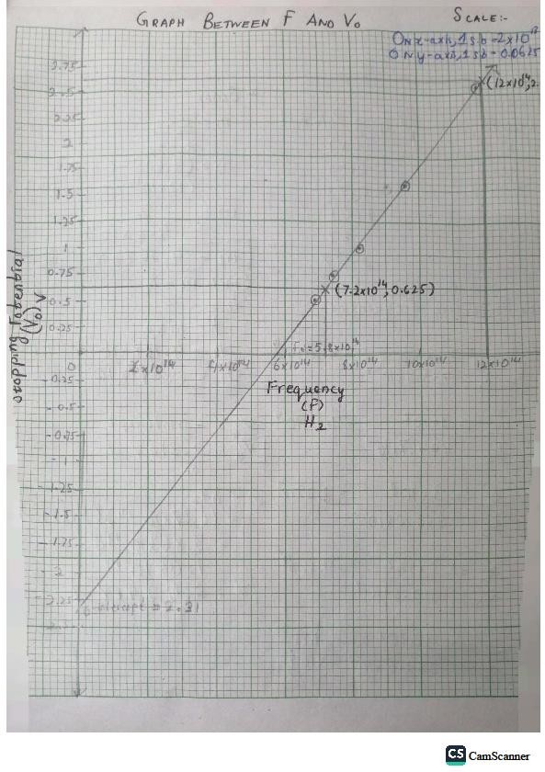

Above is the hand drawn graph. I used the readings of Excel graph to get accurate answer and avoid error due to human nature.

**ANSWER OF QUESTION NO 2**

**Question 2a:**

### If the surfaces of both metals are illuminated with the same monochromatic light, which metal will emit electrons with greater speed? How much faster will those electrons be?

**Given:**

* **Work Function of Sodium (ϕ₁)** = 2.64 eV
* **Work Function of Silver (ϕ₂)** = 4.73 eV
* **Photon Energy (E)** = Same for both since same light is used Let us assume the energy of the incident photon is:

E=6.0 eV(assumption for calculation; must be greater than both work functions)

### Step-by-step Calculations:

1. **Kinetic Energy of electrons:**

From the photoelectric equation:

K.E=E−ϕ

For **Sodium**:

K.E of Na= 6.0 eV−2.64 eV =3.36 eV

For **Silver**:

K.E of Ag= 6.0 eV−4.73 eV= 1.27 eV

### Convert K.E from eV to Joules:

1 eV=1.602×10−19 J

K.E of Na=3.36×1.602×10−19=5.38×10−19 J

K.E of Ag=1.27×1.602×10−19=2.03×10−19 J

### Use kinetic energy formula to find speed:

K.E= 1/2mv^2 ⇒ v= whole sqrt of (2 K.E whole divided by m) Where:

m=9.11×10−31 kg

### For Sodium:

V of Na= sqrt (2 x 5.38x10-19 /9.11×10−31)

= sqrt (1.18×1012)

=1.08×106 m/s

### For Silver:

V of Ag= sqrt (2 ×2.03×10−19/9.11x10-31)

=Sqrt(4.46×1011)

=6.68×105 m/s

### Answer:

Sodium emits electrons with greater speed. This also proves that lower the work function, greater will be the Kinetic Energy.

Speed difference = 1.08×106−6.68×105

=4.12×105 m/s

* Question 2b:

Calculate the cutoff wavelength for both metals.

### Formula:

ϕ=λcutoffhc⇒λcutoff=ϕhc

### Constants:

h=6.626×10−34 J⋅s

c=3×108 m/s

1 eV=1.602×10−19 J

### Sodium:

Φ of Na=2.64 eV

=2.64×1.602×10−19

=4.23×10−19 J

Λcutoff of Na=4.23×10−196.626×10−34×3×108=

4.7×10−7 m

=470 nm

### ◻ Silver:

Φ of Ag=4.73 eV=4.73×1.602×10−19=7.58×10−19 J

Λcutoff of Ag=7.58×10−196.626×10−34×3×108=2.62×10−7 m=262 nm

* **Answer:**

**Cut-off wavelength of Sodium = 470 nm , Cut-off wavelength of Silver = 262 nm**

**Technology**

**NED University of Engineering &**

**Department of Software Engineering**

**Course Code & Title: PH-122 Assessment Rubric for PBL**

Student’s Name: Muhammad Furqan Mujeeb Dero Roll No: …SE-24091…..

|  |  |  |  |  |  |
| --- | --- | --- | --- | --- | --- |
| **Criterion** | **Level Of Attainment** | | | | |
| **Below Average (1)** | **Average (2)** | **Good (3)** | **Very Good (4)** | **Excellent (5)** |
| **Understanding the Problem** | Didn’t understand the problem | Preparation of data | Correct data collection points | Correct measurement orientation | Correct data collection |
| **Analysis of data** | No data table in MS Excel | Correct data table in MS Excel | Graphs in MS  Excel | Discovering of relationship | Preparation of report |
| **Timely Submission** | No | ---- | ---- | ---- | Yes |
| **Quality of Report** | Covers no detail | Covers  limited details | Covers  required details | Covers full details | Presented in  professional style |

**Total Score = Instructor’s Signature:**