

Capstone Project Phase A

**Enhancing Proof Verification   
with ChatGPT: A Study in Intuitionistic   
and Homotopy Type Theories**

24-2-R-15

Authors: Daniel Armaganian, Tzahi Bakal

Supervisors: Dr. Dan Lemberg, Mrs. Elena Kremer

**Table of Contents**

**Abstract.** Recent advancements in artificial intelligence, particularly large language models (LLMs) such as ChatGPT, have demonstrated their capacity to generate mathematical proofs with remarkable skill. Nevertheless, ChatGPT is not yet capable of verifying the accuracy of its proofs, which presents a major obstacle to their integration into formal mathematical studies [2,5]. In order to solve this problem, this project aims to create an interactive proof verification system that makes use of the ideas behind Vladimir Voevodsky's Homotopy type theory [4] and Per Martin-Löf's intuitionistic type theory [3]. Our suggested method builds a framework in which the correctness of proofs produced by ChatGPT may be verified using a formal proof language, Agda [9]. The system features an API that lets ChatGPT and the formal proof environment interact, ensuring that proofs are both generated and validated. This integration aims to enhance the reliability of AI-assisted mathematical proofs, and by that accelerating mathematical research and improving the overall trustworthiness of AI-generated results.

**Keywords**: Artificial Intelligence · Large Language Models · ChatGPT · Proof Verification · Intuitionistic Type Theory · Homotopy Type Theory · Formal Proof Languages · Agda.

**1 Introduction**

In current years, the sphere of artificial intelligence has witnessed superb advancements, specifically within the domain of LLMs. These models, exemplified by using structures like ChatGPT, have validated an outstanding capability to interact in complicated reasoning obligations, together with the method of mathematical proofs [1,5]. However, a difficult persists: at the same time as these fashions can generate proofs, they lack the capability to verify the correctness of their very own logical structures [2,5]. This gap between proof generation and verification presents both a challenge and an opportunity for researchers in mathematical logic, formal methods, and artificial intelligence.

Our project aims to confront this problem by developing an interactive proof verification system that bridges the gap between the creative potential of the LLM and the difficult foundation of formal mathematics. Using Per Martin-Löf's [3] concept of intuitive types and Vladimir Voevodsky's [4] concept of grounded Homotopy types, we recommend a framework that can communicate with LLMs to solve and verify mathematical proofs  
  
It is impossible to exaggerate how important this task is. As LLMs are increasingly included into mathematical and scientific research, it is crucial to guarantee or at least significantly improve the accuracy of their results. By integrating between human intuition, artificial intelligence, and formal verification, a strong verification system could potentially speed up mathematical research while simultaneously improving the trustworthiness of AI-assisted mathematical discoveries.  
  
Our method is based on Voevodsky's Homotopy type theory [4], which provides tools for managing higher-dimensional structures and equalities, and Martin-Löf's intuitionistic type theory [3], which provides a framework for constructive reasoning. We build a framework in which proofs produced by ChatGPT may be validated by putting these theories into practice in formal proof languages like Agda.  
  
The remainder of this paper proceeds as follows. First, we will explore the technical details of our proposed system, starting with an overview of the relevant type theories. We will then describe the architecture of our verification system, including the design of the API for communication with ChatGPT. Finally, we will present results from our research and discuss the challenges and future directions for this research.

**2 Literature Review**

**2.1 ChatGPT as an Expert Tool**

Azaria, Azoulay, and Reches (2024) discuss the potential of ChatGPT as a powerful assistant for experts, highlighting its capability to generate complex solutions across various subjects. However, they emphasize that its outputs may require validation to ensure accuracy, pointing to the need of integrating some kind of a verification system when deploying LLMs in fields like mathematics [1]. This observation shows the importance of our system, which seeks to develop a mechanism that ensures the reliability of AI-generated proofs.

**2.2 LLMs and Software Verification**

Janßen, Richter, and Wehrheim (2024) explore the application of LLMs like ChatGPT in the domain of software verification. They find that while ChatGPT can produce valid and useful invariants that assist formal verifiers, the tool alone is insufficient for full verification of logical correctness. The study highlights the necessity of integrating these LLM-generated outputs with robust formal verification tools and human oversight [2]. This finding is relevant to our research, as it underscores the limitations of relying solely on LLMs for verifying the correctness of mathematical proofs.  
 **2.3 Foundational Theories in Proof Verification**

Our approach draws on the foundational theories of Intuitionistic Type Theory (ITT) and Homotopy Type Theory (HoTT), which provide the theoretical foundations for constructing and verifying proofs.  
  
Martin-Löf’s (1984) ITT offers a framework for constructive reasoning, where mathematical proofs are treated as algorithms that must be explicitly constructed [3]. This aligns with the need for a verification system that can confirm the correctness of AI-generated proofs through constructive methods.

Voevodsky’s HoTT introduces tools for reasoning about higher-dimensional structures and equalities, offering a robust framework for formalizing complex mathematical objects [4]. By integrating these theories into our system, we aim to create a verification framework that not only validates proofs but also accommodates the intricate structures that AI-generated proofs may involve.

**2.4 Agda in Formal Verification**

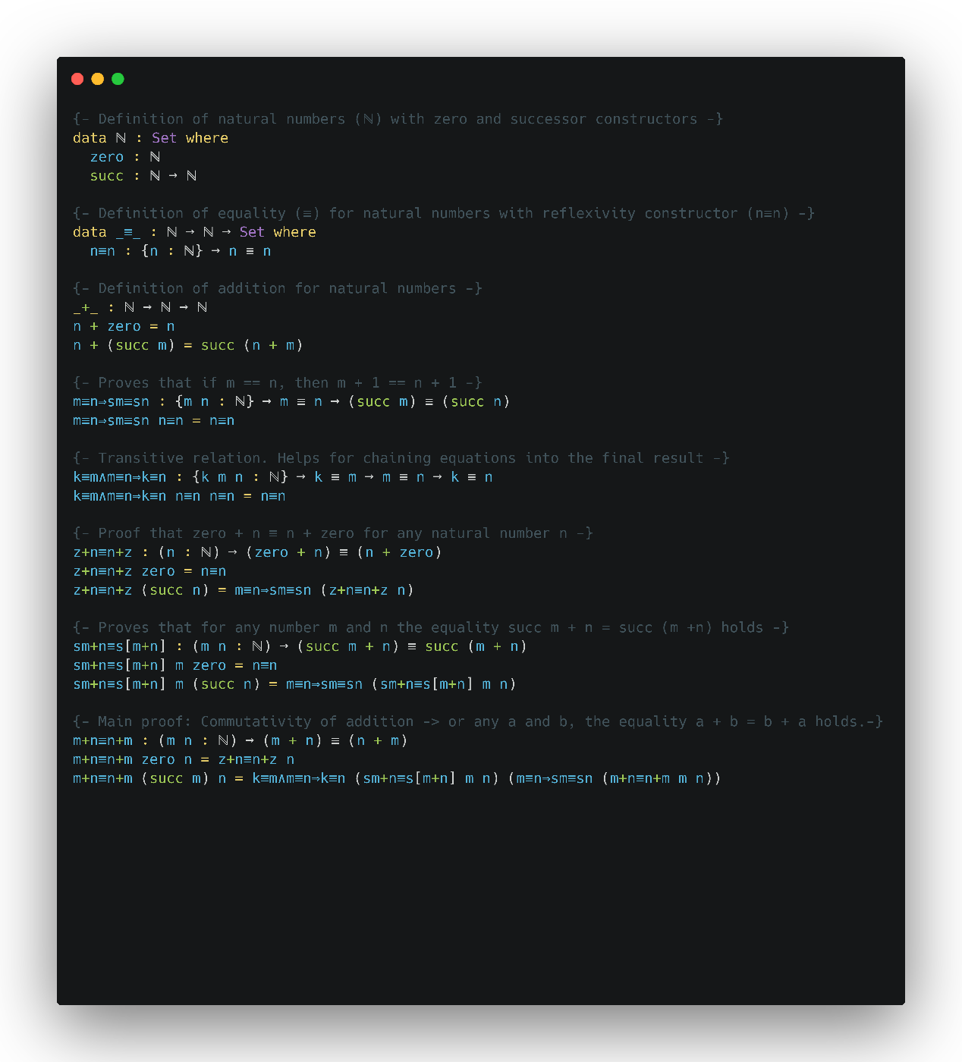The implementation of these type theories in practical proof assistants has led to the development of formal proof languages such as Agda. Stump (2016) emphasizes the role of Agda, a dependently typed programming language, in formal verification. Agda’s support for constructive proofs and its ability to represent complex mathematical structures with precision make it an ideal choice for our proposed verification system [9]. By employing Agda, our system will be able to formalize and verify the correctness of proofs generated by ChatGPT, ensuring their reliability and consistency.  
  
Fig 1. Commutativity proof of addition in Agda. Created the picture by Carbon <https://carbon.now.sh/> **2.5 LLMs in Mathematical Problem Solving**

Plevris, Papazafeiropoulos, and Rios (2023) conducted a comparative study on the performance of various LLMs, including ChatGPT, in solving mathematical and logical problems. Their research highlights the variability in the logical clearness of solutions provided by these models, showing the need for verification systems [5]. While ChatGPT can generate mathematical questions and explanations across various difficulty levels, it struggles with consistently producing correct proofs, especially for complex problems. This study supports our approach of integrating a formal verification framework with ChatGPT to ensure the soundness of its generated proofs.

**2.6 Unifying Type Theory and Formal Verification**

Pelayo and Warren (2014) explore Homotopy Type Theory and its univalent foundations, providing a unified approach to reasoning about mathematical structures. Their work highlights the potential of HoTT to serve as a robust foundation for formal verification, particularly in the context of complex mathematical proofs [4]. This theoretical foundation is critical to our project, as it informs the development of a verification system that leverages both intuitionistic and homotopy type theories to ensure the correctness of AI-generated proofs.

**3 Background**Our work builds upon two fundamental theories in type theory: Intuitionistic Type Theory (ITT) and Homotopy Type Theory (HoTT). We begin by discussing ITT, followed by HoTT, the use of the Agda programming language, and finally, our system's API.

**3.1 Intuitionistic Type Theory**

Intuitionistic Type Theory, developed by Per Martin-Löf, represents a significant advancement in the formalization of mathematical reasoning. The primary goal of ITT was to construct a formal system that could represent informal mathematical reasoning more accurately than previous foundational systems.

A key feature of ITT is the distinction between propositions and judgments. Propositions are statements that can be combined using logical operations and can be true or false, while judgments are assertions about the truth of propositions. This distinction forms the basis for the system's rules of inference, which are justified by explaining how conclusions can be drawn from premises known to be true.

ITT introduces four fundamental forms of judgment:

1. A is a set
2. A and B are equal sets
3. a is an element of set A
4. a and b are equal elements of set A

In this system, sets are defined by specifying rules for forming canonical elements and equal canonical elements. An element of a set is conceptualized as a method or program that, when executed, yields a canonical element of that set.

One of the distinguishing features of ITT is its intuitionistic approach to propositions. Rather than defining propositions in terms of truth values, ITT defines them in terms of what constitutes a proof of the proposition. This aligns with the intuitionistic interpretation of logical operations and allows for a more constructive approach to mathematics.

The theory pays particular attention to specific set operations, including the Cartesian product, disjoint union, and natural numbers. These operations and their associated rules are used to interpret various logical connectives and quantifiers. Notably, ITT provides a proof for the axiom of choice within its framework, demonstrating the system's expressive power.

To extend the system beyond finite types, ITT introduces the concept of universes. These allow for the construction of transfinite types, which are necessary for dealing with certain concepts in category theory that cannot be adequately captured with just finite types.

Overall, ITT aims to provide a rich formal system that serves a dual purpose: as a rigorous foundation for mathematics and as a practical programming language. This dual nature makes ITT particularly relevant to our work, as it bridges the gap between theoretical foundations and practical implementations in computer science.

**3.2 Homotopy Type Theory**

Homotopy Type Theory (HoTT) represents a fascinating convergence of abstract homotopy theory and type theory. It emerged from the discovery of deep connections between Martin-Löf's constructive type theory and abstract homotopy theory.

The key insight of HoTT is the interpretation of types as spaces (or homotopy types) and terms of a type as points in that space.

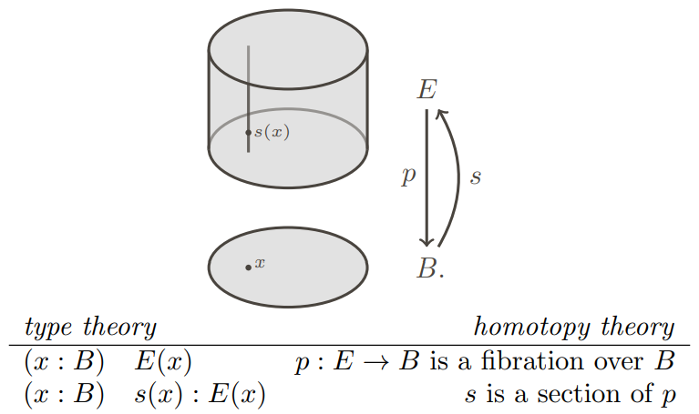  
  
  
  
  
  
  
  
  
  
  
  
  
  
  
  
  
  
  
  
  
  
  
fig 2. Illustration of how dependent types in type theory can be interpreted geometrically as fibrations in homotopy theory [4].

A central concept in HoTT is the Univalence Axiom, introduced by Vladimir Voevodsky (2014). This axiom states that identity between types is equivalent to equivalence of types. Formally: (A = B) ≃ (A ≃ B) where ≃ denotes equivalence. This principle allows for more flexible reasoning about equality.   
"In other words, identity is equivalent to equivalence. In particular, one may say that 'equivalent types are identical'. [6]

HoTT also introduces higher inductive types, which allow for the direct definition of many important spaces and constructions from homotopy theory within the type theory itself.

The univalent perspective, proposes adopting homotopy type theory as a foundation for mathematics, offering several key advantages. It provides a constructive foundation that aligns with homotopy-theoretic concepts, enabling direct formal verification of proofs in varies proof assistants. Furthermore, this approach yields fresh insights and techniques that benefit both type theory and homotopy theory. By linking the rigorous logic of type theory with the geometric intuitions of homotopy theory, HoTT creates a powerful framework that not only enhances our understanding of mathematical structures but also facilitates the development of machine-checkable proofs, potentially revolutionizing how we approach mathematical reasoning and verification.

**3.3 Agda**

In our project, we utilize Agda, a dependently typed programming language rooted in Martin-Löf’s Intuitionistic Type Theory. This theoretical foundation provides a robust framework for constructive reasoning, where mathematical proofs are approached as algorithms that need to be explicitly formulated and verified.

Agda is a dependently typed programming language primarily used for writing and verifying formal proofs in a functional programming setting. As an advanced tool for verified programming, Agda offers a unique approach where the correctness of programs is ensured through mathematical proofs written in the language itself. The proofs are checked by Agda's compiler, which verifies that the program adheres to its specifications across all possible inputs.

Agda is grounded in constructive logic, where types are viewed as logical propositions, and programs that inhabit these types serve as proofs of the propositions. This approach is based on the Curry-Howard correspondence, a fundamental concept in type theory that equates types with propositions and programs with proofs.

Agda's type system is highly expressive, supporting features like dependent types, where types can depend on values. This allows for precise specifications of program properties, such as the length of a vector being encoded in its type. Additionally, Agda supports both internal and external verification of functions, offering a robust framework for proving the correctness of complex algorithms and data structures.

The language's strong emphasis on pure functional programming, where functions behave like mathematical functions without side effects, aligns well with the goals of verified programming. Agda also enforces termination, ensuring that all programs eventually produce a result, which is crucial for maintaining logical consistency in proofs.

Agda's interactive development environment, typically integrated with the Emacs text editor, allows users to write, type-check, and interactively develop proofs and programs. This environment supports Unicode, enabling the use of mathematical symbols directly in code, which enhances the readability and expressiveness of proofs.

Overall, Agda represents a powerful tool for researchers and developers interested in formal methods, providing a platform to explore and apply advanced concepts in type theory and functional programming.

**3.3.1 Extension**   
  
Agda's power as a proof assistant and programming language stems from several key features:

**Inductive Types**: Agda allows the definition of inductive data types, which are fundamental for representing recursive structures.  
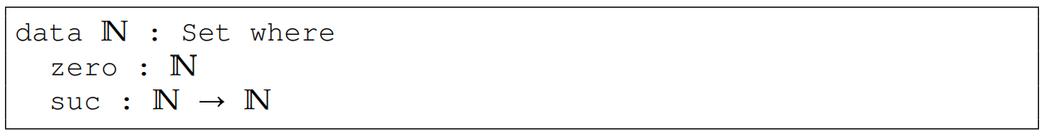

Fig 3. Agda code of inductive definition of the type N for the Peano natural numbers [9].  
  
**Pattern Matching and Recursion**: Agda uses pattern matching and structural recursion for function definitions, allowing for clear and concise code.  
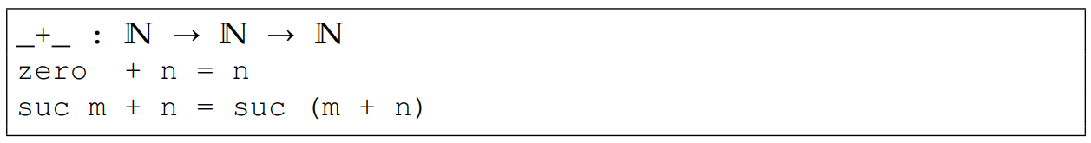

Fig 4. Agda code of recursive definition of addition [9].

**3.4 Our System's API**

Our system provides an API that serves as an interface between natural language mathematical statements and formal verification processes. The API is designed to facilitate an iterative proof generation and verification cycle. Its key features encompass several interconnected components.

The API begins by accepting a mathematical statement in natural language as input. This allows users to express theorems or conjectures in a familiar, human-readable format. Upon receiving a statement, the system leverages ChatGPT to generate a proof attempt. This proof is expressed in a semi-formal language, bridging the gap between natural mathematical discourse and formal logic.

Once generated, the proof undergoes a rigorous verification process using our Agda-based formal verification system. This step ensures the logical correctness and completeness of the proof. If the verification fails, the system initiates an iterative refinement process. It provides feedback to the proof generation module, which then attempts to refine the proof. This cycle continues until a valid proof is obtained or a predefined limit is reached.

Finally, the API presents the final outcome, including the generated proof and its verification status. In cases of successful verification, it also provides a formal, machine-checkable version of the proof.

This API structure enables a symbiotic interaction between AI-driven proof generation and formal verification methods, potentially enhancing both the efficiency of proof discovery and the reliability of mathematical reasoning.

**7 Bibliography**

1. Azaria, A., Azoulay, R., & Reches, S. (2024). ChatGPT is a remarkable tool—for experts. *Data Intelligence, 6*(1), 240-296. <https://doi.org/10.1162/dint_a_00235>
2. Janßen, C., Richter, C., & Wehrheim, H. (2024, April). Can ChatGPT support software verification? In *International Conference on Fundamental Approaches to Software Engineering* (pp. 266-279). Cham: Springer Nature Switzerland. <https://doi.org/10.1007/978-3-031-57259-3_13>
3. Martin-Löf, P., & Sambin, G. (1984). *Intuitionistic type theory* (Vol. 9, p. 136). Naples: Bibliopolis. <https://archive-pml.github.io/martin-lof/pdfs/Bibliopolis-Book-retypeset-1984.pdf>
4. Pelayo, Á., & Warren, M. (2014). Homotopy type theory and Voevodsky’s univalent foundations. *Bulletin of the American Mathematical Society, 51*(4), 597-648. <https://doi.org/10.1090/S0273-0979-2014-01456-9>
5. Plevris, V., Papazafeiropoulos, G., & Rios, A. J. (2023). Chatbots put to the test in math and logic problems: A preliminary comparison and assessment of ChatGPT-3.5, ChatGPT-4, and Google Bard. *arXiv preprint arXiv:2305.18618*. <https://doi.org/10.48550/arXiv.2305.18618>
6. Program, T. U. F. (2013). Homotopy type theory: Univalent foundations of mathematics. arXiv preprint arXiv:1308.0729.‏ <https://doi.org/10.48550/arXiv.1308.0729>
7. Shakarian, P., Koyyalamudi, A., Ngu, N., & Mareedu, L. (2023). An independent evaluation of ChatGPT on mathematical word problems (MWP). <https://doi.org/10.48550/arXiv.2302.13814>
8. Sitnikovski, B. (2023). *Introduction to dependent types with Idris: Encoding program proofs in types*. Apress. <https://doi.org/10.1007/978-1-4842-9259-4>
9. Stump, A. (2016). *Verified functional programming in Agda*. Morgan & Claypool. <https://doi.org/10.1145/2841316>