MyPC Lab
Assignment #1 — HTML & CSS Basics
A student project website about building a desktop PC from separate parts
Student: Daniyar Zhubanysh
Group: IT-2505
Course: Web Technologies — Front-End Development
Live site: https://daniarzubanys2-star.github.io/WEB-1-/about.html

1. Introduction
For this assignment I built MyPC Lab, a small three-page website about assembling a desktop computer from separate parts. I chose this topic because I put together my own PC earlier this year, and I still have the part list, the prices and the notes I wrote during the build, so the content in this project is real rather than invented for the assignment.
The site has three pages that share one navigation bar and one external stylesheet: a home page that introduces the topic, a build page about the processor I chose, and a page with a full part-cost table and a contact form. The sections below walk through each task in the order I completed it, with screenshots of the working pages and of the code behind them.

2. Part 1 — Project Setup and Home Page (Task 1)
I started by creating the project folder with the structure the assignment asked for: index.html, about.html and contact.html at the root, a css folder for the stylesheet, an images folder for the SVG diagrams, and a media folder for the audio file used later on the Build page.

Folder structure
- index.html, about.html, contact.html — the three pages
- css/style.css — a single external stylesheet linked from every page
- images/ — three SVG diagrams (case layout, build order, CPU socket)
- media/ — fan-idle.wav, used by the <audio> element on the Build page
Every page has a valid HTML5 boilerplate: <!DOCTYPE html>, the lang attribute on <html>, a UTF-8 charset meta tag and a responsive viewport meta tag. index.html is split into semantic header, nav, main and footer landmarks. Inside main there is one h1, two h2 sections ("What goes inside a PC" and "How I build a machine"), one unordered list of five hardware parts, one ordered list of six build steps, and two images — a case-layout diagram and a build-order diagram — each with descriptive alt text rather than a filename.
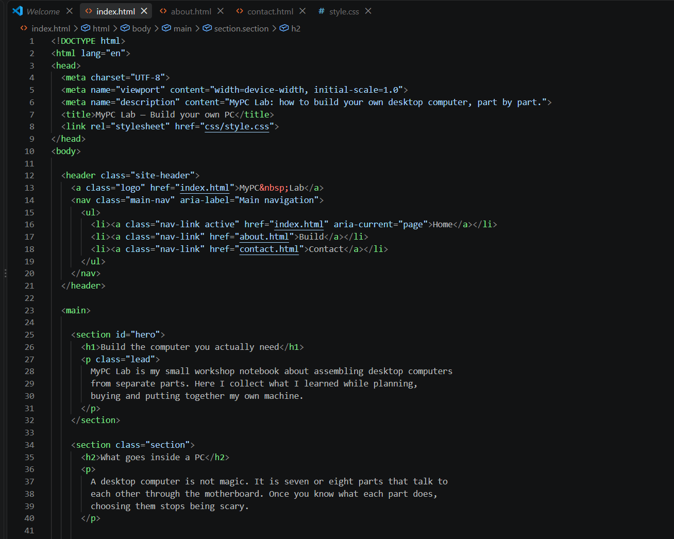
Code — the semantic structure of index.html (header, nav, main, footer, headings and lists)
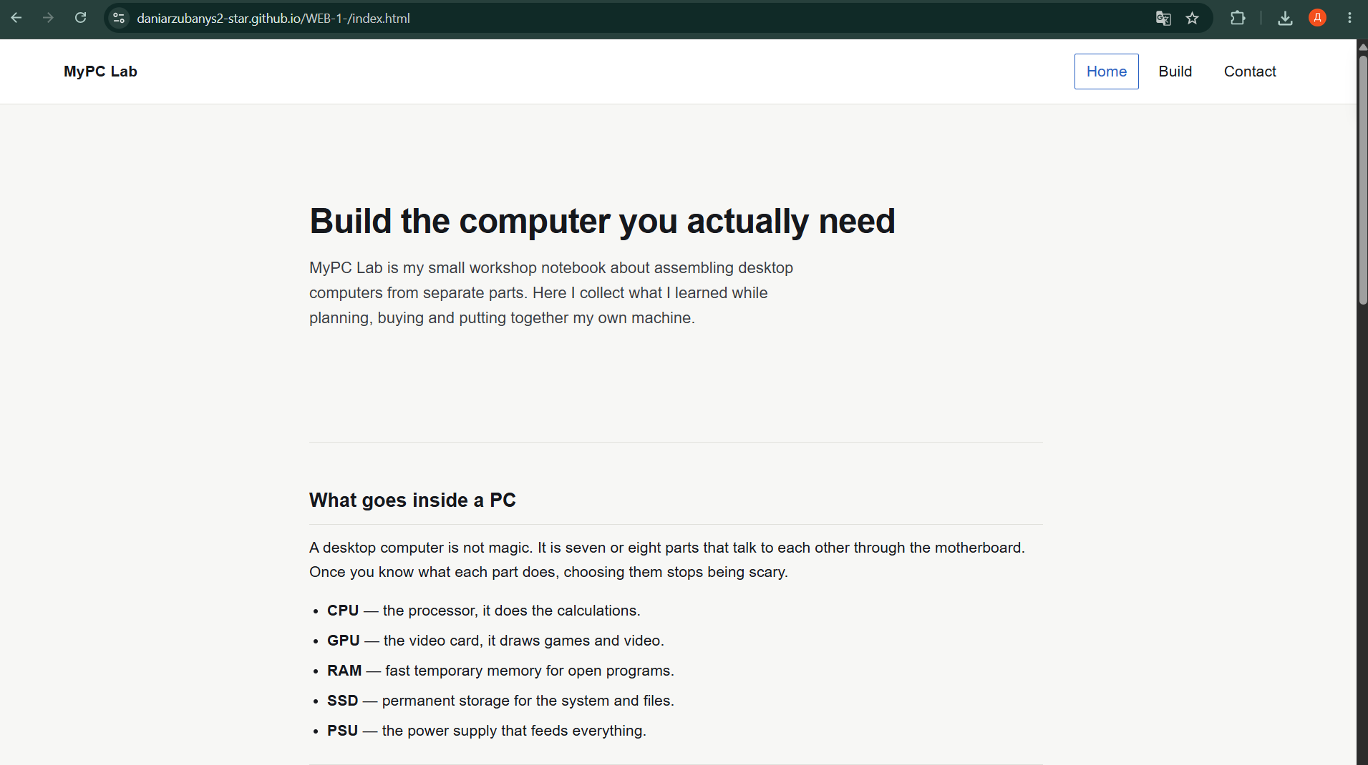
The home page in the browser: hero text, the part list and the case-layout diagram
Both pages load without any errors in the browser console — the only asset paths used are relative ones inside the project folder, so nothing is missing at runtime.

3. Part 2 — Advanced HTML (Task 2)
The Build page (about.html) is about the one part I chose first when planning the build: the AMD Ryzen 5 7600X processor. It follows the structure the task asked for:
- A heading and a five-sentence paragraph about the processor, including one strong term and one emphasised word.
- An ordered list of six key dates in the Ryzen processor family, from the first Ryzen launch in 2017 to the current generation.
- An unordered list of five technical facts about the specific processor I bought.
- A figure with an SVG diagram of the processor and the open socket, and a figcaption explaining how the processor is oriented.
- A blockquote with a lesson I learned the hard way, with the source written underneath it.
- An <audio> element with a short recording of the cooler fan at idle, so a visitor can hear what the finished build sounds like.
- An external link to AMD's own processor page, opening in a new tab with target="_blank" and rel="noopener".
The same navigation bar appears in the header of all three pages. Each nav link points to a real page in the project, and the link for the page currently open gets an "active" class plus aria-current="page", so both sighted users and screen-reader users can tell which page they are on.
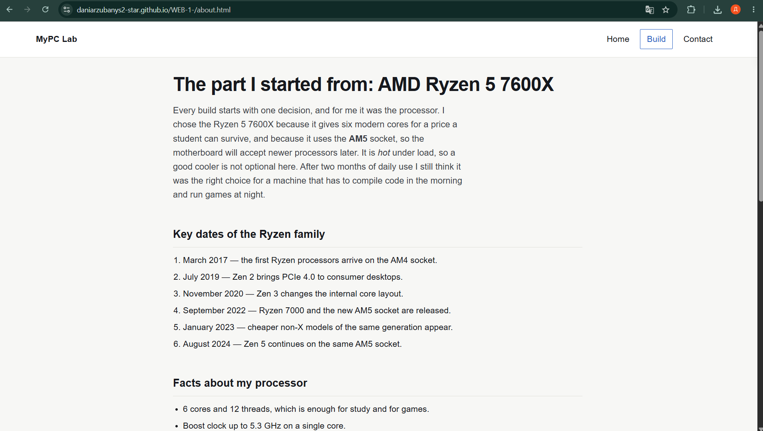
The Build page: heading, paragraph, key-date list and the CPU/socket diagram
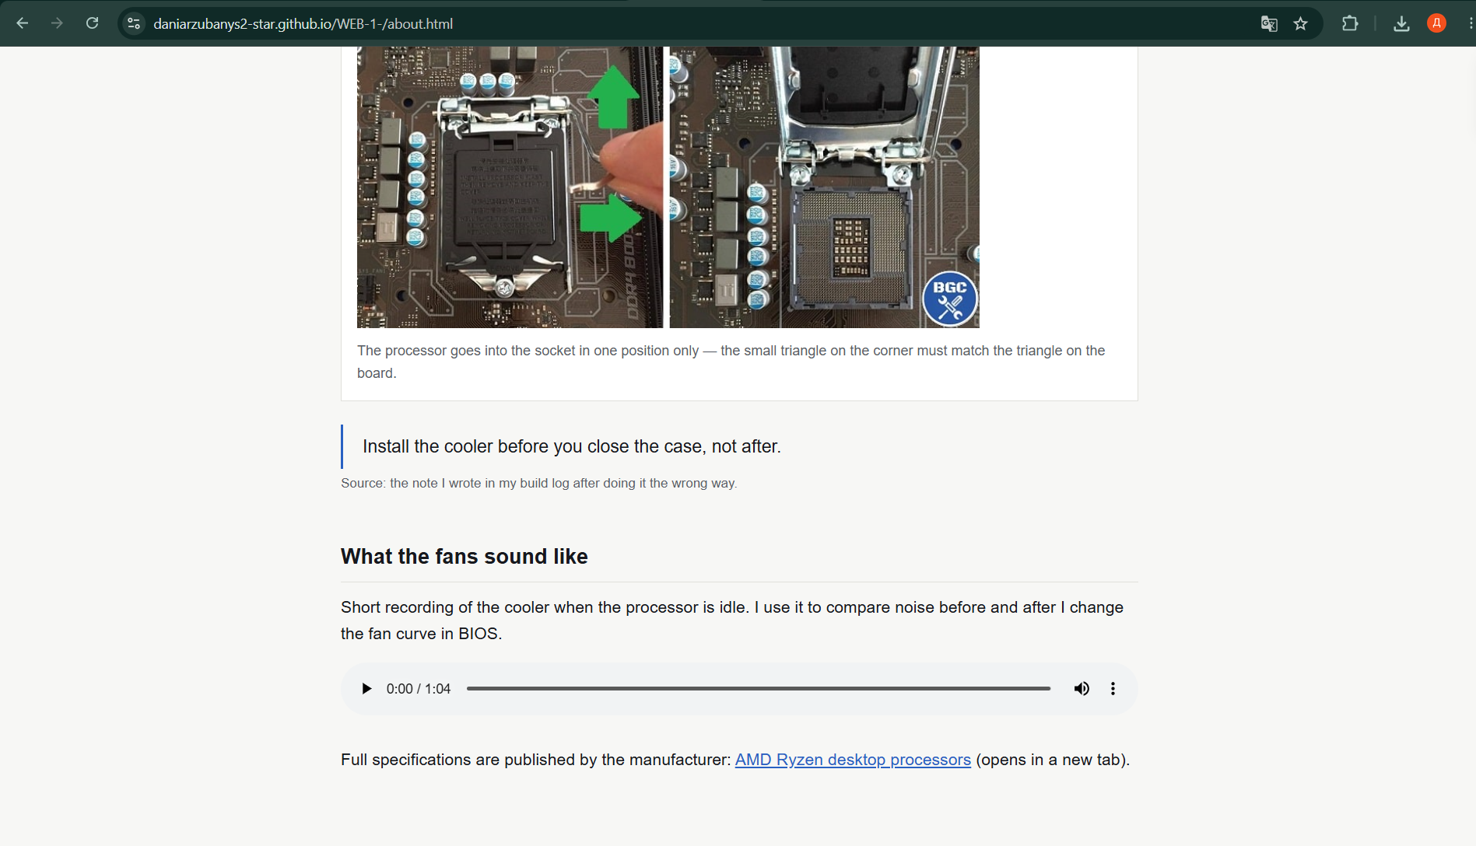
The Build page continued: blockquote, audio player and the external AMD link, opening in a new tab

4. Part 3 — Data Table and Contact Form (Task 3)

4.1 Data table
The Contact page (contact.html) contains a real part-cost table from my own build: five columns (group, part, model, price and warranty) and seven data rows, with caption, thead, tbody and tfoot used correctly. Every header cell has a scope attribute — scope="col" on the column headers and scope="row" / scope="rowgroup" on the row headers. I used rowspan to group parts that belong to the same category (for example "Core" spans the processor, motherboard and memory rows) and colspan in the footer row, where the total-cost label spans three columns before the total price.

4.2 Contact form
Below the table there is a working HTML form. The fields are grouped into two fieldset elements, each with its own legend ("Who you are" and "What the PC is for"), plus a third fieldset for the free-text message. Every input has a label connected through matching for and id attributes. The form uses eight different input types in total — text, email, number, date, color, radio, checkbox and textarea — plus a submit button. Two fields are required (name and email), and the number field additionally uses min, max and step, so the browser validates the range natively. The three usage options (study, games, video) are radio buttons that share the name="usage" attribute, so only one can be selected at a time.
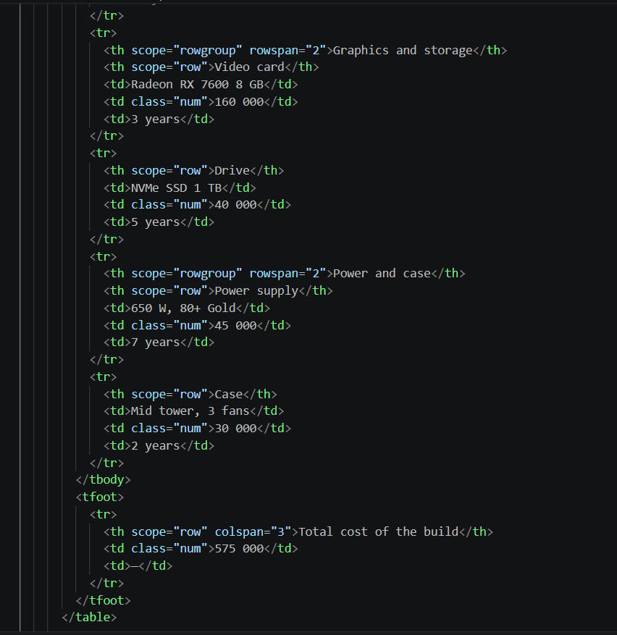
Code — the table markup with scope, rowspan and colspan, and the start of the form's fieldsets
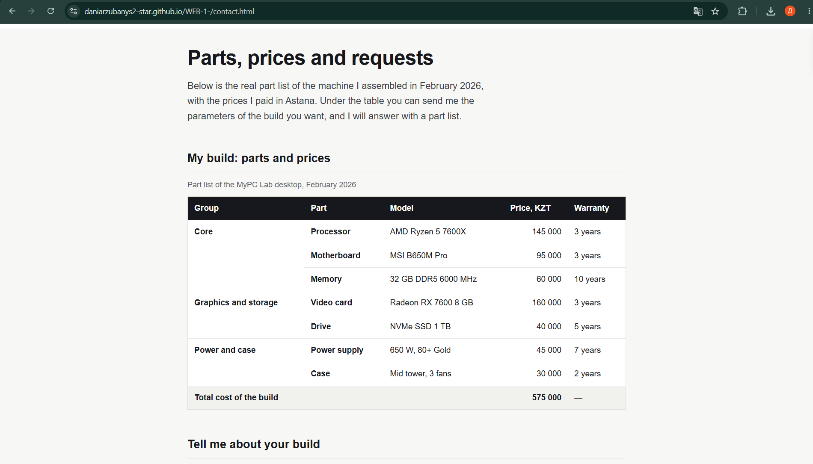
The Contact page: the part-cost table with grouped rows and a highlighted total row
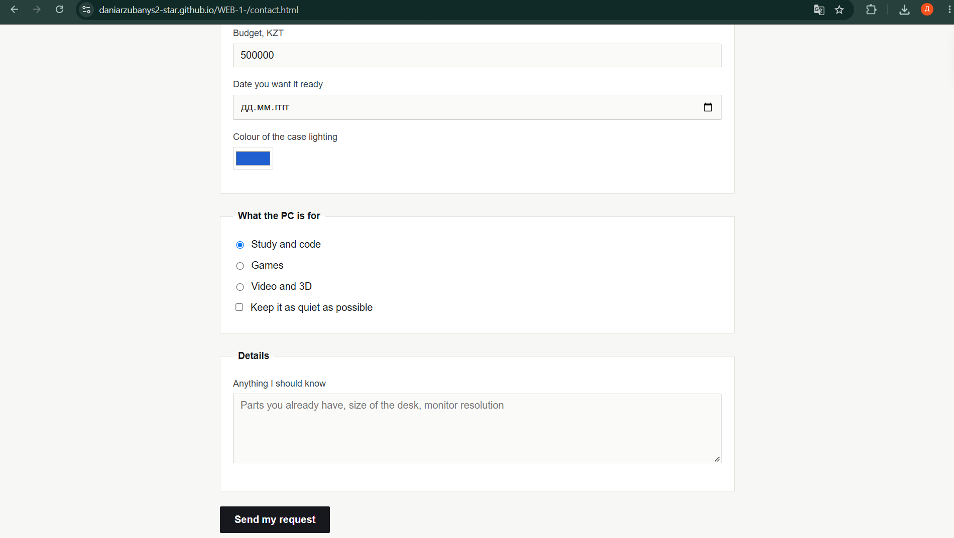
The Contact page continued: the fieldsets, labelled inputs, radio group and the submit button

5. Part 4 — CSS Styling (Task 4)
All three pages are styled from one external stylesheet, css/style.css — there are no <style> blocks and no inline style attributes anywhere in the project. The stylesheet is organised into numbered sections (base, header/nav, hero, content, table, form, footer, small screens) with a comment at the top explaining the choices.

Colour palette
I used a small palette of four colours, written in three different CSS formats so the report also demonstrates that I understand the syntax, not just the visual result:
- white — the colour keyword, used for card backgrounds
- #16181D — hex, the main ink colour for text and the dark nav hover state
- rgb(247, 247, 245) — the warm off-white page background
- hsl(218, 66%, 46%) — the blue accent used for links, the active nav item and the focus ring

Fonts, spacing and the box model
The whole site uses a single sans-serif font stack (Helvetica Neue, Arial, sans-serif) with two weights — regular body text and a bold 700 weight for headings — so the type scale stays consistent without mixing families. Margin, padding and border are used throughout to make the box model visible in DevTools: the shot figures, the table and the fieldsets all sit inside a bordered, padded white box on top of the page's warm-grey background, which makes the content box and the border clearly separate layers.

Selectors
The stylesheet uses element selectors for base typography (body, h1, h2, a, img), class selectors for reusable components (.nav-link, .parts, .build-form, .shot), and exactly one ID selector, #hero, which styles the single unique introduction block on the home page and is not reused anywhere else.

Navigation, table and form states
The nav links have no underline; on hover or focus they get a full colour change (dark background, white text, matching border) rather than only a colour swap, which satisfies the "changes more than the colour" requirement. Table rows highlight on hover so the data stays easy to scan. Every input, textarea and button has a visible outline focus state in the accent colour, so the form is usable with a keyboard alone.

CSS units used
- px — the base font-size (17px) and the main column's max-width (820px): a fixed size that does not depend on the parent element.
- rem — most spacing and heading sizes, so the whole layout scales together if the root font size changes.
- em — the letter-spacing on the h1 (-0.02em): relative to that element's own font size, so the tracking stays correct at any heading size.
- % — the main content width (92%) and the header's side padding (5%): these adapt automatically to the width of the window.
- vh — the hero section's min-height (42vh): keeps the introduction taking a fixed share of the visible screen regardless of monitor size.
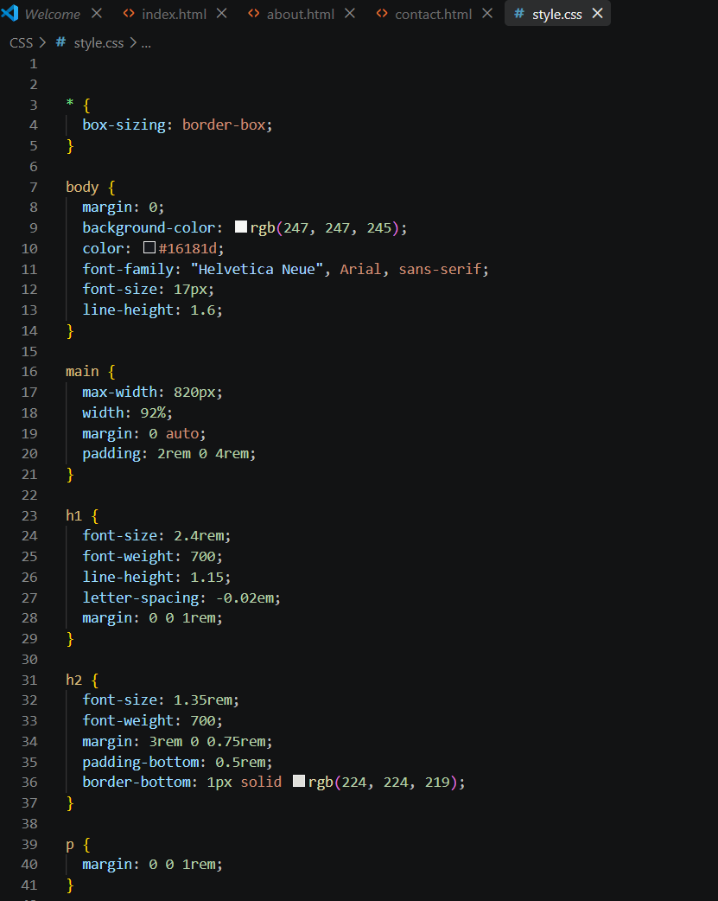
Code — the colour tokens, base typography and the CSS-unit comments in style.css

6. Part 5 — Validation and Publishing (Task 5)
Before publishing, I ran all three HTML pages through the W3C Markup Validator and the stylesheet through the W3C CSS Validator, checking each one after every change to the markup. The screenshots below show the clean, error-free results.
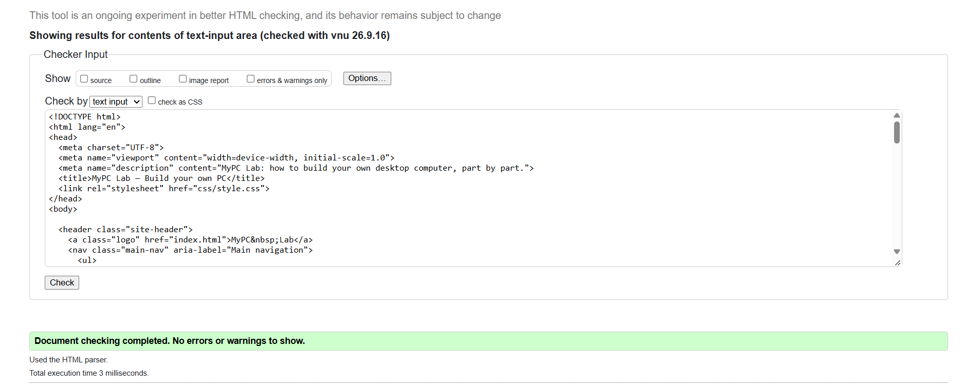
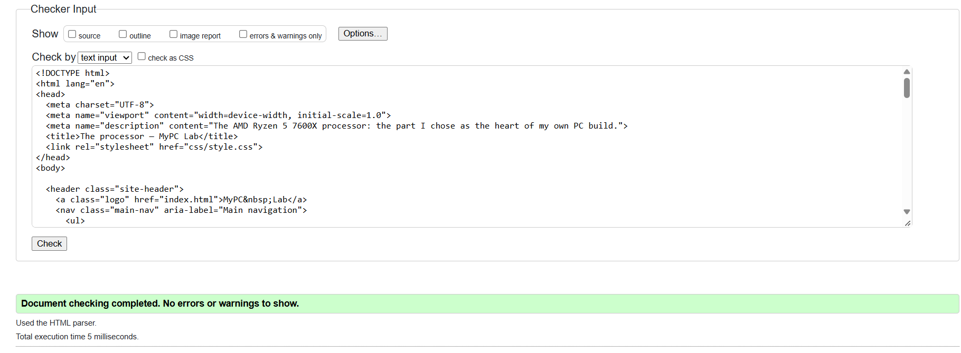
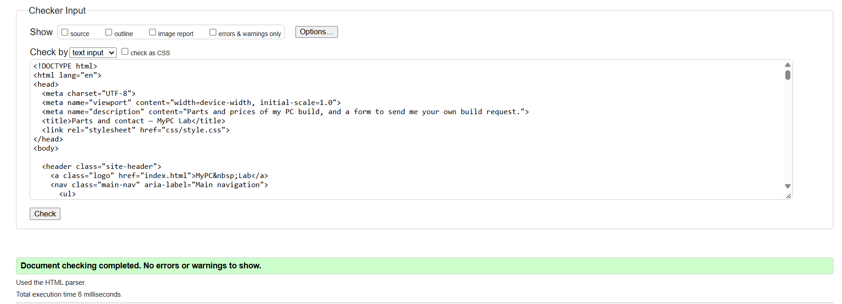
Markup Validator: https://validator.w3.org/#validate_by_input
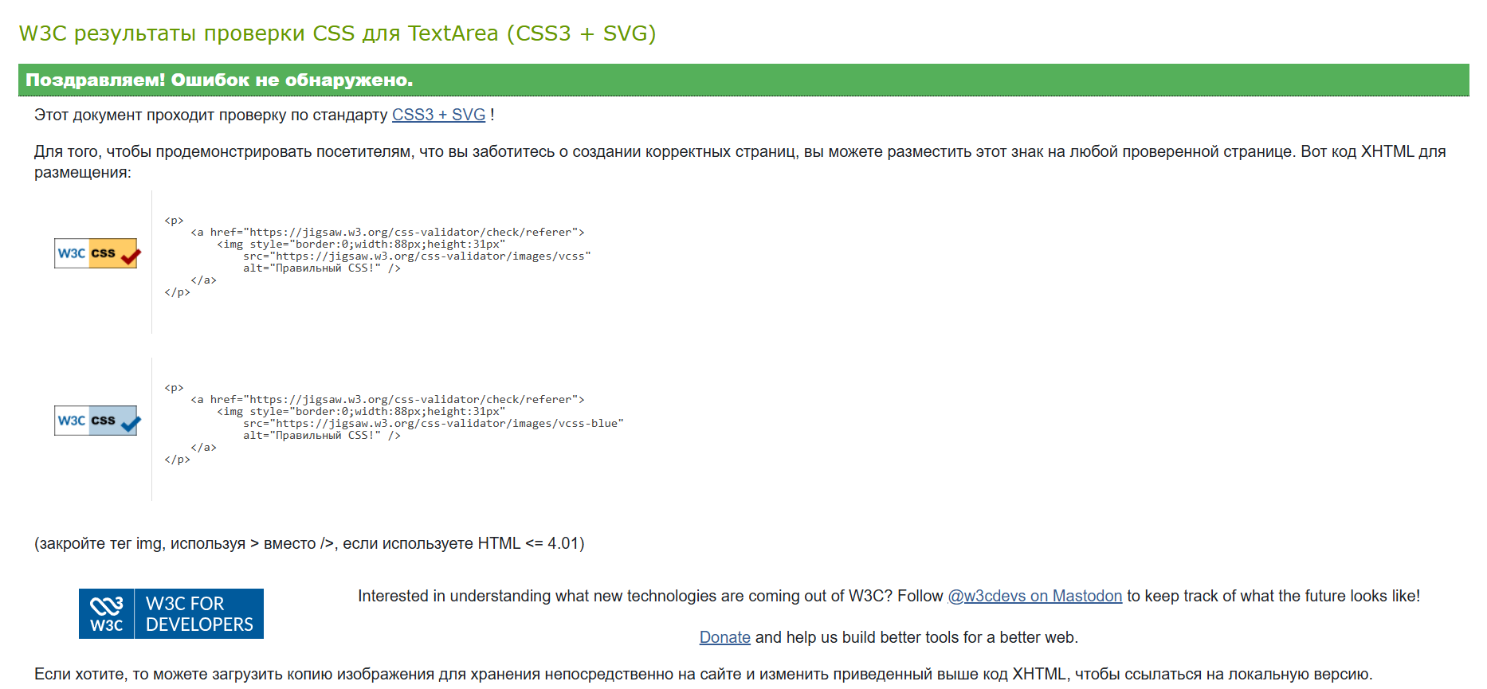
CSS Validator: https://jigsaw.w3.org/css-validator/#validate_by_input
The site is published on GitHub Pages with index.html as the entry page. I checked every page and every navbar link online after publishing, and all of them load correctly.
Live URL: [paste your GitHub Pages link here, e.g. https://yourusername.github.io/mypc-lab/]

7. Conclusion
Building MyPC Lab took the parts of HTML and CSS I had only seen in separate examples before and forced me to combine them in one real project. Writing semantic landmarks, a real data table with scope, rowspan and colspan, and a form with correctly linked labels made me pay much closer attention to structure than to appearance at first — the CSS only started to matter once the markup underneath it was already meaningful on its own.
The part I had to rethink the most was the stylesheet. My first version used more colours and two font families, and it looked busier than the subject needed; keeping the palette small and reusing the same border and spacing values across the shots, the table and the form ended up looking more consistent than the version I started with. Running the pages through the W3C validators also caught a few small mistakes — a missing scope attribute and one alt text that was not descriptive enough — that I would not have noticed just by looking at the rendered page.
Overall this assignment is where I actually understood why semantic tags and an external stylesheet matter, rather than just being able to define them.

