Assignment #2 Report — Advanced CSS (Grid & Flexbox)
Zhubanysh Daniyar Group: IT-2505
https://github.com/daniarzubanys2-star/WEB-2
https://daniarzubanys2-star.github.io/WEB-2/
1. Task 1 — Geometric Composition (Mondrian Grid)
Implementation Details
The Piet Mondrian-style composition is implemented using a single $6 \times 6$ CSS Grid container without any nested grids. The thick black lines dividing the colored blocks are created naturally using the grid gap property over a dark container background, strictly avoiding CSS border properties on individual grid items. Responsive sizing is handled through percentage widths and fixed aspect ratios.
https://daniarzubanys2-star.github.io/WEB-2/task1.html
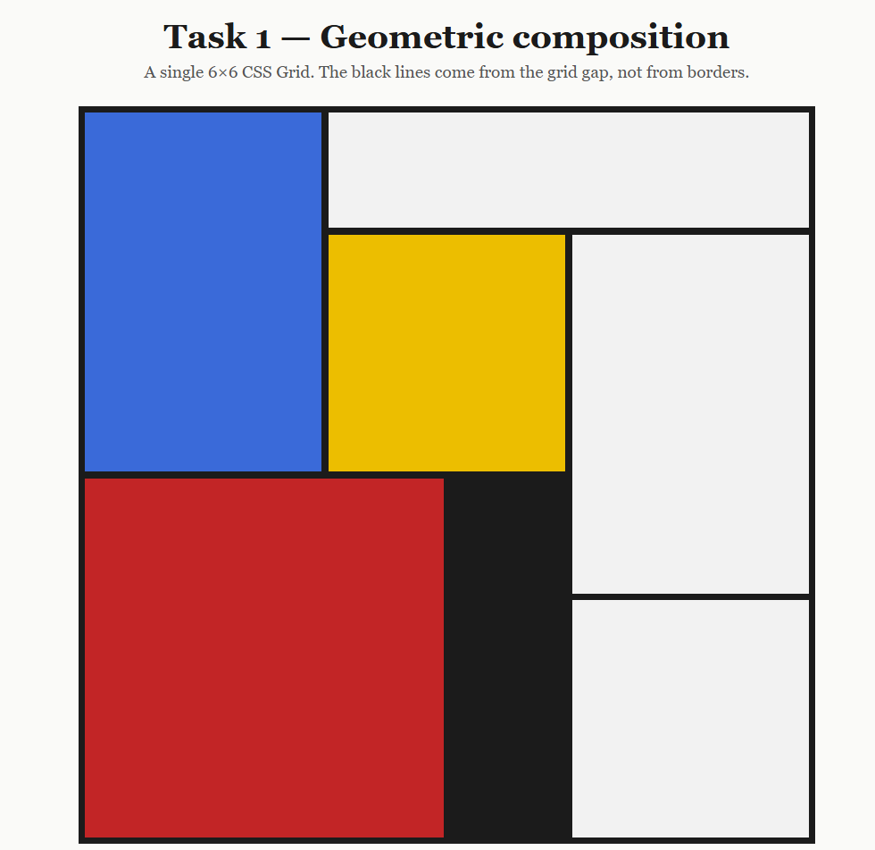
2. Task 2 — Flexbox UI Component Library
Implementation Details
This task demonstrates a practical UI component library constructed entirely with CSS Flexbox without any media queries or external libraries. It contains five distinct components:
- Responsive Navigation Bar: Items wrap cleanly on narrow screens with space-between alignment.
- Card Grid with Equal-Height Alignment: Flexbox column direction ensures that card bodies fill available height, keeping all Action buttons perfectly aligned at the bottom across cards with varying content lengths.
- Pagination Bar: Flex container with dynamic wrapping and automatic right-alignment for page counters.
- Comment Block: Fixed-size avatar with non-overflowing flexible text block.
- Form Layout: Responsive input fields with label alignment using flex-wrap and flex-grow.
https://daniarzubanys2-star.github.io/WEB-2/task2.html
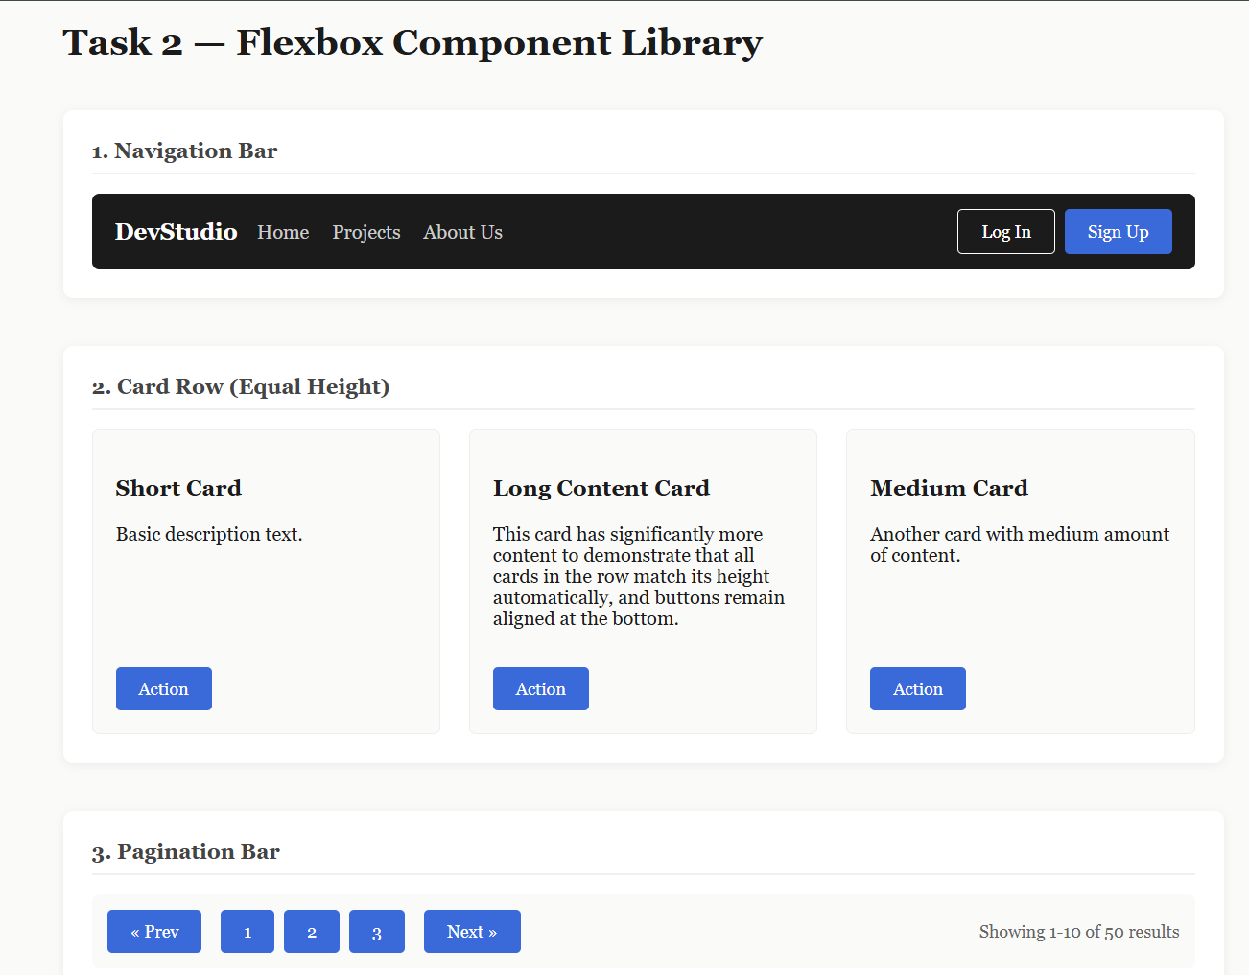
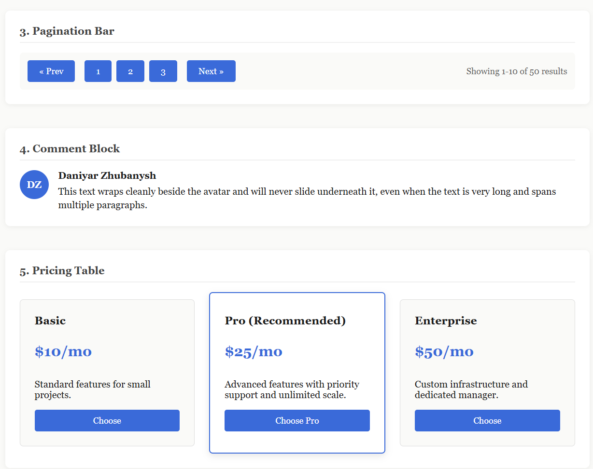
3. Task 3 — Three Layouts, One Markup
Implementation Details
Task 3 showcases the power of modern CSS by rendering three completely different layouts (Grid, List, and Magazine) from a single, identical HTML structure. The layout seamlessly transforms simply by changing the top-level container class (layout-grid, layout-list, layout-magazine) without requiring any JavaScript or @media queries:
- Grid Layout (layout-grid): Fluid CSS Grid layout utilizing repeat(auto-fit, minmax(...)) for adaptive multi-column presentation.
- List Layout (layout-list): Horizontal row-based flex orientation for media cards with right-aligned metadata.
- Magazine Layout (layout-magazine): Grid layout where the lead feature item spans two columns and two rows (grid-column: span 2; grid-row: span 2;) with custom highlight styling.
https://daniarzubanys2-star.github.io/WEB-2/task3.html

Layout 1: Grid Mode (layout-grid)
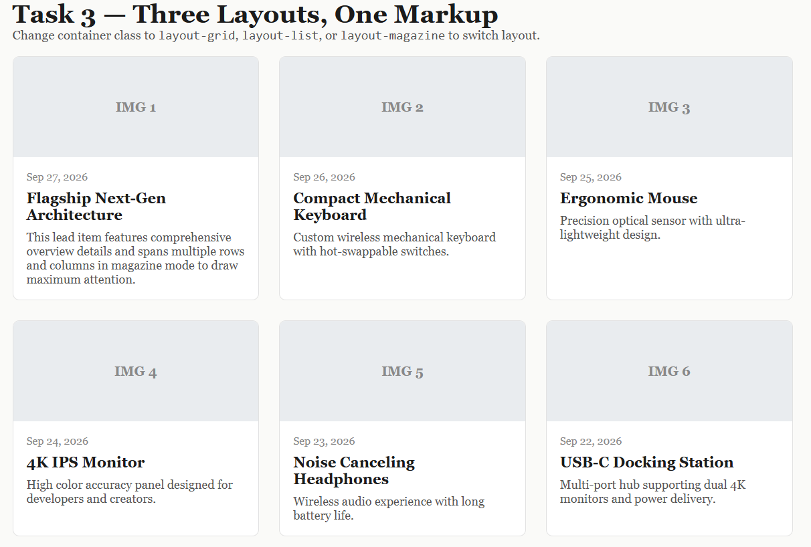
Layout 2: List Mode (layout-list)

Layout 3: Magazine Mode (layout-magazine)
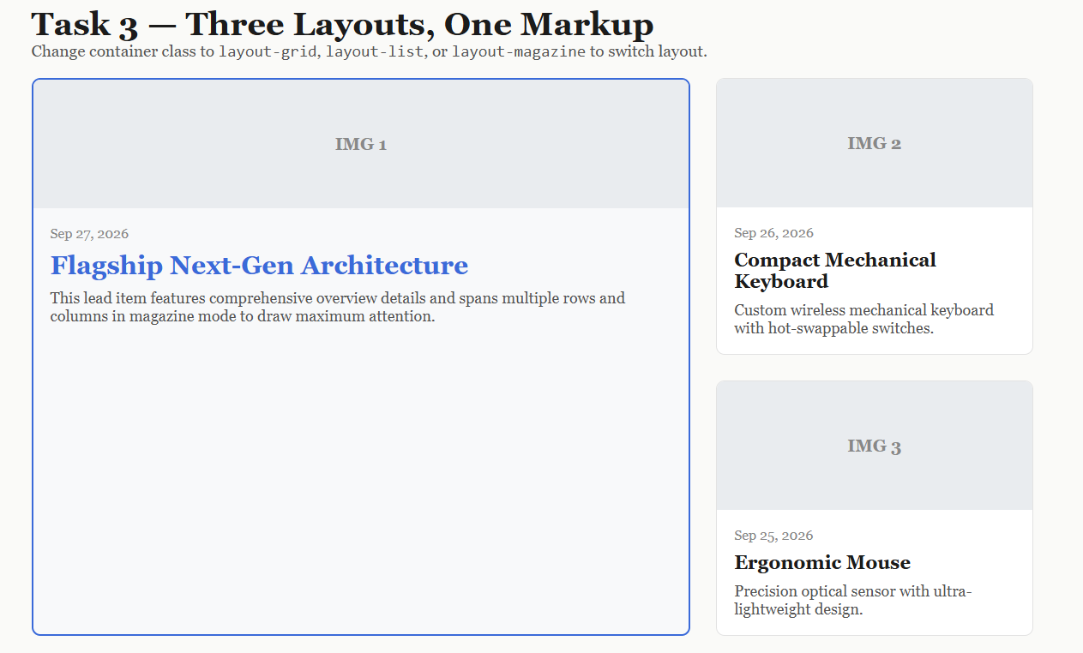
4. Conclusion
All three tasks were completed successfully in accordance with the assignment specifications. The codebase strictly adheres to pure HTML5 and CSS3 techniques, completely avoiding JavaScript, CSS frameworks, and traditional @media queries. The completed repository has been deployed and verified via GitHub Pages.

