Updates: August 1, 2026
Hi Nishant and Yuki,
I wanted to share a brief update on the top-censoring work.
I reviewed the approaches used by LIS, the CPS, WID, and the EU-SILC literature, and drafted a short literature review (below) summarizing their different objectives and methods. LIS applies a log-IQR top-coding rule; CPS top-coding is mainly designed for disclosure protection; EU-SILC compares trimming, winsorizing, and robust Pareto-based approaches; and WID focuses on correcting the underrepresentation of top incomes in surveys by combining survey, tax, and national accounts data.
I then reviewed the surveys available in the shared drive to identify those with individual-level, non-grouped microdata that can be used for this exercise. I excluded files that contain grouped/binned distributions, since they cannot be used to identify individual upper-tail observations.
Using the LIS rule, I calculated the upper ceiling as:
$$exp[Q3(log y)+3* IQR(log y)]$$
and identified the observations above this threshold. The table below summarizes the initial screening results.
Survey | Valid records | Records above LIS ceiling | Weighted population share above ceiling | Welfare share above ceiling | Welfare type
Malawi 1997 | 10,698 | 59 | 0.435% | 41.60% | Consumption
Malawi 2004 | 52,691 | 65 | 0.128% | 2.24% | Consumption
Malawi 2019 | 50,476 | 34 | 0.046% | 1.20% | Consumption
Belize 1993 | 9,097 | 22 | 0.246% | 20.09% | Income
Belize 1997 | 10,122 | 11 | 0.114% | 18.24% | Income
Angola 2000 | 10,100 | 5 | 0.010% | 0.80% | Consumption
Angola 2008 | 45,398 | 5 | 0.004% | 0.15% | Consumption
Ecuador 2006 | 77,636 | 8 | 0.009% | 3.77% | Income
Seychelles 1999 | 813 | 1 | 0.152% | 4.34% | Consumption
Zimbabwe 2019 | 987,700 | 72 | 0.013% | 0.54% | Consumption
These results are a screening exercise: observations above the LIS ceiling are candidates for review, not automatically invalid records.
The initial screening suggests that Malawi 1997 and the two Belize surveys are particularly useful case studies, because a very small weighted population share above the LIS ceiling accounts for a relatively large share of total welfare.
For Malawi 1997, the LIS ceiling is 48.57 PPP USD per person per day. The 59 observations above this threshold represent only 0.43% of the weighted population but account for 41.6% of total welfare. I fitted a Pareto distribution to the upper tail and found that the two largest values are especially inconsistent with the fitted tail. I then compared several treatments: no adjustment, trimming, winsorizing, LIS top-coding, and robust Pareto-based approaches. All approaches substantially reduce the influence of the upper tail on the mean and inequality measures, while poverty estimates remain essentially unchanged.
For Belize 1993 and Belize 1997, the pattern is similar but less extreme. The observations above the LIS ceiling account for around 20% and 18% of total welfare, respectively. The Pareto diagnostics suggest that the upper tail in Belize 1997 is particularly irregular, with the two highest values deviating strongly from the fitted Pareto pattern.
Table 1. Upper-tail screening and Pareto diagnostics
Survey | Valid records | LIS ceiling (2021 PPP USD/day) | Records above ceiling | Weighted population share | Welfare share held by these records | Pareto α (fitted above p90)
Malawi 1997 | 10,698 | 48.57 | 59 | 0.435% | 41.60% | 1.61
Belize 1993 | 9,097 | 353.80 | 22 | 0.246% | 20.09% | 1.81
Belize 1997 | 10,122 | 360.08 | 11 | 0.114% | 18.24% | 2.00

Table 2. Malawi 1997: sensitivity to the two most extreme welfare values
Indicator | Original data | Excluding the two highest values | Percentage change
Weighted mean | 5.780 | 3.800 | −34.26%
Gini | 0.658 | 0.479 | −27.13%
Mean log deviation | 0.811 | 0.392 | −51.65%
Atkinson (ε = 2) | 0.647 | 0.463 | −28.46%
Poverty headcount | 0.520 | 0.520 | approximately 0%

Figure 1:
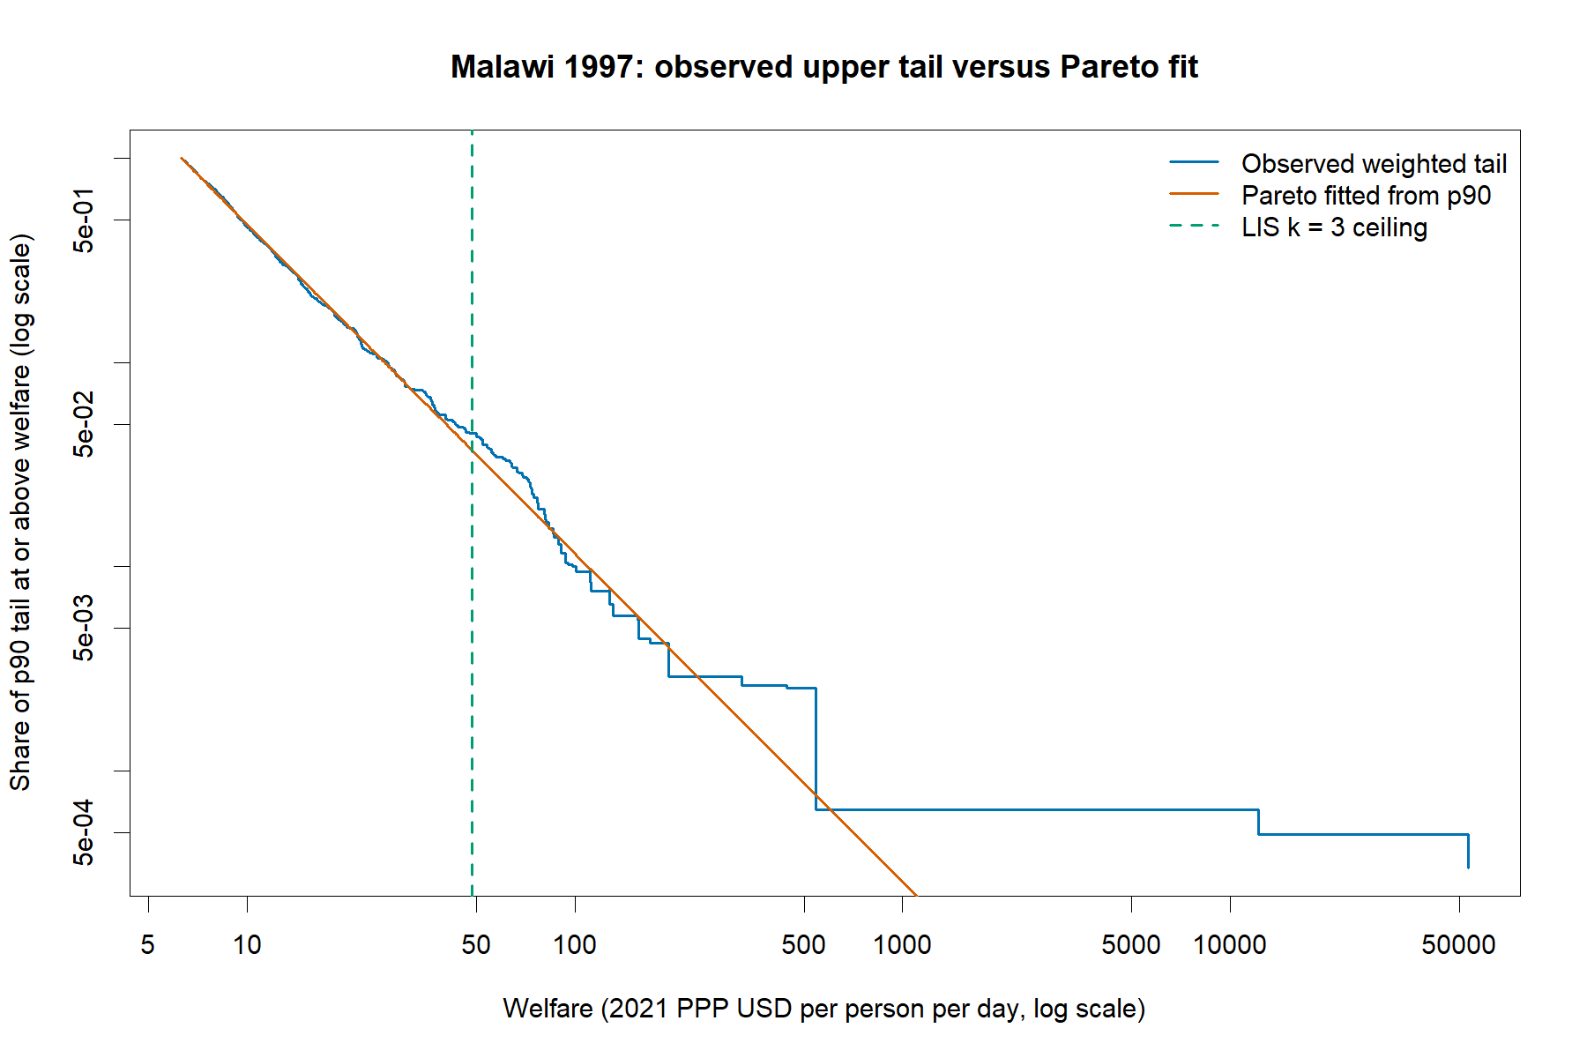Figure 2: Pareto sensitivity using Belize
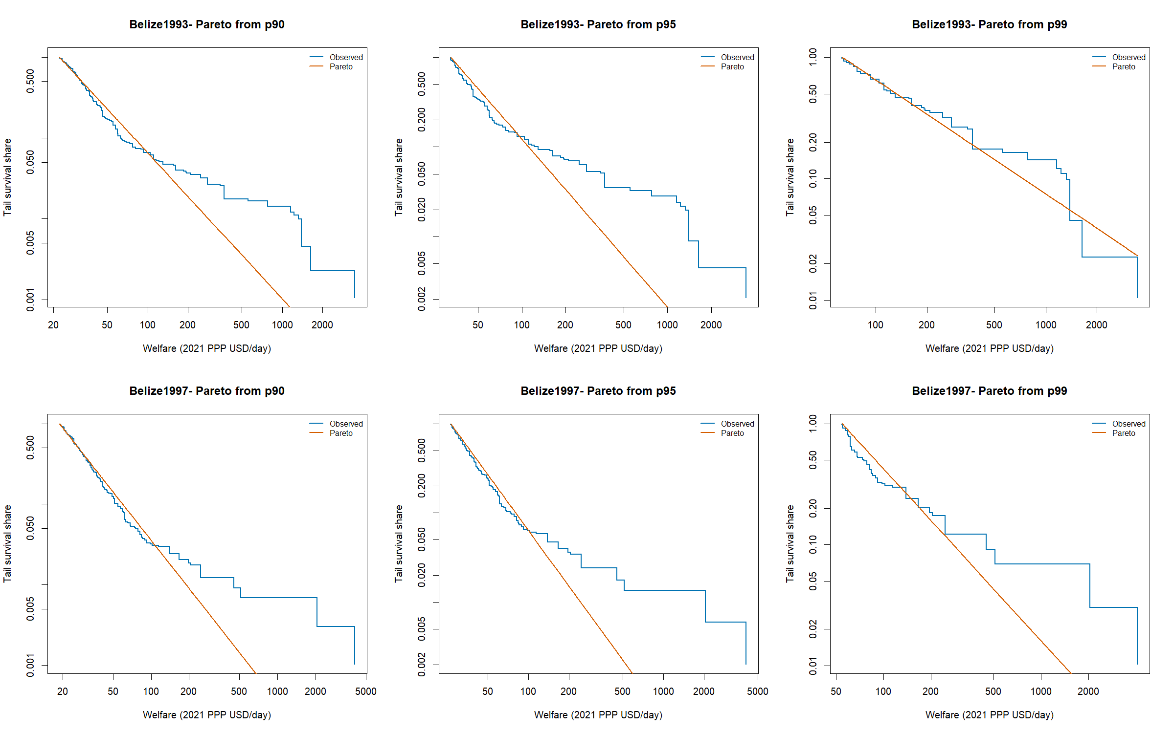
Code WIP: https://github.com/daniavayu/bindata_check/tree/main/top_censoring

Literature Review
Treatment of Upper-Tail Values in Income Distribution Analysis
Inequality measures calculated from household survey microdata can be highly sensitive to a small number of observations at the upper end of the welfare distribution. This is particularly true for the mean and for inequality measures that are sensitive to the upper tail. Extreme values may reflect genuine high incomes or consumption levels, but they may also result from reporting error, data-processing problems, measurement error, nonresponse, or the limited representation of very affluent households in household surveys.
The methodological issue is whether the observations are plausible, how much influence they have on the estimates, and whether the survey adequately represents the upper tail. A procedure that reduces the influence of extreme observations may improve robustness, but it may also remove genuine information about inequality. Conversely, a survey may contain influential high values while still underestimating the true income of the richest households because those households are underrepresented.
LIS Top-Coding
The Luxembourg Income Study has documented a distribution-based approach to identifying unusually high-income values. In the procedure described by Neugschwender (2020), the upper threshold is based on the interquartile range of log income. For a strictly positive welfare variable $y$, the threshold can be written as:
$$c=exp⁡\left[Q_{0.75}(log⁡y)+3\left\{Q_{0.75}(log⁡y)-Q_{0.25}(log⁡y)\right\}\right].$$
Values above the threshold are replaced by the threshold:
$$y_{i}^{*}=min⁡(y_{i},c).$$
This is a form of winsorization or top coding. It does not remove the affected records from the dataset. The observations remain in the sample, and their survey weights are retained, but the welfare value used in the calculation is capped.
The main advantages of this approach are transparency, simplicity, and comparability. A rule based on the distribution of log income can adapt to differences in the scale and dispersion of income across countries and surveys. However, the LIS ceiling should be interpreted as a treatment threshold rather than as proof that the observations above it are erroneous. High values above the ceiling may be genuine, and the rule does not by itself establish that they should be excluded from the underlying survey.
For the present analysis, the LIS rule is used as a transparent baseline sensitivity treatment. The implementation uses weighted quartiles of log welfare and expresses welfare in 2021 PPP dollars per person per day.
Current Population Survey
The Current Population Survey provides a different example because many of its upper-tail procedures are primarily motivated by disclosure avoidance rather than by the identification of statistically invalid observations.
The Current Population Survey (CPS) has historically applied disclosure-avoidance procedures to protect the confidentiality of respondents with high incomes, which has important implications for the measurement of inequality. Prior to 1996, income values above specified thresholds were subject to traditional topcoding, whereby all observations exceeding the threshold were assigned the same maximum value. From 1996 to 2010, the Census Bureau instead used replacement values, assigning topcoded observations values based on the average income of individuals within defined demographic groups. Beginning in 2011, the CPS adopted a rank-proximity swapping procedure, under which high-income observations are reordered and swapped with observations of similar rank rather than replaced by a common value. This approach is intended to preserve the distribution of high incomes while preventing the identification of individual respondents. Consequently, although the public-use CPS data provide greater information about the upper tail than under traditional topcoding, individual income values above the relevant thresholds should not necessarily be interpreted as the respondents' actual reported incomes (IPUMS CPS).
Trimming, Winsorizing, and Robust Tail Modelling
A standard approach to extreme observations is trimming. Trimming removes observations above a specified cutoff or percentile. It is easy to implement and useful as a diagnostic, but it gives the affected observations no influence at all. This is a strong assumption and is not generally appropriate unless there is independent evidence that the observations are invalid.
Winsorizing retains the observations but replaces values above a cutoff with the cutoff value. It therefore limits the influence of the upper tail while preserving the sample size and survey weights. The disadvantage is that all affected observations receive the same replacement value, even though their original values may have represented genuine differences among high-income households.
Van Kerm (2007) examines the sensitivity of poverty and inequality estimates to extreme incomes in EU-SILC and compares simple adjustments, including trimming and winsorizing, with approaches based on modelling the upper tail. The paper emphasizes that ordinal comparisons between countries may be relatively robust to alternative treatments, while cardinal estimates such as means, income shares, and inequality indices may be substantially more sensitive.
A Pareto model is often used to describe the upper tail of an income distribution. If the Pareto model is fitted above a threshold $u$, its survival function can be expressed as:
$$P(Y≥y∣Y≥u)={\left(\frac{u}{y}\right)}^{α},y≥u,$$
where $α$ is the Pareto shape parameter. A smaller value of $α$ indicates a heavier upper tail.
A Pareto model should not automatically be fitted to the entire welfare distribution. The bulk of the distribution and the upper tail may follow different statistical patterns. The choice of the tail threshold is therefore important, and results should be examined for sensitivity to alternative thresholds such as the 90th, 95th, or 99th percentile.
A fitted Pareto distribution can be used in several ways. It can provide a diagnostic comparison between observed and predicted tail probabilities, support a semiparametric inequality estimate, or generate plausible replacement values in a sensitivity analysis. However, replacing observed values with Pareto draws is an additional modelling choice.
In the present exercise, the Pareto analysis is inspired by the EU-SILC literature but is not an exact replication of Van Kerm’s implementation. The fitted Pareto model and the resulting capping or imputation exercises should therefore be interpreted as exploratory sensitivity analyses.
Extreme Values and Censored Data
Jenkins, Burkhauser, Feng, and Larrimore (2011) address a related but distinct problem: estimating inequality when the data are already right-censored or top-coded by the data provider. In that situation, the original values above a known threshold are not observed. The authors propose multiple-imputation methods in which the censored observations are imputed using draws from a flexible parametric distribution, particularly the generalized beta of the second kind distribution. The imputed datasets are then used to estimate inequality measures and associated uncertainty.
This approach is relevant because it demonstrates that top-coding can affect inequality estimates if the lost upper-tail variation is ignored. However, it is not directly the same as the present problem. In the current survey microdata, the extreme values are observed. The question is whether their influence should be limited, not how to reconstruct values that have already been hidden by a data provider.
Survey Underrepresentation and the World Inequality Database
The World Inequality Database addresses a different problem from top-coding: the possible underrepresentation of the richest individuals in household surveys. Household surveys may fail to capture some high-income households because of sampling limitations, nonresponse, underreporting, or difficulties linking survey responses to the very top of the income distribution.
The Distributional National Accounts framework therefore seeks, where appropriate data are available, to combine household survey information with tax records, national accounts, and other administrative or distributional sources. The purpose is to improve the representation of the full distribution, especially the upper tail. Pareto or generalized Pareto models may be used to describe the distribution above a selected threshold (World Inequality Lab, 2025).
The exact procedure is country-specific because the availability and quality of tax, survey, and national-accounts data differ across countries. The WID approach should therefore not be described as a single universal top-coding rule. Conceptually, it often moves in the opposite direction from top-coding: top-coding limits the influence of observed extreme values, whereas the WID approach may increase the estimated upper tail when survey data appear to omit or underrepresent the richest individuals.
A survey can contain a small number of highly influential observations and still understate the true share of income received by the richest households. Top-coding is therefore a robustness treatment for observed microdata, not a correction for national top-income undercoverage.
Implications for the Current Exercise
The literature does not identify one universally correct treatment for upper-tail values. The appropriate method depends on the objective:
- trimming is useful as a strong diagnostic sensitivity check
- winsorizing provides a transparent way to limit the influence of selected observations
- LIS-style top-coding provides a simple and comparable baseline rule
- Pareto modelling provides a way to assess whether the observed upper tail is compatible with a specified distribution
- multiple imputation is appropriate when values are already censored and missing above a known threshold
- survey-tax-data integration addresses underrepresentation of top incomes rather than the influence of observed outliers.
The proposed empirical strategy is therefore to use the LIS log-IQR ceiling as a transparent baseline treatment, while using Pareto diagnostics and alternative treatments as sensitivity analyses. Observations above the LIS ceiling should be regarded as candidates for review, not automatically as invalid observations.

References
IPUMS CPS. (n.d.). Income components: Topcodes, replacement values, and swap values.
Jenkins, S. P., Burkhauser, R. V., Feng, S., & Larrimore, J. (2011). Measuring inequality using censored data: A multiple-imputation approach to estimation and inference. Journal of the Royal Statistical Society: Series A (Statistics in Society), 174(1), 63–81.
Neugschwender, J. (2020). Top and Bottom Coding at LIS. LIS Technical Working Paper No. 9. Luxembourg Income Study.
U.S. Census Bureau. (2024). Disclosure Avoidance of Usual Hourly Earnings. Current Population Survey technical documentation.
Van Kerm, P. (2007). Extreme incomes and the estimation of poverty and inequality indicators from EU-SILC. Working paper available through the EU-SILC/Research Papers in Economics repository.
World Inequality Lab. (2025). Distributional National Accounts Guidelines 2025: Methods and Concepts Used in the World Inequality Database.

Updates: September 2, 2026
Notes from previous meeting:
- LIS approach
- Pareto fitting
- Dagum distribution
- Fisk distribution
To dos:
- See if Belize has newer surveys. Do a histogram with the shares of surveys within each possible extreme (distribution of shares above LIS ceiling)
Total surveys: 1825
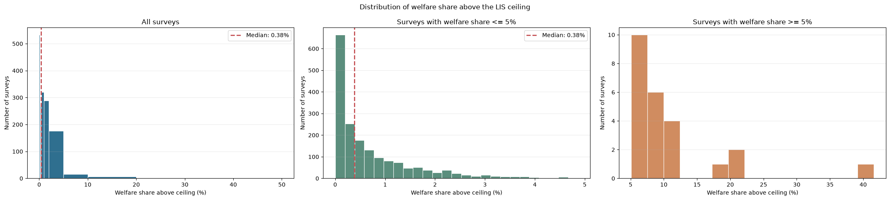
- 24 surveys have 5% or more welfare share above LIS ceiling. All of them have less than 0.5% of the population in that area. The dashed line is the median (median_share = welfare_share.median()).
Survey | Year | Country | Valid records | Records above LIS ceiling | Weighted population share above ceiling | Welfare share above ceiling
LFS | 1993 | BLZ | 704 | 9 | 0.246155% | 20.090199%
LFS | 1994 | BLZ | 660 | 6 | 0.282513% | 19.958916%
HBS | 1995 | BLZ | 785 | 0 | 0.000000% | 0.000000%
SLC | 1996 | BLZ | 602 | 2 | 0.051692% | 3.974407%
LFS | 1997 | BLZ | 753 | 4 | 0.113682% | 18.243989%
LFS | 1998 | BLZ | 711 | 1 | 0.012478% | 0.554545%
LFS | 1999 | BLZ | 730 | 1 | 0.021975% | 0.904040%

# | Country | Year | Survey | Welfare share
1 | Malawi (MWI) | 1997 | IHS-I | 41.5964%
2 | Belize (BLZ) | 1993 | LFS | 20.0902%
3 | Belize (BLZ) | 1994 | LFS | 19.9589%
4 | Belize (BLZ) | 1997 | LFS | 18.2440%
5 | Seychelles (SYC) | 2013 | HBS | 12.0630%
6 | Maldives (MDV) | 2002 | HIES | 11.8246%
7 | Malawi (MWI) | 2016 | IHS-IV | 10.9665%
8 | Ethiopia (ETH) | 1995 | HICES | 10.8902%
9 | Madagascar (MDG) | 1993 | EPM | 8.8085%
10 | Paraguay (PRY) | 2002 | EPH | 8.4229%
11 | Mozambique (MOZ) | 2014 | IOF | 8.0368%
12 | Burkina Faso (BFA) | 1998 | EP-II | 7.9044%
13 | Norway (NOR) | 2005 | EU-SILC | 7.7505%
14 | Comoros (COM) | 2004 | EIM | 7.6145%
15 | Myanmar (MMR) | 2015 | MPLCS | 7.4224%
16 | Paraguay (PRY) | 2007 | EPH | 7.1682%
17 | Norway (NOR) | 2006 | EU-SILC | 7.0417%
18 | Mozambique (MOZ) | 2002 | IAF | 6.7657%
19 | Paraguay (PRY) | 2014 | EPH | 6.5026%
20 | Rwanda (RWA) | 2005 | EICV-II | 6.1369%
21 | Central African Republic (CAF) | 2008 | ECASEB | 5.4657%
22 | Rwanda (RWA) | 2013 | EICV-IV | 5.3731%
23 | Rwanda (RWA) | 2000 | EICV-I | 5.3613%
24 | Paraguay (PRY) | 2010 | EPH | 5.0918%

Change in mean using LIS coding:
Country | Year | mean_ppp_day change (%)
MWI | 1997 | -37.9435
BLZ | 1997 | -14.3101
BLZ | 1994 | -13.6962
BLZ | 1993 | -13.3214
MWI | 2016 | -9.65411
SYC | 2013 | -9.64039
MDV | 2002 | -8.8979
NOR | 2005 | -6.50955
ETH | 1995 | -6.2831
PRY | 2002 | -5.72061
MDG | 1993 | -4.66724
MMR | 2015 | -4.55923
NOR | 2006 | -4.26547
PRY | 2007 | -4.22349
BFA | 1998 | -4.05075
MOZ | 2014 | -3.83549
COM | 2004 | -3.70192
BEL | 2005 | -3.61559
ECU | 2006 | -3.41002
PRY | 2006 | -3.23927
GEO | 1998 | -3.13232
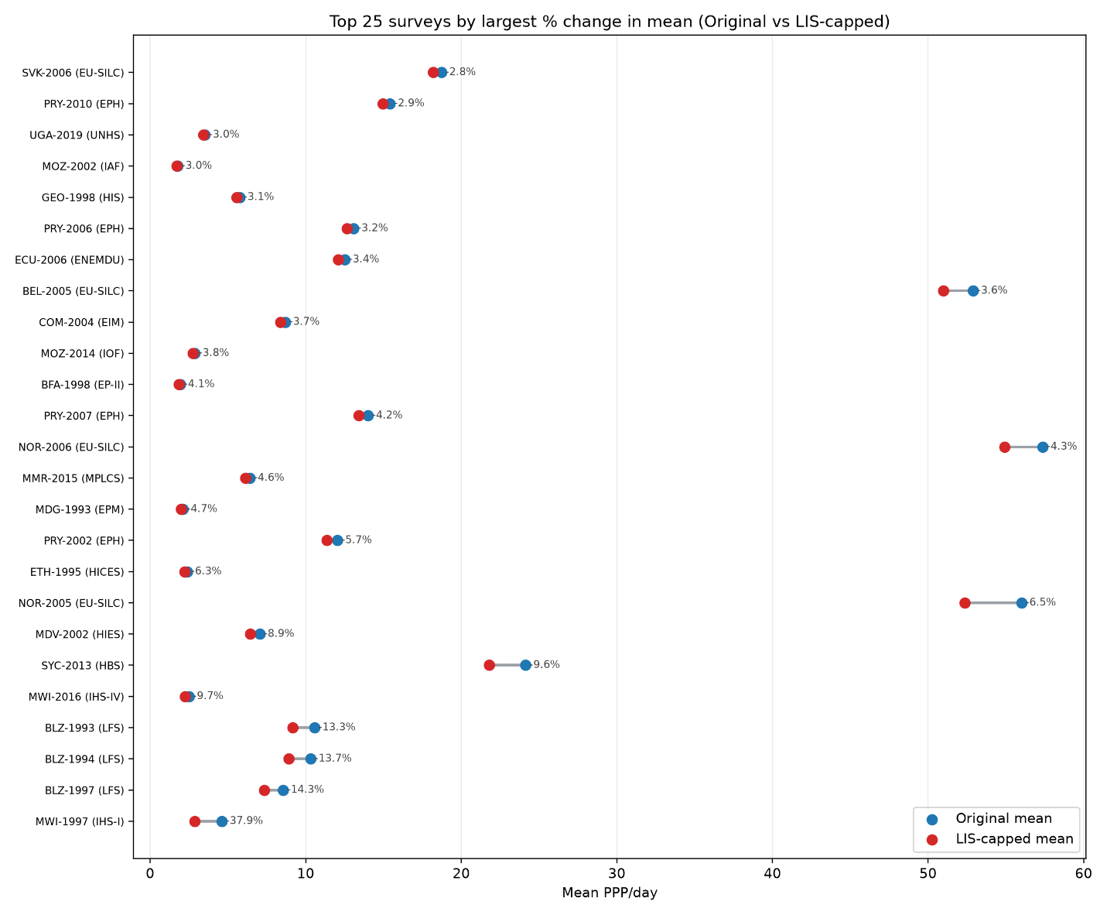
- Understand why CPS does the average of the top 3%. See what they have done in other years. See if this is a better option as mean is not affected.
The Current Population Survey provides a different example because many of its upper-tail procedures are primarily motivated by disclosure avoidance rather than by the identification of statistically invalid observations.
The Current Population Survey (CPS) has historically applied disclosure-avoidance procedures to protect the confidentiality of respondents with high incomes, which has important implications for the measurement of inequality. Prior to 1996, income values above specified thresholds were subject to traditional topcoding, whereby all observations exceeding the threshold were assigned the same maximum value. From 1996 to 2010, the Census Bureau instead used replacement values, assigning topcoded observations values based on the average income of individuals within defined demographic groups. Beginning in 2011, the CPS adopted a rank-proximity swapping procedure, under which high-income observations are reordered and swapped with observations of similar rank rather than replaced by a common value. This approach is intended to preserve the distribution of high incomes while preventing the identification of individual respondents. Consequently, although the public-use CPS data provide greater information about the upper tail than under traditional topcoding, individual income values above the relevant thresholds should not necessarily be interpreted as the respondents' actual reported incomes (IPUMS CPS).

Notes:
- Add GINI to this table:
Change in mean using LIS coding:
Country | Year | mean_ppp_day change (%)
MWI | 1997 | -37.9435
BLZ | 1997 | -14.3101
BLZ | 1994 | -13.6962
BLZ | 1993 | -13.3214
MWI | 2016 | -9.65411
SYC | 2013 | -9.64039
MDV | 2002 | -8.8979
NOR | 2005 | -6.50955
ETH | 1995 | -6.2831
PRY | 2002 | -5.72061
MDG | 1993 | -4.66724
MMR | 2015 | -4.55923
NOR | 2006 | -4.26547
PRY | 2007 | -4.22349
BFA | 1998 | -4.05075
MOZ | 2014 | -3.83549
COM | 2004 | -3.70192
BEL | 2005 | -3.61559
ECU | 2006 | -3.41002
PRY | 2006 | -3.23927
GEO | 1998 | -3.13232

Country | Year | mean_ppp_day change (%) | Gini change (%) | welfare_type
MWI | 1997 | -37.9435 | -31.8231 | consumption
BLZ | 1997 | -14.3101 | -11.0145 | income
BLZ | 1994 | -13.6962 | -10.2905 | income
BLZ | 1993 | -13.3214 | -10.1697 | income
MWI | 2016 | -9.6541 | -13.2185 | consumption
SYC | 2013 | -9.6404 | -12.0917 | income
MDV | 2002 | -8.8979 | -13.8446 | consumption
NOR | 2005 | -6.5096 | -15.1128 | income
ETH | 1995 | -6.2831 | -8.3212 | consumption
PRY | 2002 | -5.7206 | -4.5262 | income
MDG | 1993 | -4.6672 | -5.9057 | consumption
MMR | 2015 | -4.5592 | -7.7558 | consumption
NOR | 2006 | -4.2655 | -10.1010 | income
PRY | 2007 | -4.2235 | -3.9012 | income
BFA | 1998 | -4.0508 | -4.2238 | consumption
MOZ | 2014 | -3.8355 | -3.3936 | consumption
COM | 2004 | -3.7019 | -3.0262 | consumption
BEL | 2005 | -3.6156 | -8.5307 | income
ECU | 2006 | -3.4100 | -3.2319 | income
PRY | 2006 | -3.2393 | -2.9703 | income
GEO | 1998 | -3.1323 | -4.6043 | consumption

Consumption surveys: 14
Income surveys: 10
- Calculate wealth concentration by dividing share/population. Analyze concentration at different levels... pick 1 percent and cut it .1 percent, .5 percent and see what income of this groups have and compare across countries
- Try Outdetect stata: https://openknowledge.worldbank.org/server/api/core/bitstreams/a8021d9e-bdcd-5371-b00c-589e10b5c0ec/content
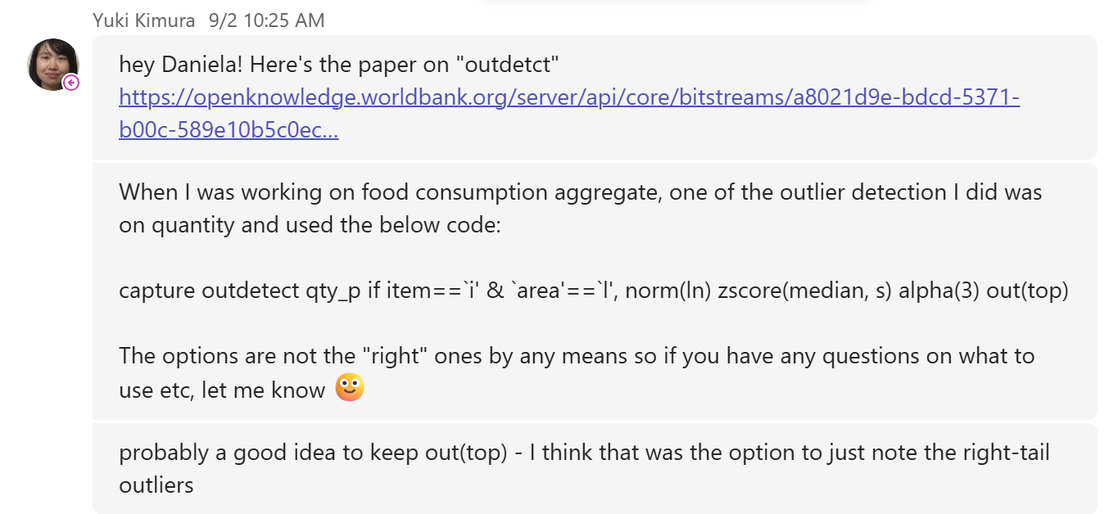

Country | Year | Survey | Welfare type | Valid records | Records flagged | Threshold (PPP/day) | Welfare share flagged (%) | Gini original | Gini capped | Gini change (%)
MWI | 1997 | IHS-I | consumption | 10,693 | 327 | 12.02 | 49.30 | 0.658 | 0.397 | -39.58
NAM | 2003 | NHIES | consumption | 9,679 | 462 | 41.89 | 31.20 | 0.633 | 0.576 | -9.06
BLZ | 1994 | LFS | income | 660 | 32 | 52.45 | 31.04 | 0.606 | 0.490 | -19.17
COM | 2004 | EIM | consumption | 2,987 | 77 | 47.25 | 27.51 | 0.559 | 0.490 | -12.47
BLZ | 1993 | LFS | income | 704 | 25 | 70.77 | 26.06 | 0.601 | 0.495 | -17.71
NAM | 2009 | NHIES | consumption | 9,649 | 353 | 52.00 | 25.90 | 0.610 | 0.561 | -8.00
BFA | 1998 | EP-II | consumption | 8,324 | 586 | 8.12 | 23.92 | 0.499 | 0.429 | -14.17
BLZ | 1997 | LFS | income | 753 | 19 | 62.29 | 23.00 | 0.602 | 0.506 | -15.94
RWA | 2005 | EICV-II | consumption | 6,900 | 244 | 14.05 | 21.60 | 0.520 | 0.462 | -11.23
MOZ | 2014 | IOF | consumption | 32,454 | 1,378 | 16.29 | 21.46 | 0.540 | 0.475 | -12.02
ZAF | 2005 | IES | consumption | 19,224 | 479 | 66.12 | 21.36 | 0.648 | 0.618 | -4.50
GNB | 2010 | ILAP-II | consumption | 3,129 | 49 | 14.39 | 20.69 | 0.507 | 0.471 | -6.97
BLZ | 1996 | SLC | income | 602 | 32 | 53.23 | 20.34 | 0.564 | 0.501 | -11.08
SYC | 2013 | HBS | income | 1,759 | 40 | 93.69 | 20.14 | 0.468 | 0.378 | -19.19
SWZ | 2000 | HIES | consumption | 3,666 | 180 | 18.89 | 19.91 | 0.531 | 0.493 | -7.22
RWA | 2000 | EICV-I | consumption | 6,419 | 229 | 10.27 | 19.71 | 0.485 | 0.435 | -10.45
ETH | 1995 | HICES | consumption | 11,524 | 398 | 9.26 | 19.43 | 0.446 | 0.367 | -17.62
RWA | 2010 | EICV-III | consumption | 14,301 | 418 | 13.20 | 19.01 | 0.472 | 0.419 | -11.18
MWI | 2016 | IHS-IV | consumption | 12,445 | 308 | 9.98 | 18.59 | 0.447 | 0.366 | -18.17
MOZ | 2002 | IAF | consumption | 8,697 | 380 | 8.24 | 17.96 | 0.470 | 0.415 | -11.80
CAF | 2008 | ECASEB | consumption | 6,894 | 86 | 24.33 | 17.87 | 0.562 | 0.515 | -8.43
CHL | 1992 | CASEN | income | 29,349 | 473 | 84.21 | 17.71 | 0.547 | 0.510 | -6.79
ECU | 1999 | ECV | income | 4,980 | 72 | 74.25 | 17.40 | 0.585 | 0.537 | -8.19
COL | 2000 | ENH | income | 6,982 | 212 | 72.90 | 17.09 | 0.553 | 0.514 | -7.21

- Evaluate Seychelles (extreme change in welfare mean)
- Analyze household characteristics (see variables like what roof is made of, water access, education and anything that might be related to being rich). Run a regression and see predicted income household income on all variables that make sense and predict income/consumption for Malawi 1997.
- (Nishant) We could try to do this like we fit Pareto. For instance, remove the top x values. Fit the GB2 and see how far these fitted values are from the actual data. This could be another exercise to what Yuki suggested yesterday: find the fitted values of the top using household and demographic characteristics and see the difference from actual values. In short, I think we have at least three approaches to understand how extreme the outliers are: (a) Pareto, (b) GB2, and (c) regression.

Updates: September 11, 2026
Idea for Wednesday’s presentation:
Project narrative: how to present it
- We started with a literature review to understand how different frameworks treat upper-tail values - LIS, CPS, EU-SILC, and WID.
Each has a different objective: LIS uses a transparent log-IQR rule; CPS is driven by disclosure avoidance, not statistical validity; EU-SILC (Van Kerm) compares trimming/winsorizing/Pareto approaches; WID goes the opposite direction, correcting for underrepresentation of the rich by blending survey and tax data.
- We applied the LIS rule to all 1,825 surveys and found 24 cases where a small share of the population accounts for a disproportionately large share of total welfare.
Threshold: $c=exp⁡[Q_{0.75}(ln⁡y)+3×IQR(ln⁡y)]$. In all 24 flagged surveys, less than 0.5% of the population sits above the ceiling, yet in several cases (led by Malawi 1997) that group holds over 40% of total measured welfare. Criteria: surveys where the population above the ceiling holds ≥5% of total welfare.
- To make sure this wasn't just an artifact of the LIS rule, we applied a second, independent method — Stata's outdetect procedure, reimplemented in Python. Outdetect uses an unweighted median + S-estimator (a robust scale estimator), which is methodologically distinct from LIS's log-IQR approach. We applied the same 5% welfare-share criterion to the observations flagged by the Python implementation of Stata’s outdetect procedure. Using its recommended robust z-score threshold of 3, outdetect identified 398 surveys where flagged observations accounted for at least 5% of total welfare. All 24 surveys identified by LIS were included in this group, together with 374 additional surveys. As an alternative criterion, we used a 1% population-share threshold. This is an empirical reference point based on the outdetect documentation, not an official survey-level cutoff. Under this criterion, 143 surveys were flagged, including 5 of the 24 LIS surveys: Comoros 2004, Malawi 1997, Rwanda 2000, Rwanda 2005, and Rwanda 2013.
- We used Malawi 1997 as a deep-dive case study to show how the headline indicators respond to different treatments of extreme welfare values, using the country file MWI_1997.dta throughout. Under the LIS correction, 59 records, representing 0.43% of the weighted population, account for 41.6% of total welfare. Capping these observations reduces the mean by 38%, the Gini by 32%, the MLD by 59%, and Atkinson(2) by 33%, while removing all observations above the LIS cap produces reductions of 41%, 36%, 64%, and 38%, respectively. The outdetect correction, which caps 206 records and uses a cap of 20.22 PPP USD per person per day, produces larger reductions: capping the affected observations reduces the mean by 42%, the Gini by 37%, the MLD by 65%, and Atkinson(2) by 39%; removing them reduces the indicators by approximately 46%, 42%, 71%, and 45%. As a simpler sensitivity check, removing only the two most extreme observations reduces the mean by 34%, the Gini by 27%, the MLD by 52%, and Atkinson(2) by 28%. This shows that extreme observations substantially affect inequality and mean estimates, while poverty estimates remain comparatively stable.
- We then fitted Pareto distributions to the upper tails of the most extreme cases. The analysis showed substantial deviations between the largest observed values and the fitted Pareto pattern, providing additional evidence that these observations were not simply large values from an otherwise regular tail.
- Two additional analyses focused on Malawi 1997 were done. First, we assess whether the extreme welfare observations are statistically plausible under a GB2 distribution. Second, we examine whether they can be explained by observable household characteristics using regression analysis, or whether substantial unexplained deviations remain after accounting for those characteristics.
  - GB2: fit a Generalized Beta of the Second Kind excluding the top-x values, then check how far the actual observed values fall from the fitted distribution.
A GB2 distribution was fitted to the positive welfare values from the Malawi 1997 country dataset using weighted maximum likelihood and 2021 PPP-adjusted welfare measures. The analysis included the full sample and additional specifications that excluded the largest 1, 2, 5, 10, and 20 observations. All models converged, but the estimated shape parameters changed as extreme observations were removed, indicating that the upper tail has a significant influence on the fitted distribution. In the full-sample model, the second-largest observation had an empirical survival probability approximately 166 times larger than the probability predicted by the GB2 distribution. These results suggest that the highest welfare observations are unusually extreme relative to a smooth GB2 tail. However, the analysis is diagnostic and does not establish that these observations are erroneous; they may reflect genuine heterogeneity, measurement issues, or other features of the survey data.
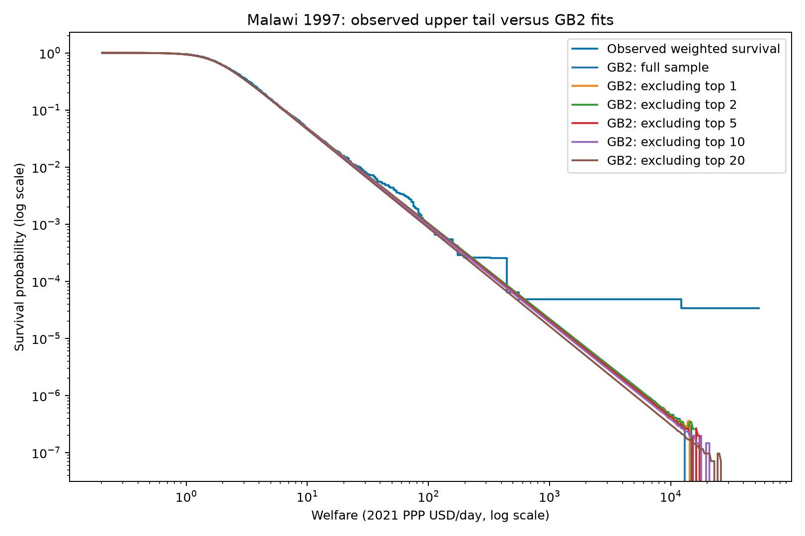

  - Regression: predict welfare/consumption from household characteristics (roof material, water access, education, etc.) and compare fitted vs. actual values to flag households whose reported welfare looks inconsistent with their observed characteristics.
**I have to figure out where to get household characteristics (in the meanwhile I just used what I found in gmd)
A weighted regression model was used to predict household welfare in Malawi 1997 based on the available characteristics in the survey: urban or rural location, household size, and subnational area. To obtain unbiased comparisons, five-fold cross-fitting was applied, meaning each household was predicted using a model estimated without that household. Households were flagged when the difference between observed and predicted log welfare exceeded three weighted standard deviations. The model explained approximately 39% of the variation in log welfare and flagged 118 households, representing about 1.1% of the sample weight. Most flagged households reported welfare substantially higher than predicted, although these flags indicate unusual observations for further review rather than confirmed errors.
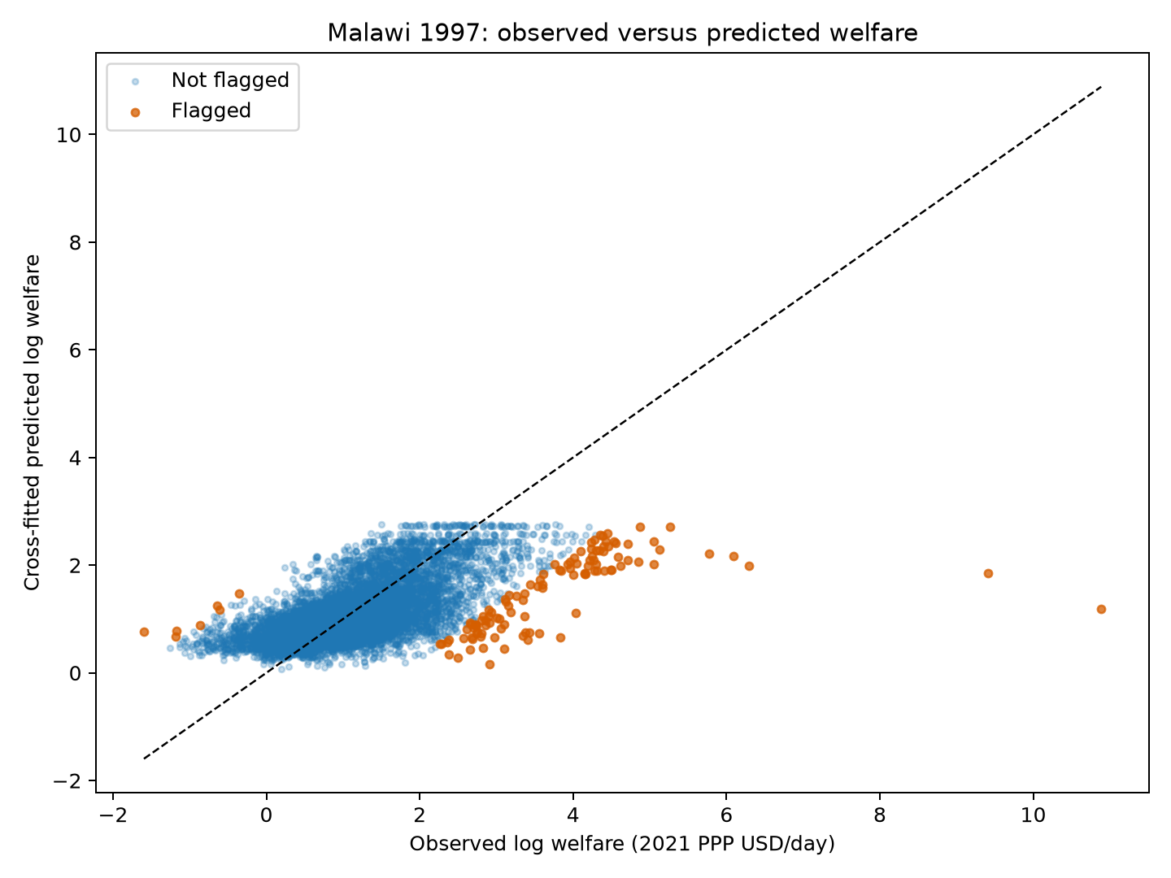
The Malawi 1997 file does not contain roof material, water access, or education variables. Therefore, the regression used the available predictors: urban/rural status, household size, and subnational area.

