**Title Page**

Title

Authors: Danielle C. Claar1,2,*, Julia K. Baum2

1 University of Washington, School of Aquatic and Fisheries Sciences, Seattle, WA, USA

2 University of Victoria, Department of Biology, Victoria, BC, Canada

* Corresponding author: [danielle.claar@gmail.com](mailto:danielle.claar@gmail.com)

Keywords: 4 to 6 key words are required for indexing purposes.

**Abstract**

Abstract goes here

**Introduction**

Motivate satellite vs. in situ comparisons

Mini lit review of previous satellite in situ comparisons – when are they typically the same (= very similar) and when are they quite different?

Satellite skin vs sampling at depth – might miss upwelling, problems if water column is not well mixed

Satellite nighttime-only analyses

Why it’s good for satellite

Considerations when asking similar questions with in situ data

**Materials and Methods**

**Study location**

**In situ temperature measurements**

Field deployment

Site choice, multiple sites per region (explanation), all regions represent different 5-km satellite pixels

All sites were located at approximately 10m depth (range 8m to 12m; Supplementary Table X).

In situ data processing

Data QC

Standardize and interpolate to daily (first to by-minute, then hourly)

All times processing

Nighttime only processing

**Satellite temperature measurements**

Satellite SST data were obtained from the NOAA Coral Reef Watch experimental daily global 5km satellite product, CoralTemp Version 1.0 [CITE]. Satellite SST values were extracted from CoralTemp for each geographic region on Kiritimati for the period spanning January 2011 to December 2018. Since CoralTemp contains curated daily data, no additional processing was necessary for comparison with in situ data.

**Statistical comparison – in situ vs. satellite & temperature consistency around island**

*Mean and variance offsets*

*Correlation*

*Power spectral density*

Cite figures as Fig. and Table as Table

**Results and Discussion**

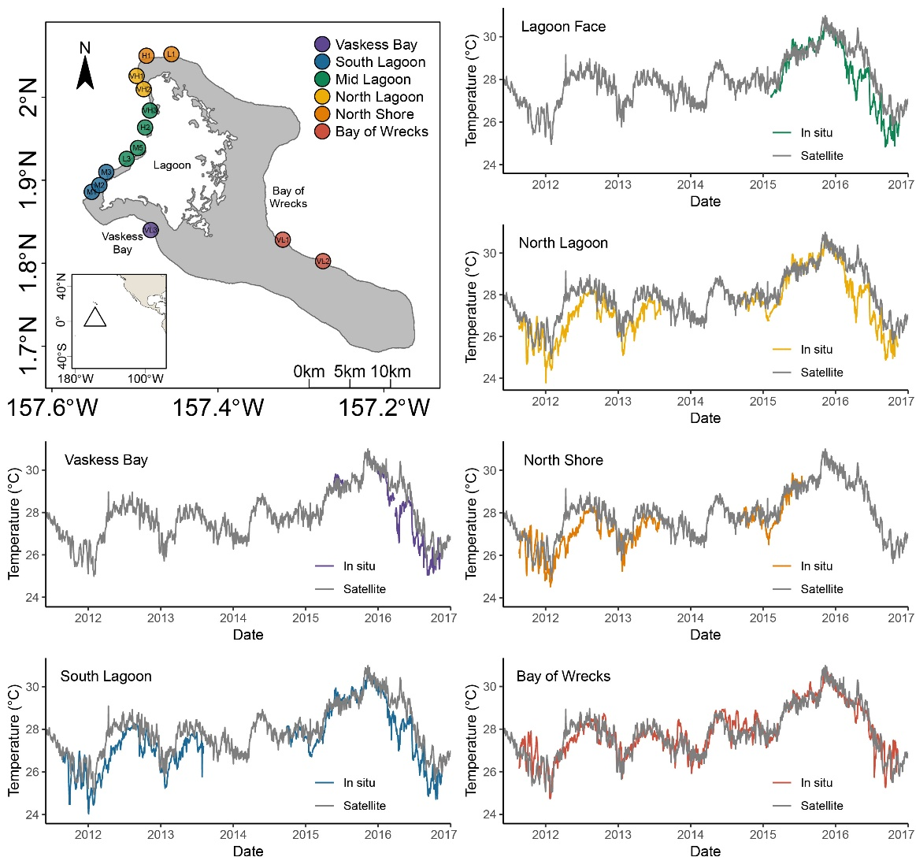

Figure 1. Satellite (NOAA CRW CoralTemp 5-km product) vs. in situ (Sea-Bird 56 temperature loggers). Satellite data are continuous throughout the time-series, in situ data are plotted when data are available for that region.

General comparison of satellite and in situ data (Figure 1). Note the event in early 2016 along the western side of the island – likely an upwelling event that was not captured by the satellite.

Table 1. Mean and variance offsets between the satellite product and in situ measurements for each sampled region of Kiritimati. Mean offset is mean of (satellite-in situ), Variance offset is variance of (satellite-in situ)

|  |  |  |
| --- | --- | --- |
| **Region** | **Mean** | **Variance** |
| *Vaskess Bay* | 0.53 | 0.44 |
| *South Lagoon* | 0.54 | 0.32 |
| *Lagoon Face* | 0.53 | 0.40 |
| *North Lagoon* | 0.59 | 0.35 |
| *North Shore* | 0.40 | 0.29 |
| *Bay of Wrecks* | -0.03 | 0.27 |

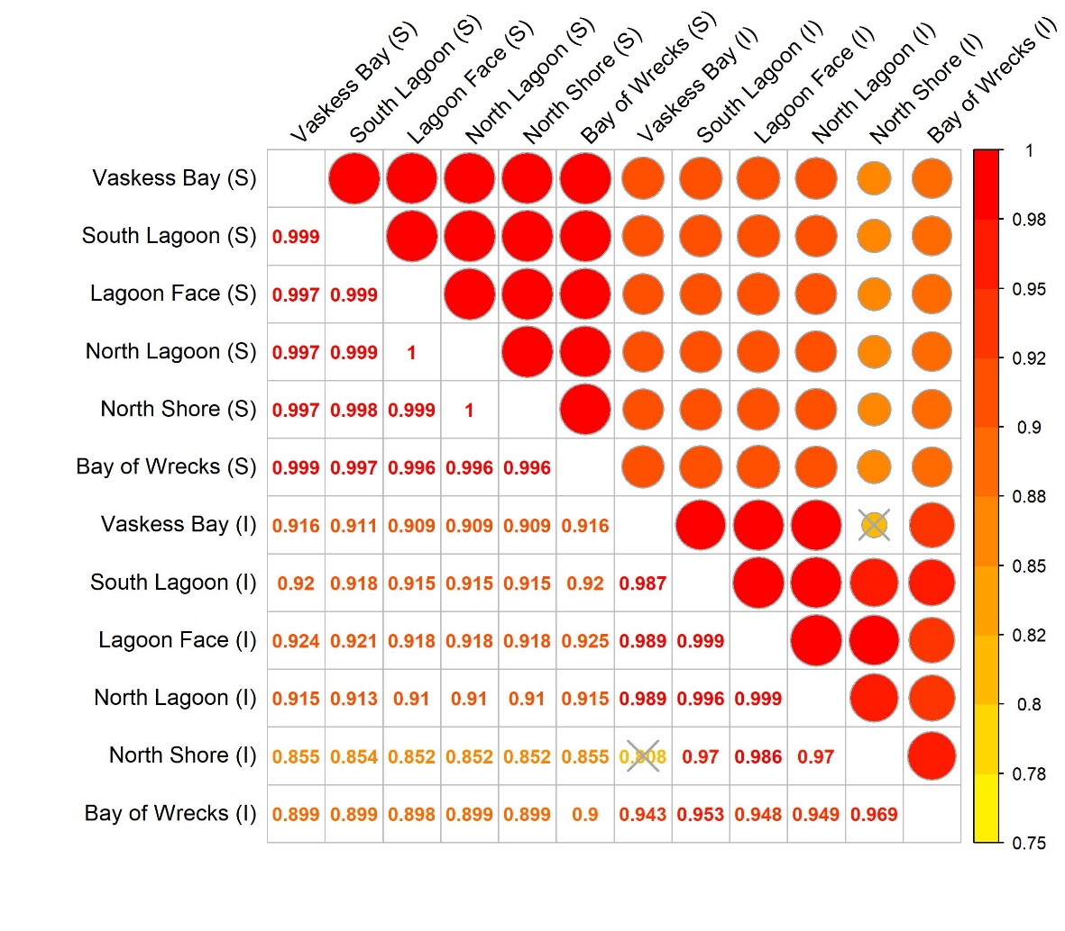

Figure 2. Correlations between satellite SST product (S) and in situ measurements (I) for all available regions on Kiritimati from 2011 to 2018. The top right quadrant of the figure shows correlations between data sources, scaled by size and color. The bottom left quadrant shows correlation values between each pair. Due to limited overlap between North Shore (I) and Vaskess Bay (I) (n = 62 days), this comparison is excluded from this analysis.

Correlations between nearby satellite pixels are high, caution for using satellite SST to resolve fine-scale thermal variability (at least in this location). Although in situ were remarkably correlated with one another as well, so perhaps different in more variable regions.

Figure 3. Power spectral density plots for both the satellite product and in situ measurements for each sampled region of Kiritimati.

Frequencies in a stable region (limited seasonal change). Similarities and differences between satellite and in situ temperatures.

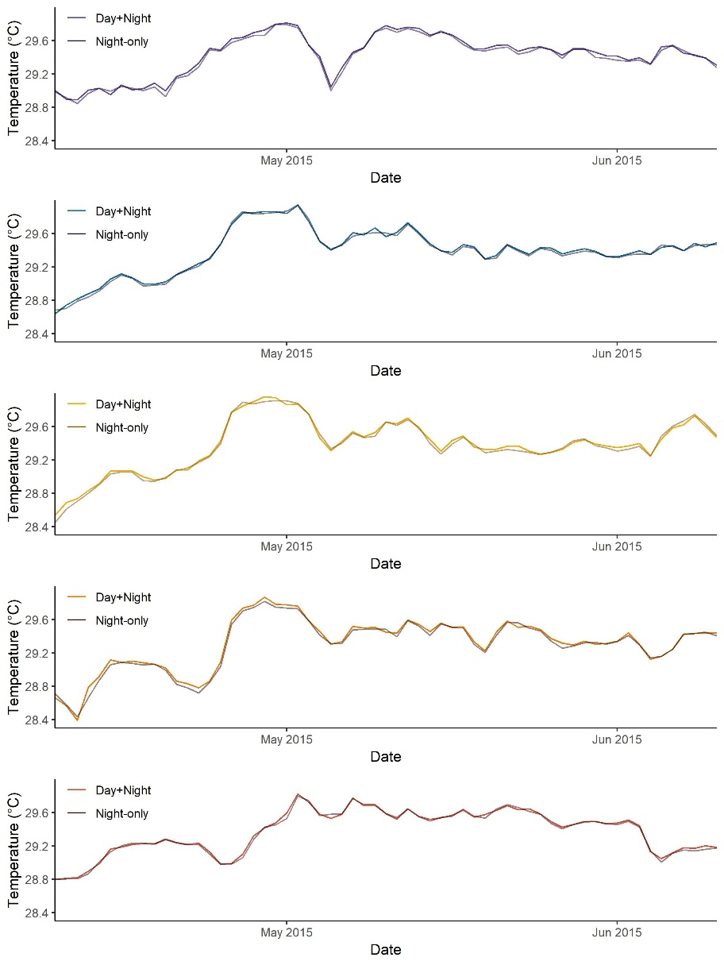

Figure 4. Comparison of nighttime-only and all times in situ measurements

Daytime temperatures at depth are ecologically relevant to corals.

Daily differences between nighttime-only and all time are extremely limited, nearly nonexistent. Where might this also hold true? Where might this be different?

**Acknowledgements**

Thanks to the Kiritimati Field Team for assistance in deploying and retrieving in situ loggers and to the NOAA Coral Reef Watch team for developing and maintaining the NOAA CoralTemp and Degree Heating Week products used in these analyses. DCC acknowledges scholarship support from an NSERC Vanier Canada Graduate Scholarship, as well as funding from the American Academy of Underwater Sciences, a National Geographic Young Explorers Grant, the University of Victoria (UVic), the Women Divers Hall of Fame, and Divers Alert network. This comparison was made possible by a Sea-Bird Electronics graduate student equipment grant to DCC. DCC and JKB acknowledge funding from UVic’s Centre for Asia-Pacific Initiatives. JKB acknowledges support from the Packard Foundation, the Rufford Maurice Laing Foundation, an NSERC Discovery Grant, the Canadian Foundation for Innovation, and UVic.

**Reference List**

Reference list goes here

Reference

Reference

**Figure Legends**

Do not embed figures, only add legends here

**Tables (move to separate document)**

Single space the body of tables

Date Format: Use English date formats, i.e., 3rd March 2005; 1–3 March2003; between 1 and 3 March 1980; 1 March to 1 April (not 1 March–1 April); March 1980 to August 1981; March – April 1991.

Supplementary Table X. In situ logger depth for each site on Kiritimati.

|  |  |  |
| --- | --- | --- |
| Site ID | Site Name | Depth (m) |
| 3 | L1 | 9 |
| 5 | VL3 | 9 |
| 8 | M1 | 8 |
| 9 | L3 | 9 |
| 15 | VL1 | 11 |
| 19 | VL2 | 9 |
| 25 | H1 | 10 |
| 27 | VH2 | 10 |
| 30 | VH1 | 12 |
| 32 | VH3 | 10 |
| 33 | M5 | NA |
| 34 | M3 | 9 |
| 35 | M2 | 8 |
| 40 | H2 | 11 |

Supplementary Figure X. corr_plot_2011to2013_noVaskessInoLagoonFaceI

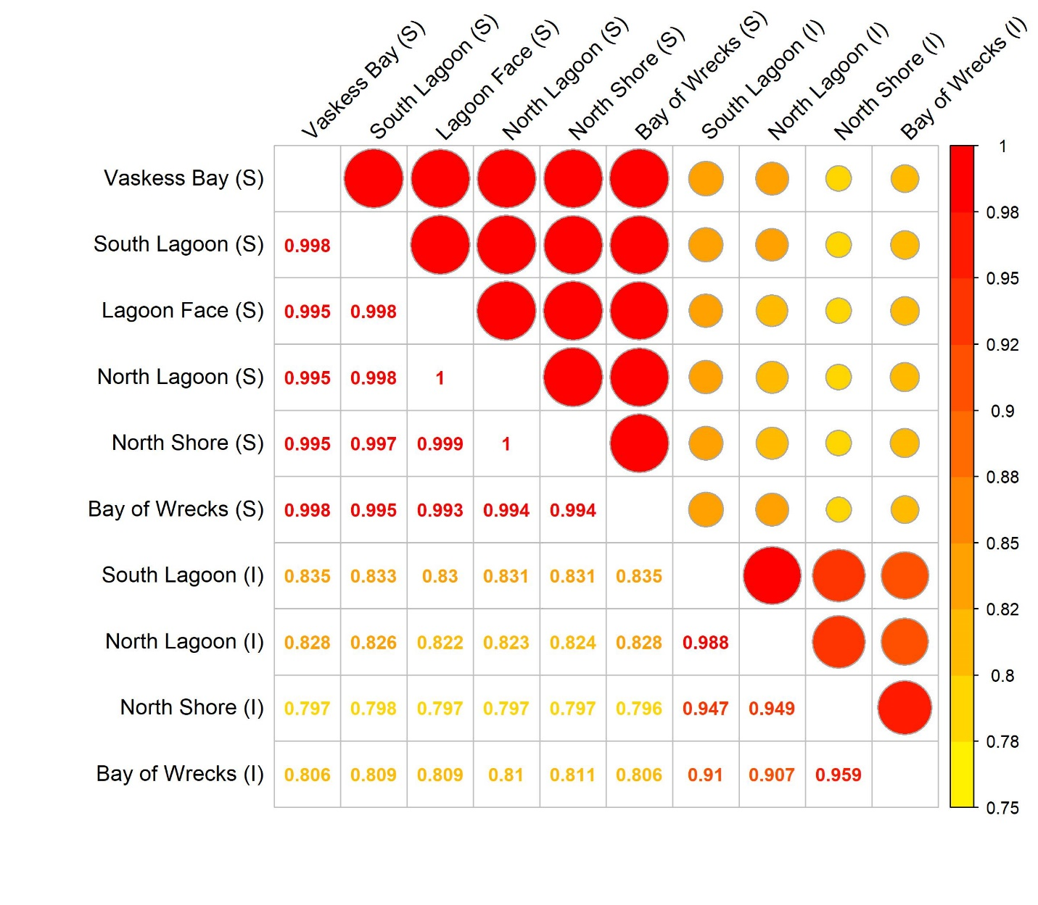

Supplementary Figure X. corr_plot_2015to2016_noNorthShoreI

