Programación
1º DAM

Final Project

I.E.S. San Vicente
San Vicente del Raspeig (Alicante)
Curso 2018/2019

Student:
Daniel Contreras

Teacher:
Nacho Cabanes

1. Introduction

Project name:
BookButler(BB) – Your book right away!

By:
Daniel Contreras

Brief description:
BookButler(BB) is a computer program to store/manage your entire library, all in one single app. User will be able to insert, modify, see and delete the book´s author, title, publisher, publication year, genre, description and ratings. In addition to this, a picture showing the book´s front-cover will be available.

2. Project functionality

As soon as app starts, a welcome screen will pop up to allow user to choose between different options:

- add a book
- see a book
- delete a book
- see all books
- edit a book

In addition to this, each book´s information will be filled up by user by filling out the fields placed at the app such as:

- title
- author
- description
- gender
- year
- ratings

The app will show a friendly and easy-to-use interface for use to interact with; all sorts of users are meant to be able to use the app, from high-level technical user down to non technical whose IT knowledge is quite limited.

The purpose of the app is to have a well organized database where to store all his books and show them by any type of order (alphabetical, ratings, year). This app will prevent user to buy the same book twice as long as he keeps it up to date and checks the app before buying a new book to check if it is already stored. No more that annoying feeling when, after bringing a new book home, you realize that the same title is sitting in your bookshelf!.

3. App screenshot

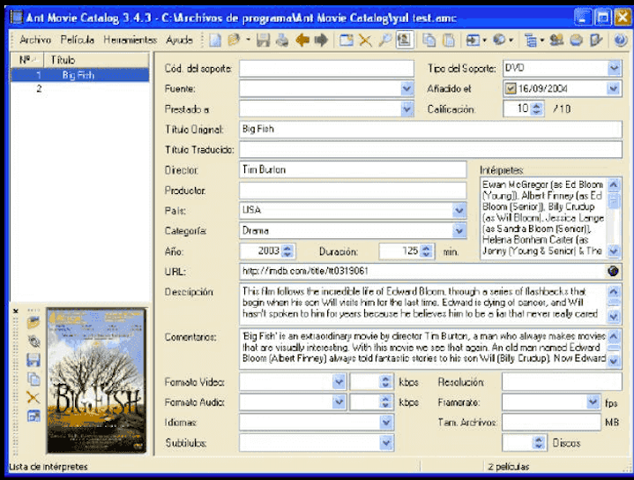

4.Forecast deliveries(updated)

(Nota: miminum of 15 deliveries, 2 hours long each)

- Project general and thorough sketch showing all different features. Class book implemented
along with its getters and setters.ToString method added. Main class with Menu options, Book list added.
- Different methods created withing the Main class(adding, searching) along with a bunch of different filters detailed below in Real Deliveries section.
- Class diagram made. CompareTo method by title and/or author. Editing a book method fully
implemented with security checks. Try – catch set.
- New class created inheriting from Book class along with father properties and methods.
Delete a book method done, with appropiate user info given. Several more features added to keep user informed detailed below in Real deliveries.
- File writing implemented today. Working successfully. Github account set and repo uploaded to github
- Foreach method implemented in book addition(writing in file also).Adding a dictionary list help section for user. User enters info about something that he is insecure about and a sort of brief explanation is given(similar of console man/help commands
- Carrying on with Dictionary list offered as user guide. All help options set. FileWriter and Reader triggered for help/guide section only(plus the one already created at the begginning of program). Try-Catch options also set for the whole program.
- Function created for options 2, 4 and 6, search a book, edit a book and user guide respectively.Functions are outside main program.
- Option 1 function code set and placed outside main scope. Later on all the rest of functions
implemented: options 3(see all books),5(delete a book), exit and default.Writing in a file fully implemented in both addition and user guide functions(2 indepent files). Array added.
- Format book(paper/electronic) saved in file along with all other features.
- Struct “BookLocation”(with 3 attributes) added along with its info written and read from a file(“location.txt”). Try-catchs implemented.
- Reading all books stored from file instead of from console session as it used to be.
- Adding colors to background and foreground so that it looks not so boring. Red (Alert) for
when wrong option is chosen and green for goodbye.
14. Polishing little details to be corrected such as indentation, spelling mistakes, etc. Searching d
for a keyword in a file line provided by user.

- Real deliveries:

    - 17/04/2019
Class Book: Getters and setters. Method ToString.
Main: Book List. Menu List. Insert method implemented.

2. 06/05/2019
Search a book either by title or by author method implemented.
If found, all its data will be printed, if not, user will be notified so he will not be left clueless.

When adding a book, title, author, description, genre checking that field is not left empy; if so, user will have to fill it to carry on.
Year field ranged between 1 and current year(using DateTime class current year will be updated each Janaury 1^{st )}.
Ratings must be between 0 and 5.

- 13/05/2019
Class diagram made in png format using Visual Studio tool.
Implementing CompareTo method by title and author respectively; whenever there is a duplicated book, they will be sorted by author.
Point 4, editing a book, fully implemented., with filters for book number wrong position, and options for whether user enters a new data or leaves it blank.
Try – catch covering most of the code; only initial menu options left outside. Simple catch yet, only 1 general exception set, to be improved.

- 15/05/2019
New class created: HistoryBooks to inherit from Book class. This new class brings a new
attribute (bool) and for the rest of attributes they are passed on by the “father” class and integrated using :base keyword. Also ternary operator implemented in override method.
Delete a book method implemented, informing user if DB is empty, and if not, informing him if the deletion was successful.
Option 2, search a book, an extra filter added: if DB is empty, user is told.
Option 1: showing number of books stored and printing them out alphabetically ordered and as stated in ToString method in Book class.

- 16/05/2019
Writing to a file implemented. File “libros.txt” created and data successfully written in file. Github set and repository created and uploaded to github(See below url).Try-catch moved to cover a bigger code portion.

6. 17/05/2019
Foreach method implemented in book addition(writing in file also).Adding a dictionary list
as help section for user. User enters info about something that he is insecure about and a sort of brief explanation is given.

- 20/05/2019
Carrying on with Dictionary list offered as user guide. All help options set. FileWriter and Reader triggered for help/guide section only(plus the one already created at the begginning of program). Try-Catch options also set for the whole program.

8. 22/05/2019
Option 6(user guide), taken out of main program and put into a function that is being called
from within main.
Option 2(search a book) and 4(edit a book) also taken off the main and dropped into a function.
This makes code clearer and easier to debug.

9 23/05/2019
Option 1(add a book) put into a function outside of main; it allows to add books and save
them into a file(among other features).
All the rest of functions added: delete a book, see all books, default and exit options.
Writing in 2 files independtly: 1 general for the books addition(BooksDB.txt) and 2 a second
writing only for function 6(help/user guide) where all info is stored in a file called guide.txt using a Dictionary List. Array added to print out menu options. Filter in case writing file does not exist for option 6.

- 24/05/2019
Either paper or electronic book format is saved in DB file using ternary operator.
Do...while set to make sure that user only inputs either “y” or “no” when asked whether book is electronic or not. Asking user to choose between history or non history book and
showing in console and saving in file accordingly.

11. 27/05/2019
BookLocation struct created. Added as a function in option number 7. User is asked to enter
info and this will be stored accordingnly into a file.Also advanced string methods added here. Reading this same file also implemented to show up in console straight away.
Try-catchs and file existing check before doing anything.

- 29/05/2019
BookLocation function with parameter passed as ref. Reading from file those books stored
instead of reading from console session as it was. Try-cathcs and File exists set. Date time
format added each time a book is stored in file.Searching books from file.

- 30/05/2019
Dark green background color and white foreground color added for option E, exit the program, to make it funnier and more eye-catching for user. Red as an alert for when user
picks the wrong option so that he sees the alert. Searching books set to search only with title
as search criteria and from file only, not from console session.

- 31/05/2019
Last day to correct details, little defects in format, indentation, spelling mistakes, etc...In
addition searching a book using a keyword in the entire line of the DB file has been finished.

CHECKLIST(red means that has been used)
github repo: https://github.com/danicurri/BookButler

if
- else
- Conectores: && y/o || y/o !
- switch
- ?
- while
- for
- foreach
- try-catch
- (arrays)
- struct
- (clases + herencia)
- (propiedades o getters y setters)
- public, protected, (opcional) private
- ArrayList o List<>
- Hashtable o SortedList o Dictionary
- StreamReader o FileStream o BinaryReader
- ref o out
- (manejo avanzado de cadenas: substring, contains, split, replace o similares)
- (consola avanzada o SDL o Windows Forms o Unity)

SCREEN-SHOTS

Book:
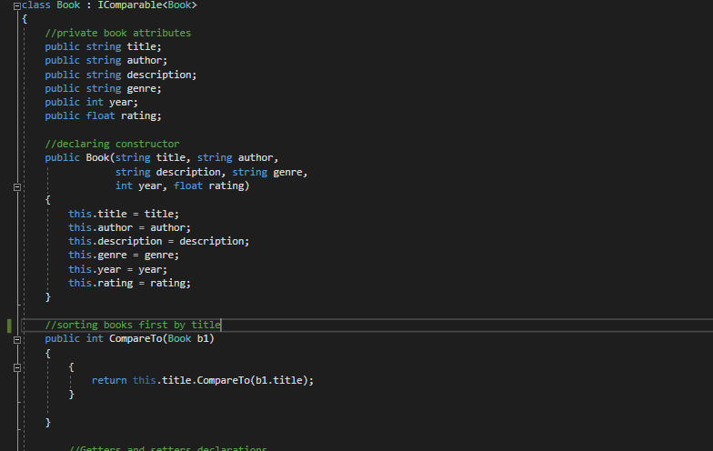
BookButler Main Screen:
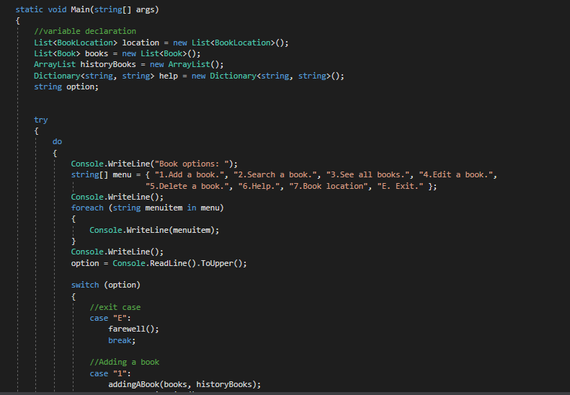

HistoryBook:

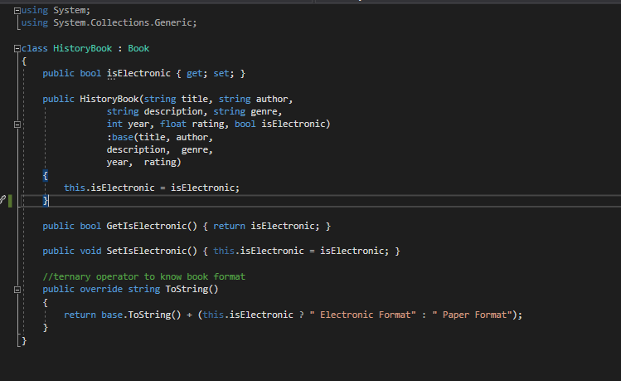

CODIGO FUENTE:

using System;

class Book : IComparable<Book>
{
//private book attributes
public string title;
public string author;
public string description;
public string genre;
public int year;
public float rating;

//declaring constructor
public Book(string title, string author,
string description, string genre,
int year, float rating)
{
this.title = title;
this.author = author;
this.description = description;
this.genre = genre;
this.year = year;
this.rating = rating;
}

//sorting books first by title
public int CompareTo(Book b1)
{
{
return this.title.CompareTo(b1.title);
}

}

//Getters and setters declarations
public string GetTitle() { return title; }

public void SetTitle(string title) { this.title = title; }

public string GetAuthor() { return author; }

public void SetAuthor(string author) { this.author = author; }

public string GetDescription() { return description; }

public void SetDescription(string description) { this.description = description; }

public string GetGenre() { return genre; }

public void SetGenre(string genre) { this.genre = genre; }

public int GetYear() { return year; }

public void SetYear(int year) { this.year = year; }

public float GetRating() { return rating; }

public void SetRating(float rating) { this.rating = rating; }

//will print out our books in the specified order
public override string ToString()
{
return "Title: " + title + " - Author: " + author + " - Description: " + description +
" - Genre: " + genre + " - Year: " + year + " - Rating: " + rating;
}
}

�using System;
using System.Collections;
using System.Collections.Generic;
using System.IO;
using System.Linq;

class BookButler
{
struct BookLocation
{
public string codeLocation;
public string houseLocation;
public string shelfLocation;

}

static void Main(string[] args)
{
//variable declaration
List<BookLocation> location = new List<BookLocation>();
List<Book> books = new List<Book>();
ArrayList historyBooks = new ArrayList();
Dictionary<string, string> help = new Dictionary<string, string>();
string option;

try
{
do
{
Console.WriteLine("Book options: ");
string[] menu = { "1.Add a book.", "2.Search a book.", "3.See all books.", "4.Edit a book.",
"5.Delete a book.", "6.Help.", "7.Book location", "E. Exit." };
Console.WriteLine();
foreach (string menuitem in menu)
{
Console.WriteLine(menuitem);
}
Console.WriteLine();
option = Console.ReadLine().ToUpper();

switch (option)
{
//exit case
case "E":
farewell();
break;

//Adding a book
case "1":
addingABook(books, historyBooks);
Console.WriteLine();
break;

//search a book either by title or author
case "2":
searchABook(books);
Console.WriteLine();
break;

//see all books
case "3":
seeAllBooks(books);
Console.WriteLine();
break;

//edit a book
case "4":
editABook(books);
Console.WriteLine();
break;

//delete a book
case "5":
deleteABook(books);
Console.WriteLine();
break;

//help section
case "6":
offeringHelp(help);
Console.WriteLine();
break;

//help section
case "7":
locatingABook(ref location);
Console.WriteLine();
break;

//wrong selection falls here
default:
wrongOption();
Console.WriteLine();
break;
}

} while (option != "E");
}

//exceptions block

catch (IOException exc)
{
Console.WriteLine("I/O error: " + exc.Message );
Console.WriteLine();
}
catch (Exception ex)
{
Console.WriteLine("Error message: " + ex.Message);
Console.WriteLine();
}
}

//add a book (option 1)
public static void addingABook(List<Book> books, ArrayList historyBooks)
{
string title, author, description, genre, format="";
int year;
float rating;
bool isElectronic = false;

//file variables
StreamWriter output;
string fileName = "BooksDB.txt";

//opening and appending to a file
output = File.AppendText(fileName);

//declaring current time
int currentYear;
currentYear = DateTime.Now.Year;

//declaring year 1 of our era
int year1 = new DateTime(0001, 01, 01).Year;

do
{
Console.WriteLine("Title: ");
title = Console.ReadLine();
if (title == "")
{
Console.WriteLine("Do not leave title field empty");
}
} while (title == "");
do
{
Console.WriteLine("Author: ");
author = Console.ReadLine();
if (author == "")
{
Console.WriteLine("Do not leave author field empty");
}
} while (author == "");
do
{
Console.WriteLine("Description: ");
description = Console.ReadLine();
if (description == "")
{
Console.WriteLine("Do not leave description field empty");
}

} while (description == "");
do
{
Console.WriteLine("Genre: ");
genre = Console.ReadLine();
if (genre == "")
{
Console.WriteLine("Do not leave genre field empty");
}

} while (genre == "");
do
{
Console.WriteLine("Year: ");
year = Convert.ToInt32(Console.ReadLine());
if (year1 > year || year > currentYear)
{
Console.WriteLine("Publishing year must be between 1 and today");
}
} while (year1 > year || year > currentYear);

do
{
Console.WriteLine("Rating: ");
rating = Convert.ToSingle(Console.ReadLine());
if (0.0 > rating || rating > 5.0)
{
Console.WriteLine("Ratings must be between 0 and 5 ");
}
} while (0.0 > rating || rating > 5.0);

string isElec;

do
{

Console.WriteLine("Is it electronic:?(y/n) ");
isElec = Console.ReadLine().ToLower();

if (isElec == "y")
{
isElectronic = true;
format = "Electronic format book";
Console.WriteLine(format);
}
else if (isElec == "n")
{
isElectronic = false;
format = "Paper format book";
Console.WriteLine(format);
}
else
{
Console.WriteLine("Please make sure to enter either 'y' or 'n' ");
}

} while (isElec != "y" && isElec != "n");

Console.WriteLine("Is it a history or non history book(h/n)? ");
char hisBook = Convert.ToChar(Console.ReadLine());
if (hisBook == 'h')
{
Console.WriteLine("A history book it is.");
historyBooks.Add(new HistoryBook(title, author, description, genre, year, rating, isElectronic));
Console.WriteLine("History book added successfully.");
Console.WriteLine("Number of history books stored: {0}", historyBooks.Count);
}
else if (hisBook == 'n')
{
Console.WriteLine("A non-history book it is");
books.Add(new Book(title, author, description, genre, year, rating));
Console.WriteLine("Book added successfuly");
Console.WriteLine("Number of non-history books stored(by title-alphabetical order): {0}", books.Count);

}
else
{
Console.WriteLine("Please make sure to enter either \"h\" or \"n\"");
Console.WriteLine("Is it a history or non history book(h/n)? ");
hisBook = Convert.ToChar(Console.ReadLine());
}
Console.WriteLine();

books.Sort();

foreach (Book book in books)
{
Console.WriteLine("Book: " + book);
output.WriteLine(DateTime.Now + " Non history book:" + book + " - " + format);
}

foreach (HistoryBook hb in historyBooks)
{
Console.WriteLine("History book: " + hb);
output.WriteLine(DateTime.Now + " History book: " + hb);
}
//closing writing file
output.Close();
}

//search a book function(option 2 in main)
public static void searchABook(List<Book> books)
{
string fileName = "BooksDB.txt";
StreamReader reader = new StreamReader(fileName);
string line;
int countLines = 0;

if (!File.Exists(fileName))
{
Console.WriteLine("Database does not exists!");
}
else
{
try
{
Console.WriteLine("What is the keyword to search: ");
string search = Console.ReadLine().ToUpper();

bool found = false;

do
{
line = reader.ReadLine();

if (line != null)
{
found = line.ToUpper().Contains(search);
countLines++;
}

} while (line != null && !line.ToUpper().Contains(search));

if (found)
{
Console.WriteLine("Match found: " + line);
Console.WriteLine("Number of books found: " + countLines);
}

if (!found)
{
Console.WriteLine("No matches found");
}

reader.Close();
}
catch (IOException ex)
{
Console.WriteLine("Error in file: " + ex);
}
catch (Exception e)
{
Console.WriteLine("General error: " + e);
}
}
}

//see all books(option 3)

public static void seeAllBooks(List<Book> books)
{
string fileName = "BooksDB.txt";
StreamReader reader = new StreamReader(fileName);
string line;
int countLines = 0;

Console.WriteLine();

if (!File.Exists(fileName))
{
Console.WriteLine("Database does not exists!");
}
else
{
try
{
do
{
line = reader.ReadLine();

if (line != null)
{
countLines++;
Console.WriteLine(line);
}
} while (line != null);

Console.WriteLine("Number of books stored: " + countLines);

reader.Close();
}
catch (IOException ex)
{
Console.WriteLine("Error in file: " + ex);
}
catch (Exception e)
{

Console.WriteLine("General error: " + e);
}

}

Console.WriteLine();
}

//edit a book function(option 4 in main)
public static void editABook(List<Book> books)
{
Console.WriteLine("What book number would you like to edit(available for console session only): ");

int bookPosition = Convert.ToInt32(Console.ReadLine()) - 1;
if (bookPosition < 0 || bookPosition > books.Count - 1)
{
Console.WriteLine("Wrong position, try again");
}

Book bookEdited = books[bookPosition];

Console.WriteLine("New title (it was {0}): ", bookEdited.title);
string newBook = Console.ReadLine();

if (newBook != "")
{
bookEdited.title = newBook;
}

else
{
Console.WriteLine("Book title has not been modififed");
}

Console.WriteLine("New author (it was {0}): ", bookEdited.author);
newBook = Console.ReadLine();

if (newBook != "")
{
bookEdited.author = newBook;
}

else
{
Console.WriteLine("Book author has not been modififed");
}

Console.WriteLine("New description (it was {0}): ", bookEdited.description);
newBook = Console.ReadLine();

if (newBook != "")
{
bookEdited.description = newBook;
}

else
{
Console.WriteLine("Book description has not been modififed");
}

Console.WriteLine("New genre (it was {0}): ", bookEdited.genre);
newBook = Console.ReadLine();

if (newBook != "")
{
bookEdited.genre = newBook;
}

else
{
Console.WriteLine("Book genre has not been modififed");
}

Console.WriteLine("New year (it was {0}): ", bookEdited.year);
newBook = Console.ReadLine();

if (newBook != "")
{
bookEdited.year = Convert.ToInt32(newBook);
}

else
{
Console.WriteLine("Book year has not been modififed");
}

Console.WriteLine("New rating (it was {0}): ", bookEdited.rating);
newBook = Console.ReadLine();

if (newBook != "")
{
bookEdited.rating = Convert.ToSingle(newBook);
}

else
{
Console.WriteLine("Book rating has not been modififed");
}
}

//delete a book(option 5)
public static void deleteABook(List<Book> books)
{
if (books.Count == 0)
{
Console.WriteLine("DataBase is empty");
}

Console.WriteLine("Enter index to delete(available for console session only): ");
int posDelete = Convert.ToInt32(Console.ReadLine()) - 1;
if (posDelete < 0 || posDelete > books.Count)
{
Console.WriteLine("Wrong number");
}
else
{
books.RemoveAt(posDelete);
Console.WriteLine("Book {0} successfully deleted", posDelete+1);
}
}

//user help/guide function(option 6 in main)
public static void offeringHelp(Dictionary<string, string> dict)
{
Dictionary<string, string> help = new Dictionary<string, string>();
string helpOptions;
string nameOfFile = "guide.txt";

if (!File.Exists(nameOfFile))
{
Console.WriteLine("File not found");
}
else
{
do
{
StreamWriter helpFileWriter;
helpFileWriter = File.AppendText(nameOfFile);

Console.WriteLine("What would you like help about: ");
Console.WriteLine("1.How to add a book: ");
Console.WriteLine("2.How to search a book: ");
Console.WriteLine("3.See all books: ");
Console.WriteLine("4.How to edit a book: ");
Console.WriteLine("5.How to delete book: ");
Console.WriteLine("Q.Quit");
Console.WriteLine();
helpOptions = Console.ReadLine().ToUpper();
Console.WriteLine();

switch (helpOptions)
{
case "Q":
Console.BackgroundColor = ConsoleColor.DarkBlue;
Console.ForegroundColor = ConsoleColor.White;
Console.WriteLine("You are going back to main menu");
Console.BackgroundColor = ConsoleColor.Black;
break;

case "1":
help.Add("Adding", "Comment: Feature to add books one by one to DB. All fields must be filled in.");
if (help.ContainsKey("Adding"))
{
Console.WriteLine(help["Adding"]);
helpFileWriter.WriteLine("Adding: " + help["Adding"]);
}

Console.WriteLine();
break;

case "2":
help.Add("Search", "Comment: Search a book either by title or author.");
if (help.ContainsKey("Search"))
{
Console.WriteLine(help["Search"]);
helpFileWriter.WriteLine("Search: " + help["Search"]);
}
Console.WriteLine();
break;

case "3":
help.Add("See", "Comment: See all books in DB so far.");
if (help.ContainsKey("See"))
{
Console.WriteLine(help["See"]);
helpFileWriter.WriteLine("See: " + help["See"]);
}

Console.WriteLine();
break;

case "4":
help.Add("Edit", "Comment: Edit a particular book of your chosing.");
if (help.ContainsKey("Edit"))
{
Console.WriteLine(help["Edit"]);
helpFileWriter.WriteLine("Edit: " + help["Edit"]);
}

Console.WriteLine();
break;

case "5":
help.Add("Delete", "Comment: Delete a particular book that you wish.");
if (help.ContainsKey("Delete"))
{
Console.WriteLine(help["Delete"]);
helpFileWriter.WriteLine("Delete: " + help["Delete"]);
}

Console.WriteLine();
break;

default:
Console.BackgroundColor = ConsoleColor.Red;
Console.ForegroundColor = ConsoleColor.White;
Console.WriteLine("Wrong option");
Console.WriteLine("Choose a number between 1 to 5.");
Console.BackgroundColor = ConsoleColor.Black;
Console.WriteLine();
break;
}

//closing files
helpFileWriter.Close();
} while (helpOptions != "Q");
}
}

//locating a book , option 7
static void locatingABook(ref List<BookLocation> location)
{
string fileLocation = "location.txt";

if (!File.Exists(fileLocation))
{
Console.WriteLine("File can't be found");
}
else
{
try
{
StreamWriter writingLocation = File.AppendText(fileLocation);

Console.WriteLine("What is the book's code location: ");
string codeLoc = Console.ReadLine();
if (codeLoc.Length > 20)
{
Console.WriteLine("Do not write more than 20 characters");
}
writingLocation.Write(codeLoc);

Console.WriteLine("What is the book's house location: ");
string houseLoc = Console.ReadLine();
if (houseLoc.Trim() == "")
{
Console.WriteLine("Do not leave field empty");
}
writingLocation.Write(" - " + houseLoc + " - ");

Console.WriteLine("What is the book's shelf location: ");
string shelfLoc = Console.ReadLine();
if (shelfLoc.Contains(";"))
{
shelfLoc = shelfLoc.Replace(";", ",");
}
writingLocation.WriteLine(shelfLoc);

//closing writing file so we can open reading file inmmediately afterwards
writingLocation.Close();

StreamReader readingLocation = File.OpenText(fileLocation);
string linea;
do
{
linea = readingLocation.ReadLine();

if (linea != null)
{
Console.WriteLine(linea);
}
} while (linea != null);

readingLocation.Close();

}
catch (IOException e)
{
Console.WriteLine("Error: " + e.Message);
}

catch (Exception ex)
{

Console.WriteLine("General error: " + ex.Message);
}
}
}

//goodbye(option E)
public static void farewell()
{
Console.BackgroundColor = ConsoleColor.DarkGreen;
Console.ForegroundColor = ConsoleColor.White;
Console.WriteLine("Goodbye and thank your for your time");
}

//wrong input(Default option)
public static void wrongOption()
{
Console.BackgroundColor = ConsoleColor.Red;
Console.ForegroundColor = ConsoleColor.White;
Console.WriteLine("Wrong option");
Console.WriteLine("Choose a number between 1 to 5.");
Console.BackgroundColor = ConsoleColor.Black;
Console.WriteLine();
}
}

�using System;
using System.Collections.Generic;

class HistoryBook : Book
{
public bool isElectronic { get; set; }
public HistoryBook(string title, string author,
string description, string genre,
int year, float rating, bool isElectronic)
:base(title, author,
description, genre,
year, rating)
{
this.isElectronic = isElectronic;
}

public bool GetIsElectronic() { return isElectronic; }

public void SetIsElectronic() { this.isElectronic = isElectronic; }
//ternary operator to know book format
public override string ToString()
{
return base.ToString() + (this.isElectronic ? " Electronic Format" : " Paper Format");
}
}

Daniel Contreras Corrius

