AIOps Guardian Pro
SRE Incident Intelligence, Governed Remediation, and Operational Learning
Confluence-ready product and end-user guide
Version 1.0 | 22 September 2026
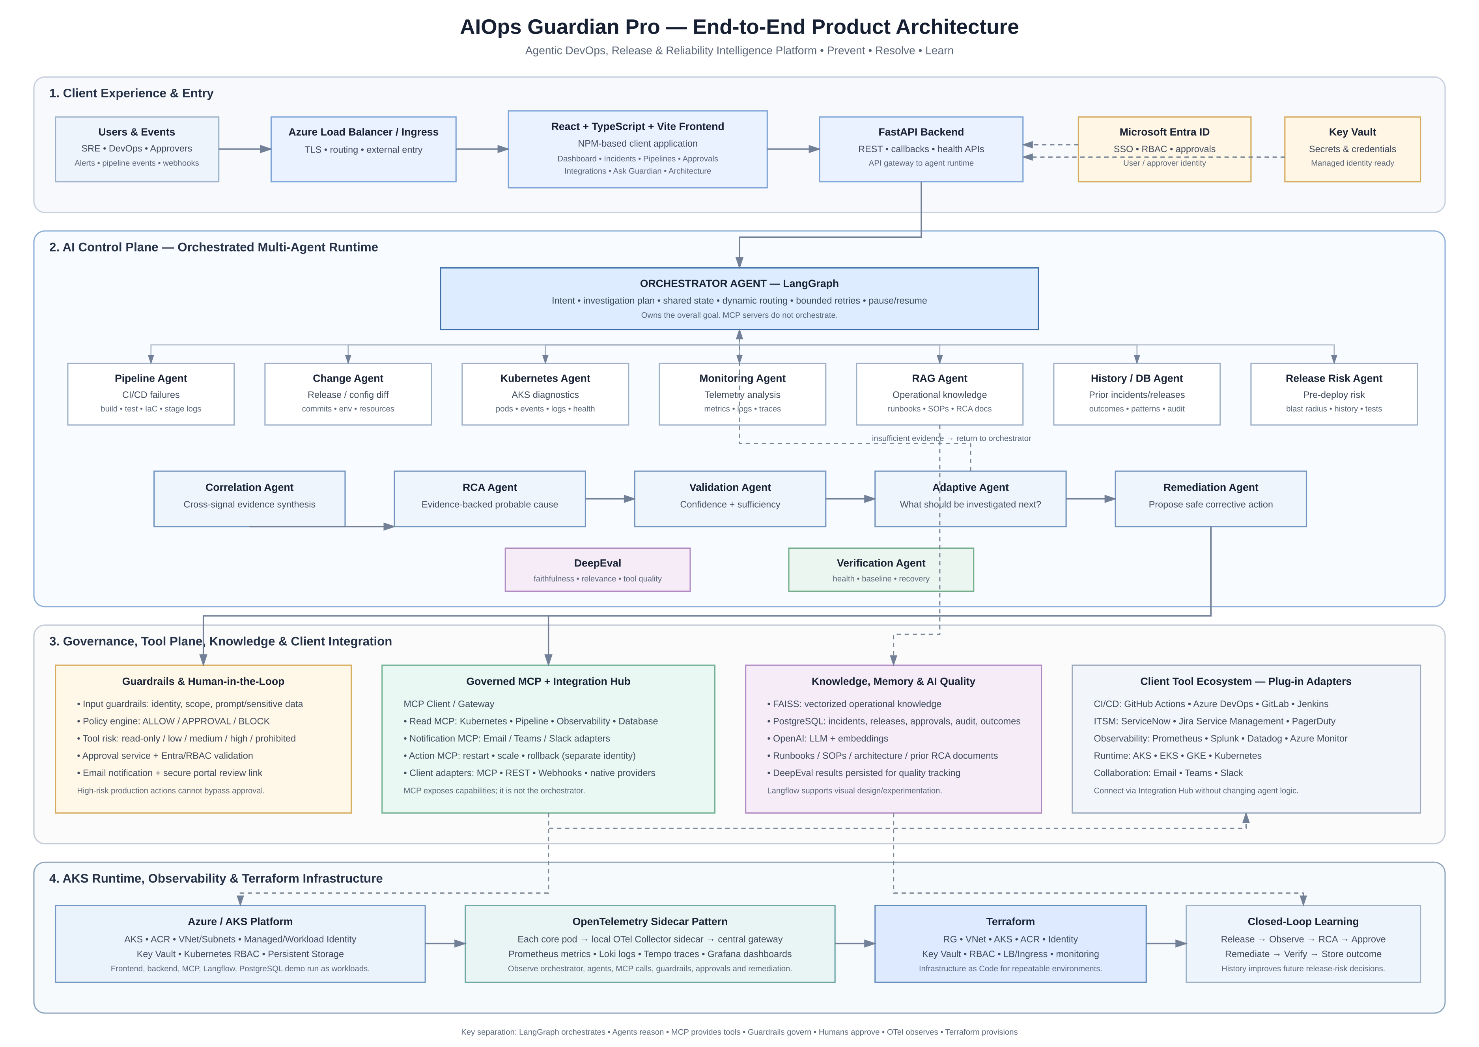
Figure 1. End-to-end product architecture.
One-line value proposition
AIOps Guardian turns operational signals into explainable, evidence-backed, and governed SRE actions.

1. Executive Summary
AIOps Guardian Pro is an SRE control plane for detecting, investigating, explaining, and safely remediating production issues. It combines a React operations console, FastAPI services, a LangGraph orchestrator, specialized diagnostic agents, live observability integrations, deterministic guardrails, human approvals, MCP tool execution, verification, and an operational audit trail.
An end user does not need to understand Kubernetes, Prometheus, tracing, MCP, or agent orchestration. They can ask a question such as:
Example user question
Why is checkout-api failing after today's production deployment?

Guardian collects evidence, correlates signals, explains the likely cause, proposes a practical response, and pauses risky production actions until an authorized approver decides.
Capability | What the user gets
Investigate | Plain-language incident analysis with evidence and confidence.
Observe | Metrics, logs, Kubernetes health, deployment context, and telemetry quality.
Decide | Recommended containment and remediation with policy reasoning.
Control | Human approval for risky actions and single-use approval decisions.
Learn | Persisted incidents, audit events, reports, and historical comparisons.

2. Product Scope
Area | Included behavior
Incident intelligence | Correlates metrics, logs, Kubernetes events, pipeline changes, runbooks, and incident history.
Release intelligence | Identifies risky releases, missing evidence, configuration regressions, and promotion concerns.
SRE guidance | Produces advanced metrics, PromQL examples, containment steps, remediation steps, and verification criteria.
Governance | Separates read-only analysis from controlled actions and records the decision trail.
Integrations | Supports live Prometheus and Loki connections with validated URLs and environment-backed credentials.
Deployment | Runs locally on kind Kubernetes and is structured for GKE/GCP deployment.

3. End-User Experience

Primary workflow
- Open the Dashboard to see current incident, approval, release-risk, and platform-health signals.
- Open Ask Guardian and describe the problem in natural language.
- Review the root cause, confidence, evidence sources, agent trace, metrics, and recommended action.
- Follow the SRE action plan: contain, remediate, and verify.
- If the action is high risk, review it in Approvals and approve or reject it.
- Use Investigations and Reports to review history, telemetry quality, and recovery evidence.
Screen | Purpose | Typical user action
Dashboard | Operational overview | Identify what needs attention first.
Ask Guardian | Investigation and release-risk analysis | Ask a question and review the evidence-backed response.
Live Reports | Telemetry trends and data quality | Inspect request rate, errors, latency, burn rate, restarts, and logs.
Simulator | Training and demo data | Generate deterministic incidents and exercise approvals.
Investigations | Incident history | Review prior investigations and root causes.
Pipelines | Release intelligence | Compare pipeline status, version, and risk.
Approvals | Human-in-the-loop control | Approve or reject pending production actions.
Integrations | Data-source management | Test, save, and activate Prometheus/Loki sources.
Architecture | Platform explanation | Explain how agents, MCP, guardrails, and observability fit together.

4. Incident Investigation Example
The reference scenario is an unsafe checkout-api release that changes the container memory limit from 1Gi to 128Mi.
Signal | Before | After | Interpretation
HTTP 5xx rate | 0.2% | 6.8% | Customer-visible failures.
p95 latency | 180 ms | 690 ms | Severe performance degradation.
Pod restarts | 0 | 9 | Runtime instability.
Error-budget burn | 1x | 34x | SLO risk is accelerating.
Termination reason | Healthy | OOMKilled | Memory limit is below demand.

Example conclusion
The latest deployment reduced the memory limit below application demand, causing OOMKilled terminations, pod restarts, HTTP 5xx errors, and latency degradation.

Recommended operating response
- Contain: pause promotion and route traffic to the last known-good version.
- Remediate: restore the validated memory limit or roll back to v1.9.0.
- Verify: require stable 5xx, p95 latency, restart, and error-budget metrics for 15 minutes.

5. Architecture and Control Boundaries
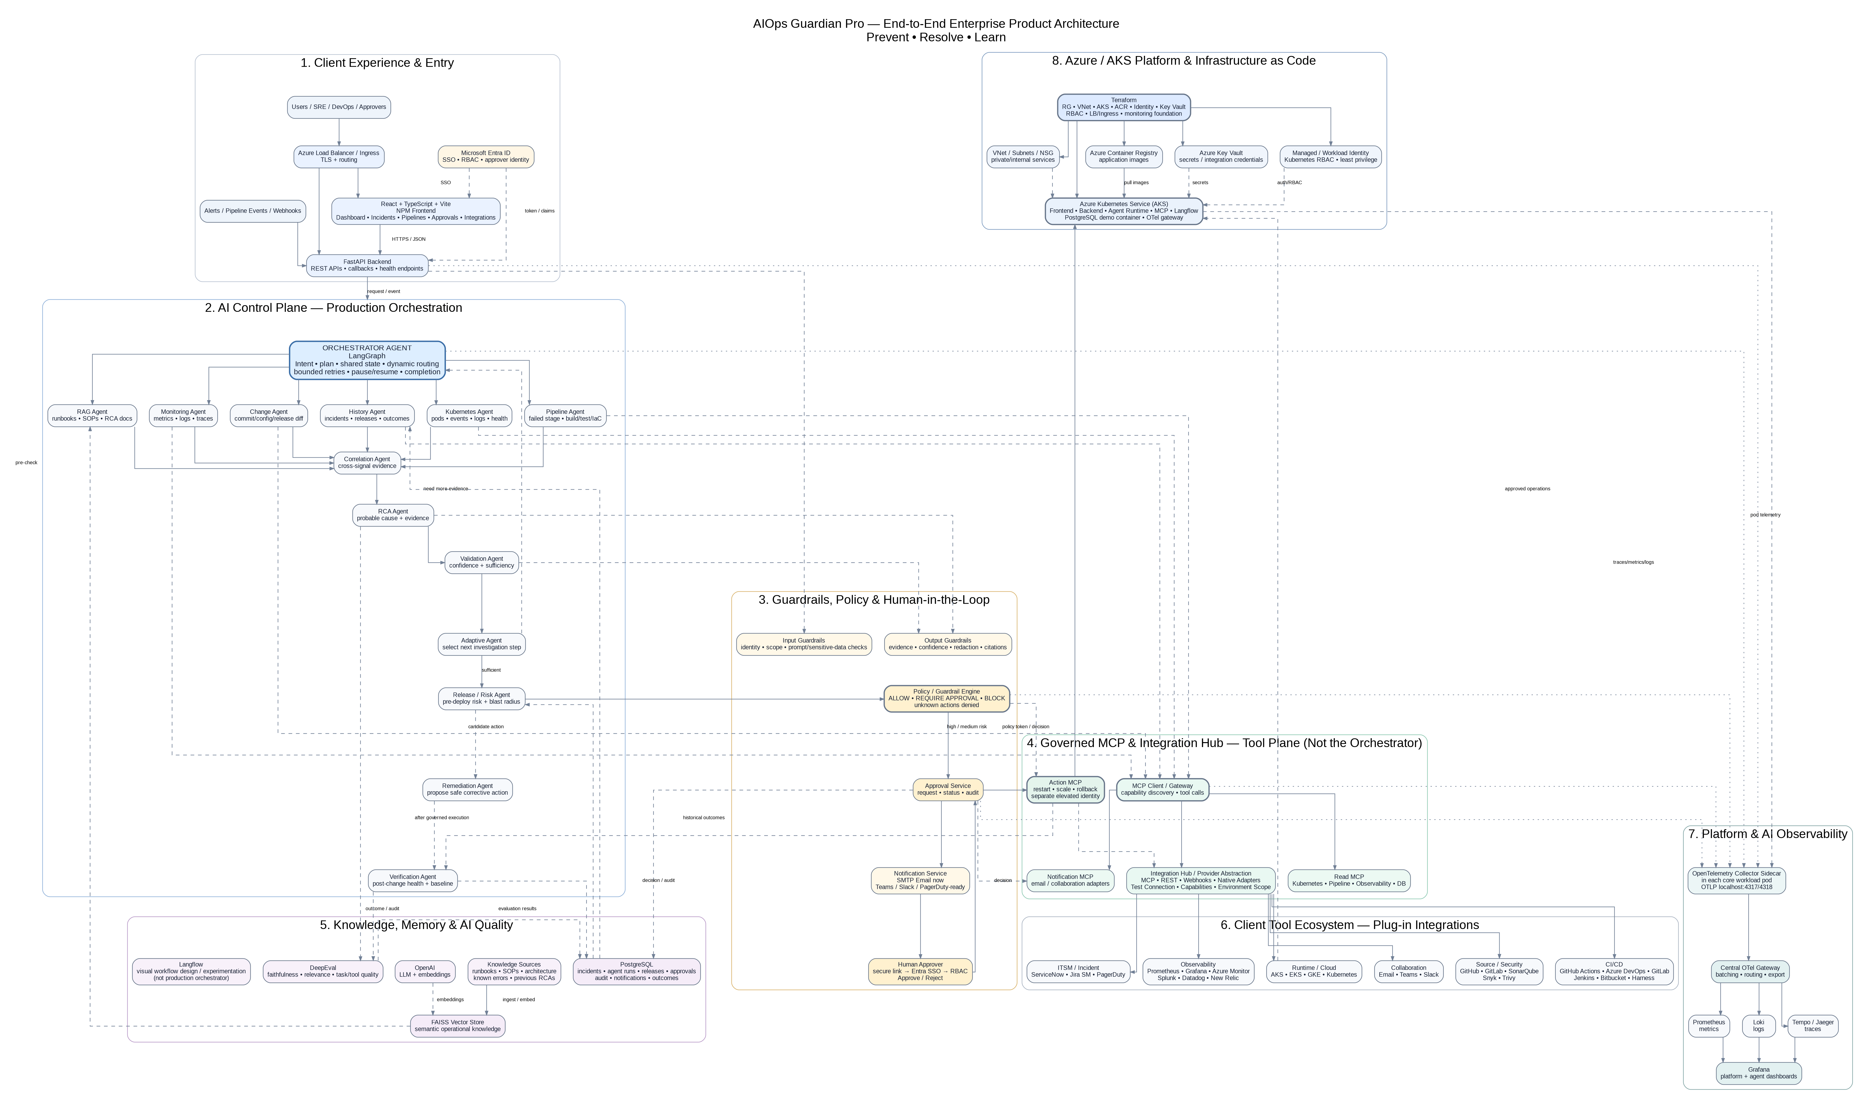
Figure 2. Enterprise architecture and integration boundaries.
Component | Responsibility
React/Vite UI | User workflow, investigation results, reports, simulator, and approvals.
FastAPI | API boundary, authentication, persistence orchestration, and route-level authorization.
LangGraph orchestrator | Intent, plan, shared state, agent routing, validation, guardrails, and completion.
Specialized agents | Pipeline, Kubernetes, monitoring, change, RAG, history, RCA, release risk, and verification.
MCP tool plane | Governed access to Kubernetes, CI/CD, metrics, logs, traces, notifications, and actions.
Guardrails | Deterministically allow, block, or require approval for operational actions.
PostgreSQL and FAISS | Structured audit/incident memory and operational knowledge retrieval.
OpenTelemetry | Trace agent execution, tool calls, approvals, remediation, and verification.

Editable architecture diagram
Mermaid source (paste into Confluence Mermaid macro)
flowchart TD
U[User / Alert / Pipeline Event] --> UI[React Operations UI]
UI --> API[FastAPI API]
API --> O[LangGraph Orchestrator]
O --> A[Specialized Agents]
A --> E[Evidence Correlation and RCA]
E --> V[Validation and Adaptive Routing]
V --> G[Guardrail Policy]
G -->|Allow| M[Action MCP]
G -->|Require approval| H[Human Approval]
H --> M
M --> X[Verification]
X --> DB[(PostgreSQL Audit and Incident Memory)]
A --> OBS[Prometheus / Loki / Tempo / OTel]
A --> RAG[FAISS and Runbooks]

6. Safety, Identity, and Authorization
Guardian separates evidence collection from action execution. Read-only investigation can be performed by a viewer. Production actions require an approver role, and approval decisions are single-use to prevent replay.
Role | Allowed behavior
Viewer | Read dashboards, reports, investigations, pipeline data, integrations, and run conversations.
Approver | Everything a viewer can do, plus approve/reject actions, activate integrations, add integrations, and send operational notifications.
Admin | Everything above, subject to organization policy and deployment controls.

- Production Kubernetes configuration enables authentication by default.
- Local demo mode explicitly disables authentication for disposable development use.
- Integration URLs reject metadata, private, loopback, reserved, multicast, and link-local addresses.
- Credentials are referenced through environment-backed secrets rather than saved as raw integration values.
- PostgreSQL deployments use Alembic migrations; SQLite table creation remains limited to local demo/test use.

7. Observability and SRE Metrics
Metric family | Purpose | Example
RED metrics | Request health | Rate, HTTP 5xx ratio, duration histogram.
Saturation | Resource pressure | Memory working set, memory limit, CPU throttling.
Reliability | SLO health | Error-budget burn rate and scrape freshness.
Kubernetes | Runtime state | Restarts, OOMKilled, desired versus healthy replicas.
Trace correlation | Causality | W3C trace context and deployment.version.

Guardian marks unavailable data as unknown or insufficient rather than treating missing telemetry as healthy. Each report exposes scope, timestamp, source, query, status, and data gaps.

8. Local Deployment
make local-build
kind load docker-image guardian-backend:reports-v1 guardian-mcp:local guardian-frontend:reports-v1 --name guardian-local
make local-deploy
Service | Local access
Frontend | http://localhost:30081
Backend Swagger | http://localhost:30800/docs
Prometheus | ClusterIP; port-forward when needed
Loki | ClusterIP; used by Live Reports
PostgreSQL | Internal ClusterIP service with persistent storage

The local kind deployment includes the frontend, backend, MCP server, checkout-api telemetry target, Prometheus, Loki, PostgreSQL, OpenTelemetry sidecars, and a persistent Prometheus volume.

9. GCP / GKE Deployment Path
- Bootstrap Terraform state, Workload Identity Federation, and the deployment service account.
- Create Secret Manager versions for database, OpenAI, SMTP, and authentication secrets.
- Build commit-addressed images and push them to Artifact Registry.
- Apply Terraform to provision GKE, networking, IAM, secrets, and the Helm release.
- Expose the frontend and /api through a managed ingress with TLS and Cloud Armor.
- Place the application behind Google Cloud IAP or an organization-managed OIDC gateway.
- Use Cloud SQL for production PostgreSQL and persistent storage for telemetry systems.
GCP production gate
Do not expose the API publicly until identity-aware access, Secret Manager, managed TLS, network policy, database migrations, and action authorization are configured.

10. Confluence Publishing Guide
Recommended Confluence parent page: AIOps Guardian Pro
Child page | Content
Product Overview | Executive summary, value proposition, user journey, and scope.
End User Guide | Dashboard, Ask Guardian, Reports, Simulator, Investigations, Pipelines, Approvals, and Integrations.
SRE Runbook | Incident workflow, metrics, containment, remediation, verification, and escalation.
Architecture | Architecture diagram, responsibility boundaries, MCP tool plane, and data flow.
Security Model | Identity, roles, guardrails, secrets, SSRF controls, and audit requirements.
Local Kubernetes | kind setup, image loading, port forwarding, simulator, and telemetry.
GCP / GKE | Terraform bootstrap, Secret Manager, Artifact Registry, Workload Identity, and ingress.
API Reference | Swagger URL, route groups, authentication, and example payloads.

For editable diagrams, copy the Mermaid source blocks from the appendix into a Confluence Mermaid macro. Keep the PNG architecture diagrams as the executive-friendly visual fallback.

11. Editable Diagram Sources

Incident response sequence
Mermaid source (paste into Confluence Mermaid macro)
sequenceDiagram
participant User
participant UI as Guardian UI
participant API as FastAPI
participant O as Orchestrator
participant Obs as Metrics/Logs/K8s
participant G as Guardrail
participant A as Approver
participant MCP as Action MCP
participant V as Verification
User->>UI: Ask incident question
UI->>API: Investigation request
API->>O: Create investigation
O->>Obs: Collect scoped evidence
Obs-->>O: Metrics, logs, events, changes
O->>O: Correlate and validate RCA
O->>G: Evaluate recommended action
G-->>O: Require approval
O-->>UI: RCA, metrics, action plan, approval
A->>API: Approve or reject
API->>MCP: Execute approved action
MCP-->>API: Action result
API->>V: Verify recovery
V-->>UI: Recovery status and audit trail

Deployment topology
Mermaid source (paste into Confluence Mermaid macro)
flowchart LR
subgraph GKE[GKE / Local kind]
FE[Frontend] --> BE[FastAPI Backend]
BE --> DB[(PostgreSQL)]
BE --> MCP[MCP Server]
BE --> P[Prometheus]
BE --> L[Loki]
BE --> O[OTel Sidecar]
P --> PVC[(Persistent Prometheus Volume)]
end
O --> OTG[OTel Gateway]
BE --> SM[Secret Manager / Kubernetes Secrets]
User --> IAP[OIDC or Google IAP]
IAP --> FE

12. Source References
- README.md - product scope and quick start
- docs/architecture-one-page.md - responsibility boundaries and closed-loop flow
- docs/security.md - identity, authorization, secrets, network, AI controls, and audit
- docs/live-integrations.md - live telemetry and controlled traffic scenario
- docs/deployment-gcp.md - Terraform, GKE, Secret Manager, and deployment workflow
- docs/observability.md - OTel, Prometheus, Loki, Tempo, and recommended spans
- demo/README.md - unsafe memory release incident scenario

Document Maintenance
Owner: Platform Engineering / SRE
Review cadence: Each release or architecture change
Last validated: 22 September 2026
Repository: AIOps Guardian Pro

