AIOps Guardian integration and incident investigation use case
  - A practical guide for SRE and cloud teams
Guardian needs access to live monitoring data to make useful operational recommendations. Connect the systems your teams already use, preserve where each observation came from, and let engineers investigate the same service and time window across metrics, logs, changes, and traces.
The product should help an engineer identify the next useful check, explain the evidence behind a hypothesis, and verify recovery. This guide explains the integration design, the current local workflow, and a complete target incident procedure. It separates implemented capabilities from work still required.

What the product supports now
Capability | Current scope
Live metrics | Prometheus request rate, HTTP 5xx percentage, p95 latency, and short-window error-budget burn.
Conversation | Saved multi-turn investigations, clarifying questions, reported context, and explicit metric refresh. Guided replies work without an LLM key.
Integrations and reports | Read-only Prometheus and Loki adapters; a scoped reporting view for 15, 30, or 60 minutes. A connection requires a reachable endpoint and matching telemetry.
Operational boundary | Live investigations provide observations and advice. They do not execute infrastructure changes or establish a proven root cause from metrics alone.

Why integrations matter
Metrics show the scale and timing of degradation. Logs can reveal concrete failures. Traces can locate the slow dependency. Kubernetes events and release history can show what changed. Runbooks add service-specific checks and recovery constraints. Each source answers a different question; a healthy API connection alone does not mean the required evidence is present.
Start with useful depth for one service, then add providers through a common adapter contract. A catalog entry must distinguish a working connector from a planned connector. Compatibility also depends on authentication, labels, metric names, API versions, permissions, and network access.
Recommended first outcome: an on-call engineer can investigate checkout-api, inspect real trends, identify missing evidence, and hand off a clear explanation with the next diagnostic action.

How integrations provide usable evidence
Guardian queries existing telemetry stores through backend adapters. Application instrumentation and collectors feed those stores. The browser uses Guardian APIs; provider credentials stay on the server.
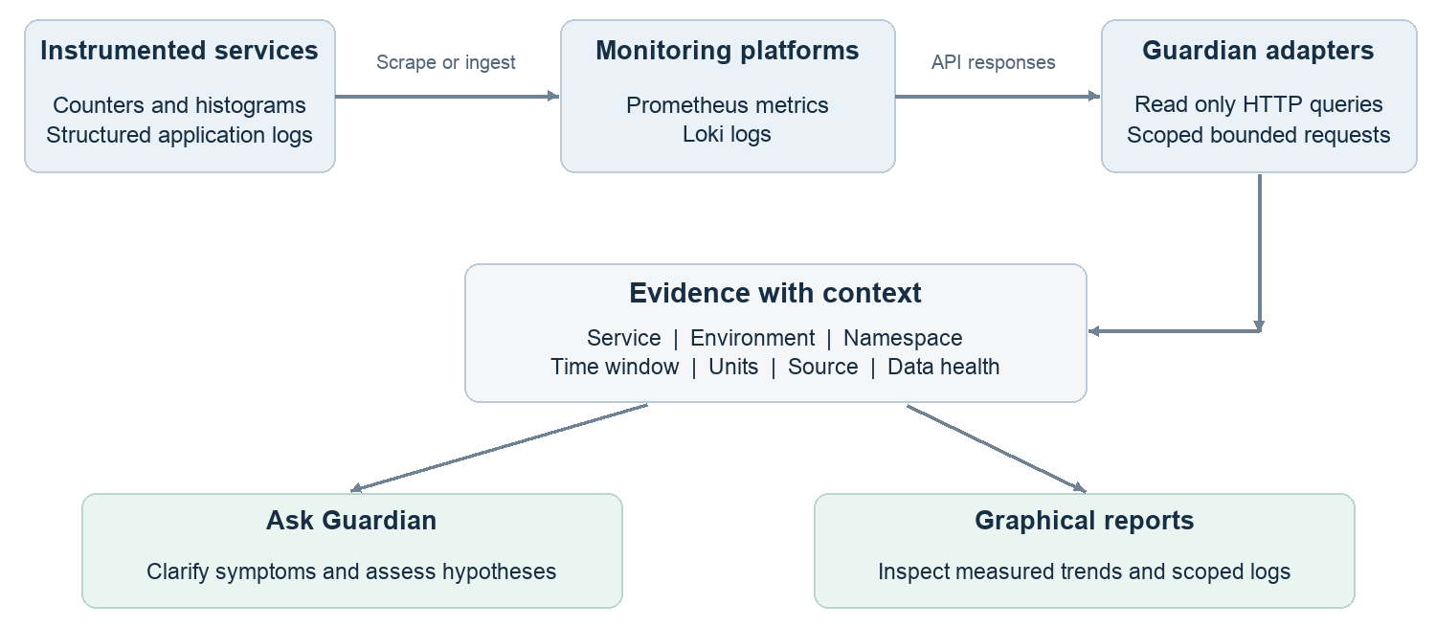
Figure 1 Current integration pattern. The adapters read data; instrumentation and ingestion remain separate responsibilities.

Connection and query sequence
1. Instrument the application and configure its monitoring pipeline. The checkout example exports request counters and duration histograms. Use consistent service, environment, and namespace labels so records can be compared.
2. Register the Prometheus or Loki base URL in Integrations. Add an optional backend environment variable name for a bearer token. Configure the value through a secret or server environment; never place the token itself in source code or the browser.
3. Test the connection, then query a known service. The first check validates API reachability and permissions. The second validates the requested metrics or log streams. A successful empty query is not evidence of a healthy application.
4. Use the same scope and time window in investigations and reports. Retain the query, source, units, timestamps, and missing-data status beside each result. Add future providers by translating their results into this common evidence model.

Boundaries for a team deployment
Use read-only provider credentials and restrict reachable destinations. The local implementation supports an optional bearer token reference, not every vendor authentication scheme. Hosted endpoints that require Basic authentication, tenant headers, OAuth, or cloud request signing need further adapter work. Add organization authentication, role-based access, tenant isolation, secret management, and an audit trail before exposing the product broadly.
For broader instrumentation, OpenTelemetry provides a standard collection layer for receiving, processing, and exporting telemetry. It does not make Guardian compatible with every monitoring query API. Each backend still needs a tested adapter. [1–3]

Run an investigation with the current product
Use the local Kubernetes deployment for this walkthrough. Select application checkout-api, environment prod, and namespace aiops-guardian. The separate standalone Docker example uses different ports and may use namespace default; do not combine those scopes.

Prepare and connect
1. Open http://localhost:30081/integrations. Configure the local Prometheus URL http://guardian-prometheus:9090, test it, and select it for investigations. A browser localhost address is not automatically reachable from a Kubernetes pod. Active provider selection is shared across this deployment.
2. Confirm that Prometheus scrapes checkout-api and that the application has received requests. The metric names are http_server_requests_total and http_server_duration_seconds_bucket. Both require service, environment, and namespace labels. Allow at least two 15-second scrapes; several minutes provide more useful rates.
3. If a Loki backend and log ingestion are available, register its endpoint and test it. The local URL is http://guardian-loki:3100. Queries use the same three scope labels. Without a configured source or matching streams, logs remain unavailable or empty; they are not invented.

Ask and refine
4. Open http://localhost:30081/ask and choose Live Prometheus. Start with “Checkout is slow. Help me assess customer impact and choose the next check.” Answer the clarifying question with what you know about onset, affected routes, and recent changes. Say “unknown” when a fact is unavailable.
5. Read the measured evidence separately from your reported context. A statement such as “this started after deployment” remains an engineer report until release evidence corroborates it. Use Refresh metrics when you want a new snapshot; ordinary follow-up replies retain the existing snapshot.
6. Open http://localhost:30081/reports, use the same scope, and choose a 15, 30, or 60 minute window. Inspect the trend and data health before treating any value as actionable. Return to the saved conversation with observations and a focused follow-up.
Signal | Interpretation
Request rate | Requests per second across matching replicas. Compare with a baseline; lower traffic can make error and latency estimates unstable.
HTTP 5xx | Percentage of observed requests with server errors. It does not include every network failure or prove all customers are affected.
p95 latency | Estimated 95th percentile from duration histogram buckets, shown in milliseconds. Sparse traffic and bucket boundaries affect the estimate.
Error-budget burn | Observed HTTP 5xx fraction divided by 1 minus the availability SLO. The default SLO is 99.8%; 1% errors therefore equals 5 times burn.

Missing samples, stale scrapes, failed targets, and zero-traffic ratios must remain unknown. The burn figure is a short-window indicator, not remaining monthly budget. [4]

Demonstrate degradation and recovery locally
This controlled exercise sends real HTTP traffic to the instrumented local checkout service. Prometheus measures that traffic and Reports displays the resulting trends. Faults are enabled only for the local demonstration with ENABLE_DEMO_FAULTS=true; the application default keeps them disabled.
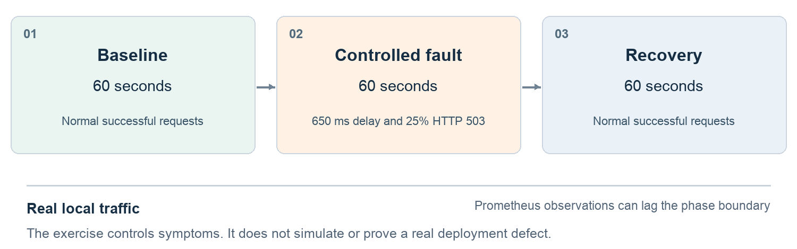
Figure 2 Exercise schedule. The phases describe requested test traffic, not a measured production incident.

Execute the walkthrough
Keep the existing frontend and backend port forwards running. If checkout is not already forwarded, open a separate terminal from the repository root and run:
kubectl --context kind-guardian-local -n aiops-guardian port-forward service/checkout-api 18081:8080
Run the traffic exercise from another terminal in the repository root:
python scripts/run_reporting_scenario.py
The exercise runs for approximately three minutes: 60 seconds of baseline requests, 60 seconds of delayed requests with a 25% HTTP 503 pattern, then 60 seconds of recovery. Watch the 15-minute report for checkout-api / prod / aiops-guardian, and refresh the conversation evidence during the fault and after recovery.

Explain what the graphs show
A useful investigation reports the onset, magnitude, affected scope, and remaining uncertainty. Request rate provides volume context; latency and errors show symptoms. The five-minute rate window retains recent failures after the recovery phase ends, so recovery is gradual in those charts even when the latest requests succeed.
Example follow-up: “The fault phase ended. Do the new metrics support recovery, and what remains uncertain?” The answer should identify when the snapshot was collected, account for the trailing window, and request more observation time if the data is still incomplete.
Passing this exercise means that controlled traffic reaches the telemetry store, the report shows measurements, and Guardian preserves context without claiming an unobserved deployment or remediation. The exercise does not prove a root cause or demonstrate an automatic production rollback.

Target use case for an organization
Scenario: checkout latency rises after a release that may have reduced a database connection pool. An SRE owns the incident, the service owner reviews application changes, and a cloud engineer checks infrastructure capacity. The following procedure combines current metrics, reports, and conversation features with future change, trace, and Kubernetes connectors.

Establish impact and gather evidence
The SRE starts a scoped investigation and supplies the suspected onset. Guardian asks which routes, regions, and customers are affected and whether the onset is confirmed. The engineer compares request rate, errors, and latency before and after that time. Unknown data and conflicting observations stay visible.
Next, the proposed change connector retrieves the deployed revision and configuration diff. Kubernetes evidence checks restart reasons, failed scheduling, resource limits, and rollout state. A trace connector compares slow checkout requests with normal requests to locate time spent waiting for a database connection. Logs are queried for matching timeout or pool-exhaustion messages.

Evaluate competing explanations
Hypothesis | Evidence needed before recommending action
Connection pool reduced | A verified configuration change plus increased connection-wait time or pool-exhaustion observations in the affected workload.
Traffic or capacity pressure | A traffic increase correlated with saturation, throttling, queueing, or autoscaling limits.
Slow database dependency | Elevated database spans or query duration, with corroborating database health and workload observations.

Guardian should say which observations support each explanation, which contradict it, and which check would change the conclusion. Temporal proximity to a release supports investigation; it does not establish causality.

Review an action and verify recovery
If the evidence supports restoring a pool setting or rolling back a release, the service owner reviews a concrete change: affected service and revision, expected effect, capacity constraints, blast radius, rollback method, and recovery criteria. An authorized operator executes it through the existing deployment or runbook system. This is a target operating procedure; live Guardian conversations do not execute that change today.
For this scenario, agree on recovery criteria before acting: HTTP 5xx below 0.2%, p95 latency below 500 ms, sufficient representative traffic, and no worsening dependency signal. These are example criteria based on the local defaults, not a production SLO recommendation. Hold them for at least 15 minutes after the trailing measurement window clears; extend the observation if traffic is low or symptoms recur.
The incident review records the timeline, exact observations, selected action, operator approval, post-change results, and unresolved questions. An instrumentation task adds connection-pool occupancy and wait-time metrics if the diagnosis lacked them. Reuse the saved investigation as handoff context; avoid treating an unverified hypothesis as a confirmed runbook fact.

Expand integrations around diagnostic needs
Prioritize connectors that answer the next unanswered question for your pilot service. The following roadmap describes additions, not supported live integrations. Avoid committing to “any tool” until its query, authentication, permissions, and data mapping are tested.
Priority | Evidence and candidate systems | What it enables
Next | Kubernetes API and kube-state-metrics | Events, OOM and restart causes, workload configuration, limits, and rollout state.
Next | GitHub, GitLab, Azure DevOps and deployment systems | Verified release time, revision, configuration diff, and build failures.
Next | Tempo or Jaeger and OpenTelemetry traces | Slow dependency spans and request-level correlation.
Then | Datadog, New Relic, Dynatrace, CloudWatch, Azure Monitor, Google Cloud Monitoring | Existing vendor telemetry and cloud service context through provider-specific adapters.
Then | ServiceNow, PagerDuty, runbooks and service inventory | Incident history, ownership, operational constraints, and relevant procedures.

Make reporting useful to engineers and leaders
Keep the current service report focused on readable metric trends, units, scope, time range, source health, and log evidence. Add deployment and action annotations only when verified event connectors exist. Future views can compare services, display SLO burn across longer windows, show incident timelines, and summarize unresolved evidence gaps. Every visual should allow the reader to find the underlying observation.
Measure pilot value with time to the first evidence-backed finding, time spent gathering handoff context, recommendation acceptance, and unsupported-claim rate. Compare similar incidents and record missing integrations. Do not claim an MTTR or cost improvement before measuring it.

Integration acceptance checklist
Before enabling a new provider, verify read permissions, secret handling, destination restrictions, label mapping, time zones, units, query bounds, timeouts, partial failures, and empty results. Test one normal case, one known incident, and one unavailable-source case. For Kubernetes, grant only the resource and verb permissions the connector requires. [5]

Primary references
[1] Prometheus HTTP API
[2] Grafana Loki HTTP API
[3] OpenTelemetry Collector
[4] Google SRE Workbook on alerting with SLOs
[5] Kubernetes RBAC authorization
Local implementation references: observability/README.md, docs/conversations.md, and the Integrations and Reports pages. The broader operating procedure is a proposed product direction.

