**משימות למעבדה מס' 12**

**fast-food restaurant**

* We've considered a business case of fast-food restaurant where a typical meal could be a burger and a cold drink. Burger could be either a **Veg Burger** or **Chicken Burger**. Cold drink could be either a **Coke** or **Pepsi**.
* We're going to create an ***Item*** interface representing food items such as concrete classes implementing the ***Item*** interface.
* We then create a ***Meal*** class having ***ArrayList*** of ***Item*** and a ***MealBuilder*** *(****DP Builder****)*  to build different types of ***Meal*** object by combining *Item*.
* We're going to create ***CostBridge*** class (***DP Bridge***) that gets the **ArrayList** from *Meal* to implement function ***getCost****().*
* The ***ProxyMealBuilder*** class (***DP Proxy***) should be created to substitute the real ***MealBuilder***.
* ***BuilderPatternDemo***, our demo class will use ***ProxyMealBuilder*** to build a ***Meal***.

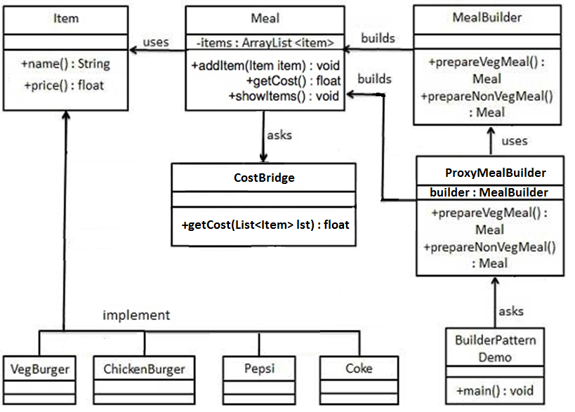

**בהצלחה !**