ESP32 + Ethernet Controlled Servo Actuator for Remote Power Control

1. Introduction
This document specifies a low-cost device that remotely controls the physical power button of a computer (e.g., Mac Mini) located in a datacentre or server room. The device uses an ESP32 microcontroller with Wi‑Fi and Ethernet connectivity, exposing a password-protected web interface that commands a compact servo to perform short presses (power toggle) and long presses (forced shutdown/reset).

2. Use Case
Designed for administrators who need to power on/off or reset machines without local access. The actuator is mounted to press the rear or underside power button of a Mac Mini (or similar), enabling reliable physical control even when firmware-level options (e.g., Wake-on-LAN) are unavailable.

3. Hardware Overview
• MCU: ESP32 module (Wi‑Fi built-in) with external Ethernet via W5500 (SPI) or LAN8720 (RMII).
• Actuator: Micro servo (5 V), sized to fit a compact 3D-printed bracket and lever.
• Power: USB‑C 5 V input; onboard regulation to 3.3 V for digital logic; servo powered from 5 V rail.
• Controls: Reset (EN) and Factory Default buttons; Status LED.
• Indicators: RJ45 link/activity (from magjack).

4. Circuit Wiring (Descriptive)
Power enters via USB‑C at 5 V. A 3.3 V regulator supplies the ESP32 and Ethernet interface. The servo uses the 5 V rail with a local bulk capacitor (470–1000 µF) for surge. The web server and configuration logic run on the ESP32. A dedicated PWM GPIO drives the servo’s signal line; grounds are common.
Two Ethernet implementations are provided:
• Variant A (recommended): ESP32 + W5500 (SPI). Fewer pins, simpler layout, robust.
• Variant B: ESP32 + LAN8720 (RMII). Higher throughput interface; requires clock and length-matching.
Buttons: Reset connects to EN (momentary to GND). Factory Default connects to a pulled-up GPIO and, when held on boot (≈10 s), wipes configuration to defaults. Status LED connects to a GPIO via ~330 Ω series resistor.

5. Firmware Overview
ESP‑IDF firmware provides: Ethernet (static IP default), Wi‑Fi AP setup/captive portal and STA client, password-protected web UI, REST API, WebSocket status, NVS configuration (user + network), actuator control with timed short/long presses, OTA update, and factory reset logic. Security hardening includes hashed credentials, CSRF on mutating routes, SameSite/HttpOnly cookies, and login rate limiting.

6. Mechanical Design
The servo mounts on a compact 3D‑printed bracket that references the case chassis, not the moving button. A lever/horn with a TPU or silicone pad applies ~0.3–1 N over 1–2 mm of travel. Include an adjustable stop (set resting gap to ~0.5–1.0 mm) and a flexure/spring feature for compliance to avoid over‑travel loads on the switch.

7. Operation
Via the web UI, the user triggers a Short Press (≈200 ms dwell) or Long Press (≈5 s dwell). The actuator ignores overlapping commands and enforces a brief cooldown. Network, credentials, and timings are configurable from the UI.

8. Security
• Password‑protected web UI; credentials stored hashed in NVS.
• CSRF protection on all mutating API routes; SameSite cookies.
• Login rate limiting and optional lockout.
• Optional HTTPS with device certificate or reverse proxy on LAN.

9. Summary
This design provides a compact, reliable, network‑controlled servo pusher to physically actuate a Mac Mini’s power button. It is suitable for datacentre deployment and can be adapted mechanically to other equipment.

10. Detailed Schematic (Electrical Wiring)
Two supported Ethernet options are shown below. Choose one variant. Pin mappings are provided after each diagram.

Variant A: ESP32 + W5500 (SPI Ethernet)
Simple SPI wiring; recommended for fast bring‑up. Keep SPI short; decouple VDD with 0.1 µF & 4.7 µF.
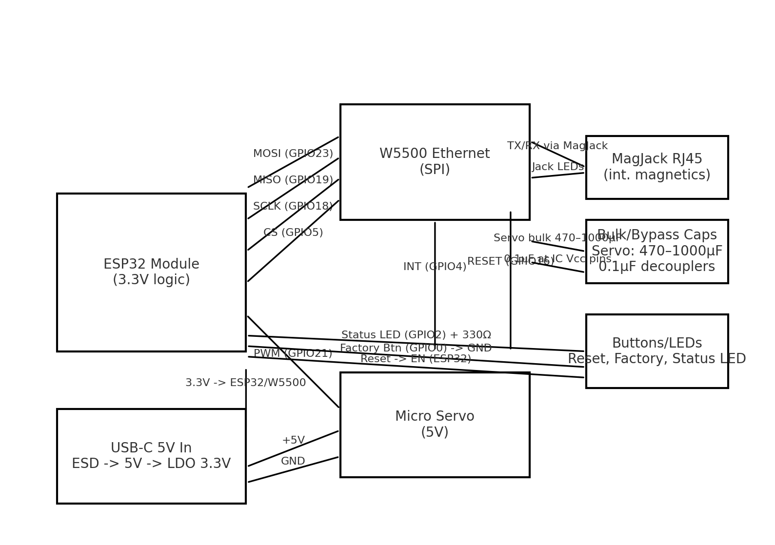
Function | ESP32 GPIO | W5500 Pin | Notes
SPI MOSI | GPIO23 | MOSI | Series 33–68Ω optional
SPI MISO | GPIO19 | MISO | 10k pull‑up optional
SPI SCLK | GPIO18 | SCLK | No stubs
Chip Select | GPIO5 | SCSn | 10k pull‑up to 3.3V
Interrupt | GPIO4 | INTn | Active low; 10k pull‑up
Reset | GPIO16 | RSTn | Active low
3.3V | — | VDD | 0.1 µF + 4.7 µF near VDD
GND | — | GND | Solid return
RJ45 Tx/Rx | — | TX±, RX± | Through magjack
Servo PWM | GPIO21 | — | Servo signal
Servo +5V | — | — | 470–1000 µF near connector
Status LED | GPIO2 | — | 330Ω series
Factory Btn | GPIO0 | — | To GND; internal pull‑up
Reset Btn | EN | — | Momentary to GND

Variant B: ESP32 + LAN8720 (RMII Ethernet PHY)
Use clean 50 MHz reference; length‑match RMII. Follow vendor reference design for straps and magnetics.
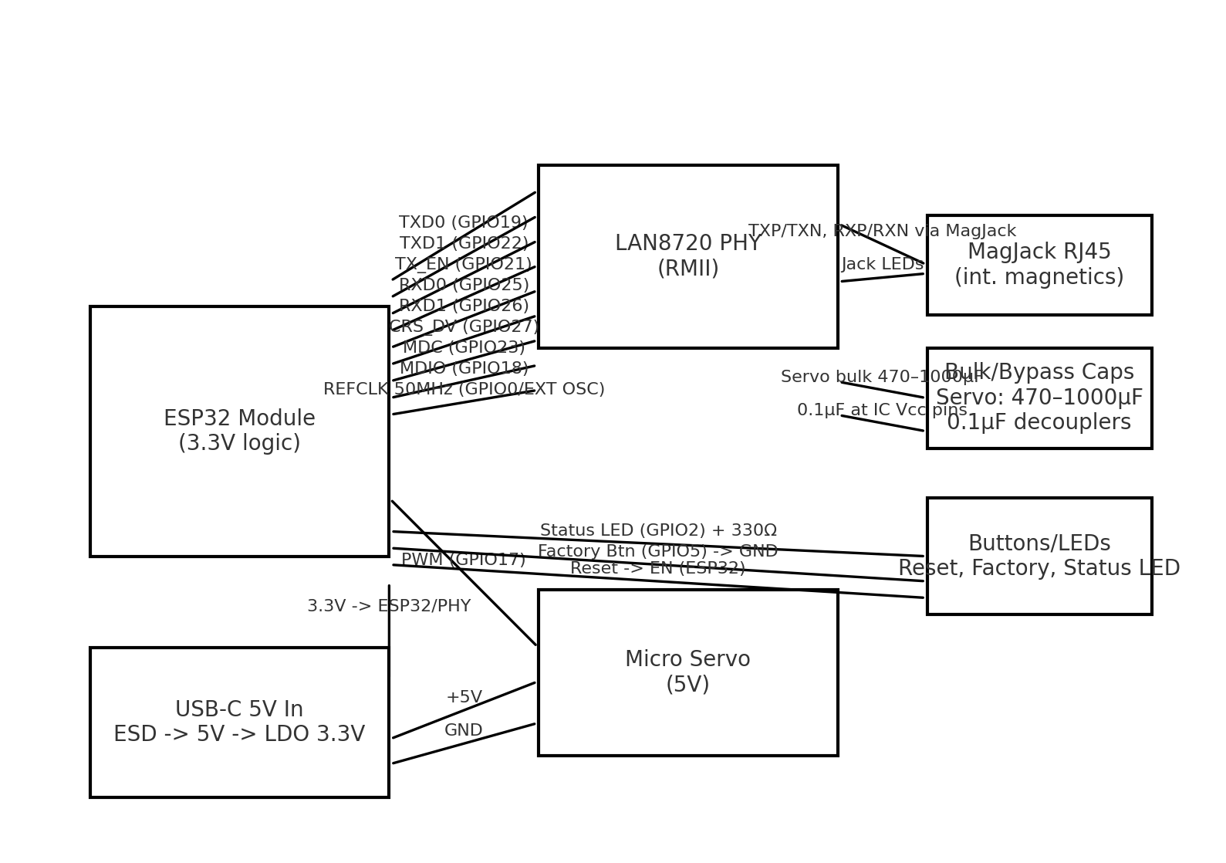
Function | ESP32 GPIO | LAN8720 Pin | Notes
TXD0 | GPIO19 | TXD0 | Length‑match
TXD1 | GPIO22 | TXD1 | Length‑match
TX_EN | GPIO21 | TXEN | —
RXD0 | GPIO25 | RXD0 | —
RXD1 | GPIO26 | RXD1 | —
CRS_DV | GPIO27 | CRS_DV | —
MDC | GPIO23 | MDC | —
MDIO | GPIO18 | MDIO | Pull‑up 1.5–4.7k
REFCLK 50 MHz | GPIO0 / ext | XTAL1/CLKIN | Prefer ext 50 MHz
3.3V | — | VDDIO/VDDCR | 0.1 µF + 10 µF
GND | — | GND | Solid plane
RJ45 MDI | — | TXP/TXN, RXP/RXN | Via magjack; TVS @ jack
Servo PWM | GPIO17 | — | Servo signal
Status LED | GPIO2 | — | 330Ω series
Factory Btn | GPIO5 | — | To GND; internal pull‑up
Reset Btn | EN | — | Momentary to GND

11. Protection & Power Notes
• Place a TVS diode at USB‑C 5 V input and an ESD array at RJ45. • Recommended regulator: ≥600 mA 3.3 V LDO/buck; check transient response (Wi‑Fi bursts). • Keep servo on 5 V with its own bulk capacitor; route high‑current returns away from signal grounds. • If servo noise couples into ESP32, add an LC filter (≈2.2 µH + 100 µF) to the servo branch.

