ESP32 + Ethernet Controlled Servo Actuator for Remote Power Control

1. Introduction
This document specifies a low-cost device that remotely controls the physical power button of a computer (e.g., Mac Mini) located in a datacentre or server room. The device uses an ESP32 microcontroller with Wi‑Fi and Ethernet connectivity, exposing a password-protected web interface that commands a compact servo to perform short presses (power toggle) and long presses (forced shutdown/reset).

2. Use Case
Designed for administrators who need to power on/off or reset machines without local access. The actuator is mounted to press the rear or underside power button of a Mac Mini (or similar), enabling reliable physical control even when firmware-level options (e.g., Wake-on-LAN) are unavailable.

3. Hardware Overview
• MCU: ESP32 module (Wi‑Fi built-in) with external Ethernet via W5500 (SPI) or LAN8720 (RMII).
• Actuator: Micro servo (5 V), sized to fit a compact 3D-printed bracket and lever.
• Power: USB‑C 5 V input; onboard regulation to 3.3 V for digital logic; servo powered from 5 V rail.
• Controls: Reset (EN) and Factory Default buttons; Status LED.
• Indicators: RJ45 link/activity (from magjack).

4. Circuit Wiring (Descriptive)
Power enters via USB‑C at 5 V. A 3.3 V regulator supplies the ESP32 and Ethernet interface. The servo uses the 5 V rail with a local bulk capacitor (470–1000 µF) for surge. The web server and configuration logic run on the ESP32. A dedicated PWM GPIO drives the servo’s signal line; grounds are common.
Two Ethernet implementations are provided:
• Variant A (recommended): ESP32 + W5500 (SPI). Fewer pins, simpler layout, robust.
• Variant B: ESP32 + LAN8720 (RMII). Higher throughput interface; requires clock and length-matching.
Buttons: Reset connects to EN (momentary to GND). Factory Default connects to a pulled-up GPIO and, when held on boot (≈10 s), wipes configuration to defaults. Status LED connects to a GPIO via ~330 Ω series resistor.

5. Firmware Overview
ESP‑IDF firmware provides: Ethernet (static IP default), Wi‑Fi AP setup/captive portal and STA client, password-protected web UI, REST API, WebSocket status, NVS configuration (user + network), actuator control with timed short/long presses, OTA update, and factory reset logic. Security hardening includes hashed credentials, CSRF on mutating routes, SameSite/HttpOnly cookies, and login rate limiting.

6. Mechanical Design
The servo mounts on a compact 3D‑printed bracket that references the case chassis, not the moving button. A lever/horn with a TPU or silicone pad applies ~0.3–1 N over 1–2 mm of travel. Include an adjustable stop (set resting gap to ~0.5–1.0 mm) and a flexure/spring feature for compliance to avoid over‑travel loads on the switch.

7. Operation
Via the web UI, the user triggers a Short Press (≈200 ms dwell) or Long Press (≈5 s dwell). The actuator ignores overlapping commands and enforces a brief cooldown. Network, credentials, and timings are configurable from the UI.

8. Security
• Password‑protected web UI; credentials stored hashed in NVS.
• CSRF protection on all mutating API routes; SameSite cookies.
• Login rate limiting and optional lockout.
• Optional HTTPS with device certificate or reverse proxy on LAN.

9. Summary
This design provides a compact, reliable, network‑controlled servo pusher to physically actuate a Mac Mini’s power button. It is suitable for datacentre deployment and can be adapted mechanically to other equipment.

10. Detailed Schematic (Electrical Wiring)
Two supported Ethernet options are shown below. Choose one variant. Pin mappings are provided after each diagram.

Variant A: ESP32 + W5500 (SPI Ethernet)
Simple SPI wiring; recommended for fast bring‑up. Keep SPI short; decouple VDD with 0.1 µF & 4.7 µF.
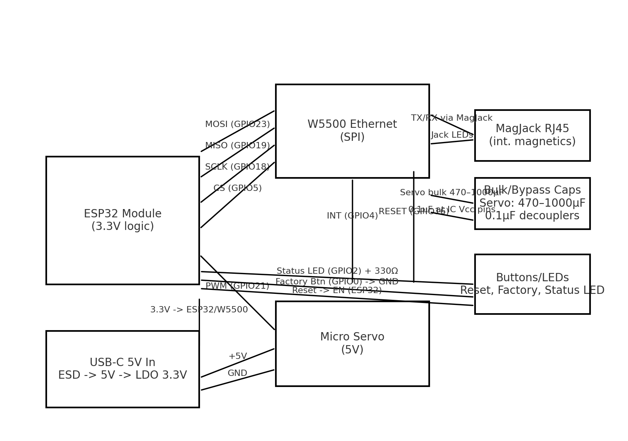
Function | ESP32 GPIO | W5500 Pin | Notes
SPI MOSI | GPIO23 | MOSI | Series 33–68Ω optional
SPI MISO | GPIO19 | MISO | 10k pull‑up optional
SPI SCLK | GPIO18 | SCLK | No stubs
Chip Select | GPIO5 | SCSn | 10k pull‑up to 3.3V
Interrupt | GPIO4 | INTn | Active low; 10k pull‑up
Reset | GPIO16 | RSTn | Active low
3.3V | — | VDD | 0.1 µF + 4.7 µF near VDD
GND | — | GND | Solid return
RJ45 Tx/Rx | — | TX±, RX± | Through magjack
Servo PWM | GPIO21 | — | Servo signal
Servo +5V | — | — | 470–1000 µF near connector
Status LED | GPIO2 | — | 330Ω series
Factory Btn | GPIO0 | — | To GND; internal pull‑up
Reset Btn | EN | — | Momentary to GND

Variant B: ESP32 + LAN8720 (RMII Ethernet PHY)
Use clean 50 MHz reference; length‑match RMII. Follow vendor reference design for straps and magnetics.
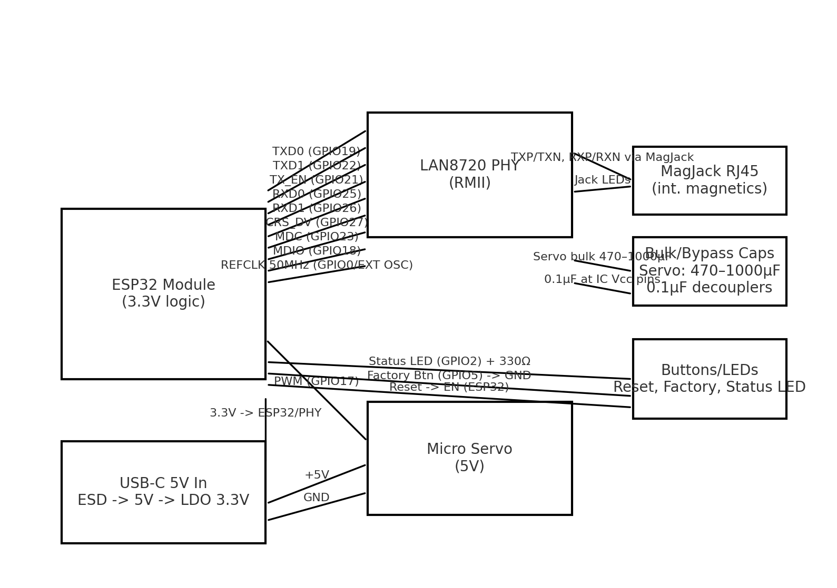
Function | ESP32 GPIO | LAN8720 Pin | Notes
TXD0 | GPIO19 | TXD0 | Length‑match
TXD1 | GPIO22 | TXD1 | Length‑match
TX_EN | GPIO21 | TXEN | —
RXD0 | GPIO25 | RXD0 | —
RXD1 | GPIO26 | RXD1 | —
CRS_DV | GPIO27 | CRS_DV | —
MDC | GPIO23 | MDC | —
MDIO | GPIO18 | MDIO | Pull‑up 1.5–4.7k
REFCLK 50 MHz | GPIO0 / ext | XTAL1/CLKIN | Prefer ext 50 MHz
3.3V | — | VDDIO/VDDCR | 0.1 µF + 10 µF
GND | — | GND | Solid plane
RJ45 MDI | — | TXP/TXN, RXP/RXN | Via magjack; TVS @ jack
Servo PWM | GPIO17 | — | Servo signal
Status LED | GPIO2 | — | 330Ω series
Factory Btn | GPIO5 | — | To GND; internal pull‑up
Reset Btn | EN | — | Momentary to GND

11. Protection & Power Notes
• Place a TVS diode at USB‑C 5 V input and an ESD array at RJ45. • Recommended regulator: ≥600 mA 3.3 V LDO/buck; check transient response (Wi‑Fi bursts). • Keep servo on 5 V with its own bulk capacitor; route high‑current returns away from signal grounds. • If servo noise couples into ESP32, add an LC filter (≈2.2 µH + 100 µF) to the servo branch.

Finalized Variant: ESP32 + W5500 (SPI Ethernet)
This section locks the design to the W5500 SPI Ethernet interface. It includes exact GPIO mapping, power tree, protection parts, servo connector specification, and a bring‑up test plan. Use this as the implementation baseline.

W5500 Pin Mapping (Final)
Function | ESP32 GPIO | W5500 Pin / Node | Notes
SPI MOSI | GPIO23 | MOSI | Series 33–68 Ω optional near ESP32
SPI MISO | GPIO19 | MISO | Optional 10 kΩ pull‑up to 3.3 V
SPI SCLK | GPIO18 | SCLK | Keep short, no stubs
Chip Select | GPIO5 | SCSn | 10 kΩ pull‑up to 3.3 V
Interrupt | GPIO4 | INTn | Active‑low; 10 kΩ pull‑up
Reset | GPIO16 | RSTn | Active‑low; allow manual reset via MCU
3.3 V | — | VDD | 0.1 µF + 4.7 µF at each VDD pin
GND | — | GND | Solid ground plane
RJ45 Pairs | — | TX±, RX± | Magjack with integrated magnetics
Status LED | GPIO2 | — | 330 Ω to LED anode → GND
Factory Button | GPIO0 | — | Momentary to GND, internal pull‑up
Reset Button | EN (ESP32) | — | Momentary to GND
Servo PWM | GPIO21 | — | To servo signal (5 V tolerant at servo)
Servo +5 V | — | — | Dedicated 470–1000 µF bulk cap near header

Preliminary BOM (W5500 Variant)
Item | Part / Example | Qty | Notes | Footprint
MCU | ESP32‑WROOM‑32E | 1 | Wi‑Fi, 3.3 V logic | Castellated module
Ethernet | W5500 | 1 | SPI Ethernet controller | QFN/TQFP
RJ45 Magjack | Hanrun HR911105A (or equiv.) | 1 | Integrated magnetics + LEDs | RJ45 TH
USB‑C Receptacle | USB Type‑C 16‑pin | 1 | 5 V only, no PD | SMD/TH hybrid
CC Resistors | 5.1 kΩ 1% to CC1/CC2 | 2 | Advertise as UFP (sink) | 0603
TVS (USB) | SMAJ5.0A (or SMF5.0A) | 1 | 5 V rail surge clamp | SMA/SMF
ESD (RJ45) | Semtech RClamp0512TQ (or Littelfuse SP3012‑06UTG) | 1 | Ethernet ESD protection | QFN/µDFN
Regulator 3.3 V | AP2112K‑3.3 (600 mA) or MP1584 buck | 1 | ESP32 + W5500 rail | SOT‑23‑5 / Module
Bulk Caps | 100 µF 6.3 V low‑ESR | 2 | 5 V & 3.3 V rails | 1206/1210
Bypass Caps | 0.1 µF X7R | 8–12 | Near VDD pins | 0603
Servo Bulk | 470–1000 µF 6.3 V | 1 | Near servo header | Radial/SMD
Status LED | Any 0603 LED | 1 | Green or blue | 0603
LED Resistor | 330 Ω 1% | 1 | LED series | 0603
Factory Button | Tactile, top‑actuated | 1 | GPIO0→GND | SMD/TH
Reset Button | Tactile, top‑actuated | 1 | EN→GND | SMD/TH
Servo Header | JST‑PH‑3 (2.0 mm) | 1 | GND / +5 V / Signal | TH
Mounting | M2.5/M3 standoffs | 4 | Board mounting | —

Servo Connector Specification (JST‑PH‑3)
Pinout (board silkscreen from left to right when header key notch faces up):
• Pin 1: GND (black/brown)
• Pin 2: +5 V (red)
• Pin 3: SIGNAL (white/orange) → ESP32 GPIO21 via 100 Ω series (optional)
Recommendations: place the 470–1000 µF bulk capacitor within 10–20 mm of the header; route the signal away from the RJ45 and high di/dt loops. Provide a 3‑pin 2.54 mm adapter on the harness if needed for common servo cables.

Power Tree & Protection
USB‑C 5 V → TVS (SMAJ5.0A) → main 5 V rail → branches:
• Branch A: 3.3 V regulator → ESP32 + W5500 + logic (decouple with 0.1 µF per VDD and 4.7–10 µF per IC).
• Branch B: Servo 5 V with 470–1000 µF bulk near connector. Consider LC filter (≈2.2 µH + 100 µF) if noise affects logic.
RJ45: place ESD array (RClamp0512TQ or SP3012‑06UTG) at connector pins; short return to chassis/ground.
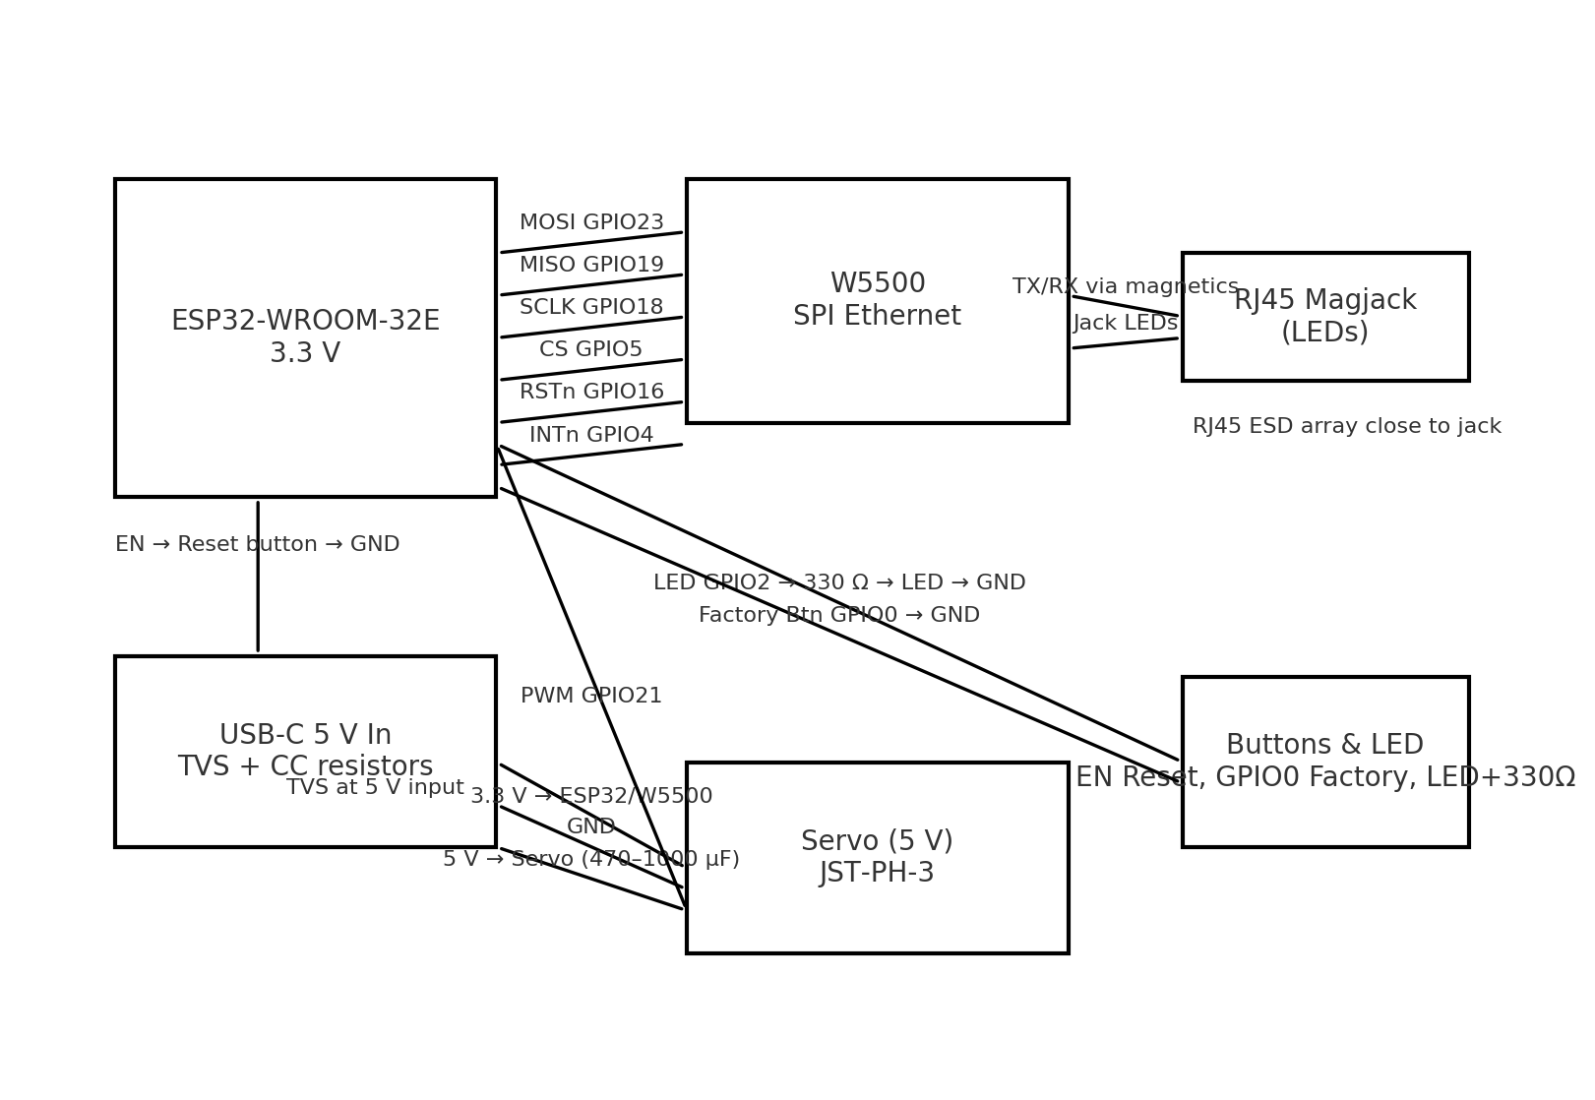

Bring‑Up & Test Checklist (W5500)
1) Power‑only test: no servo connected. Verify 5.0 V and 3.3 V rails; ripple under Wi‑Fi burst <100 mVpp.
2) Flash firmware; confirm web UI on Ethernet (default static IP) and Wi‑Fi AP SSID.
3) SPI loop: read W5500 version register (0x0039 expected = 0x04).
4) Link check: RJ45 LEDs and DHCP/static IP; ping from laptop.
5) Servo test: connect servo, verify idle current and motion at 1.0–2.0 ms PWM; tune ‘short’ (200 ms) and ‘long’ (5 s).
6) Factory reset: hold GPIO0 button during boot ≥10 s; confirm defaults restored.
7) EMI sanity: actuate servo repeatedly while streaming pings; check for packet loss; add LC filter if needed.

