***Development***

**Q: 01 Click the Exhibit button.**

**Given the fully-qualified class names:**

**com.foo.bar.Dog**

**com.foo.bar.blatz.Book**

**com.bar.Car**

**com.bar.blatz.Sun**

**Which graph represents the correct directory structure for a JAR file from which those classes can be used by the compiler and JVM?**

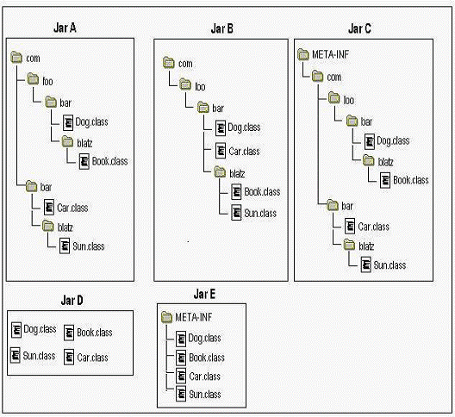

A. Jar A

B. Jar B

C. Jar C

D. Jar D

E. Jar E

**Q: 02**

**A class games.cards.Poker is correctly defined in the jar file Poker.jar. A user**

**wants to execute the main method of Poker on a UNIX system using the command:**

**java games.cards.PokerWhat allows the user to do this?**

A. put Poker.jar in directory /stuff/java, and set the CLASSPATH to include /stuff/java

B. put Poker.jar in directory /stuff/java, and set the CLASSPATH to include /stuff/java/*.jar

C. Put Poker.jar in directory /stuff/java, and set the CLASSPATH to include /stuff/java/Poker.jar

D. put Poker.jar in directory /stuff/java/games/cards, and set the CLASSPATH to include /stuff/java

E. put Poker.jar in directory /stuff/java/games/cards, and set the CLASSPATH to include /stuff/java/*.jar

F. put Poker.jar in directory /stuff/java/games/cards, and set the CLASSPATH to include /stuff/java/Poker.jar

**Q: 03 Given:**

**11. public class Commander {**

**12. public static void main(String[] args) {**

**13. String myProp = /* insert code here */**

**14. System.out.println(myProp);**

**15. }**

**16. }**

**and the command line:**

**java -Dprop.custom=gobstopper Commander**

**Which two, placed on line 13, will produce the output gobstopper? (Choose two.)**

A. System.load("prop.custom");

B. System.getenv("prop.custom");

C. System.property("prop.custom");

D. System.getProperty("prop.custom");

E. System.getProperties().getProperty("prop.custom");

**Q: 04**

**A developer is creating a class Book, that needs to access class Paper. The**

**Paper class is deployed in a JAR named myLib.jar. Which three, taken independently, will allow thedeveloper to use the Paper class while compiling the Book class? (Choose three.)**

A. The JAR file is located at $JAVA_HOME/jre/classes/myLib.jar.

B. The JAR file is located at $JAVA_HOME/jre/lib/ext/myLib.jar..

C. The JAR file is located at /foo/myLib.jar and a classpath environment variable is set that includes

/foo/myLib.jar/Paper.class.

D. The JAR file is located at /foo/myLib.jar and a classpath environment variable is set that includes

/foo/myLib.jar.

E. The JAR file is located at /foo/myLib.jar and the Book class is compiled using javac -cp /foo/myLib.jar/Paper Book.java.

F. The JAR file is located at /foo/myLib.jar and the Book class is compiled using javac -d /foo/myLib.jar

Book.java

G. The JAR file is located at /foo/myLib.jar and the Book class is compiled using javac -classpath

/foo/myLib.jar Book.java

**Q: 05 Click the Task button.**

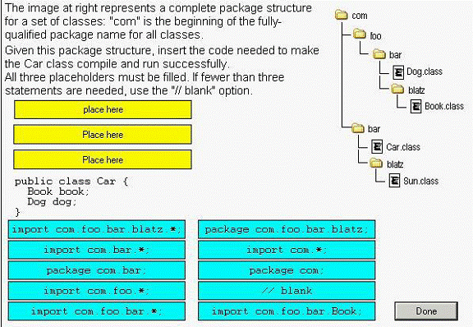

**Q: 06 Given:**

**1. package com.company.application;**

**2.**

**3. public class MainClass {**

**4. public static void main(String[] args) {}**

**5. }**

**And MainClass exists in the /apps/com/company/application directory. Assume the CLASSPATH**

**environment variable is set to "." (current directory).**

**Which two java commands entered at the command line will run MainClass? (Choose two.)**

A. java MainClass if run from the /apps directory

B. java com.company.application.MainClass if run from the /apps directory

C. java -classpath /apps com.company.application.MainClass if run from any directory

D. java -classpath . MainClass if run from the /apps/com/company/application directory

E. java -classpath /apps/com/company/application:. MainClass if run from the /apps directory

F. java com.company.application.MainClass if run from the /apps/com/company/application directory

**Q: 07 Given a correctly compiled class whose source code is:**

**1. package com.sun.sjcp;**

**2. public class Commander {**

**3. public static void main(String[] args) {**

**4. // more code here**

**5. }**

**6. }**

**Assume that the class file is located in /foo/com/sun/sjcp/, the current directory is /foo/, and that the classpath contains "." (current directory).**

**Which command line correctly runs Commander?**

A. java Commander

B. java com.sun.sjcp.Commander

C. java com/sun/sjcp/Commander

D. java -cp com.sun.sjcp Commander

E. java -cp com/sun/sjcp Commander

**Q: 08**

**A UNIX user named Bob wants to replace his chess program with a new one,**

**but he is not sure where the old one is installed. Bob is currently able to run a Java chess program starting from his home directory /home/bob using the command:**

**java -classpath /test:/home/bob/downloads/*.jar games.**

**Chess Bob's CLASSPATH is set (at login time) to:**

**/usr/lib:/home/bob/classes:/opt/java/lib:/opt/java/lib/*.jar**

**What is a possible location for the Chess.class file?**

A. /test/Chess.class

B. /home/bob/Chess.class

C. /test/games/Chess.class

D. /usr/lib/games/Chess.class

E. /home/bob/games/Chess.class

F. inside jarfile /opt/java/lib/Games.jar (with a correct manifest)

G. inside jarfile /home/bob/downloads/Games.jar (with a correct manifest)

**09. Given these classes in different files:**

**package xcom;**

**public class Useful {**

**int increment(int x) { return ++x; }**

**}**

**import xcom.*; // line 1**

**class Needy3 {**

**public static void main(String[] args) {**

**xcom.Useful u = new xcom.Useful(); // line 2**

**System.out.println(u.increment(5));**

**}**

**}**

**Which statements are true? (Choose all that apply.)**

A. The output is 0. B. The output is 5.

C. The output is 6. D. Compilation fails.

E. The code compiles if line 1 is removed.

F. The code compiles if line 2 is changed to read

Useful u = new Useful();

**10. Given the following directory structure:**

**org**

**| -- Robot.class**

**|**

**| -- ex**

**|-- Pet.class**

**|**

**|-- why**

**|-- Dog.class**

**And the following source file:**

**class MyClass {**

**Robot r;**

**Pet p;**

**Dog d;**

**}**

**Which statement(s)** *must* **be added for the source file to compile? (Choose all that apply.)**

A. package org;

B. import org.*;

C. package org.*;

D. package org.ex;

E. import org.ex.*;

F. package org.ex.why;

G. package org.ex.why.Dog;

**11. Given:**

**1. // insert code here**

**2. class StatTest {**

**3. public static void main(String[] args) {**

**4. System.out.println(Integer.MAX_VALUE);**

**5. }**

**6. }**

**Which, inserted independently at line 1, compiles? (Choose all that apply.)**

A. import static java.lang;

B. import static java.lang.Integer;

C. import static java.lang.Integer.*;

D. import static java.lang.Integer.*_VALUE;

E. import static java.lang.Integer.MAX_VALUE;

F. None of the above statements are valid import syntax.

**12. Given the default classpath:**

**/foo**

**And this directory structure:**

**foo**

**|**

**test**

**|**

**xcom**

**|--A.class**

**|--B.java**

**And these two files:**

**package xcom;**

**public class A { }**

**package xcom;**

**public class B extends A { }**

**Which allows B.java to compile? (Choose all that apply.)**

A. Set the current directory to xcom then invoke

javac B.java

B. Set the current directory to xcom then invoke

javac -classpath . B.java

C. Set the current directory to test then invoke

javac -classpath . xcom/B.java

D. Set the current directory to test then invoke

javac -classpath xcom B.java

E. Set the current directory to test then invoke

javac -classpath xcom:. B.java

**13. Given two files:**

**package xcom;**

**public class Stuff {**

**public static final int MY_CONSTANT = 5;**

**public static int doStuff(int x) { return (x++)*x; }**

**}**

**import xcom.Stuff.*;**

**import java.lang.System.out;**

**class User {**

**public static void main(String[] args) {**

**new User().go();**

**}**

**void go() { out.println(doStuff(MY_CONSTANT)); }**

**}**

**What is the result?**

A. 25

B. 30

C. 36

D. Compilation fails.

E. An exception is thrown at runtime.

**14. Given three files:**

**package xcom;**

**public class A {**

**// insert code here**

**}**

**package xcom;**

**public class B extends A {public void doB() { System.out.println("B.doB"); } }**

**import xcom.B;**

**class TestXcom {**

**public static void main(String[] args) {**

**B b = new B(); b.doB(); b.go();**

**}**

**}**

**Which, inserted at // insert code here will allow all three files to compile? (Choose all**

**that apply.)**

A. void go() { System.out.println("a.go"); }

B. public void go() { System.out.println("a.go"); }

C. private void go() { System.out.println("a.go"); }

D. protected void go() { System.out.println("a.go"); }

E. None of these options will allow the code to compile.

**15. Given:**

**class TestProps {**

**public static void main(String[] args) {**

**String s = System.getProperty("aaa","bbb");**

**}**

**}**

**And the command-line invocation:**

**java -Daaa=ccc TestProps**

**What is always true? (Choose all that apply.)**

A. The value of property aaa is aaa.

B. The value of property aaa is bbb.

C. The value of property aaa is ccc.

D. The value of property bbb is aaa.

E. The value of property bbb is ccc.

F. The invocation will not complete without error.

**16.** If three versions of MyClass.java exist on a file system:

Version 1 is in /foo/bar

Version 2 is in /foo/bar/baz

Version 3 is in /foo/bar/baz/bing

And the system's classpath includes:

/foo/bar/baz

And this command line is invoked from /foo

javac -classpath /foo/bar/baz/bing:/foo/bar MyClass.java

Which version will be used by javac?

A. /foo/MyClass.java

B. /foo/bar/MyClass.java

C. /foo/bar/baz/MyClass.java

D. /foo/bar/baz/bing/MyClass.java

E. The result is not predictable.

**17. Which are true? (Choose all that apply.)**

A. The java command can access classes from more than one package, from a single JAR file.

B. JAR files can be used with the java command but not with the javac command.

C. In order for JAR files to be used by java, they MUST be placed in the /jre/lib/ext subdirectory

within the J2SE directory tree.

D. In order to specify the use of a JAR file on the command line, the JAR file's path and

filename MUST be included.

E. When a part of a directory tree that includes subdirectories with files is put into a JAR file, all of the files are saved in the JAR file, but the subdirectory structure is lost.

**18. Given two files:**

**package pkg;**

**public class Kit {**

**public String glueIt(String a, String b) { return a+b; }**

**}**

**import pkg.*;**

**class UseKit {**

**public static void main(String[] args) {**

**String s = new Kit().glueIt(args[1], args[2]);**

**System.out.println(s);**

**}**

**}**

**And the following sub-directory structure:**

**test**

**|--UseKit.class**

**|**

**com**

**|--KitJar.jar**

**If the current directory is test, and the file pkg/Kit.class is in KitJar.jar, which command line will produce the output bc ? (Choose all that apply.)**

A. java UseKit b c

B. java UseKit a b c

C. java -classpath com UseKit b c

D. java -classpath com:. UseKit b c

E. java -classpath com/KitJar.jar UseKit b c

F. java -classpath com/KitJar.jar UseKit a b c

G. java -classpath com/KitJar.jar:. UseKit b c

H. java -classpath com/KitJar.jar:. UseKit a b c