Collections and Generics

Q: 04 Click the Task button.
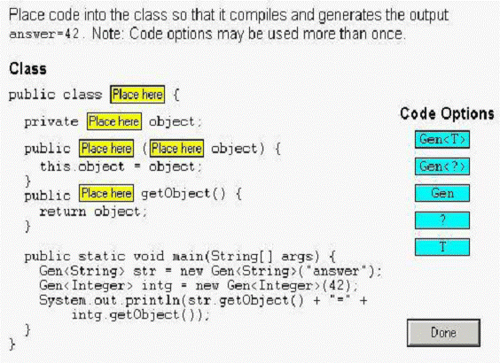

Solution:
1.Gen<T>
2.T
3.Gen
4.T
5.T

Q: 05 Click the Task button.
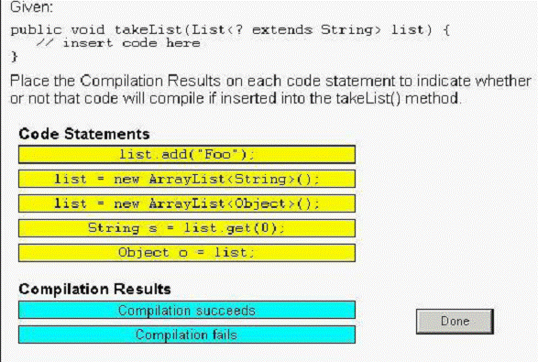

Solution:
1. list.add("foo"); ----------- Compilation fails
2. list = new ArrayList<String>(); ------Compilation succeeds
3.list=new ArrayList<Object>( ); ---- Compilation fails
4. String s = list.get(0); ------ Compilation succeeds
5. Object o = list; ----- Compilation succeeds

Q: 07 Given:
1. import java.util.*;
2. public class Old {
3. public static Object get0(List list) {
4. return list.get(0);
5. }
6. }
Which three will compile successfully? (Choose three.)
A. Object o = Old.get0(new LinkedList());
B. Object o = Old.get0(new LinkedList<?>());
C. String s = Old.get0(new LinkedList<String>());
D. Object o = Old.get0(new LinkedList<Object>());
E. String s = (String)Old.get0(new LinkedList<String>());
Answer: A, D, E

Q:10 given
Click the Task button.
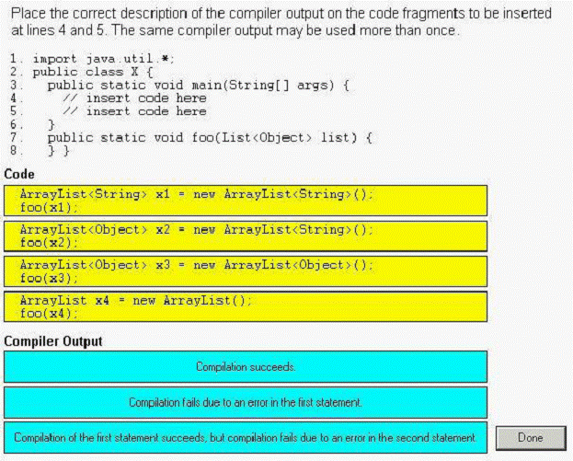
Solution:
- Compilation of the first statement succeeds ,but compilation fails due to an error in the second statement.
- Compilation fails due to an error in the first statement
- Compilation succeeds
4. Compilation succeeds

Q: 12 Click the Task button.
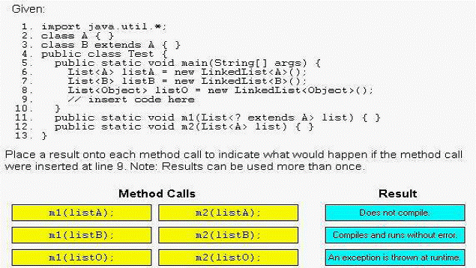
============does not compile================
1.m1(listO );
2.m2(listB);
3.m2(listO);
=====compiles and runs with out error=========
1.m1(listA);
2.m1(listB);
3.m2(listA);

Q: 16 Given a pre-generics implementation of a method:
11. public static int sum(List list) {
12. int sum = 0;
13. for ( Iterator iter = list.iterator(); iter.hasNext(); ) {
14. int i = ((Integer)iter.next()).intValue();
15. sum += i;
16. }
17. return sum;
18. }
Which three changes must be made to the method sum to use generics? (Choose three.)
A. remove line 14
B. replace line 14 with "int i = iter.next();"
C. replace line 13 with "for (int i : intList) {"
D. replace line 13 with "for (Iterator iter : intList) {"
E. replace the method declaration with "sum(List<int> intList)"
F. replace the method declaration with "sum(List<Integer> intList)"
Answer: A, C, F

Q: 17 Given:
11. // insert code here
12. private N min, max;
13. public N getMin() { return min; }
14. public N getMax() { return max; }
15. public void add(N added) {
16. if (min == null || added.doubleValue() < min.doubleValue()) 17. min = added;
18. if (max == null || added.doubleValue() > max.doubleValue()) 19. max = added;
20. }
21. }
Which two, inserted at line 11, will allow the code to compile? (Choose two.)
A. public class MinMax<?> {
B. public class MinMax<? extends Number> {
C. public class MinMax<N extends Object> {
D. public class MinMax<N extends Number> {
E. public class MinMax<? extends Object> {
F. public class MinMax<N extends Integer> {
Answer: D, F

Q: 19 Click the Task button.
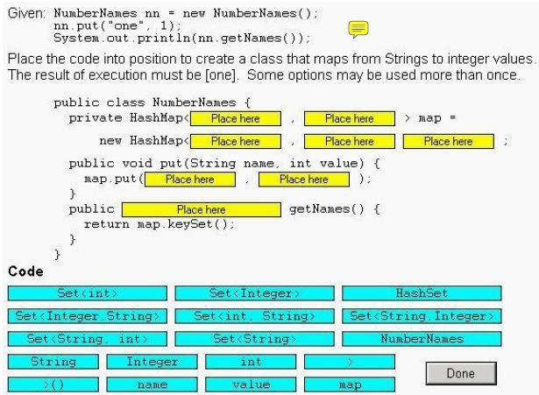
Solution:
public class NumberNames{
private HashMap< String , Integer> map=
new HashMap< String , Integer >( );
public void put(String name . int Value) {
map.put(name , Value);
}
public Set<String> getNames( ) {
return map.keySet( );
}
}

Q: 24 Given:
10. interface A { void x(); }
11. class B implements A { public void x() {} public void y() {} }
12. class C extends B { public void x() {} }
And:
20. java.util.List<A> list = new java.util.ArrayList<A>();
21. list.add(new B());
22. list.add(new C());
23. for (A a : list) {
24. a.x();
25. a.y();
26. }
What is the result?
A. The code runs with no output.
B. An exception is thrown at runtime.
C. Compilation fails because of an error in line 20.
D. Compilation fails because of an error in line 21.
E. Compilation fails because of an error in line 23.
F. Compilation fails because of an error in line 25.
Answer: F

Q: 26 Given:

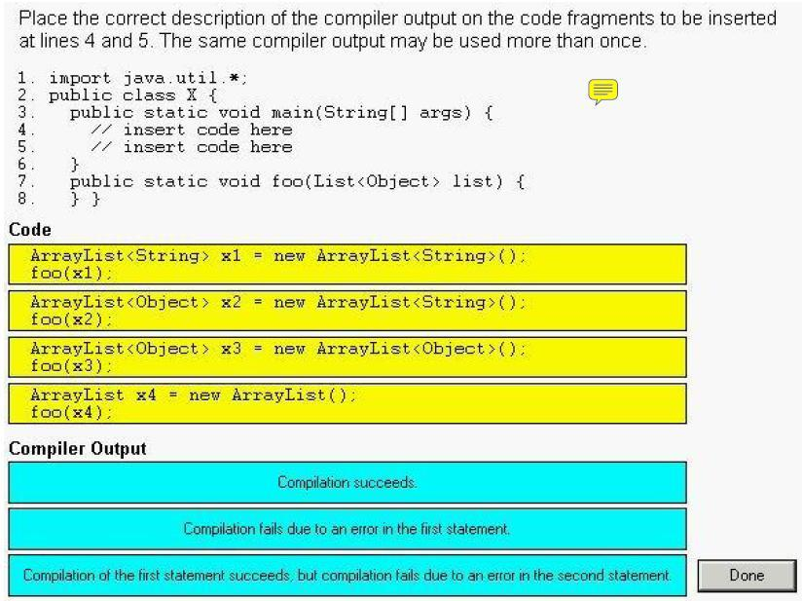

Solution:
- Compilation of the first statement succeeds ,but compilation fails due to an error in the second statement.
- Compilation fails due to an error in the first statement
- Compilation succeeds
- Compilation succeeds

Q: 26 Click the Task button.
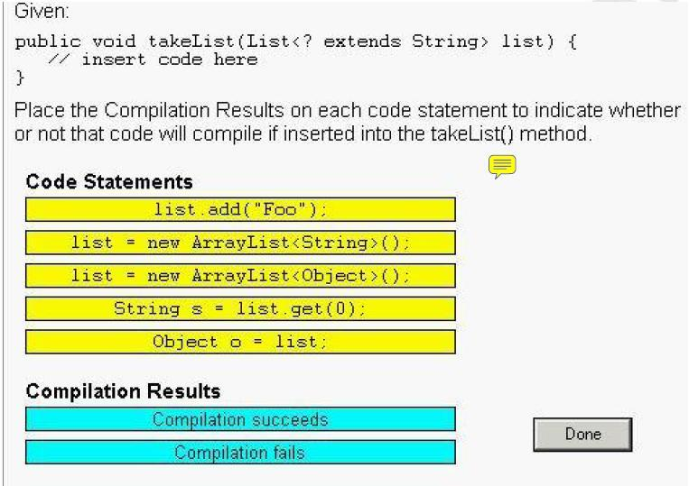
Solution:
1. list.add("foo"); ----------- Compilation fails
2. list = new ArrayList<String>(); ------Compilation succeeds
3.list=new ArrayList<Object>( ); ---- Compilation fails
4. String s = list.get(0); ------ Compilation succeeds
5. Object o = list; ----- Compilation succeeds

Q: 32 Given:
11. public static void append(List list) { list.add("0042"); }
12. public static void main(String[] args) {
13. List<Integer> intList = new ArrayList<Integer>();
14. append(intList);
15. System.out.println(intList.get(0));
16. }
What is the result?
A. 42
B. 0042
C. An exception is thrown at runtime.
D. Compilation fails because of an error in line 13.
E. Compilation fails because of an error in line 14.
Answer: B

Q: 34
A programmer must create a generic class MinMax and the type parameter
of MinMax must implement Comparable. Which implementation of MinMax will compile?
A. class MinMax<E extends Comparable<E>> {
E min = null;
E max = null;
public MinMax() {}
public void put(E value) { /* store min or max */ }

B. class MinMax<E implements Comparable<E>> {
E min = null;
E max = null;
public MinMax() {}
public void put(E value) { /* store min or max */ }

C. class MinMax<E extends Comparable<E>> {
<E> E min = null;
<E> E max = null;
public MinMax() {}
public <E> void put(E value) { /* store min or max */ }

D. class MinMax<E implements Comparable<E>> {
<E> E min = null;
<E> E max = null;
public MinMax() {}
public <E> void put(E value) { /* store min or max */ }

Answer: A

Question: 36
Given:
1. public class Score implements Comparable<Score> {
2. private int wins, losses;
3. public Score(int w, int 1) { wins = w; losses = 1; }
4. public int getWins() { return wins; }
5. public int getLosses() { return losses; }
6. public String toString() {
7. return “<“ + wins + “,“ + losses + “>”;
8. }
9. // insert code here
10. }
Which method will complete this class?
A. public int compareTo(Object o) {/*mode code here*/}
B. public int compareTo(Score other) {/*more code here*/}
C. public int compare(Score s1,Score s2){/*more code here*/}
D. public int compare(Object o1,Object o2){/*more code here*/}
Answer: B

Question: 38
Given:
1. import java.util.*;
2. public class Test {
3. public static void main(String[] args) {
4. List<String> strings = new ArrayList<String>();
5. // insert code here
6. }
7. }
Which four, inserted at line 5, will allow compilation to succeed?
(Choose four.)
A. String s = strings.get(0);
B. Iterator i1 = strings.iterator();
C. String[] array1 = strings.toArray();
D. Iterator<String> i2 = strings.iterator();
E. String[] array2 = strings.toArray(new String[1]);
F. Iterator<String> i3 = strings.iterator<String>();
Answer: ABDE

Question: 39
Given:
classA {}
class B extends A {}
class C extends A {}
class D extends B {}
Which three statements are true? (Choose three.)
A. The type List<A> is assignable to List.
B. The type List<B> is assignable to List<A>.
C. The type List<Object> is assignable to List<?>.
D. The type List<D> is assignable to List<? extends B>.
E. The type List<? extends A> is assignable to List<A>.
F. The type List<Object> is assignable to any List reference.
G. The type List<? extends B> is assignable to List<? extends A>.
Answer: CDG

Question:40
Given:
11. public void addStrings(List list) {
12. list.add(”foo”);
13. list.add(”bar”);
14. }
What must you change in this method to compile without warnings?
A. add this code after line 11:
list = (List<String>) list;
B. change lines 12 and 13 to:
list.add<String>(”foo”);
list.add<String>(”bar”);
C. change the method signature on line 11 to:
public void addStrings(List<? extends String> list) {
D. change the method signature on line 11 to:
public void addStrings(List<? super String> list) {
E. No changes are necessary. This method compiles without warnings.
Answer: D

Question: 41
Given:
1. public class Test {
2. public <T extends Comparable> T findLarger(T x, T y) {
3. if(x.compareTo(y) > 0) {
4. return x;
5. } else {
6. return y;
7. }
8. }
9. }
and:
22. Test t = new Test();
23. // insert code here
Which two will compile without errors when inserted at line 23?
(Choose two.)
A. Object x = t.findLarger(123, “456”);
B. int x = t.findLarger(123, new Double(456));
C. int x = t.findLarger(123, new Integer(456));
D. int x = (int) t.findLarger(new Double(123), new Double(456));
Answer: AC

45. Given:
import java.util.*;
class Test {
public static void main(String[] args) {
// insert code here
x.add("one");
x.add("two");
x.add("TWO");
System.out.println(x.poll());
}
}
Which, inserted at // insert code here, will compile? (Choose all that apply.)
A. List<String> x = new LinkedList<String>();
B. TreeSet<String> x = new TreeSet<String>();
C. HashSet<String> x = new HashSet<String>();
D. Queue<String> x = new PriorityQueue<String>();
E. ArrayList<String> x = new ArrayList<String>();
F. LinkedList<String> x = new LinkedList<String>();
Answer:
-> D and F are correct. The poll() method is associated with Queues. The LinkedList class implements the Queue interface.
->A is incorrect because the List interface does not implement Queue,

53. Given:
interface Hungry<E> { void munch(E x); }
interface Carnivore<E extends Animal> extends Hungry<E> {}
interface Herbivore<E extends Plant> extends Hungry<E> {}
abstract class Plant {}
class Grass extends Plant {}
abstract class Animal {}
class Sheep extends Animal implements Herbivore<Sheep> {
public void munch(Sheep x) {}
}
class Wolf extends Animal implements Carnivore<Sheep> {
public void munch(Sheep x) {}
}
Which of the following changes (taken separately) would allow this code to compile?
(Choose all that apply.)
A. Change the Carnivore interface to
interface Carnivore<E extends Plant> extends Hungry<E> {}
B. Change the Herbivore interface to
interface Herbivore<E extends Animal> extends Hungry<E> {}
C. Change the Sheep class to
class Sheep extends Animal implements Herbivore<Plant> {
public void munch(Grass x) {}
}
D. Change the Sheep class to
class Sheep extends Plant implements Carnivore<Wolf> {
public void munch(Wolf x) {}
}
E. Change the Wolf class to
class Wolf extends Animal implements Herbivore<Grass> {
public void munch(Grass x) {}
}
F. No changes are necessary.
Answer:
-> B is correct. The problem with the original code is that Sheep tries to implement
Herbivore<Sheep> and Herbivore declares that its type parameter E can be any type that extends Plant. Since a Sheep is not a Plant, Herbivore<Sheep> makes no sense— the type Sheep is outside the allowed range of Herbivore's parameter E. Only solutions that either alter the definition of a Sheep or alter the definition of Herbivore will be able to fix this. So A, E, and F are eliminated. B works, changing the definition of an Herbivore to allow it to eat Sheep solves the problem. C doesn't work because an Herbivore<Plant> must have a munch(Plant) method, not munch(Grass). And D doesn't work, because in D we made Sheep extend Plant, now the Wolf class breaks because its munch(Sheep) method no longer fulfills the contract of Carnivore.

57. Given that String implements java.lang.CharSequence, and:
import java.util.*;
public class LongWordFinder {
public static void main(String[] args) {
String[] array = { "123", "12345678", "1", "12", "1234567890"};
List<String> list = Arrays.asList(array);
Collection<String> resultList = getLongWords(list);
}
// INSERT DECLARATION HERE
{
Collection<E> longWords = new ArrayList<E>();
for (E word : coll)
if (word.length() > 6) longWords.add(word);
return longWords;
} }
Which declarations could be inserted at // INSERT DECLARATION HERE so that the program will compile and run? (Choose all that apply.)
A. public static <E extends CharSequence> Collection<? extends CharSequence>
getLongWords(Collection<E> coll)
B. public static <E extends CharSequence> List<E>
getLongWords(Collection<E> coll)
C. public static Collection<E extends CharSequence> getLongWords(Collection<E> coll)
D. public static List<CharSequence>
getLongWords(Collection<CharSequence> coll)
E. public static List<? extends CharSequence>
getLongWords(Collection<? extends CharSequence> coll)
F. static public <E extends CharSequence> Collection<E>
getLongWords(Collection<E> coll)
G. static public <E super CharSequence> Collection<E>
getLongWords(Collection<E> coll)
Answer:
-> F is correct.
-> A is close, but it's wrong because the return value is too vague. The last line of the
method expects the return value to be Collection<String>, not
Collection<? extends CharSequence>. B is wrong because longWords has been declared as a Collection<E>, and that can't be implicitly converted to a List<E> to match the declared return value. (Even though we know that longWords is really an ArrayList<E>, the compiler only know what it's been declared as.) C, D, and E are wrong because they do not declare a type variable E (there's no <> before the return value) so the getLongWords() method body will not compile. G is wrong because E super CharSequence makes no sense—super could be used in conjunction with a wildcard but not a type variable like E.

59. Given a method declared as:
public static <E extends Number> List<? super E> process(List<E> nums)
A programmer wants to use this method like this:
// INSERT DECLARATIONS HERE
output = process(input);
Which pairs of declarations could be placed at // INSERT DECLARATIONS HERE to allow the code to compile? (Choose all that apply.)

A. ArrayList<Integer> input = null;
ArrayList<Integer> output = null;
B. ArrayList<Integer> input = null;
List<Integer> output = null;
C. ArrayList<Integer> input = null;
List<Number> output = null;
D. List<Number> input = null;
ArrayList<Integer> output = null;
E. List<Number> input = null;
List<Number> output = null;
F. List<Integer> input = null;
List<Integer> output = null;
G. None of the above.
Answer:
->B, E, and F are correct.
-> The return type of process is definitely declared as a List, not an ArrayList, so A and D are wrong. C is wrong because the return type evaluates to List<Integer>, and that can't be assigned to a variable of type List<Number>. Of course all these would probably cause a NullPointerException since the variables are still null—but the question only asked us to get the code to compile.

