# Serena Deployment Automation plugin for Jenkins

* Install the sra-deploy.hpi file in to Jenkins using the Manage Jenkins -> Manage Plugins -> Advanced menu
* Go to Manage Jenkins -> Configure System and add a new Serena DA Server connection:

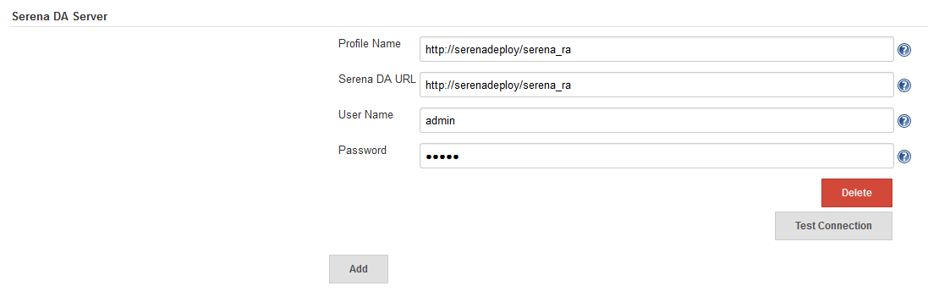

* Go to an existing Job and add a Post-Build Action for “Publish artifacts to Serena DA”.
* Enter the parameters for SDA (see screenshots as an example).
* In SDA, select None as the source type for the component you are uploading to as the plugin resides in Jenkins
* The plugin will optionally upload a new version into SDA using the built artefacts.
* The plugin will optionally create component version properties to the uploaded version.
* The plugin will optionally apply a status to the uploaded version.
* The plugin will optionally execute a process to deploy it.
* A parameter can be passed to the plugin to determine if deployment should occur. For example create a parameter "DeployFromSDA" as below and then in the plugin parameter "Deploy to Version if" reference this parameter.

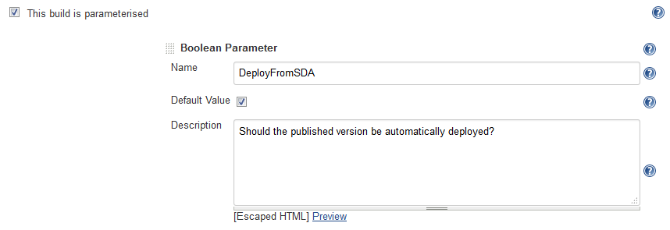

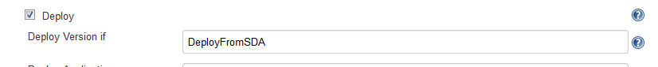

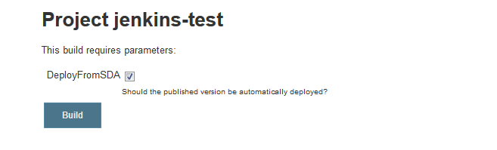

* The publishing and deployment can be run as a separate user from the global configuration by selecting “Use Another User” and entering the user’s credentials.

## Example Setup (1/2):

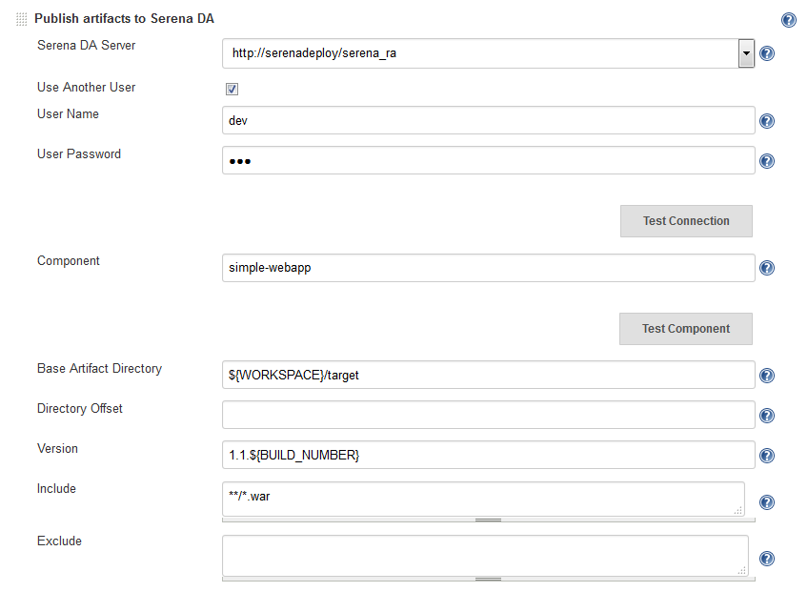

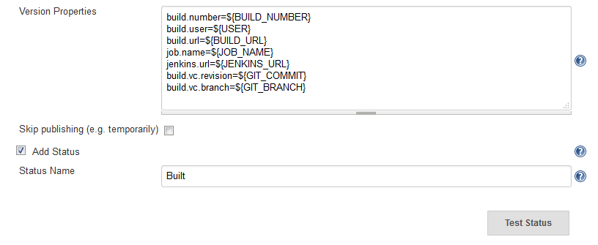

## Example Setup (2/2):

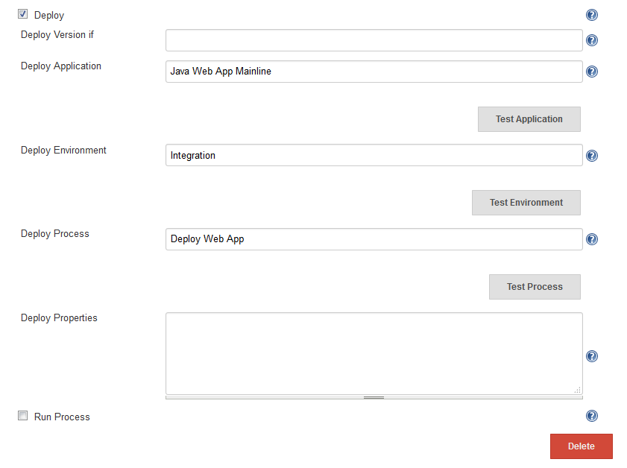

## Example Successful Build Output:

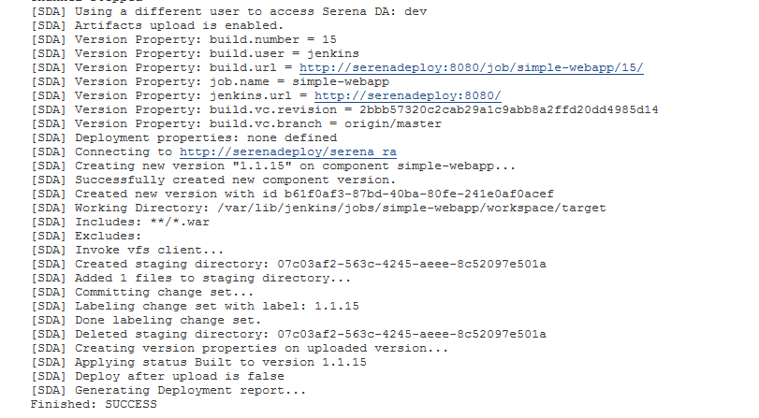

## Example Successful Serena Deploy Results:

