***API Gateway***

***General***

Part of AWS where API (REST functions) are defined, configured and tested

Has distinct areas:

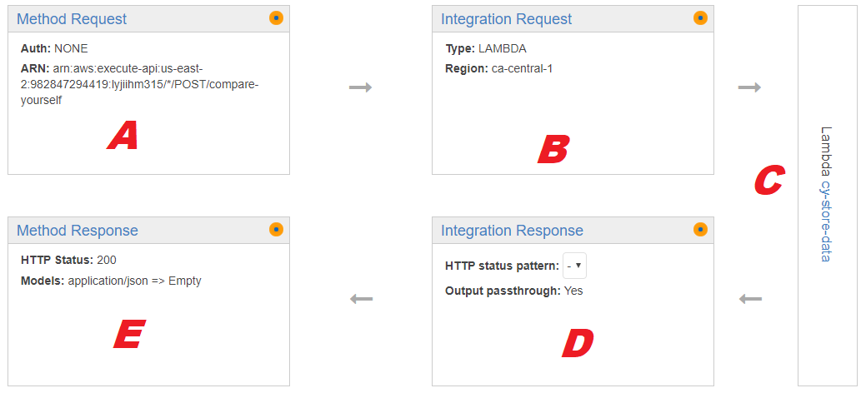

|  |  |
| --- | --- |
| ***Param*** | ***Description and Possible Content*** |
| ***A*** | Incoming Request: Define the HTTP parameters to be handled, and can reformat incoming information in the body of request |
| ***B*** | Incoming Processing: While the Method Request works on the reformatting and restructuring of the info coming in (Params in Headers, Values in Body), the real work and assignment of values is done in this section |
| ***C*** | Lambda Section: Where the Java or NodeJS code is implemented |
| ***D*** | Outcoming Processing: Mirror the function of the Integration Request, but with the outcoming info. All the reassignment of values from the output of the Lambda, and restructuring of the params and values going out is done here. |
| ***E*** | Outcoming Response: Set the structure of the response to the caller (headers params, variable to be passed back, etc) |

There are 3 possible variables to be passed to a Lambda NodeJS

|  |  |
| --- | --- |
| ***Param*** | ***Description and Possible Content*** |
| Event | Give the Body Info of the request  (i.e: if any JSON params are passed to the Lambda, they will be contained in the Event param)  exports.handler = (event, context, callback) => {  console.log( event ); //Will log all the params in the logger system  callback(null, event); //Will return all the param back to the caller  }; |
| Context |  |
| callback |  |

Lambda Header and Body related functions

Here are few code snippet that make easier to work with the HTTP headers (read param, change value of params, etc) or with the HTTP body.

***Cognito***

From API Gateaway Console, and if you click on a Method Request of a specific method.

***API Key (x-api-key)***

Many API requires an API Key to be sent in the HTTP header (x-api-key 🡪 Some Random Key)

From the APIGateway console, the left link ***API Keys*** give access to the key defined

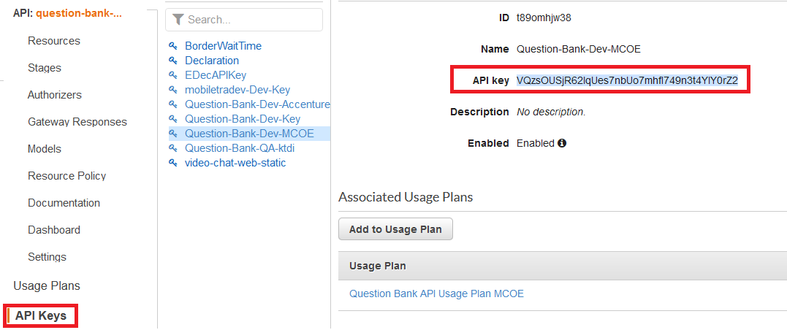

***Which API Key on which exposed APIGateway?***

There may be multiple API keys defined, the left link ***Usage Plans*** identify all the association API & API Keys

***Authorisation***

You can specify the type of Authorisation

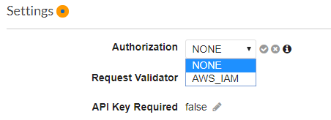

***CORS- Cross Origin Request***

In API gateaway, select a resource or method inside a resource (GET,POST) and in the button Action, you can see the CORS headers and option

|  |  |
| --- | --- |
|  | **‘Access-Control-Allow-Origin’** |

***Testing***

 Postman is a tool that facilitate the testing of REST and other type of API.

Download: <https://www.postman.com/downloads/>