***Create an EC2 instance***

Only the Amazon Linux 2 AMI (HVM), SSD Volume Type is free

Step 2,3 & 4 requires no change

Step 5: (tags)

Make sure to create a tag 'Name' with the name of the instance you want

Step 6: (Security Rules)

Add an HTTP rule for accessing the instance via HTTP (SSH come by default)

Also, put 'my IP' in the source

Next Step Click on launch instance

Step 7: identify and Download the key pair file (required to log with Putty)

Next make sure the Amazon network rules allow Echo Requests. Go to the Security Group for the EC2.

right click, select inbound rules

A: select Add Rule

B: Select Custom ICMP Rule - IPv4

C: Select Echo Request

D: Select either

***Connect to EC2 using Putty SSH Client***

Create an EC2 server (previous section)

In the AWS Console

1 - make sure to switch to the EC2 section

2 - Click on Launch Instance

3 - Select the server type Amazon Linux 2 AMI (HVM)

4 - Click on the Next button (bottom right), till you reach Add tags section

5 - Add a tag named 'Name' and with the value "My First Instance"

6 - Click on Launch Instance

7 - When asked to create a .pem file, save it to your local hard drive...

***Using Putty to log an SSH session***

Use ***PuttyGen*** to generate a .ppk file from the .pem file produced when you created you instance



Note: ***PuttyGen*** tool may not be installed in all Putty installation

Download and install Putty again if you can find PuttyGen.exe

1 - Start ***PuttyGen***

2 - From the File menu, select Load Private key

3 - Locate your private key file (pem file download during step 7 above

(Note: you may switch the file type to all file in the dialog box)

4 - Click on button Save Private Key

Find a location where to put your private key file (*.ppk file)

Make to note the IP adress of you EC2 instance create in the previous section (gave me 99.79.79.165)

The host name to use in Putty is your ip address with the prefix ec2.user [ec2-user@99.79.79.165](mailto:ec2-user@99.79.79.165)

***Transfer File to EC2 instance***

Use either the command line ***scp*** or its GUI version, ***WinSCP***



Here is the details on how to use ***WinSCP***

<https://asf.alaska.edu/how-to/data-recipes/moving-files-into-and-out-of-an-aws-ec2-instance-windows/>

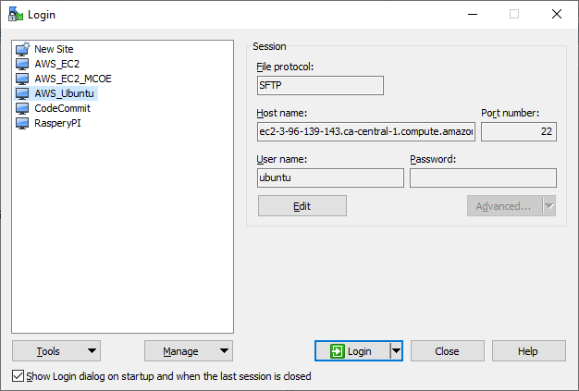

***Installation Hints***

Connect from the EC2 console, instead of using ***Putty***

You can have a console access from the AWS EC2 console.

There is a 'Connect' button on top of the screen

sudo su --> Elevate the privilige of your user

Note: the -y in the commands following means that you won't be prompted to confirm each package to be

downloaded and installed

***YUM*** 🡪 Some Linux Distro, like the AWS Linux 2 AMI are using a command line system called YUM.

Here is a cheat sheet of basic YUM commands:

<https://access.redhat.com/articles/yum-cheat-sheet>

And few other userfull commands

yum update -y --> Check for update

yum install -y httpd.x86_64 --> Install the httpd package on the server (x86_64 appears to be the 64 bits version)

systemctl start httpd.service

systemctl enable httpd.service

see the following page for details about the linux system control:

https://www.digitalocean.com/community/tutorials/how-to-use-systemctl-to-manage-systemd-services-and-units

systemctl list-units | grep .service --> Will list all the service on the system (remove the grep if you want to see all other types of deamons and threads)

EC2 User Data

-------------

You can add script to be run when the EC2 intance is built/started.

In AWS, when an instance is created, it recreate a Linux server from scratch.

The script can be added in the Step 3 of the creation of an EC2 instance

(Configure Instance Details)

Elastic IP

-----------

Can reserve a WWW IP that will be reassigned to our EC2 instances when we restart

Step 1 - Go to Elastic IP, and click on allocate

Step 2 - Right click on the ip address that is allocated

Step 3 - Associate to one of your EC2 instance

Note: The instance id is used for the association, not the instance name tag

YUM appears to be a command used for the Linux 2 server available on AWS.

https://www.tecmint.com/20-linux-yum-yellowdog-updater-modified-commands-for-package-mangement/