*Encryption*

Buckets can 4 encrypted. 4 different ways are possible

1. SSE-S3 is the one where AWS encryption system will be used
2. SSE-KMS is also a way where AWS encrypts on the server but using a KMS system
3. SSE-C , the client has to provide a key, but the encryption processing is done on server
4. Client Side Encryption, Client has to encrypt himself the data, and pass it to AWS S3

***SSE-S3 & SSE-KMS***

To use those 2 encryptions type, you can set them right in the AWS S3 console, when you upload a file into a specific bucket

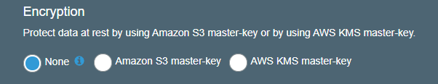

Bucket Policy: Popular way to control the encryption on bucket, and across many regions

JSON based 🡪 Define resource, Action (API) , Effect (Allow/Deny)

***Amazon Policy Generator***

Amazon gives a Web page to produce policy JSON files

<https://awspolicygen.s3.amazonaws.com/policygen.html>

***S3 as Web Site***

You can upload your HTML pages and images as normal file, and they can be served to the public

* Make sure to Enable in ***Block public access***

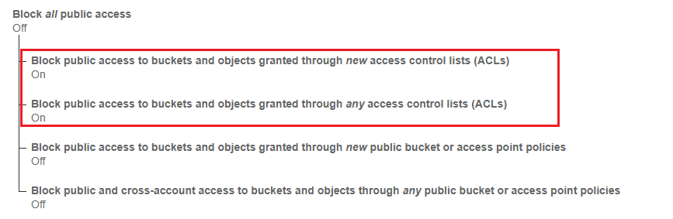

* Make sure that there is a Bucket policy to make visible

(Use AWS Policy generator to make the JSON policy file)

In the Property tab, make sure to set the Static Website hosting options…

