***File Transfer***

The transfer of file on an EC2 instance can be done with WinSCP

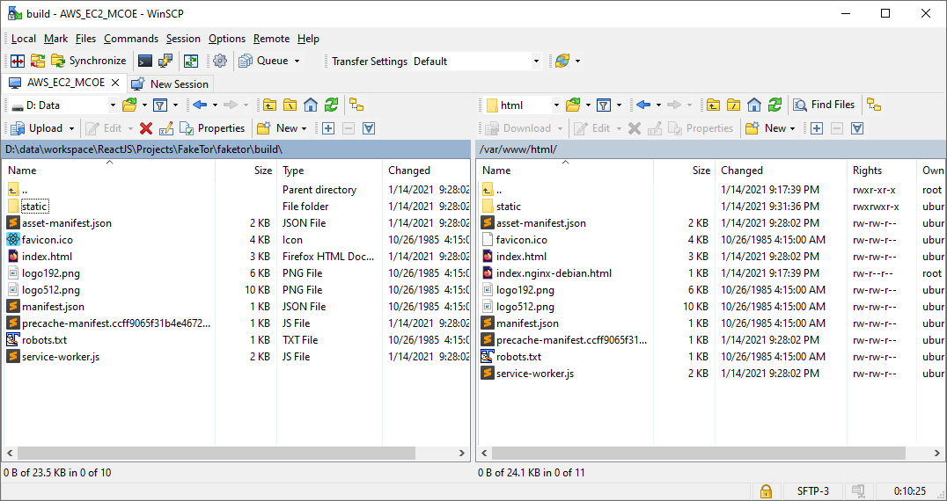

***NGINX***

The default web server on AWS EC2 instance is NGINX

Basic Command (from SSH console)

|  |  |
| --- | --- |
| ***Command*** | ***Comments*** |
| sudo apt install nginx | Install nginx server |
| sudo systemctl start nginx | Start the nginx service |
| sudo systemctl status nginx | Tells if nginx is running, and give its status |
| sudo systemctl restart nginx | Restart nginx, if you have problems… |
|  |  |

Folders:

/var/www/html 🡪 Location of the static file of the web site to be served (HTML, CSS, JS, etc)

_