Macro Variables

***$(SolutionDir)***

Locate the folder of the solution (where the .sln is)

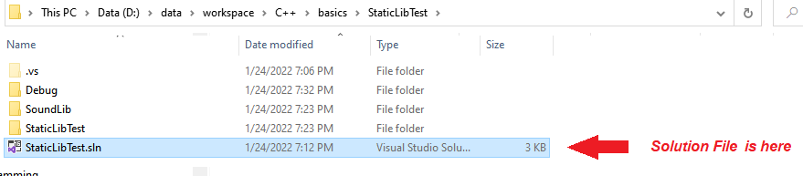

Use the following in the VC++ Directories ***Include*** and ***Library*** directories configs

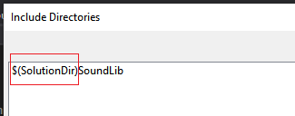

***$(TargetName)$(TargetExt)***

Used in the Linker settings

$(TargetName) 🡪 The name of the output to be produced

$(TargetExt) 🡪 The file extensions of the file to be produced

