Vice is a Commodore Emulator (VIC-20, C64, C128 and other)

***Saving to a virtual Floppy Drive (the 1541 Drive)***

***1 - Attach a virtual Drive***

File 🡪 Attach Disk image 🡪 8 **

** Here, the device 8 been traditionnaly the 1541 drive

***1B - Select a Virtual File Drive***

To complete the configuration, you need a *.d64 file, which is a representation a virtual drive

(Here Emulator1541.d64 is the file)

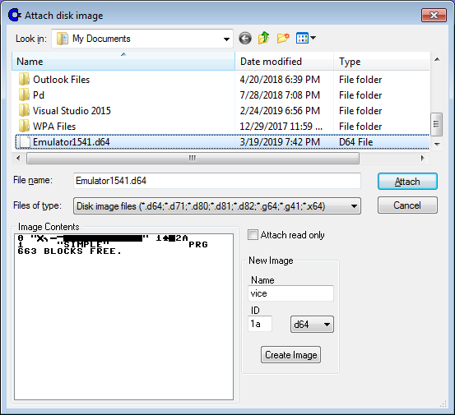

***1C - Save a program***

SAVE “NameOfProgram”, 8

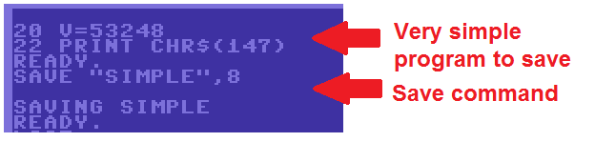

1D – List the saved program (optional)

