***Check this series of videos:***

<https://www.youtube.com/watch?v=fuddZUv7MzA&list=PLdFBjtsWmM96iY6Zz67wpv_WhK_1h-11U&index=2>

***Selection:***

***Edge Loops***: Chain of segments connected together (around an object)

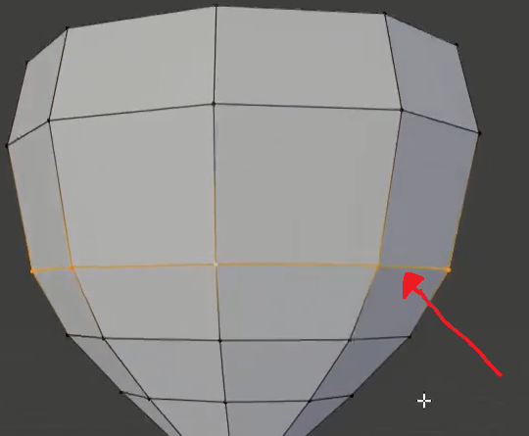

***How***: ALT + Left Button on a specific Vertex

<https://www.youtube.com/watch?v=g85Ij6ObMKo>

***Note***: Have to be In Edit Mode

***Edge Ring:*** Similar to Edge Loops, but segments are on a faces, so you can work on all those faces at the same time

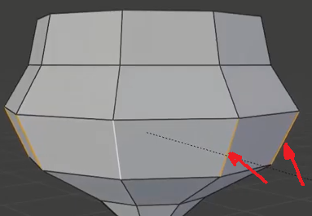

***Now***: CTRL + ALT + Left Button on a segment

***Circular Select:***  Selection from within a circle (the white dashed circle)

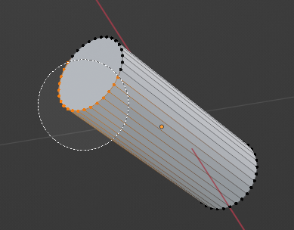

***Now***: ***C*** , mouse wheel to extend or shrink the radius of the selection circle.

***Adding:***

**Add Segment (Between 2 vertices)**

**How:** Select 2 vertex (Hold Shift)

Type J

**Add Face (Fill with a new face)**

**How:** Pickup the vertex around the future face to be created (Selection Mode Vertex is needed here)

Type F (for Fill)

**Loop Cut**

Adding segment into an existing object

***How***: CRTL + R

***Note:*** Use Scroll Wheel to increase number of loop cuts to be added in on single action.

**Special Extrude Face (Into Volume)**

The classic Extrude is no secret, but the following can be handy

* **Extrude Individuals Faces: Can extrude many faces at the same time, toward the outside**

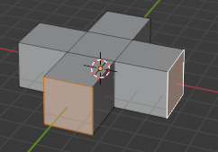

**How:** Alt + E

Select **Extrude Individuals Faces**

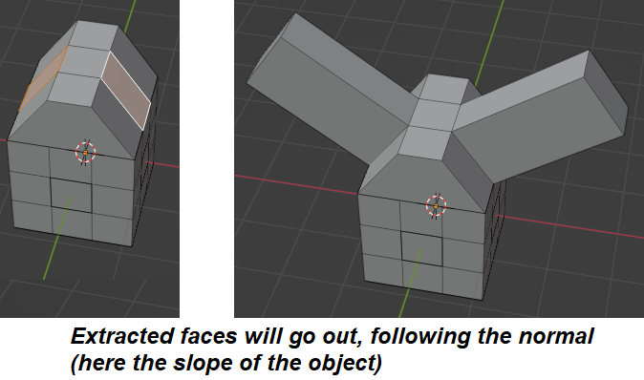

**How:** Alt + E

Select **Extrude Faces along normals**

**Note: Extrude Individuals Faces** and **Extrude Faces along normals** appears to have the same behavior???

**Simple Extra**

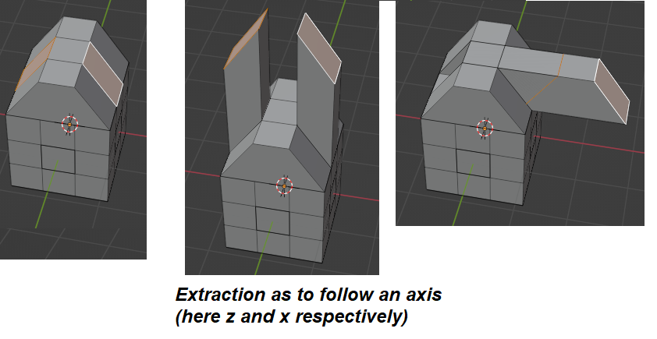

**How:** Alt + E

Select **Extrude Faces**

* **Right Click Extrude**

That one is super handy! It will extrude a selected face toward where you right click on canvas

***How***: Hold CTRL + Right Click somewhere

**Inset (Inner Face)**

From a selected face, you can create an face inside it.

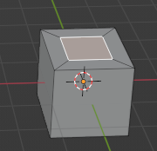

***How:*** Type i

***Note***: To create Insets on more than one selected face: Type twice i

***Modifications***

**Reset Location, Rotation or Scale :**

All the modifications and modifiers can be affected by a non-zero or non-one values

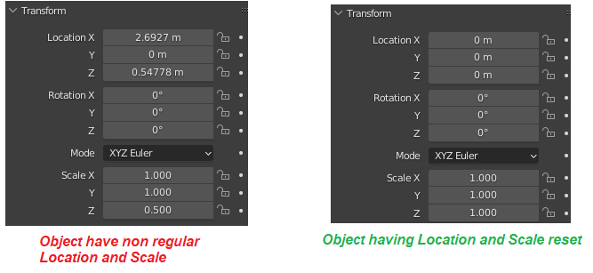

**How: CTRL + A**

A context menu appears and you can reset the desired cords (or all at the same time if wanted)

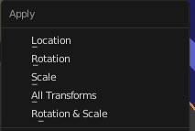

**Force Triangle Faces**

Rendering engine like OpenGL will work faster if models have Triangle face ***only***

**How: (**while in Edit Mode**)**

select all the faces

Go to Face > Triangulate Faces  (or just press Ctrl+T f)

**Slide Move:**

Very like a normal Move (type on ‘G’ and move a point or segment), the slide move will move along a segment (in yellow below)

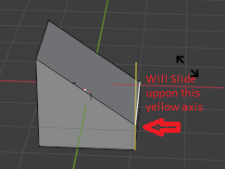

**How:** double type on G (G and then G)

**Bevel (Add faces to round up corners or other)**

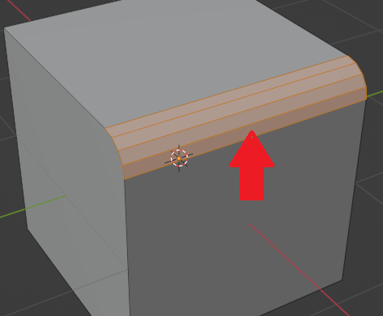

**How: Select an Edge (where the bevel effect with be applied)**

Type CTRL + B (for Bevel)

**Note 1**: You may have to adjust the values in the left panel (Like the num of face to add)

**Note 2**: If the object scale is not x:1, y:1, z:1, you may have a corner not a 45 deg (see image below)

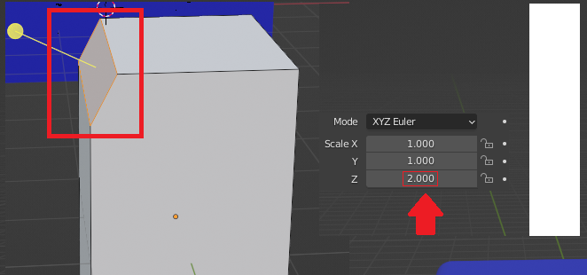

The z scale is greater, so the Bevel Angle is greater than 45 degrees

See in the sections ***Modifications*** the ***‘*Reset Location, Rotation or Scale’ to make the scale 1:1:1 (so that the bevel as the correct angle)**

**Smooth All Corners**

You can remove all the hard edges from a model with the ***Subdivsion*** Modifier

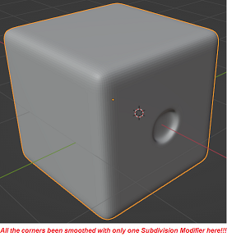

How:

1 – Select the object

2 – In the right section Click on the Modifier 

3 – Select the Subdivision Modifier 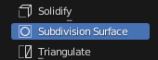

***Important:*** Make sure that your object has enough subsurface first!!!

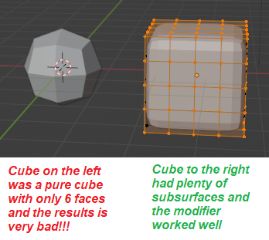

***Texture & Images:***

**Image Plugin** --> To be able to add image as background or a Decals on a surface

https://www.youtube.com/watch?v=UBBx-kZcmzI

s

* Add image as a plane (Can be used later to paste on a surface!!!)

Menu Add --> Menu Image -> Images as Plane

***Apply Basic Textures:***

* In the right icon column, Select the Material Prop 
* Click on the blue button Add Material
* In the Base Color control, Click on the Yellow
* In the overlay Dialog that appears, select ***Image Texture***
* Click on Button Open
* Select the image file of the texture to apply

Note: To view the texture applied, make sure to view the model in the ***Viewport Shading***



Here is a video describing the steps: <https://youtu.be/r5YNJghc81U>

***Note***: Here is a great number of free textures

<https://ambientcg.com/list>

**Transparent Material**

To create glass, the following video explain the process

**How**:

* Select the Shading in the main menu
* Add a Mix Shader from **Add / Shader / Mixer Shader**
* Connect the BSDF of the **Principled BSDF** to the **Mix shader**
* Add a Transparent BSDF Shader from **Add / Shader / Transparent BSDF**
* Change the **Alpha** in the **Principled BSDF** (at the bottom)

Or follow the instructions here: <https://www.youtube.com/watch?v=esIKF8WvaVg>

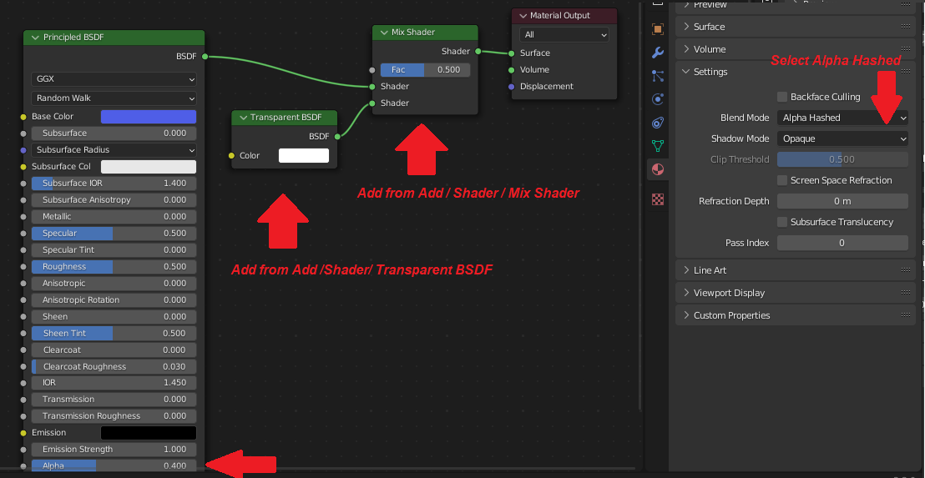

***Camera:***

***Move the camera to the active view***

Moving the camera can be a real pain… But this trick is super handy

***How***:

1 - Make sure to move your current view where you want the camera to look

2 – CTRL-ALT-NumPad0

***Misc:***

***Get Edges &Faces Count***

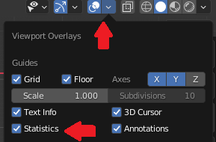

***How***: In the top right corner of screen, locate the Show Overlay (2 circles intersect)

Check the item Statistics

***Move the 3D Cursor:***

The 3D Cursor is the red-white circle, and when it points on an object, some more function can be applied. For instance, if you want to add a new cube, rotate, etc, it will add it right at the place of the cursor.

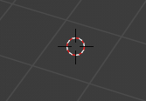

**How**: 1 - Shift + Right Click

2 – In the menu ‘***Object’***, Expend ‘***Set Origin’***, and select ‘***Origin to 3D Cursor***’

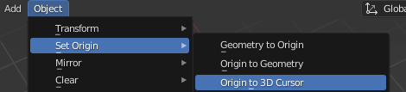

***Note***: In origin is set to the 3D cursor, and extra yellow dot at the middle of the circle appears



***Display Normals:***

Can display Faces, Edge or Vertex Normal

Note: Must be in Edit mode (will not work when in Object mote)

***How***: In the top right corner, expend the menu/section ***Show Overlays***

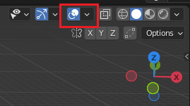

Toward the bottom of the Show Overlays, panel, click on the type of normal (vertex,edge, face)



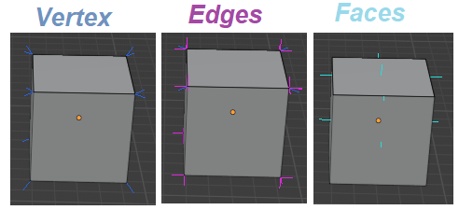

***Web Site with Multiple palettes:***

<https://lospec.com/palette-list>

***Simple 3D Models:***

<https://quaternius.com/>