***WasmFiddle***

Support web site to help to create rapidy Wasm module (light weight version of Emscripten)

<https://wasdk.github.io/WasmFiddle/>

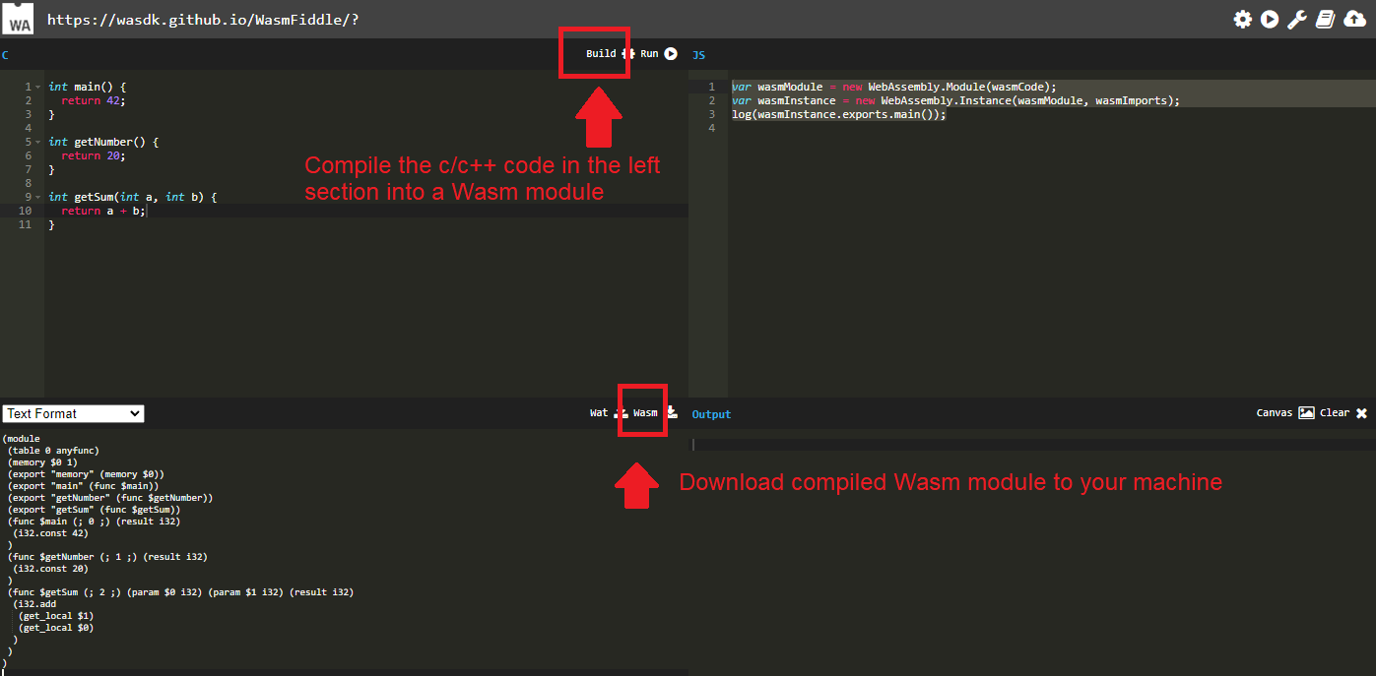

***WebAssembly Studio***

Similar to WasmFiddle, but with different functionality

[***https://webassembly-studio.kamenokosoft.com/***](https://webassembly-studio.kamenokosoft.com/)

***Browser support***

Chrome can display variable in the Console Debug tool

