***Windows Ribbons***

Enhanced Toolbars introduced since Microsoft Office 2007

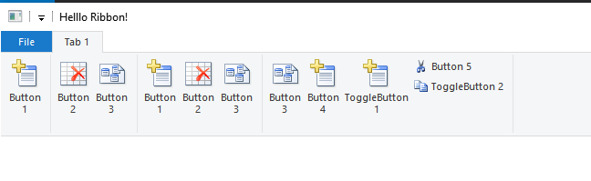

Here is a Web Page from Microsoft on the topic:

<https://docs.microsoft.com/en-us/windows/win32/windowsribbon/windowsribbon-stepbystep#initialize-the-ribbon>

Another place with good examples:

<https://codejock.com/downloads/samples/ribbon.asp>

Here is an example that work:

D:\data\workspace\C++\Windows-classic-samples\Samples\Win7Samples\winui\WindowsRibbon\SimpleRibbon\CPP

The example from Microsoft are here (Few very good one!):

<https://www.microsoft.com/en-us/download/details.aspx?id=9620>

The ribbons are defined in an XML, and have to be compiled by the UICC tool