NodeJS can be used a programming language as ASW Lambda

Logging:
console.log( obj );
NPM
NPM is the base Command line tool to build Javascript/NodeJS project
Few basic command:

Command | Description / Comment
npm init | Very first command of every Javascript project  It creates the basic folder structure and the package.json description file
npm install < libToInstal> | Any library required for the project can be downloaded and put in the right folder with this command.  See next tab for common installation package
npm install | Multiple install à Will read the dependencies in the package.json file and download all required libraries

Install Command | Descriptio Description / Comment n / Comment
npm install aws-sdk | Install all lib for a Amazon Cloud project
npm install mysql | MySql drivers/files required for accessing a MySQL database
npm install pg | PostgreSQL drivers/files required for PostgreSQL project
npm install pg | Another set of driver/files for the PostgreSQL. Documentation here:  https://www.npmjs.com/package/postgres

Build in Libraries
Here is good list of existing lib for Node JS.
https://www.w3schools.com/nodejs/ref_modules.asp

API Access From JavaScript
To access an API using an AJAX call from a JavaScript, you can run into Browser Cross Origin problems.
The quick way to avoid this is to use the SDK Generation, in API Gateaway

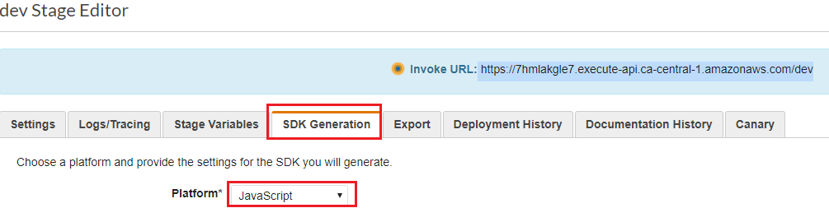
DB Access
AWS Documentation about NodeJS (javascript) access to Database
https://aws.amazon.com/sdk-for-node-js/

MySQL access example here: https://www.youtube.com/watch?v=hGZX_SA7lYg

NodeJS Study Plan:

1 - W3C pages: https://www.w3schools.com/nodejs/ref_fs.asp
2 - YouTube Series on NodeJS: https://www.youtube.com/watch?v=pgHcWAh9sFA
3 - NodeJS Book on OneDrive

