React Rooter handle the links of various page in your project

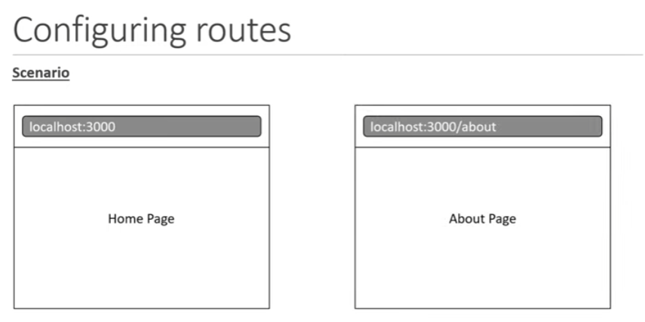
Installation:
npm install react-router-dom

App Coding:
In index.js

…
// The 2 following components needs to be imported
import ReactDOM from 'react-dom/client';
import { BrowserRouter } from 'react-router-dom';
…

const root = ReactDOM.createRoot(document.getElementById('root'));
root.render(

{ /* Need to sandwich the <App /> tag between the <BrowserRouter>*/}
<React.StrictMode>
<BrowserRouter>
<App />
</BrowserRouter>

</React.StrictMode>
);

In App.js

…
// Need to import the Routes and Route
import { Routes, Route } from 'react-router-dom';
// Create and import the sub component to be displayed and managed
// by the React Rooter lib…
import Home from './containers/Home.js';
import About from './containers/About.js';
…
function App() {
return (

{/* Use a <Routes> structure to insert the various sub pages contained in the project*/ }
<Routes >
<Route path='/' element={ <Home />} />
<Route path='about' element={ <About />} />
</Routes>

);
}

export default App;

