Daniel Dressler

Email: [danieru.dressler@gmail.com](mailto:danieru.dressler@gmail.com) HP: <http://danieru.com/> Phone: 070-1076-4098

Github**:** <https://github.com/daniel-dressler>

〒174-0052　東京部板橋区蓮沼町　45-18-210　実用蓮沼マンション

Authorized to work in Japan. Canadian citizen. Willing to relocate.

Technical Skills

**Languages:** C, Javascript, C++, GLSL, C#, Perl **Protocols:** TCP/IP, HTTP, Host side USB

**Tools:** Git, Vim, Visual Studio, BZR, SVN **Libraries:** Bullet Physics, Libusb

**Build Tools:** GCC, Make, Cmake, Clang

Internship Experience

**Linux Foundation Role**: GsoC Student **Timeline**: April 2014 to October 2014

Implemented the IPP over USB standard as ratified by the USB Implementers Forum. This brought support support for next-generation USB printers to Linux. Related work included working with Red Hat to patch Linux’s udev based printer auto-start infrastructure. Worked with **C** & **Python**.

Later work included assisting Brother in debugging their printer’s implementation.

Initial work was sponsored under Google Summer of Code. Work has continued on a volunteer basis.

**Microsoft Windows Division Role**: SDE Intern **Timeline**: May 2013 to August 2013

Developed tool for crash analysis of mini-crash dumps. Included a domain specific language which developers could use to script interactions with the Windows Debugger. Prototype written in **C#**. Production developed in **C++**.

**Linux Foundation Role**: GSoC Student **Timeline**: April 2012 to September 2012

Sponsored by Google Summer of Code I developed the first implementation of the job ticket abstraction standard JTAPI. Written in **C**.

**Linux Foundation Role**: GSoC Student **Timeline**: April 2011 to September 2011

Rewrote Linux’s xml printer database backend from C to Perl. Reduced maintainer’s burden from 10k lines of **C** to 1k lines of **Perl**. Sped up static database generation through careful profiling. Work sponsored by Google Summer of Code. Development in **Perl**. Worked with **XML** & **SQLite**.

Personal Projects

**3D Strategy Game** May 2014 to Present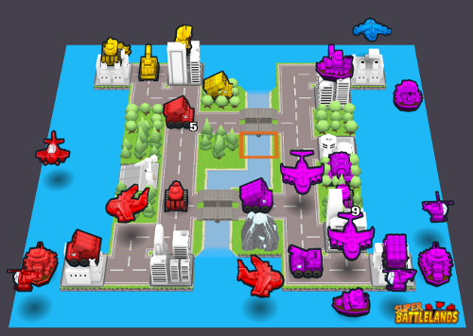

Developed the AI, gamelogic, asset loader, GLSL shaders for a turn-based strategy game. The game has been developed in partnership with an artist. It features: hot-seat multiplayer, blob shadows, 17 units, 4 teams, and a map editor. Official title: “Super Battlelands”.

**Crypto Currency Mining Pool** February 2014

Ran a profitable mining pool for an alternative crypto currency during the currency's boom. Earned customer's trust and respect through customer service and support. Over 60K USD worth of crypto currency was mined through the pool. Reviewed mining pool's software and reported critical denial of service attack vector to upstream. Mining pool was closed once the currency's popularity faded.

**Keymaping for PSP emulator** July 2013

Restructured the PSP emulator PPSSPP's input path to support key mapping. Supported gradual migration for existing platforms' platform specific key mapping schemes. Worked in **C++**. Included GUI work. Contribution shipped as part of version 0.9

Notable Course-based Projects

**Zip library for Blackberry10 HTML apps** Fall 2013

As part of the cross Canada Undergraduate Capstone Open Source Project program I developed an open source zip library for Blackberry 10 HTML applications. Project was written in **C++** and **Javascript**. My work was supervised on a one on one basis with the professor in a manner similar to graduate students' thesis work.

**Original Gameboy Game** Spring 2014

Working in a group of three I wrote the game logic to a shoot-em-up video game running on the original Gameboy. Other teammates handled Audio and Graphics. Written in **C** the game pushed the limits of the 1Mz Z80 CPU. It featured more enemies and more bullets than any Gameboy game before it. Featured semi-random enemy flight paths despite lack of random api or CPU support for multiply & divide.

**Rootkit for FreeBSD**  Winter 2013

Developed a rootkit within a locked lab as part of the Virus and Malware course. This rootkit successfully attacked other student's anti-virus programs. Won best virus award as voted by class in a landslide victory. As part of the award the professor gave my group a monetary prize. I developed the rootkit in **C** while my teammate developed the self-replicating virus.

Education

**University of Calgary Graduated**: 2014 **GPA**: 3.4

Bachelors of Science in Computer Science