Assets
fonts
OFL.txt
VT323-Regular.ttf
araniis.png
ava.png
lek.png
matilda.png
torga.png
common
box
init
README.md
vec
database
entities
dragonet
druid
evil-dm
fighter
ranger
parties
evil-dms01
heroes

graphics (VIEW)
arena /drawable (‘bg’)
avatar /composite (‘entities’)
bar /drawable
char_cursor/drawable (‘cursor’)
composite /drawable
drawable
font_loader
init
layer
leftbar /bar
menu /drawable (‘gui’)
notification /drawable (‘fx’)
polygon /drawable
rightbar /bar
shadow /drawable
sprite /drawable
model (MODEL)
property
character /property
init
routine
init
pool
stage
state (CONTROLLER)
base
stack
battle /base
choose_action /base
choose_option /base
choose_target /base
execute_action /base
conf.lua
main.lua
-------------------------------- main

local _var0
local _var1

function love.load()

_var0 = new 'pasta0.arquivo0' { }
_var1 = new 'pasta1.arquivo1' { var = 10 }
local var2 = 2
local var3 = require 'pasta1.pasta2'

end

function love.update(dt)
end

function love.draw()

------------------------------- database

return {

sprite = 'lek'
name = 'evil-dm'
properties = {

full_hp = 100

}

}

-------------------------------- arquivo2

local Arquivo = new 'pasta0.arquivo0' {
var0 = nil,
var1 = 0
}

function Arquivo:init()
end

function Arquivo:nomeFuncao(var0, var1)
-- posso usar arquivo1 diretamente se tiver na
-- pasta0 (pasta atual) POO do init
self.arquivo1:funcao()
end

return Arquivo

-------------------------------- arquivo1

local Arquivo = new(Object) {
var0 = nil,
var1 = 0
}

function Arquivo:init()
end

function Arquivo:nomeFuncao(var0, var1)
end

return Arquivo

MVC

controller
/ \
view __ model

MODEL – model : stage/routine *properties*
VIEW – graphics : sprites/renderização/etc
CONTROLLER – state : pilha de status

* controller que mudaria para o estado de game over *

VIEW
view > controller > model > db
* display the user interface and data
* detect events from the user

MODEL

* manage the (connection with) data(base)

CONTROLLER

* handle the communication between MODEL and VIEW

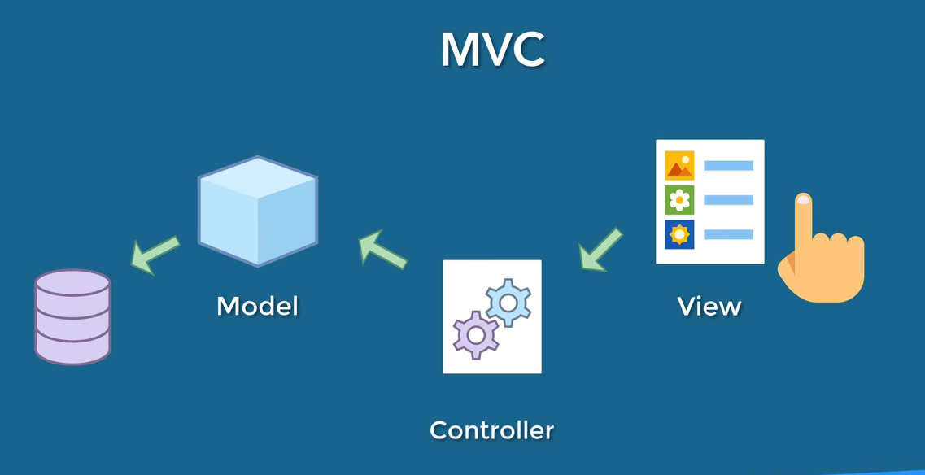
db < model < controller < view

view < controller < model < db < model < controller

