1. Clean and prepared data
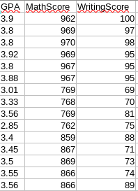

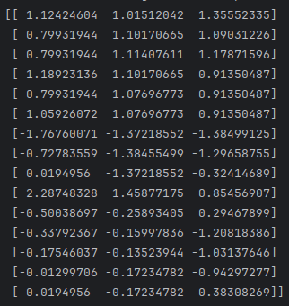
2. Normalized data:

3.
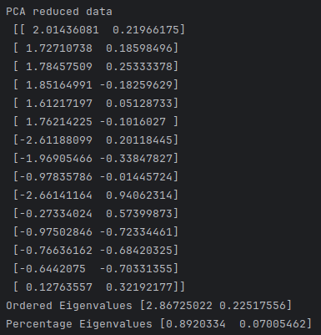

f) The percentage retained is 0.89 + 0.07 = 0.96 = 96%

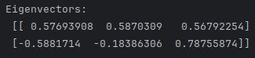
g)

4)
a)
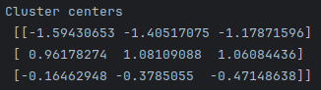

The centroids tell us the average of all the data points in a cluster.

b)
