1. Clean and prepared data

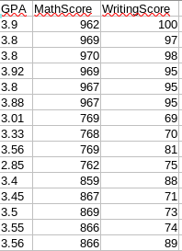

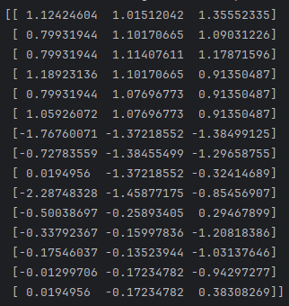2. Normalized data:

3.

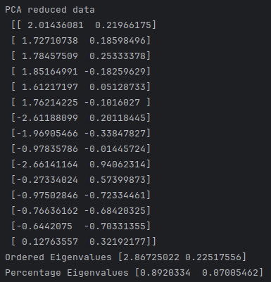

f) The percentage retained is 0.89 + 0.07 = 0.96 = 96%

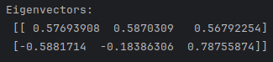g)

4)

a)

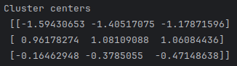

The centroids tell us the average of all the data points in a cluster.

b)

