1)

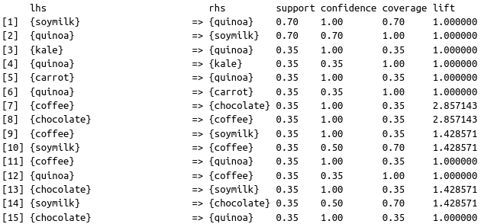

2)

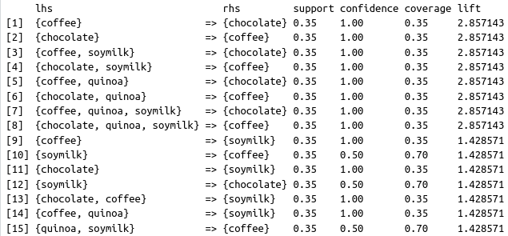

3)

a) {chocolate} →{quinoa} (rule 15 in the first image) is not a rule with a strong association. The lift is equal to 1. According to the definition of lift, a value of 1 indicates no correlation.

b) I would not recommend a store manager to place quinoa next to chocolate. The reasoning goes back to the lift of the association rule. There is no correlation, so it would not make a difference.

c) The confidence of the rule is 1.

4)

a) {chocolate} →{coffee} (rule 2 in the second image) is a rule with a strong association. The lift is equal to 2.86. According to the definition of lift, a value greater than 1 indicates a positive correlation.

b) I would recommend a store manager to place quinoa next to chocolate. The reasoning goes back to the lift of the association rule. There is a positive correlation between the two items, so putting them next to each other might increase sales of both.

c) The confidence of the rule is 1.

5)

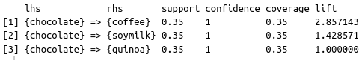a)

b) Given that somebody has chocolate in their cart, they are highly likely to also purchase coffee and soymilk. Because of this, place chocolate on the left side of the store, soymilk in the middle, and quinoa on the right side. This will make customers walk through the entire store when they are buying chocolate and will potentially increase sales. It does not matter where quinoa is as there is no correlation.