COURSE: DOT NET

GROUP ASSIGNNMENT: DOT NET PROJECT ASSIGNMENT

GROUP NAMES Members Ids

Habimana Daniel 25111

Mukanyandwi Priscilla 25101

Ishimwe Elie 24783

Ufiteyesu Rachel 24770

**PROJECT PROPOSAL**

EMPLOYEE_RECRUITMENT_MANAGEMENT_SYSTEM

**PROBLEM STATEMENT**

The recruitment process in many organizations is inefficient due to manual handling, lack of centralized systems, and poor communication between stakeholders. This leads to delays, higher operational costs, and poor candidate experiences. Furthermore, challenges such as difficulty in tracking applications, generating reports, and evaluating candidates hinder decision-making and recruitment efficiency. There is a pressing need for a centralized, automated system to streamline these processes and enhance transparency, accuracy, and communication.

**OBJECTIVE**

* Centralized Recruitment Process: Provide a single platform to manage job postings, applications, and evaluation.
* Efficient Job Posting and Application Management: Enable recruitment staff to post vacancies easily and applicants to search and apply for jobs conveniently.
* Improved Candidate Communication: Automate notifications to ensure candidates are updated on their application status.
* Streamlined Candidate Evaluation: Introduce scoring and ranking mechanisms for fair and objective candidate selection.
* Automated Reports: Generate insightful reports to assist managers in making data-driven decisions.
* Notification System: Alert stakeholders about key updates and events in real time.

**Functional Requirements**:

**User Management**:

Applicants can register, search for jobs, and apply online.

Admin roles for recruitment units, department heads, hiring managers, and top managers.

**Job Management:**

Recruitment units can create and manage job descriptions and person specifications.

Applicants can view job postings and check application status.

**Application Processing:**

Automated shortlisting based on predefined criteria.

Update applicant status (e.g., shortlisted, rejected, hired).

**Notifications:**

Automatic email notifications for applicants and internal stakeholders (e.g., status updates, interview invitations).

**Approval Workflow:**

Hiring managers and department heads can recommend, approve, or reject candidates.

**Reporting and Ranking:**

Generate detailed reports on recruitment metrics.

View final rankings for shortlisted candidates

**Non Functional Requirements:**

**Scalability**: The system should support a growing number of users and job postings.

**Usability**: The interface should be user-friendly and intuitive for all stakeholders.

**Performance**: The system should process tasks (e.g., shortlisting and notifications) efficiently.

**Availability**: Ensure the system is available 24/7 with minimal downtime.

**USECASE DIAGRAM**

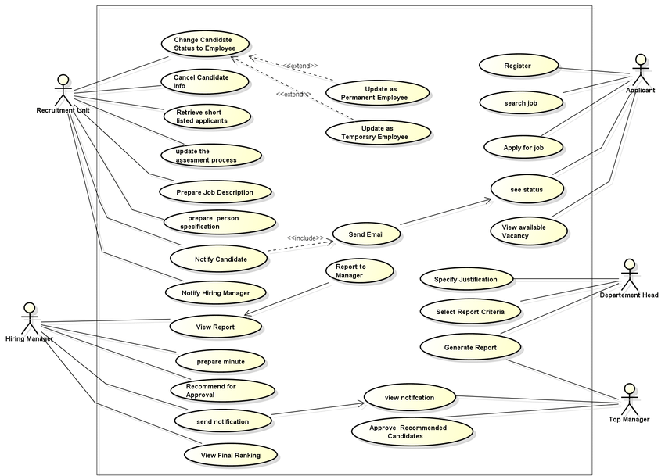

**DATABASE DIAGRAM**

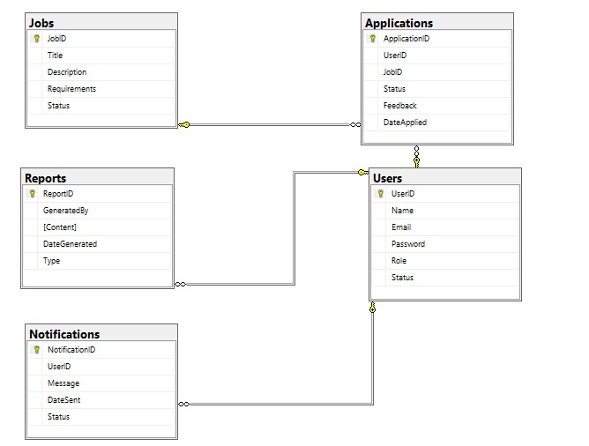

**Project Timeline (2 Weeks)**

Week 1

Day 1-2:

Finalize project requirements (problem statement, objectives, use case diagram, database schema).

Design ER Diagram and database structure.

Day 3-5:

Develop core backend modules:

User management (register, login, role-based access).

Job management (CRUD for job postings).

Day 6-7:

Implement frontend interface:

Applicant dashboard for viewing vacancies and application status.

Recruitment staff dashboard for managing jobs and applications.

Week 2

Day 8-9:

Implement application processing:

Application submission by applicants.

Notifications for status updates and approvals.

Day 10-11:

Develop reporting and ranking module.

Integrate email notifications for stakeholders.

Day 12-13:

Testing and debugging:

Ensure all functional requirements are met.

Conduct usability testing with sample users.

Day 14:

Final review, documentation, and project submission.