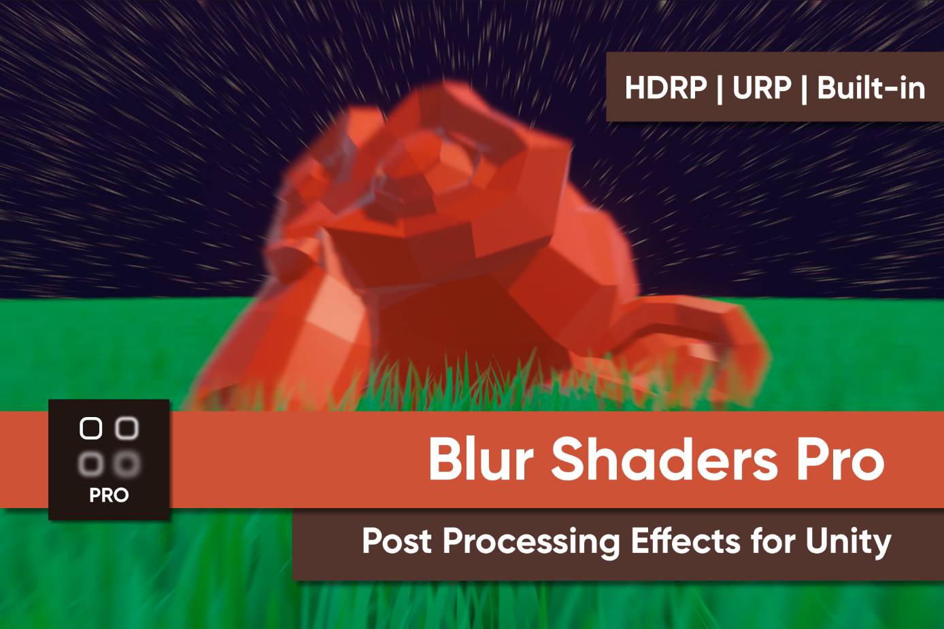

What is “Blur Shaders Pro”?
Blur Shaders Pro is a collection of blur post processing shaders for Unity.
This README is intended for the version designed for Unity’s Post Processing Stack v2, which is installed by default if you got this pack from the Asset Store. PPv2 is compatible with the built-in renderer.

Setup (Post Processing Stack v2)
This shader pack uses Post-Processing Stack v2 as its base. Ensure it is installed using the Unity Package Manager. Otherwise, you will encounter compiler errors.
Use the Quick Start guide to create a Post Processing Layer on your camera and a Post Processing Volume to contain your profile. Then, you’ll be able to add these custom effects to your profile!

Effects Included
The following effects are included in the collection:

Version 1.0 Effects

Radial Blur
A directional blur which gets stronger towards the edges of the image.
- Strength: The size of the blurring kernel (and the strength of the effect). Larger smoothing kernels require more pixel operations per frame.
- Step Size: The distance between samples. Higher values may result in visual artefacts.
Note: Both properties increase the extent of the blur effect, but in different ways. Increasing strength results in more samples, while increasing strength increases the distance between samples.

Blur
Blurs each pixel based on the colours of nearby pixels.
- Strength: The size of the blurring kernel (and the strength of the effect). Larger smoothing kernels require more pixel operations per frame.
- Blur Type: Toggle between Gaussian blur (the blurring kernel uses a Gaussian curve to soften further from the middle) and Box blur (all pixels in the blurring kernel are weighted evenly).

