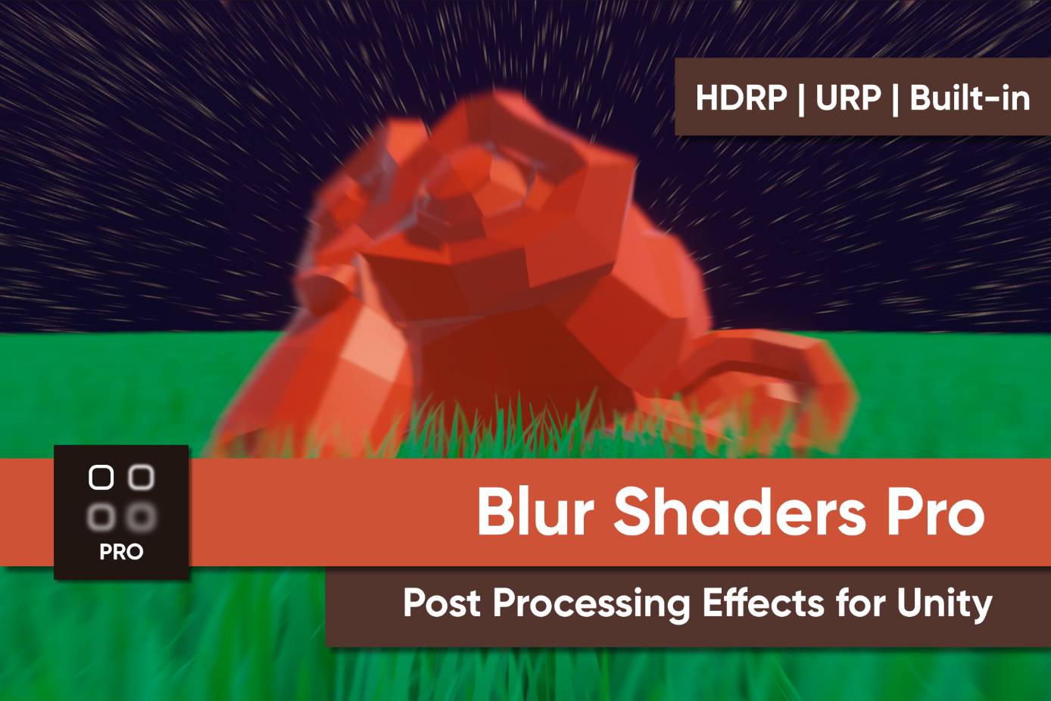

What is “Blur Shaders Pro for HDRP”?
Blur Shaders Pro for HDRP is a collection of blur post-processing shader effects designed for Unity’s High Definition Render Pipeline.

Usage
This shader pack uses High Definition Render Pipeline’s built-in post processing functionality. Use the documentation if you’re unfamiliar with the basics of HDRP. Then, you’ll be able to add these custom effects to your project!
REMEMBER: You need to add each effect to the custom post process list for them to work, even if you’ve added them to a Volume in your scene. Go to Project Settings -> HDRP Default Settings -> Custom Post Process Orders and add each of the effects in this asset pack to the After Post Process section.

Effects Included
The following effects are included in the collection:

Version 1.0 Effects

Radial Blur
A directional blur which gets stronger towards the edges of the image.
- Strength: The size of the blurring kernel (and the strength of the effect). Larger smoothing kernels require more pixel operations per frame.
- Step Size: The distance between samples. Higher values may result in visual artefacts.
Note: Both properties increase the extent of the blur effect, but in different ways. Increasing strength results in more samples, while increasing strength increases the distance between samples.

Blur
Blurs each pixel based on the colours of nearby pixels.
- Strength: The size of the blurring kernel (and the strength of the effect). Larger smoothing kernels require more pixel operations per frame.
- Blur Type: Toggle between Gaussian blur (the blurring kernel uses a Gaussian curve to soften further from the middle) and Box blur (all pixels in the blurring kernel are weighted evenly).

