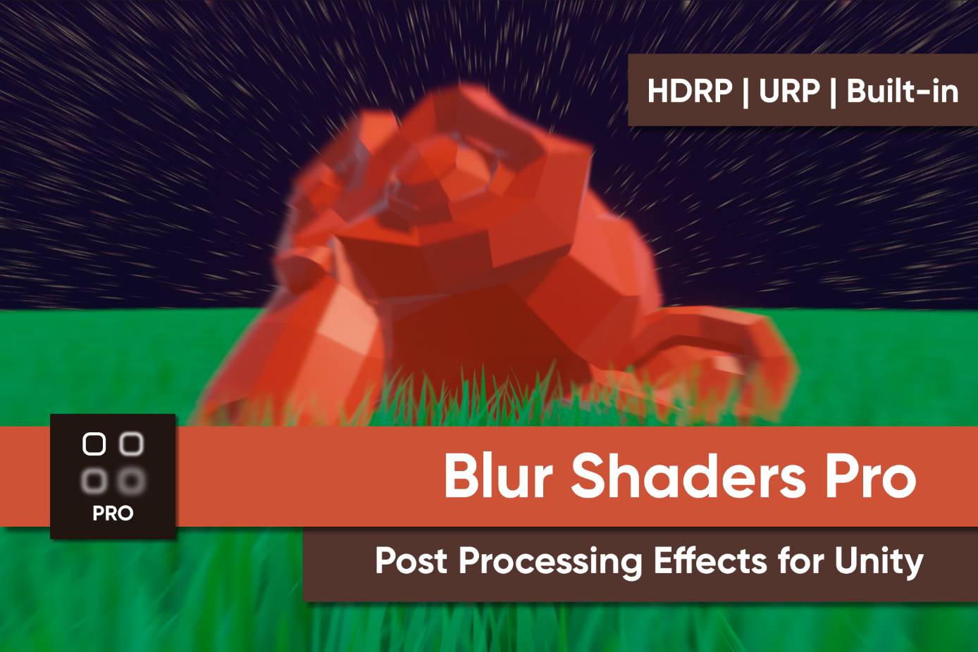

What is “Blur Shaders Pro for URP”?
Blur Shaders Pro for URP is a collection of blur post-processing shader effects designed for Unity’s Universal Render Pipeline.

Setup
This shader pack uses Universal Render Pipeline’s ScriptableRenderFeature functionality for the custom post processing effects. The Unity documentation will outline the basics of URP if you’re not familiar with how to create custom renderers.
Please follow these steps to enable an effect in your scene:
- Find your URP Renderer Asset and add the effect(s) you wish to use in the Renderer Features section at the bottom.
  - This is most commonly found in the Assets/Settings folder if you created a new project using the URP template from the Unity Hub.
  - This asset will be named something like “UniversalRP-HighQuality” (Unity versions 2022.3 and prior) or “PC_RPAsset” (Unity 6) by default.
  - Blur Shaders Pro also includes a ready-made asset named “BlurRP” which has every effect pre-added.
- Create a volume profile asset via Create -> Volume Profile and add the same effects you want to use to the profile.
- Add a volume to your scene and attach the volume profile.
- Tweak the settings on your volume profile. All effects start in an inactive state. Take note of which effects require textures to work properly (they are listed in the full effect list).
The latest version of this asset was created using Unity 2022.3.0f1 and URP 14.0.7.

Using Unity 6 (Important)
Post processing effects in Unity 6 will eventually require support for Render Graph. Blur Shaders Pro does not yet support Render Graph workflows, so to use the pack, you will need to disable Render Graph.
You can do this via Project Settings -> Graphics -> Pipeline Specific Settings -> URP. You will find a checkbox to disable Render Graph near the bottom of the window.
Render Graph support is planned in the future.

Additional Warnings
Please take note of the workflow for this asset pack, which utilizes URP’s volume system.
These shaders are designed for linear color space, so you may encounter issues in gamma space. To swap between color spaces, go to Project Settings->Player->Other Settings and find the Color Space dropdown option.
REMEMBER: You must add each effect to your Forward Renderer asset’s Renderer Features drop-down to function. Blur Shaders Pro URP comes with defaults that you can use in the package root folder – in Project Settings->Graphics, attach the BlurRP asset to the Scriptable Render Pipeline Settings field. You may also need to attach the BlurRP asset in Project Settings->Quality to the Rendering field for each quality level. Then, you can add effects to the Renderer Features list on the BlurRenderer asset.
FOR THOSE USING UNITY 6.0.0: As of the release of Blur Shaders Pro 1.6.3, URP is supported in Unity 6. However, due to breaking changes associated with the Render Graph API, you MUST be using compatibility mode. You can find this under Project Settings -> Graphics -> Pipeline Specific Settings -> URP. You will find a checkbox to disable Render Graph near the bottom of the window.

Effects Included
The following effects are included in the collection:

Version 1.0 Effects

Radial Blur
A directional blur which gets stronger towards the edges of the image.
- Strength: The size of the blurring kernel (and the strength of the effect). Larger smoothing kernels require more pixel operations per frame.
- Step Size: The distance between samples. Higher values may result in visual artefacts.
Note: Both properties increase the extent of the blur effect, but in different ways. Increasing strength results in more samples, while increasing strength increases the distance between samples.

Blur
Blurs each pixel based on the colours of nearby pixels.
- Strength: The size of the blurring kernel (and the strength of the effect). Larger smoothing kernels require more pixel operations per frame.
- Blur Type: Toggle between Gaussian blur (the blurring kernel uses a Gaussian curve to soften further from the middle) and Box blur (all pixels in the blurring kernel are weighted evenly).

