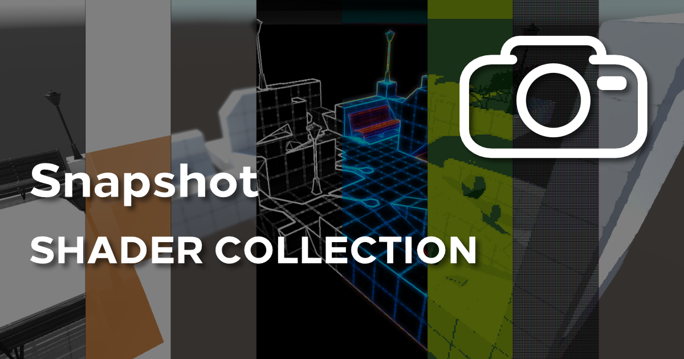

# Usage

Attach the SnapshotMode.cs script as a component to your main camera. Then, drag the SnapshotModeCanvas prefab from the Prefabs folder to the corresponding variable on the Snapshot Mode component you just attached to your camera.

The SnapshotMode.cs script uses the Shader.Find() function extensively, so the user may need to add the shaders manually to the “Always Included Shaders” section in Project Settings -> Graphics.

No further configuration is required. If the user wishes to decouple the individual shader files from the provided script and use them in materials or other scripts, then a full rundown of the Properties on those shaders is provided.

# Shaders Included

The following shaders are included:

* **Base** – preserves the original image colours;
* **Bloom** – makes bright portions of the image glow;
* **CRTScreen** – adds a screen overlay to mimic a CRT screen;
* **EdgeBlur** – keeps the image sharp in the centre, and blurs strongly towards the edges;
* **EdgeDetect** – detects edges in the images, colouring them white on a black background;
* **GaussianBlur** – blurs the image uniformly;
* **Greyscale** – turns the image greyscale based on pixel luminance;
* **Neon** – detects edges, saturates their colours and adds a bloom effect;
* **Painting** – employs a Kuwuhara filter for an oil painting effect;
* **PixelGB** – pixelates the image and gives it four shades of green (based on the original Game Boy display);
* **PixelNES** – pixelates the image and posterises it to a smaller range of colours (based on the original NES display);
* **PixelSNES** – pixelates the image and posterises it to a larger range of colours than the PixelNES effect (based on the original SNES display);
* **Sepia** – turns the image sepia-tones based on pixel luminance;
* **Silhouette** – colours the image such that the closer the object, the more saturated the colour.

# Shader Properties

Shaders contained within this package use the same conventions between shader files.

* **_MainTex** – typically, for an image effect shader, the screen contents are automatically passed to the shader;
* **_KernelSize** – for some shaders, this controls the number of pixels the filter operates over;
* **_Spread** – for blurring shaders, this controls the strength of the blur;
* **_Threshold** – for the Bloom shader, this controls the luminance over which bloom is applied;
* **_Brightness** – for the CRTScreen shader, this controls the colour luminance shift upwards to correct for scanline darkness;
* **_Contrast** – also for the CRTScreen shader, this controls the difference in luminance between light and dark pixels;
* **_GB[XYZ]** – for the PixelGB shader, there are four properties which control the four colours of the screen;
* **_NearColour** – for the Silhouette shader, this controls the colour of objects existing at the camera’s near clip distance;
* **_FarColour** – for the Silhouette shader, this controls the colour of objects at the camera’s far clip distance and in the background.