

Internet and Web Programming Project Component Stock Market Simulation Website

CSE3002 - Internet and Web Programming

***J COMPONENT PROJECT DOCUMENT FALL 2022 - 2023***

**TEAM MEMBERS:**

**Daniel Jebarson K 20BCE0082 Reovwin John 20BCE0570 Rithvik Hariprasad 20BCE0980**

UNDER THE GUIDANCE OF

Prof. Jayakumar K. SCOPE

# Abstract

This project is mainly for people to understand how stock markets work. In this game we have different pages like the login page, registration page, dashboard etc. The project is made using ReactJS for frontend. The rules of this game are simple: Buy stocks when the cost value is low and sell them when they are high thus to earn a good amount of profit. The dashboard will be the place where the stocks will be displayed and from where we will be buying and selling the stocks. There are a few APIs used in this project. One of them is to retrieve the stock market data. The data acquired by this API is then made into a graph and displayed on the dashboard screen.

# Introduction

A share which entitles the holder to a fixed dividend, whose payment takes priority over that of ordinary share dividends is called a stock and stock market is a place where shares of pubic listed companies are traded. The primary market is where companies float shares to the general public in an initial public offering (IPO) to raise capital. The stock market works through a network of exchanges .Companies list shares of their stock on an exchange through a process called an initial public offering, or IPO. Investors purchase those shares, which allows the company to raise money to grow its business. Investors can then buy and sell these stocks among themselves. Buyers offer a “bid,” or the highest amount they’re willing to pay, which is usually lower than the amount sellers “ask” for in exchange. This difference is called the bid-ask spread. For a trade to occur, a buyer needs to increase his/her price or a seller needs to decrease hers. This all may sound complicated, but computer algorithms generally do most price-setting calculations. When buying stock, you’ll see the bid, ask, and bid- ask spread on your broker's website, but in many cases, the difference will be pennies, and won’t be of much concern for beginner and long-term investors. The point of the stock market is to provide a place where anyone can buy and sell fractional ownership in a publicly traded company. It distributes control of some of the world’s largest companies among hundreds of millions of individual investors. And the buying and selling decisions of those investors determine the value of those companies. Investing in stocks has become very common in the last few decades and has also become a good way to get profits and also have liquid assets which can easily be converted to cash. But stocks are also very volatile and can shift in an instant so it is necessary to learn to invest in the stock market. We have therefore put together this site which is a simulation game where users can invest virtual currency/points in companies and can also observe the graph of the stocks to predict uptrend and when there is a downtrend. They can choose to sell and buy at any point and it might lead to a profit or loss. This will get them ready for the “real stock market world”.

# Existing system problems

There is high risk involved with investing in the stock market. If a company does poorly, then investors will sell therefore sending the stock to plummet and when stocks are sold the initial investment is lost. Also there is an issue of time. If you are buying stocks on your own, you must first conduct due diligence on each firm to establish whether you believe it will be lucrative before purchasing its stock. You must become proficient at reading financial statements, yearly reports, and news articles about your organisation. Additionally, you need to keep an eye on the stock market because even the best companies will have their value decline during a market correction, market crash, or bear market. And you can be eligible for a tax benefit if you sell your shares at a loss. However, you would have to pay capital gains taxes if you sold your stock at a profit. Obviously, Second by second, stock prices increase and decrease. People frequently sell cheap out of fear and buy high out of greed. The best course of action is to simply check in occasionally rather than continually monitoring stock price changes. Professional traders and institutional investors have greater time and resources to invest. Additionally, they have access to sophisticated computer systems, financial models, and trading instruments.

1. **Proposed System Design**

HOME PAGE

GAME PAGE

REGISTRATION PAGE

DASHBOARD

PROFILE

**MODULE DESCRIPTION**

The homepage with the path “/” contains the buttons to login and sregister. It also contains text that displays the instructions and guidelines to play the stock market game. Then finally there is a graph of a random company’s stock. The login page with the path “/registration” has two text fields. One for the username and the other for the password. There is also a forgot password option. Then there is a submit button and a link to the signup page if the user has not yet registered. The signup page is also on the same page as the login. When the user presses the signup option ,the page turns to signup form with three fields and a submit button. The three fields being name, email and password. There is a main game page where option to choose from a list of companies are given along with the option to buy and sell. You can choose the amount you want to buy or sell. Then there is a profile page which shows the user details like when he started playing and the number of points he/she has. There is also a dashboard page were the graphs of all the company stocks are given for the user to see trends and play accordingly.

**UML Diagram**

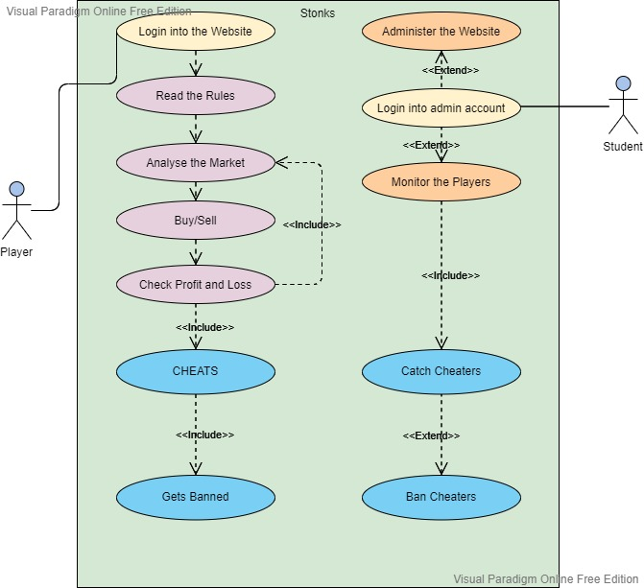

# Results

Database Design/Table Schema

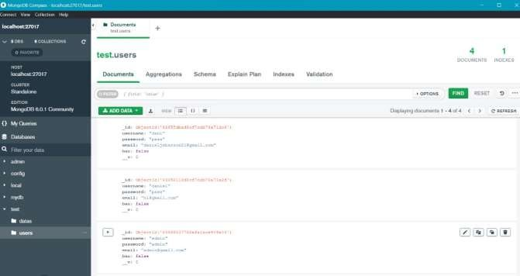

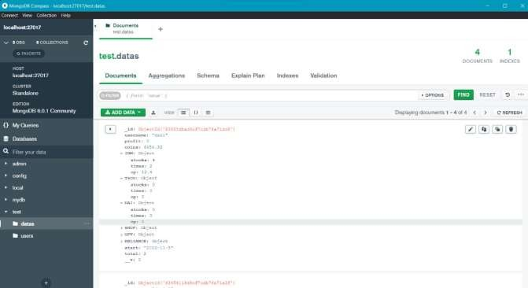

There are two databases of the users i.e. one for initial login which have the columns: username, password, email and ban .The ban tells us whether the account is banned from logging in ,if yes then the value of ban is true ,else then ban is set to false. The other database is for the data on the profits, companies invested by the user, current points of the user ,etc.

Homepage

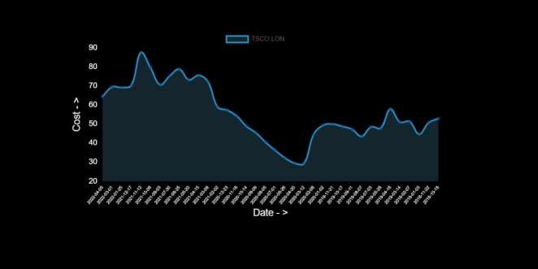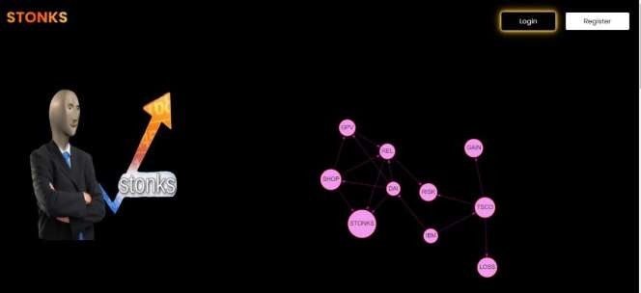

Registration Page

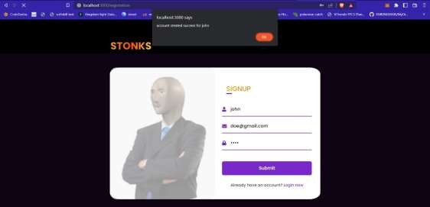



In the above images , an account is made in the signup section of the registration page. The user has to input three fields; name, email and password. Then the user can click on login and then he/she will be directed to the login section where they have to input username and password and if correct they will be granted access. Unless there is a ban i.e. the ban is set to true by the admin. The admin can also login through here.

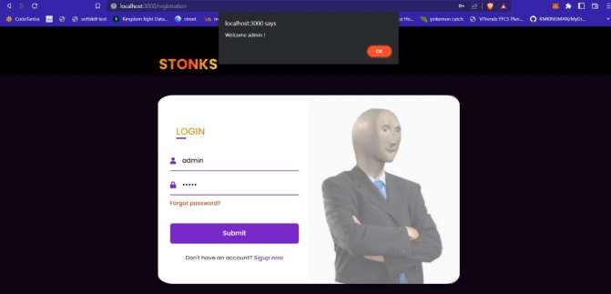

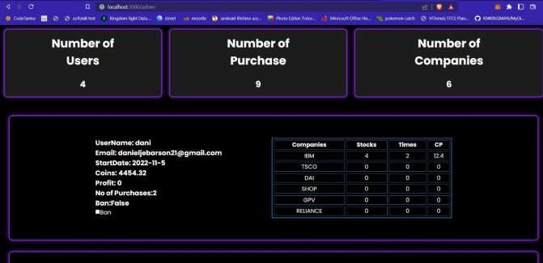

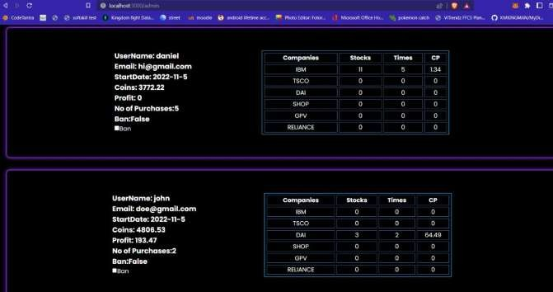

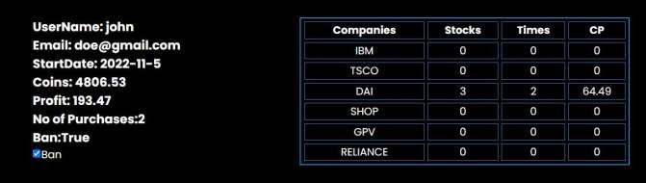

As you can see, there is also accounts for admin who have privileges to view the user account details such as companies they have invested in ,their profit ,the number of transactions that the user has made in total i.e. both buying and selling stocks. The admin’s details will however not be visible in the list of details.

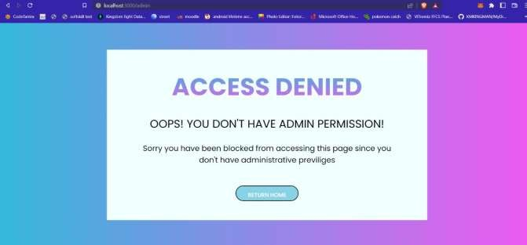

Only admin can access the admin section. The users cannot use the admin privileges by just adding the /admin to the path. If they do so, the above error page is displayed. If the users have access to admin privileges then there might be unauthorized transactions and also breach of the other users’ data.

Dashboard

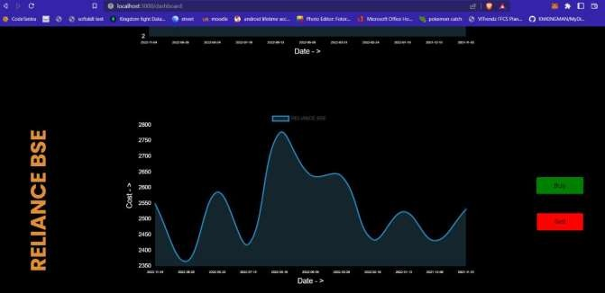

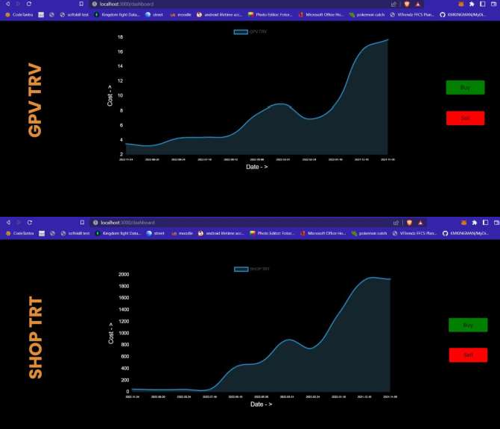

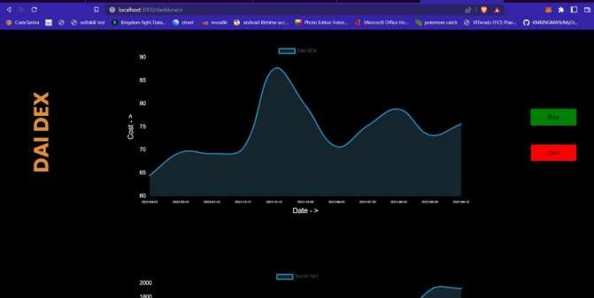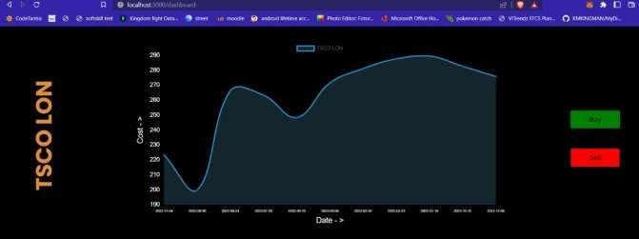

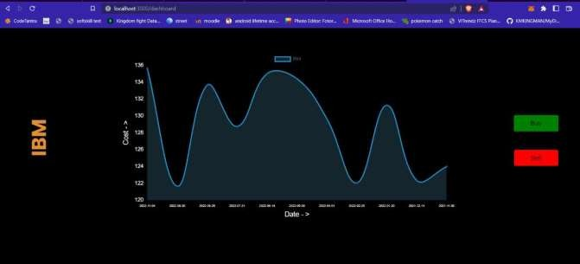

The dashboard page that has the graphs of the stock trends of all the companies. This will help the user to assess the ups and downs of the trends and make appropriate decisions regarding whether to buy or not. The buy and sell buttons on the side navigate to the main game page where the user can input the amount of stocks to be bought or sold.

Mainpage

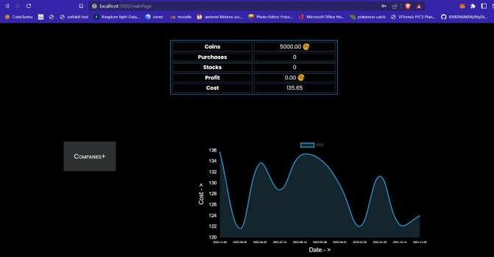

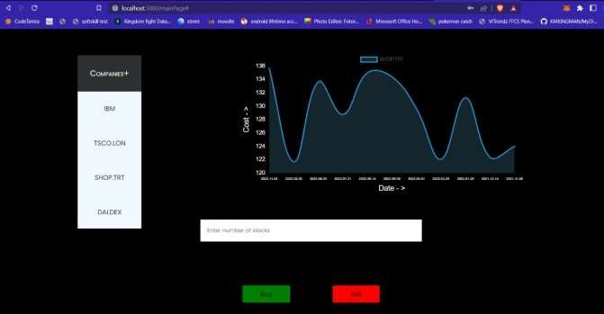

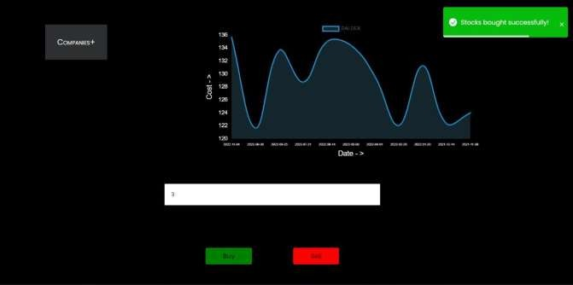

The mainpage contains a dropdown list of the companies to choose from to buy/sell their stock. The amount of stocks to buy should be written and after pressing the buy button ,the stocks are successfully bought as seen above.The notification is shown using a library called toastifier.

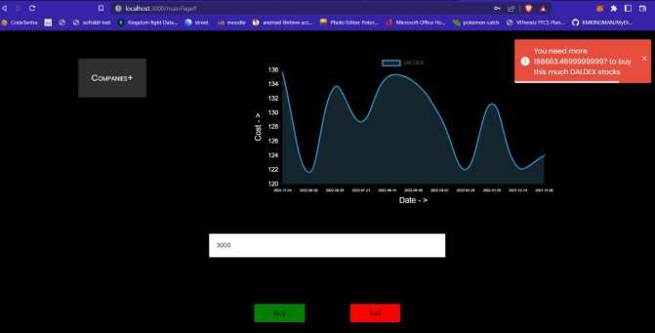

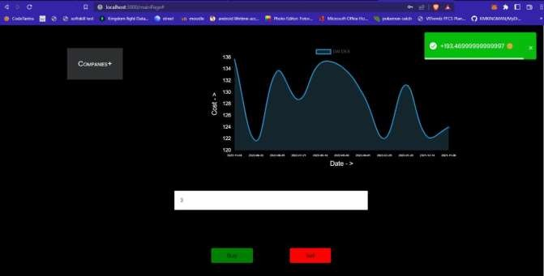

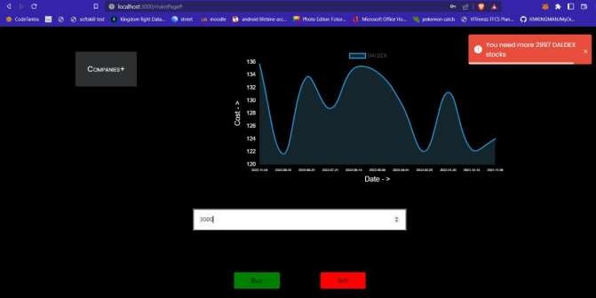

If the amount is more than what is present in the user’s points wallet then the buy transaction is invalid and an error occurs .Entering a given amount of stock and pressing sell, that amount is sold and the cost corresponding to that stocks is added to the points wallet of the user. If the amount to sell is more than what is owned by the user then it shows an error

Profile Page

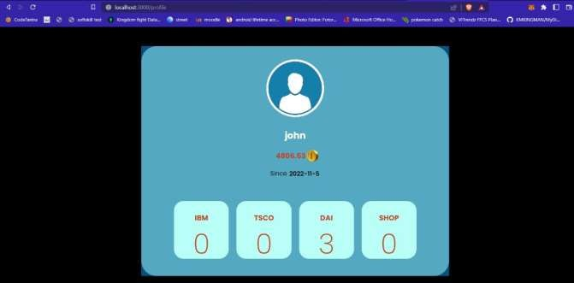

This shows the user’s details such as the companies they have invested in, their points, etc.

The number being shown below the company name depicts the number of stocks that the user has of that company. There is also a date that shows when the user first started playing.

# Conclusion

Our website aims to better the knowledge about investing in stock market and gives beginners a hand on experience without risk of losing any money. Many people lose money because of inexperience in stock market trading. Our Project helps such people to train and make themselves better at stock market. The buy and sell feature of stock market gives the user a real life like feel to buying stocks. The graphs of each company provided in the game is the real graph based on the actual companies trading policies. These real life values are more helpful than fake values as it helps the user to grow in actual sense. Not only for training but also people can play this game just for the sake of playing a game. Hence this game/training website will prove to be of great functionality to everyone.

# References

# *[1] Hinojosa, T., Miller, S., Swanlund, A., Hallberg, K., Brown, M., & O’Brien, B. (2009). The Stock Market Game™ Study: Brief Report. Washington, DC: FINRA Investor Education Foundation.*

# *[2] Aggarwal, S. (2018). Modern web-development using reactjs. International Journal of Recent Research Aspects, 5(1), 133-137.*

# *[3] Duckett, J. (2014). Web design with HTML, CSS, JavaScript and jQuery set (Vol. 1). IN: Wiley.*

# *[4] Goodman, D. (2002). Dynamic HTML: The definitive reference: A comprehensive resource for HTML, CSS, DOM & JavaScript. " O'Reilly Media, Inc.".*

# *[5] Patel, J., Shah, S., Thakkar, P., & Kotecha, K. (2015). Predicting stock market index using fusion of machine learning techniques. Expert Systems with Applications, 42(4), 2162-2172.*

# *[6] Boicea, A., Radulescu, F., & Agapin, L. I. (2012, September). MongoDB vs Oracle--database comparison. In 2012 third international conference on emerging intelligent data and web technologies (pp. 330-335). IEEE.*

# *[7] De Bondt, W. F., & Thaler, R. (1985). Does the stock market overreact?. The Journal of finance, 40(3), 793-805.*

# *[8] Aggarwal, R. K., & Wu, G. (2006). Stock market manipulations. The Journal of Business, 79(4), 1915-1953.*

# *[9] Teweles, R. J., & Bradley, E. S. (1998). The stock market (Vol. 64). John Wiley & Sons.*

# *[10] Barro, R. J. (1990). The stock market and investment. The review of financial studies, 3(1), 115-131.*

# *[11] Bosworth, B., Hymans, S., & Modigliani, F. (1975). The stock market and the economy. Brookings Papers on Economic Activity, 1975(2), 257-300.*

# *[12] Gackenheimer, C., & Paul, A. (2015). Introduction to React (Vol. 52). Apress.*

# *[13] Fedosejev, A. (2015). React. js essentials. Packt Publishing Ltd.*

# *[14] Gackenheimer, C. (2015). What is react?. In Introduction to React (pp. 1-20). Apress, Berkeley, CA.*

# *[15] Web App Development With Node. js Framework.*

# *[16] Augarten, B., Kuo, M., Lin, E., Shaikh, A., Soriani, F. P., Tisserand, G., ... & Zhang, K. (2015). Express. js Blueprints. Packt Publishing.*

# *[17] Banker, K., Garrett, D., Bakkum, P., & Verch, S. (2016). MongoDB in action: covers MongoDB version 3.0. Simon and Schuster.*

# *[18] Győrödi, C., Győrödi, R., Pecherle, G., & Olah, A. (2015, June). A comparative study: MongoDB vs. MySQL. In 2015 13th International Conference on Engineering of Modern Electric Systems (EMES) (pp. 1-6). IEEE.*